This program compute the dipsarity map from two images taken in the rectified situation with the graph cut algorithm.

First, I tried to modifie the regularization term :
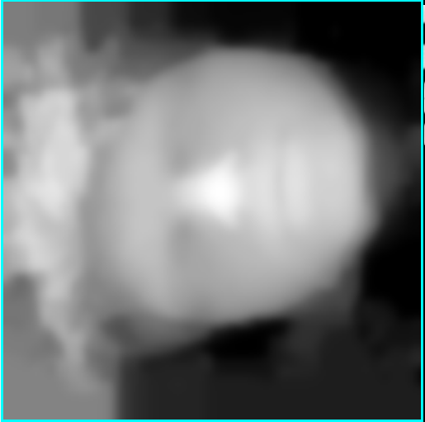Illustration 2: lambda f=0.1
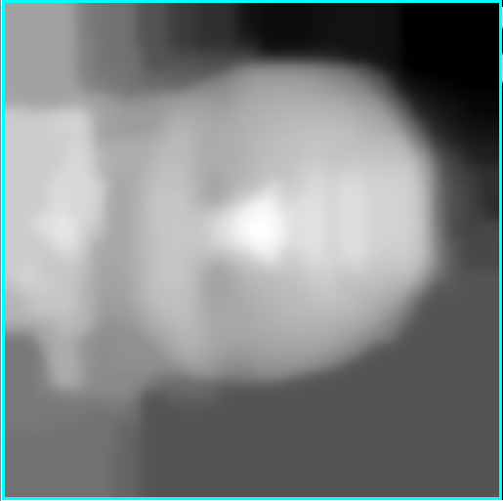Illustration 1: lambdaf=0.3

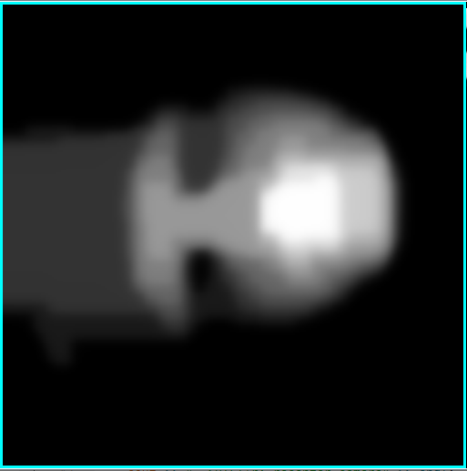Illustration 3: lambdaf = 0.6

As we can see the higher the lambdaf is, the more regular is the image. In order to reduce the cost of the cut, the algorithm will only cut between pixels which have a « distant label ». That is why in the third image we have a such jump between the face and the background.
After, I tried to modifie the size of the window for the zncc : (I kept lambdaf=0.1)
Illustration 4: win = 3
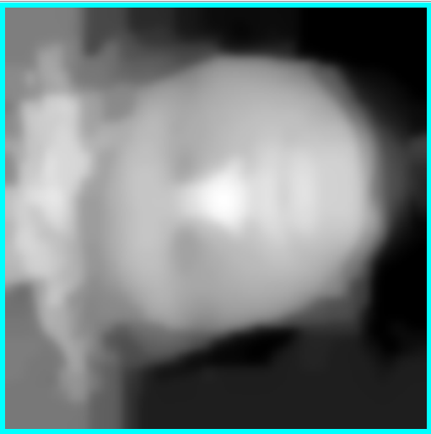Illustration 5: win = 6
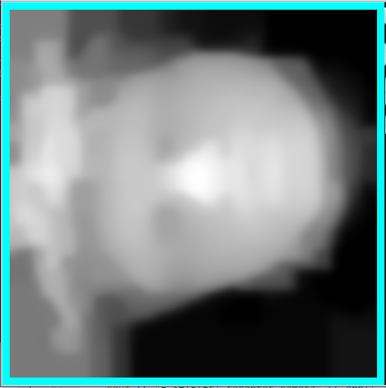Illustration 6: win = 12
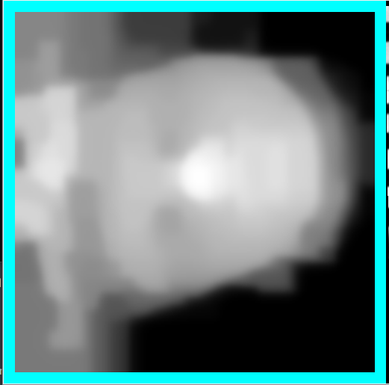Illustration 7: win = 15

As we can see, this algorithm is quite robust to the modification of the windows size if we compare with the local methods.

