

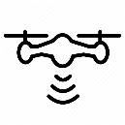

SAR my UE

SAR my UABS



SAR my UE

SAR my UABS

SAR other UE





Call, calling, man, person, phone, talking, using icon

Call, calling, man, person, phone, talking, using iconCall, calling, man, person, phone, talking, using icon

SAR my UE

SAR my UABS

SAR other UE

SAR other UABSs