Call, calling, man, person, phone, talking, using iconCall, calling, man, person, phone, talking, using iconCall, calling, man, person, phone, talking, using icon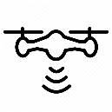Call, calling, man, person, phone, talking, using iconCall, calling, man, person, phone, talking, using iconCall, calling, man, person, phone, talking, using iconCall, calling, man, person, phone, talking, using icon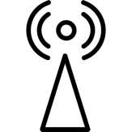Call, calling, man, person, phone, talking, using iconCall, calling, man, person, phone, talking, using iconCall, calling, man, person, phone, talking, using iconCall, calling, man, person, phone, talking, using iconCall, calling, man, person, phone, talking, using iconCall, calling, man, person, phone, talking, using iconCall, calling, man, person, phone, talking, using iconCall, calling, man, person, phone, talking, using iconCall, calling, man, person, phone, talking, using icon

Transmission tower is damaged and doesn’t accept connection anymore

Transmission tower is saturated with

too many connections