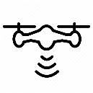Call, calling, man, person, phone, talking, using icon

SAR my UE

SAR my UABS

SAR other UE

SAR other UABSs