Clean start

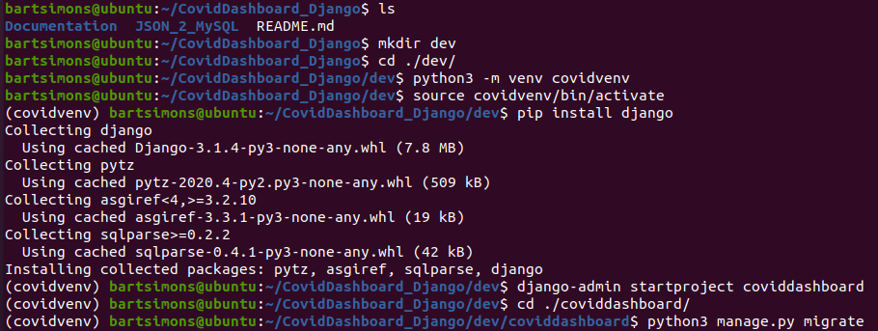
Next we created a superuser using python3 manage.py createsuperuser

Next setting up mysql & mysql for python
https://www.digitalocean.com/community/tutorials/how-to-create-a-django-app-and-connect-it-to-a-database
$ sudo apt update
$ sudo apt install mysql-server
$ sudo systemctl status mysql
Active?

Next change settings.py in venv
ALLOWED_HOSTS = ['127.0.0.1']
LANGUAGE_CODE = 'nl-BE'
TIME_ZONE = 'CET'

STATIC_URL = '/static/'
STATIC_ROOT = os.path.join(BASE_DIR, 'static')

(covidvenv) $ sudo apt install python3-dev
→ already installed? CHECK
(covidvenv) $ sudo apt install python3-dev libmysqlclient-dev default-libmysqlclient-dev
(covidvenv) $ pip install mysqlclient

(covidven) $ sudo mysql -u root

mysql> source <path>/<to>/InitCovidDB.sql
mysql> CREATE USER 'djangouser'@'%' IDENTIFIED WITH mysql_native_password BY 'bartsimons';
mysql> GRANT ALL ON coviddb.* TO 'djangouser'@'%';

