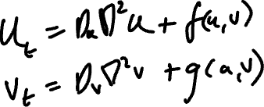

PAINT BY NUMBERS: A Herring

5

|  |  |  |  |
| --- | --- | --- | --- |
|  | 1 |  | 4 |
|  | 2 |  | 5 |
|  | 3 |  | 6 |

To do list:

Monday – Break Enigma Code.

Tuesday - Develop new test for computer  
 intelligence

Wednesday - Theorise about how biological

complexity arises.

Thursday - Pick up racket around 10ish

Dentist appointment at 2:30.

Friday - Buy new ribbon for typewriter.

