|  |
| --- |
|  |
|  |
|  |
|  |
|  |
|  |
|  |
|  |
| Concept of Operations |
|  |
|  |

|  | Name | **Role/Title** |
| --- | --- | --- |
| **Owner** | Peter Temesvari | C3S Technical leader |
| **Reviewer** | Thilo Friedrich  Wojtek Fabianowski | Systems Engineering and Engineering Process Coordinator  Work Unit Leader |
| **Approver** | <<Name>> | <<Role/Title>> |

|  |
| --- |
| NOTE: The authoring instruction box should be deleted from the document before it is finalised  Authoring instruction  This document is a standard template. Please remove any headings not needed   * Instruction text is placed between text entry points shown as << >>. * Header and Footer information in Controlled Documents are mandatory and must not be changed manually. It contains document attributes which will be updated automatically when document is checked in to Chess. * Title field between the two bold lines on first page must not be changed as that contains similar attribute information which will display the title. * Follow the ESS Authoring Guide [ESS-0025989](https://chess.esss.lu.se/enovia/tvc-action/showObject/dmg_Guideline/ESS-0025989/valid) * Please use Insert Cross-reference when referring to references. |

|  |  |
| --- | --- |
| Table of content | Page |

1. Scope 3

2. Issuing organisation 3

3. CONTEXT 3

4. DESCRIPTION 4

4.1. Control system architecture 4

4.2. Automation hardware 5

4.3. Software components 5

4.3.1. System-internal software components 5

4.3.2. System-external services provided by ESS 6

4.4. Networks and connections 6

4.4.1. System-internal networks 6

4.4.2. System-external network services provided by ESS 6

4.5. Operation use cases 7

4.5.1. Manual operation mode 7

4.5.2. Automatic operation mode 8

4.6. Operation risks 9

4.6.1. Control network failure 9

4.6.2. Auxiliary power supply failure 9

5. Summary 9

6. Glossary 10

7. references 10

Document Revision history 11

# Scope

This Concept of Operations document is a conceptual description of how the Cryomodule and Cryodistribution Control System (C3S) will be operated from the Operator Interface (OPI). For complete C3S documentation references, consult the System Engineering Management Plan [1].

# Issuing organisation

This document is issued by the European Spallation Source (ESS), ICS Division, Hardware and Integration Group.

# CONTEXT

Cryomodule and Cryodistribution Control System will control the cooling Helium flow of the 13 pcs of Spoke, 9 pcs of Medium-Beta and 21 pcs of High-Beta cryogenic modules with the connected 13 + 9 + 21 ValveBoxes and EndBox of the Cryogenic distribution line. See on the figure below:

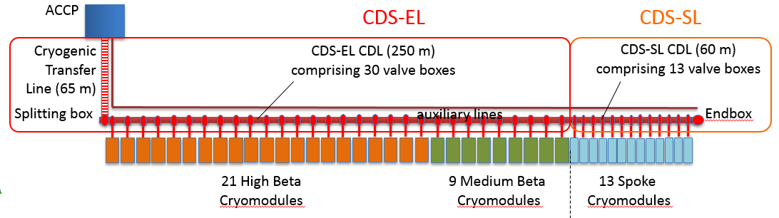

1. Figure: Linac CDS layout [2]

“The proposed controls architecture for the cryomodule is based on a Programmable Logic Controller (PLC), which is integrated into EPICS through the Controls Network and takes care of the process functions.

This type of integration allows for the remote operation of the cryomodule from the control room and the necessary interaction of the cryomodule control system with other related systems (e.g. RF system, Vacuum System, Control Room and EPICS services like archiving, alarms and save-and-restore).The logic contained on the cryomodule PLC is the implementation of the states diagram, complementary to the process diagram (shown in Fig. 4), where for each operating mode, steady state and transition state of the process a corresponding state in the control system is present. Each state is characterized by a set of process variables that are inputs or outputs to the PLC IO.” [3]

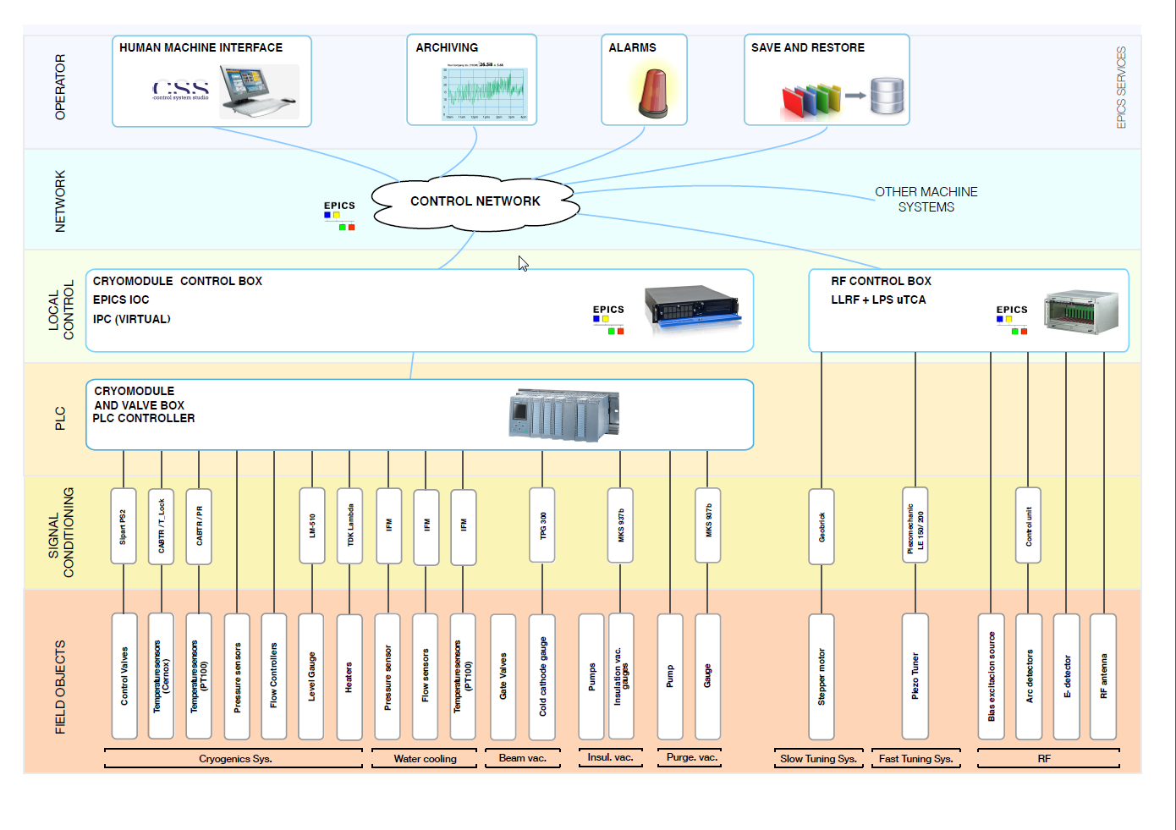

2. Figure: The proposed controls architecture [3]

# DESCRIPTION

## Control system architecture

The whole system to be controlled by the control system can be partitioned to more subsystems listed in following table:

1. Table: Subsystem Names & Numbers

| System Name | System Tag |
| --- | --- |
| Cryogenic Distribution System (CDS) – Spoke Linac ValveBoxes with EndBox | =ESS.ACC.W07.W04 |
| Cryogenic Distribution System (CDS) – Elliptical Linac ValveBoxes | =ESS.ACC.W07.W03 |
| Cryomodules SPK - Spoke Linac | =ESS.ACC.A03 |
| Cryomodules MBL - Medium Beta Linac | =ESS.ACC.A04 |
| Cryomodules HBL - High Beta Linac | =ESS.ACC.A05 |

From point of the view of the Main Control Room Operator all Spoke modules are the same, and all Elliptical are also the same. Differences will be the parameters and tag names only. Therefore, we decided to partition the whole system into units based on that, what objects are controlled and monitored by one PLC controller. Which means in practice, that a unit will consist of a cryomodule and the associated valve box. There will be 43 units consist from a cryomodule and a valve box. In addition, there will be the end box as a unique unit at the end. This kind of partition means only three types of PLC programs to be developed, commissioned and maintain later.

## Automation hardware

The automation hardware components selected for system are Siemens products, which are accepted and already known by ESS.

The central automation component will be a S7-1500 type CPU in all units. Below this CPU there will be remote I/O modules to get the measurement values from transmitters. These remote I/O modules will be connected through ProfiNet network to the CPU.

Next to the remote I/O modules there will DP/PA link to connect the Sipart PS2 positioners to the CPU. The CPU has Profibus DP connection, and the positioners have Profibus PA interface. Therefore the DP/PA link is necessary.

## Software components

### System-internal software components

The main software logic will be implemented in the PLC controllers in all units. There will be three types of PLC programs, for the Elliptical units, for the Spoke units and for the Endbox unit. All of these PLC programs will be able to control and monitor the objects of the assigned unit. These PLC programs will not exchange data between each other; they will operate independently from each other.

PLC programs will exchange data with other control systems (PSS, Vacuum System, RF System, Water System) using remote I/O connections. These data to be exchanged with other control systems are status (binary) information. (For more details see the Interface Control Document.)

PLC programs will exchange data also with the EPICS layer for the OPI, alarm and archiver services through the control network.

### System-external services provided by ESS

The handling of alarms and the archiving of process values will be executed by ESS tools in the EPICS layer. For more details see the Software System Description document.

## Networks and connections

### System-internal networks

There will be ProfiNet, Proifbus-DP and Profibus-PA fieldbuses in all automation control cabinets. See on the figure below:

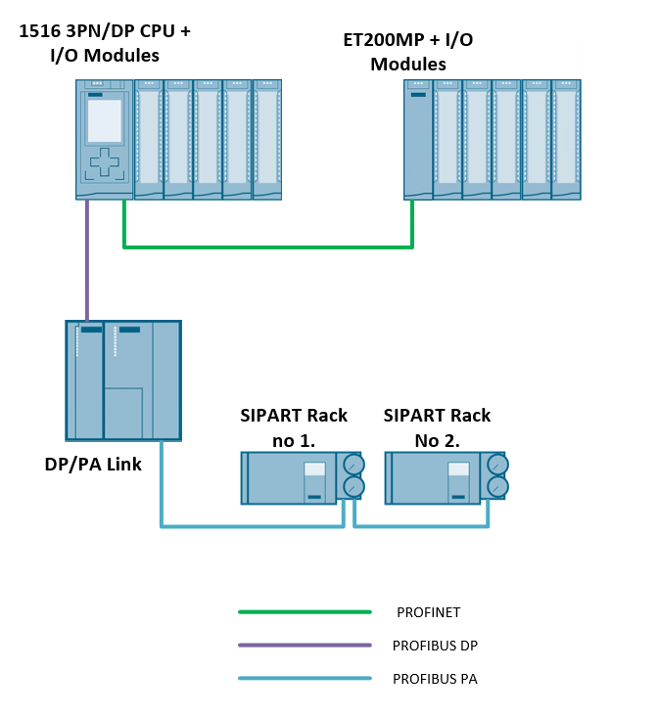

3. Figure: System-internal networks

### System-external network services provided by ESS

All of the 44 PLC in the system will be connected to the Technical Network to reach the EPICS IOCs. This is a non-redundant Ethernet based network.

## Operation use cases

There will be 44 PLCs in the system, which will be in RUN operating mode after the successful commissioning (if the control cabinets on the Klystron Gallery are powered up). Therefore there is not any things to do with PLCs from the user’s aspect normally.

The OPI screens, alarm system and archive services will be available in the control room through EPICS. To be able to operate and monitor the system from the control room, the launch of Control System Studio is necessary. This launch can be automated e.g. by running a script. In case of a manual launch the operator has to select the right Control System Studio project and start the OPI runtime. There will not be any user authorization at starting the Control System Studio nor at starting the OPI runtime. The only one authorization will be at the very beginning, at logging in to the operating system in the control room.

At launch of the OPI a start screen shall appear with an overview of the 44 units of the system and a status information about the actual operation mode and short list of recent alarms.

There will be two main operation modes for operators, the manual and the automatic mode. There will be approx. 20 control valves in every units (a ValveBox with a cryogenic module), which means nearly 900 control valves (with the EndBox together) to be controlled simultaneously. Therefore, the system will operate in automatic operation mode usually. The manual operation mode is for commissioning, early operation phase, and for maintenance purposes.

### Manual operation mode

In early stage, there will be only manual operation mode for the Cryogenic Distribution System. So the operators have to be able control all of the valves, monitor all measurements and check the incoming alarms simultaneously. This means, they need to know deep technology information how run the system.

The block icons and the faceplates on OPI screens will be derived from the common OPI Master Library to get a unified operator interface, which can be see through easily. Block icon and faceplate of a control valve can be seen on the following figures:

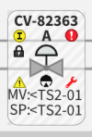

4. Figure: Block icon of control valve

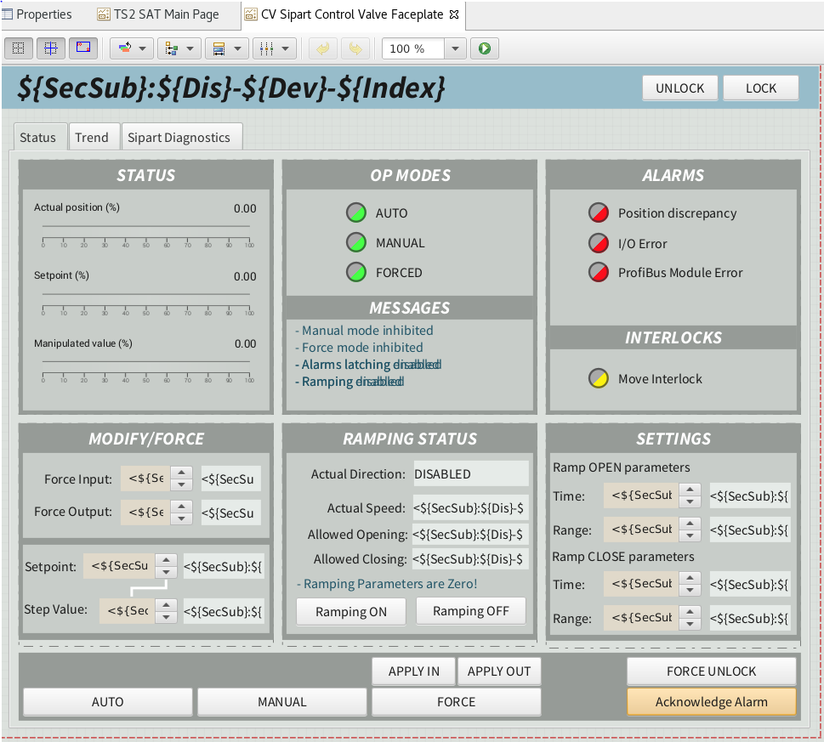

5. Figure: Faceplate of control valve

### Automatic operation mode

Automation Concepts are not designed yet. With continued progress and experience, this section will be used to capture operational procedures (with their actors, conditions, etc.) of the CDS, which shall be partially or fully automated.

## Operation risks

### Control network failure

If there is a connection failure between a PLC and the EPICS layer, the manual control from OPI will be lost, but the programmed interlocks can prevent technology hazards.

In case of automatic operation mode the PLC will run the software further without OPI.

### Auxiliary power supply failure

All of the system component will be powered through the automation control cabinet, which will be equipped with an UPS. So in case of auxiliary power supply failure the whole system operates for a short period depending on the applied UPS type.

In case of longer blackout the system can not operate and the operators will not be able to control the system.

# Summary

All in all the control system for control the Cryomodules and Cryodistribution System will be developed and installed using the standardized tools and objects accepted at ESS. Therefore, the operation and maintenance of the system will be unified and easy to adopt for operational personnel as well.

# Glossary

| Term | | Definition | | |
| --- | --- | --- | --- | --- |
| BEAST  C3S  CCDB  CDR  EPICS  ESS  GUI  ICS  IOC  MPS  OPI  ORR  PDR  PLM  PSS  SAR | | Best Ever Alarm System  Cryomodule and Cryodistribution Control System  Controls Configuration Database  Critical Design Review  Experimental Physics and Industrial Controls System  European Spallation Source  Graphical User Interface  Integrated Control System  Input Output Controller  Machine Protection System  OPerator Interface, EPICS based GUI  Operational Readiness Review  Preliminary Design Review  Product Lifecycle Management  Personnel Safety System  System Acceptance Review |
| TIA  TRR  WBS  WP  WU | | Totally Integrated Automation, Siemens Programming Platform  Test Readiness Review  Work Breakdown Structure  Work Package  Work Unit |

# references

1. SYSTEM ENGINEERING MANAGEMENT PLAN FOR C3S: ESS-1406553
2. Jaroslaw Fydrych: Cryogenic Distribution System for the ESS Superconducting Linac
3. PRELIMINARY FUNCTIONAL ANALYSIS AND OPERATING MODES OF THE ESS 704 MHz SUPERCONDUCTING RADIO-FREQUENCY LINAC

Document Revision history

| Revision | Reason for and description of change | Author | Date |
| --- | --- | --- | --- |
| 1 | First issue for CDR#1 | Peter Temesvari | 2019-09-16 |
|  |  |  |  |