|  |
| --- |
|  |
|  |
|  |
|  |
|  |
|  |
|  |
|  |
| Interface Control Document of CDS |
|  |
|  |

|  | Name | **Role/Title** |
| --- | --- | --- |
| **Owner** | Fenyvesi, Gábor | C3S Control System Engineer |
| **Reviewer** | Thilo Friedrich  Wojtek Fabianowski  Peter Temesvari | Systems Engineering and Engineering Process Coordinator  Work Unit Leader  Technical Leader |
| **Approver** | <<Name>> | <<Role/ Title>> |

|  |
| --- |
| NOTE: The authoring instruction box should be deleted from the document before it is finalised  Authoring instruction  This document is a standard template. Please remove any headings not needed   * Instruction text is placed between text entry points shown as << >>. * Header and Footer information in Controlled Documents are mandatory and must not be changed manually. It contains document attributes which will be updated automatically when document is checked in to Chess. * Title field between the two bold lines on first page must not be changed as that contains similar attribute information which will display the title. * Follow the ESS Authoring Guide [ESS-0025989](https://chess.esss.lu.se/enovia/tvc-action/showObject/dmg_Guideline/ESS-0025989/valid) * Please use Insert Cross-reference when referring to references. |

|  |  |
| --- | --- |
| Table of content | Page |

1. Scope 3

2. Issuing organisation 3

3. CONTEXT 3

4. Interfaces descriptions 4

4.1. Electrical 5

4.1.1. Between electrical cabinets 5

4.1.2. Between electrical power interfaces 5

4.1.3. Between PLC hardware components 5

4.1.4. Between PLC network components 5

4.1.5. Between CDS + CM and Vacuum 6

4.1.6. Between CDS + CM and PSS 6

4.1.7. Between CDS + CM and Purge 6

4.1.8. Between CDS + CM and RF 6

4.1.9. Between CDS + CM and Water 7

4.1.10. Cryogenic sensor signal conditioners 7

4.1.11. Cryogenic valve positioners 7

4.1.12. Power and Instrumentation cables and accessories 7

4.2. Software 7

4.2.1. Between EPICS and CDS + CM 7

4.2.1.1. Control Signals 8

4.2.1.2. Status Signals 8

4.2.1.3. Parameters 9

4.2.1.4. Alarms 10

4.3. Mechanical and Physical 10

5. Glossary 12

6. references 12

Document Revision history 12

# Scope

Scope of this document is to describe the interface between the ICS (responsible of the control systems for all ESS) and CDS of LINAC. It contains the communication subsystems and devices with their channels and protocols, the list of signals.

# Issuing organisation

Both parties are part of the European Spallation Source ERIC (ESS) organization; being ICS the Integrated Control System Division, and being cryomodules of Spoke and Elliptical LINAC the Accelerator Division (AD).

# CONTEXT

The superconducting section of the ESS linear accelerator will include 30 elliptical cavity cryomodules and 13 spoke cavity cryomodules and 1 Endbox.

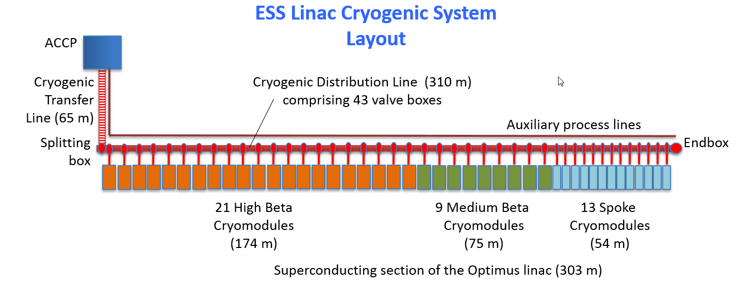

1. Figure: ESS linear accelerator

The cryomodules will be connected to CDS (Cryo Distribution system). The CDS is a constant part of LINAC tunnel. It will supply the CM (cryomodules). They can be connected to CDS or disconnected from CDS. The CDS have some units like tubes (He recovery line, Purge return, SV relief, HP line, TS supply and return, He supply and return), valve boxes and jumper connections. The relevant electrical components of units and the devices of CM are controlled by Siemens PLC. The PLCs have control signals from EPICS. The EPICS is the Control System Architecture chosen at ESS to manage the accelerator and related facilities.

So each cryomodule has a PLC and this PLC can control or regulate the cool down and warm up process with control valves and heaters. The pressure of gas and the level or flow value of liquid will be controlled by PLC also. The Figure 2 shows one instance of CS (Cryogenics System), it contains CDS and CM.

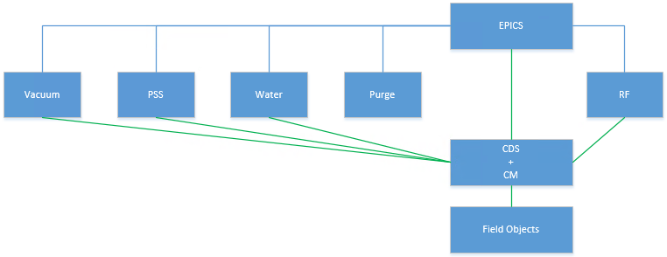

2. Figure: Communication partners

The partners will communicate on the network buses according to Figure 3.

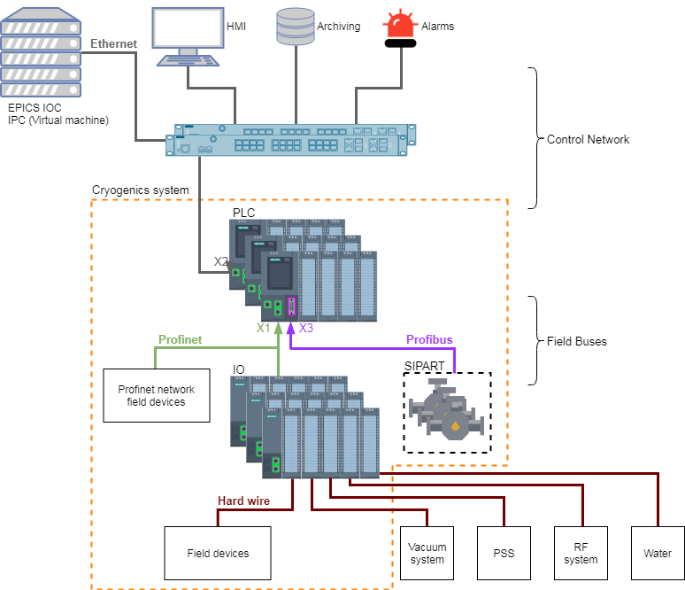

3. Figure: Network buses

# Interfaces descriptions

The following basic interface definitions are identified and valid for Spoke, Elliptical LINAC and Endbox too:

1. Electrical: to define and control the interdependence of two or more pieces of equipment when the interdependence arises from the transmission of an electrical signal from one piece of equipment to another;
2. Software: to define the interdependence of system components that result from an interchange of information;
3. Mechanical / Physical: to define and control the mechanical features, characteristics, dimensions, and tolerances of one equipment design that affect the design of another subsystem;

## Electrical

### Between electrical cabinets

According to approved electrical drawings of Spoke, Elliptical and Endbox.

### Between electrical power interfaces

According to approved electrical drawings of Spoke, Elliptical and Endbox.

### Between PLC hardware components

The control system PLC is a Siemens S7-1500 PLC with onboard IO cards and separately distributed IO cards with communication module Siemens ET200MP:

- CPU 1516-3 PN/DP [6ES7516-3AN01-0AB0];

- Digital input, DI 16x24VDC HF [6ES7521-1BH00-0AB0];

- Digital output, DQ 16x24VDC/0.5A HF [6ES7522-1BH01-0AB0];

- Analog input, AI 8xU/I/RTD/TC ST [6ES7531-7KF00-0AB0];

- Analog output, AQ 8xU/I HS [6ES7532-5HF00-0AB0];

- IM 155-5 PN HF (comm. module of remote IO) [6ES7155-5AA00-0AC0].

Further details are in approved electrical drawings of Spoke, Elliptical and Endbox.

### Between PLC network components

The PLC has 2 pcs. Profinet ports and 1 pc. Profibus port. The connections to the partners:

- Profinet X1 port to field bus,

- Profinet X2 port to control network,

- Profibus X3 port to field bus (it is used for SIPART PS2 with Profibus DP-PA coupler).

Further details are in approved electrical drawings of Spoke, Elliptical and Endbox.

### Between CDS + CM and Vacuum

The communication is going to be hard wired with dry contact. In different operation mode of CS [1] it has to activate different vacuum system like Beam Vacuum and Insulation Vacuum. The activation of Vacuums will not be controlled by CS, but the status of their normal state is received by PLC of CS.

* Signals between CS and Beam Vacuum:

|  |  |  |  |
| --- | --- | --- | --- |
| **Signal name** | **Signal type** | **Source** | **Direction** |
| boBeamVacuumOK | Digital feedback | Vacuum | CS |

* Signals between CS and Insulation Vacuum:

|  |  |  |  |
| --- | --- | --- | --- |
| **Signal name** | **Signal type** | **Source** | **Direction** |
| boInsulationVacuumOK | Digital feedback | Vacuum | CS |

### Between CDS + CM and PSS

The communication is going to be hard wired with dry contact. It is necessary to send the alarm signal of high pressure value of He guard for PSS in every operation mode of CS [1].

* Signals between CS and PSS:

|  |  |  |  |
| --- | --- | --- | --- |
| **Signal name** | **Signal type** | **Source** | **Direction** |
| boHighPressureHeGuard | Digital feedback | CS | PSS |

### Between CDS + CM and Purge

The Cryogenic System does not have any interface signal with Purge.

### Between CDS + CM and RF

The communication is going to be hard wired with dry contact. In adequate operation mode of CS (Cryogenics System) [1] it has to activate the RF System, but this activation is out of CS functionality. For the operation state “Nominal 2K + RF” is necessary to have a feedback signal if the RF system is active.

* Signals between CS and RF:

|  |  |  |  |
| --- | --- | --- | --- |
| **Signal name** | **Signal type** | **Source** | **Direction** |
| boRF_Enable | Digital control | CS | RF |
| boRF_On | Digital feedback | RF | CS |

### Between CDS + CM and Water

The communication is going to be hard wired with dry contact. In adequate operation mode of CS (Cryogenics System) [1] it has to activate the Water System.

* Signals between CS and Water:

|  |  |  |  |
| --- | --- | --- | --- |
| **Signal name** | **Signal type** | **Source** | **Direction** |
| boWater_On | Digital feedback | Water | CS |

### Cryogenic sensor signal conditioners

According to approved electrical drawings of Spoke, Elliptical and Endbox.

### Cryogenic valve positioners

The valve positioners will be SIPART PS2. It can communicate on Profibus PA, but the PLC has just Profibus DP, therefore a Profibus DP – PA coupler is used to link the Profibus networks.

Further details are in approved electrical drawings of Spoke, Elliptical and Endbox.

### Power and Instrumentation cables and accessories

According to approved electrical drawings of Spoke, Elliptical and Endbox.

## Software

### Between EPICS and CDS + CM

The communication is going to be on Profinet network.

The interface signal groups will be:

* control signals
* status signals
* parameters
* alarms

The appearance of the OPI (Operator Panels Interface) is defined according to the SDD ().

#### Control Signals

The Cryogenics System can be controlled by control signals. They control the enables with digital signals and the setpoints with analog values in manual or automatic modes. The enables can activate or deactivate manually on the HMI of EPICS by the operators in manual mode. In automatic mode the controls and regulations of enables and setpoints will be processed by PLC, the operators are able to start or to stop this process.

Some necessary control signals:

|  |  |  |  |
| --- | --- | --- | --- |
| **Signal name** | **Signal type** | **Source** | **Direction** |
| boAutoMode | Boolean | EPICS | CS |
| boManualMode | Boolean | EPICS | CS |
| boOpenValve_x | Boolean | EPICS | CS |
| boCloseValve_x | Boolean | EPICS | CS |
| iValveSetpoint_x | Integer | EPICS | CS |
| iTempSetpoint_x | Integer | EPICS | CS |
| iLevelSetpoint_x | Integer | EPICS | CS |
| iPressureSetpoint_x | Integer | EPICS | CS |
| boForceManualMode | Boolean | EPICS | CS |
| boForceOpenValve_x | Boolean | EPICS | CS |
| boForceCloseValve_x | Boolean | EPICS | CS |
| iForceValveSetpoint_x | Integer | EPICS | CS |
| iForceTempSetpoint_x | Integer | EPICS | CS |
| iForceLevelSetpoint_x | Integer | EPICS | CS |

x: device identifier

#### Status Signals

The Cryogenics System can be monitored by status signals. They give feedback of actual status signals and values. The status signals are digitals and the feedback values are analogs. In both control modes of CS they can monitored on HMI of EPICS.

Some necessary status signals:

|  |  |  |  |
| --- | --- | --- | --- |
| **Signal name** | **Signal type** | **Source** | **Direction** |
| bCurrentOperationMode | Byte | CS | EPICS |
| boValveOpen_x | Boolean | CS | EPICS |
| boValveClosed_x | Boolean | CS | EPICS |
| boValveOffline_x | Boolean | CS | EPICS |
| boLimitHigh_x | Boolean | CS | EPICS |
| boLimitLow_x | Boolean | CS | EPICS |
| iValvePosition_x | Integer | CS | EPICS |
| iTempValue_x | Integer | CS | EPICS |
| iLevelValue_x | Integer | CS | EPICS |
| iPressureValue_x | Integer | CS | EPICS |
| iFlowValue_x | Integer | CS | EPICS |
| boManualModeInterlock | Boolean | CS | EPICS |
| boAutoModeInterlock | Boolean | CS | EPICS |
| boValveControlInterlock_x | Boolean | CS | EPICS |
| boLevelControlInterlock_x | Boolean | CS | EPICS |
| boPressureControlInterlock_x | Boolean | CS | EPICS |
| boFlowControlInterlock_x | Boolean | CS | EPICS |

x: device identifier

#### Parameters

The parameters of CS are necessary to parametrize the processes of CS or setup several settings from EPICS.

Some necessary parameters:

|  |  |  |
| --- | --- | --- |
| **Signal name** | **Signal type** | **Remark** |
| iTempRegulationParameter_x | Integer | for PID regulation |
| iLevelRegulationParameter_x | Integer | for PID regulation |
| iPressureRegulationParameter_x | Integer | for PID regulation |
| iAlarmLimitHigh_x | Integer |  |
| iAlarmLimitLow_x | Integer |  |

x: signal identifier

#### Alarms

In definite case, there are some alarms for EPICS. The operators can be informed the malfunctions of CS.

Some necessary alarms:

|  |  |  |  |
| --- | --- | --- | --- |
| **Signal name** | **Signal type** | **Source** | **Direction** |
| boAutoModeError | Boolean | CS | EPICS |
| boManualModeError | Boolean | CS | EPICS |
| boValveError_x | Boolean | CS | EPICS |
| boLimitHighError_x | Boolean | CS | EPICS |
| boLimitLowError_x | Boolean | CS | EPICS |
| boTempError_x | Boolean | CS | EPICS |
| boLevelError_x | Boolean | CS | EPICS |
| boPressureError_x | Boolean | CS | EPICS |
| boFlowError_x | Boolean | CS | EPICS |

x: device identifier

## Mechanical and Physical

|  |  |  |  |
| --- | --- | --- | --- |
| No. | Type | Interface | Reference |
| 1 | Mechanical | Electrical cabinets | According to approved electrical drawings of Spoke, Elliptical and Endbox. |
| 2 | Physical | Environmental characteristic | * Ambient temperature: 0-60 [°C], * Atmospheric pressure: ca. ~1008 [hPa], * Humidity: 10 – 95 [%], * Operating condition: stationary use in weather-proof locations, * Concentration of pollutants:   - SO2: < 0.5 ppm;  - RH: < 60 %, no condensation;  - H2S: < 0.1 ppm;  - RH: < 60 %, no condensation. |

# Glossary

| Term | Definition |
| --- | --- |
| ESS | European Spallation Source ERIC |
| ICS | Integrated Control System Division |
| ICD | Interface Control Document |
| RF | Radiofrequency |
| AD | Accelerator Division |
| CM | Cryomodule |
| CDS | Cryogenic Distribution System |
| CS | Cryogenic System |
| VB | Valvebox |
| PLC | Programmable Logic Controller |
| EPICS | Experimental Physics and Industrial Control System |
| IOC | Input/Output Controller |
| CA | Channel Access |
| PID | Proportional Integral Differential Controller |
| HMI | Human Machine Interface |
| OPI | Operator Interface |
| PSS | Personal Safety System |
| CDS | Cryogenic Distribution System |
| IO | Input Output Device |
| SDD | Interface Control Document |

# references

1. Definition of the operating modes of ESS cryomodules and cryogenic distribution line: ESS-0034178
2. Technical Specifications of the Cryogenic Control System: (2016-11-28)
3. EPICS Home page: http://www.aps.anl.gov/epics/

Document Revision history

| Revision | Reason for and description of change | Author | Date |
| --- | --- | --- | --- |
| 1 | First issue for CDR#1 | G. Fenyvesi | 2019-09-17 |
|  |  |  |  |