|  |
| --- |
|  |
|  |
|  |
|  |
|  |
|  |
|  |
|  |
| System Design Document |
|  |
|  |

|  | Name | **Role/Title** |
| --- | --- | --- |
| **Owner** | Zoltan Madi | C3S Control System Engineer |
| **Reviewer** | Thilo Friedrich  Wojtek Fabianowski  Peter Temesvari | Systems Engineering and Engineering Process Coordinator  Work Unit Leader  Technical Leader |
| **Approver** | <<Name>> | <<Role/ Title>> |

|  |
| --- |
| NOTE: The authoring instruction box should be deleted from the document before it is finalised  Authoring instruction  This document is a standard template. Please remove any headings not needed   * Instruction text is placed between text entry points shown as << >>. * Header and Footer information in Controlled Documents are mandatory and must not be changed manually. It contains document attributes which will be updated automatically when document is checked in to Chess. * Title field between the two bold lines on first page must not be changed as that contains similar attribute information which will display the title. * Follow the ESS Authoring Guide [ESS-0025989](https://chess.esss.lu.se/enovia/tvc-action/showObject/dmg_Guideline/ESS-0025989/valid) * Please use Insert Cross-reference when referring to references. |

|  |  |
| --- | --- |
| Table of content | Page |

1. Scope 4

2. Issuing organisation 4

3. CONTEXT 4

4. System design 5

4.1. PLC Design 6

4.1.1. PLC Hardware modules 6

4.2. Software Design 7

5. Separation of PLC software functions 8

5.1. Data Inputs/Outputs 9

5.1.1. Input Data 9

5.1.2. Output Data 9

5.2. Object Operation 9

5.2.1. Automatic Mode: 9

5.2.2. Manual Mode: 10

5.2.3. Forced Mode: 10

5.3. Valve Control loops 10

5.3.1. Valve Handler 11

5.3.2. Parameter Mode UDT 11

5.3.3. Parameter DB 11

5.3.4. PID controller 12

5.3.5. Valve OP Interface 12

5.4. System Mode selection 12

5.5. Alarm 13

5.5.1. Alarm design principles 13

5.6. Interlocks 13

6. OPI Design 13

6.1. Monitoring and control 14

6.1.1. Monitoring 14

6.1.2. Control 14

6.2. Screen philosophy 14

6.2.1. Main Screen 14

6.2.2. Valvebox and cryomodule screen 14

6.2.3. Mode selection screen 14

6.2.4. Interlock screen 14

6.2.5. Parameter screen 15

6.2.6. Diagnostic screen 15

6.3. Archiver 15

6.4. Alarm Setup and Indication 15

6.4.1. Device Error 15

6.4.2. Limit Alarms 15

6.4.3. Discrepancy Alarms 16

6.4.4. Timeout Alarms 16

7. Glossary 16

8. references 16

Document Revision history 17

# Scope

The scope of this document is to describe the software system of the Cryomodules and Cryodistribution Control System in ESS.

The document describes the system architecture and software modules applied on C3S PLC and the Operator Interface PC (OPI). The purpose of this documentation is to have a deeper understanding of the software system. The intended audience are the stakeholders to let them understand and except the design of the system. The scope of this Document covers all software modules in C3S (Cryomodules and cryodistribution control system). Third-party software are listed, but not described in detail.

This documentation should be used with the User Manual, which contains a significant amount of system description. In addition, for understanding the software, one should read the source code, as well.

# Issuing organisation

This document is issued by the Cryomodules and cryodistribution control system within the Integrated Control Systems (ICS) Division.

# CONTEXT

Cryogenic Distribution System for the ESS linac is intended for delivering the cooling power from the Accelerator Cryogenic Plant (ACCP) to the cryomodules by means of the constant flows of supercritical and cold gaseous helium, at 4.5 K and 40 K, respectively. The Linac Cryogenic System divided of 3 different section namely: spoke cryomodules section, medium-beta cryomodules section and high-beta cryomodules section and also contains an endbox.

Figure 1: Linac System Layout

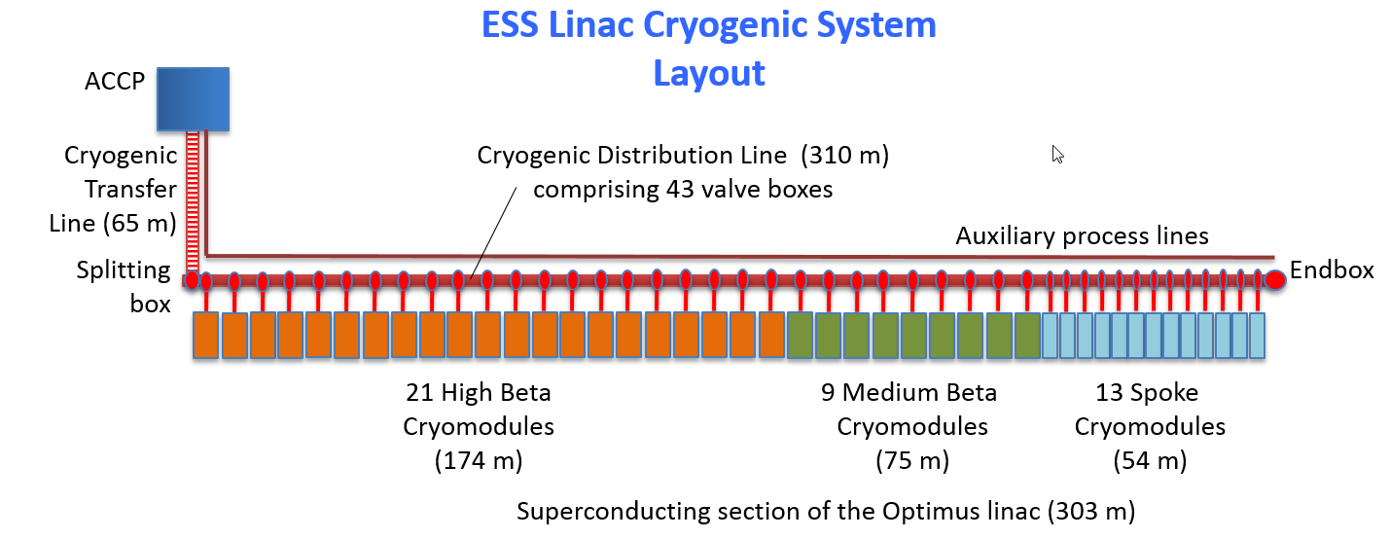

The C3S responsible for the control of the Valve boxes and for cryogenic components of the cryomodules. The whole system contains 43 valve boxes and cryomodules plus one endbox.

A cryomodule and the belonging valve box together make a unit. Every each unit will have an individual Control PLC on the technical level.

There will be no communication on technical level among the control PLC-s. They will have connection only to the EPICS system via IOCs and only to other systems via dry contacts.

# System design

The C3S design is based on the ICS system’s design philosophy, architecture and equipment standards defined in the ICS Handbook [4]. Therefore it is consisted of EPICS at top application layer and PLCs at system control layer. Detailed hierarchy shown in next figure:

Figure 2: C3S Conceptual Architecture

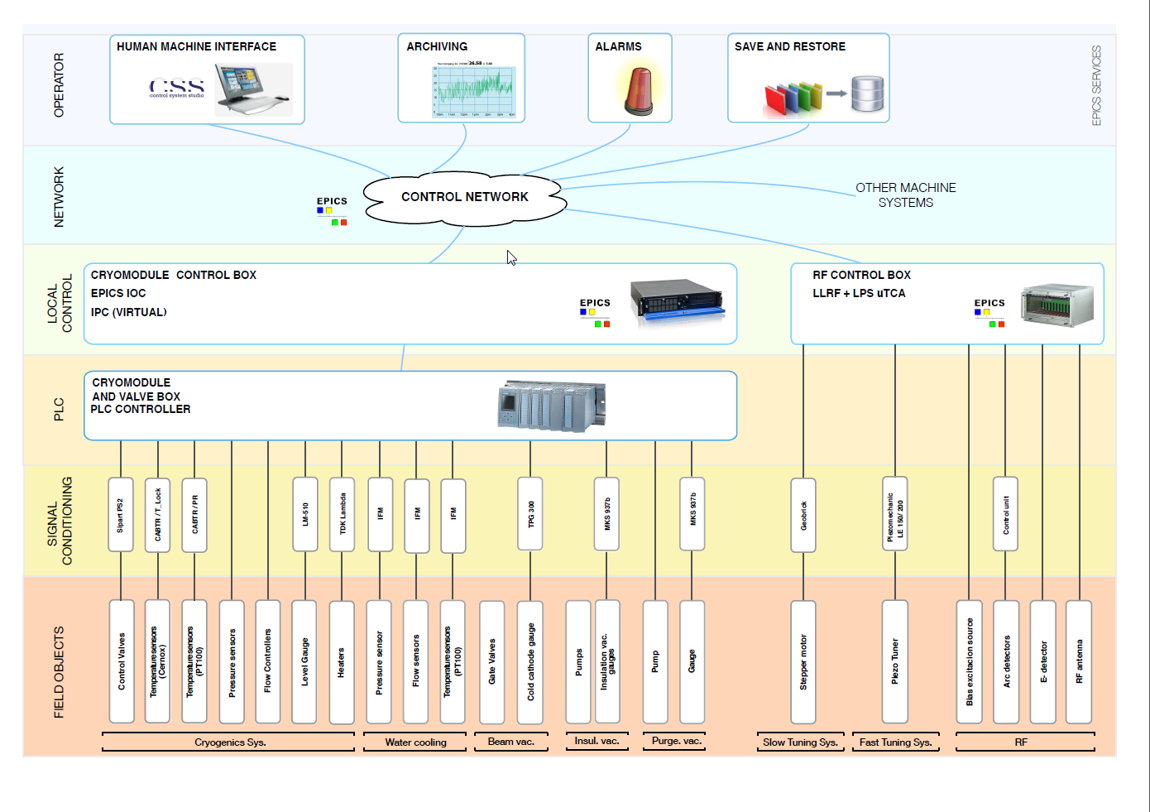

Based on the system requirement [5] the control of the C3S are distributed across 44 PLC units.Each PLC has control trough their equipments creating an individual unit. The system divided between the following 3 types:

* Spoke Linac Cryomodules and Cryodistribution system
* Eliptical Linac Cryomodules and Cryodistribution system
* Endbox

The individual PLC units are connected to the common OPI, what gives possibilities to the operators to control all of them.

## PLC Design

Every unit has a similar structure on the technical level.

* Control CPU 1516.
* ET200
* DP/PA Link

The CPU has PROFINET communication to the ET200. The point to having this to be able to distribute I/O to two cabinets, one for valve box I/O-s and the other for the cryomodule I/O-s.

The DP/PA Link purpose in the system is to connect Profibus PA Sipart PS 2 modules to the CPU’s Profibus DP network.

The CPU connection to EPICS via IOC has made according the EPICS and IOC Guideline [2].

Figure 2: C3S PLC Design

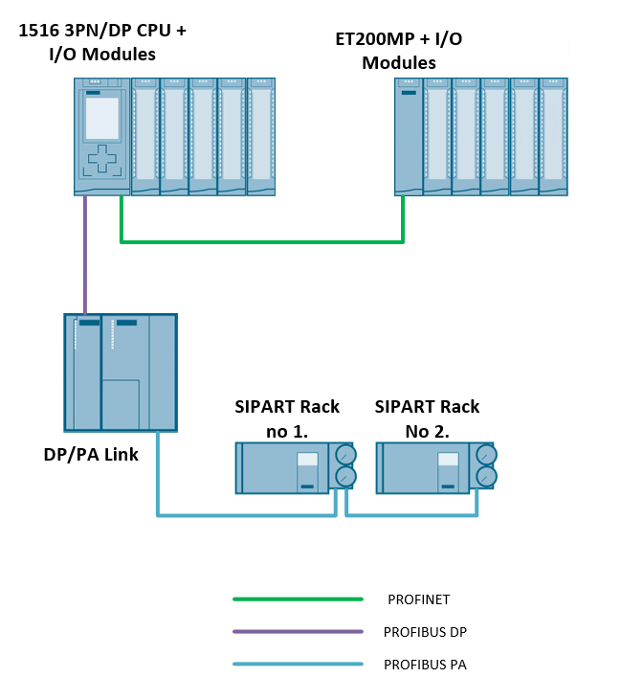

### PLC Hardware modules

Hardware configuration of C3S PLC systems is build with the following hardware modules from the ESS Standardised PLC Equipment.

Table 1: PLC Component

| Item No. | Module Type | Description | Ordering Code |
| --- | --- | --- | --- |
| 1 | PS | System power supply, PS 60W 24/48/60V DC | 6ES7505-0RA00-0AB0 |
| 2 | CPU | CPU 1516-3 PN/DP | 6ES7516-3AN01-0AB0 |
| 3 | CM | Communication Module, CM 1542-1, PROFINET Controller | 6GK7542-1AX00-0XE0 |
| 4 | DI | Digital input, DI 16x24VDC HF | 6ES7521-1BH00-0AB0 |
| 5 | DO (DQ) | Digital output, DQ 16x24VDC/0.5A HF | 6ES7522-1BH01-0AB0 |
| 6 | AI | Analog input, AI 8xU/I/RTD/TC ST | 6ES7531-7KF00-0AB0 |
| 7 | AO (AQ) | Analog output, AQ 8 X U/I HS | 6ES7532-5HF00-0AB0 |
| 8 | IM | Interface Module, IM 155-5 PN BA | 6ES7 155-5AA00-0AA0 |

## Software Design

The application software runs on different hardware designation, namely on the OPI Computer, the IOC server and the S7-1500 PLCs. No application software will be installed on the IM153-2 distributed IO peripherals and other equipment.

From the software point of view, the following software items work together in the system.

* PLC
* OPI
* IOC (EPICS Services)

PLC software is responsible the control of the field devices and for the exchange data with the IOC.

The IOC runs on the Industrial PC it can be physical machine or virtualized one. Their main responsibility is the data transfer between the different component, like feed the Archiver and Alarm services with data and also data exchange between the PLC and the OPI.

The OPI is the operator interface it is located in the Control Room. The task of the OPI is to inform the operator about the system status and let the operator control the field devices trough the PLC.

The connection overview between the main software items are shown in the following picture.

Figure 2: SW Component Overview

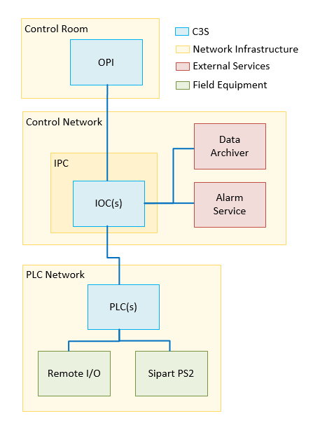

# Separation of PLC software functions

The software architecture described above allows the separation of the different functions. For the correct operation of the system, the following functions (and their subprograms) shall work together:

* DATA_INPUT_OUTPUT
* VALVE_CONTOL
* MODE_SELECTION
* ALARM_PROTECTION_CONTROL
* INTERLOCKS

The software modules described here are kept as simple as possible.

## Data Inputs/Outputs

This section contains the processing and indication the signals of the field sensors as temperature, level, flow, position probes. The scaling and processing of the signals happens in the PLC. The indication, and configuration of the measurements also necessary, therefore there is an OP Interface on EPICS services.

The existing Handler block has been used in the project according ESS standard.

According signal type there are two different main type:

* Inputs
* Outputs

### Input Data

There are 2 types of measurement devices:

* Analogue – Transmitters, feedback of control valves
* Digital – Switches, external status signals

Each type of analogue sensor has their Handler block. Handler block makes the scaling of the signal, raise alarm if the signal out of the expected range etc… The following handler blocks are existing in the PLC program:

* Temperature PT100
* Pressure Transmitter Measurements
* Temperature Cernox
* etc…

Digital signals does not require any scaling, they can be used without any processing.

Output Data

There are 2 types of actuation devices:

* Analogue – Control valves
* Digital – On/off valves, externals status signals

The control of the analogue devices in the system are the Control Valves (CV) their operation happens trough their control loops. Detailed information in the 6.3 Chapter.

## Object Operation

The actuation device has 3 mutually exclusive operational modes:

### Automatic Mode:

* The value of the output control variable is generated automatically from the control logic according specified functional process requirements.
* The value of the process variable of the device’s feedback is obtained from the field device.
* Interlocks are active.

### Manual Mode:

* The value of the output control variable is generated manually from device’s OPI faceplate.
* The value of the process variable of the device’s feedback is obtained from the field device.
* Interlocks are active.

### Forced Mode:

* The value the of output control variable is generated manually from device’s OPI faceplate.
* The value of the process variable of the device’s feedback is generated manually from device’s OPI faceplate.
* Interlocks are suspended.

## Valve Control loops

In this section control architecture of the valve loops will be described. Each valve has their individual control loop what builds up from the following elements:

* Valve Handler FB
* Parameter Mode UDT
* Parameter DB
* Control PID
* Valve OP Interface

Figure 4: Valve Control diagram

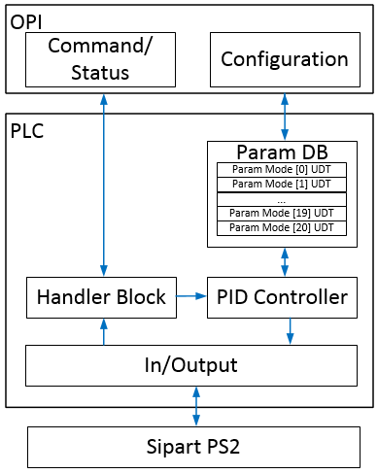

Valve Handler

The Valve Handler Function block runs on the PLC. This block processing the valve data from the Sipart module itself and responsible to handle the OPI commands ad feedbacks.

The existing Handler block has been used according ESS standard. (STANDARD PLC BLOCK LIBRARY)

Parameter Mode UDT

The Parameter Mode UDT is a user defined data type what contains a relevant parameter list for one operating mode of the valve (See the operation modes in the Definition of the operation Modes [1] document). This is a part of the PLC program.

The Parameter Mode UDT contains two section:

* Self-regulation: This section contains those parameters what relevant for self-regulation. This case the valve gats a certain Setpoint and regulate itself to this point. This is like when the valve needs to open 100%.
* Regulation by external parameter: This section contains those parameters what relevant for regulation for external value. This case valve needs to regulate to another physical unit (like, temperature, container level, etc.).

Parameter DB

The Parameter DB (Data Block) is a part of the PLC program. This DB contains an array of a Parameter Mode UDT. This responsible to store the parameter list for each operation mode. The parameter DB does not contains any additional element for Purging and for Abnormal modes, but also contains some empty spare lists.

Figure 5: List of Operation Modes

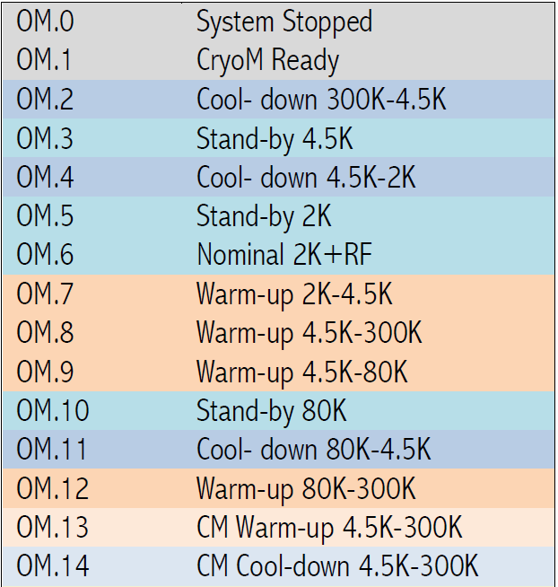

### PID controller

PID controller is a standard universal PID controller provided by TIA Portal.

### Valve OP Interface

The OP Interface runs on EPICS Service and responsible to configure and operate the valves by the operator.

For configuration, a receipt base interface has been developed to let the operator modify the values of the parameter list of the valves.

For operation, the existing OP Interface has been used according ESS standard. (gitlab: OPI_MASTER_LIBRARY)

## System Mode selection

The mode selection software block is responsible for the safe transition between different operation modes in automatic mode. This is a part of the PLC program but also has a OPI interface to let operator choose among the available modes.

The mode selection block has interconnections to all the relevant control loops. These interconnections are important for setting the corresponding data limits for the actual operation mode. The control loops reaches the proper data from the parameter DB according the selected operation due this interface.

Figure 6: Diagram of Operation Modes

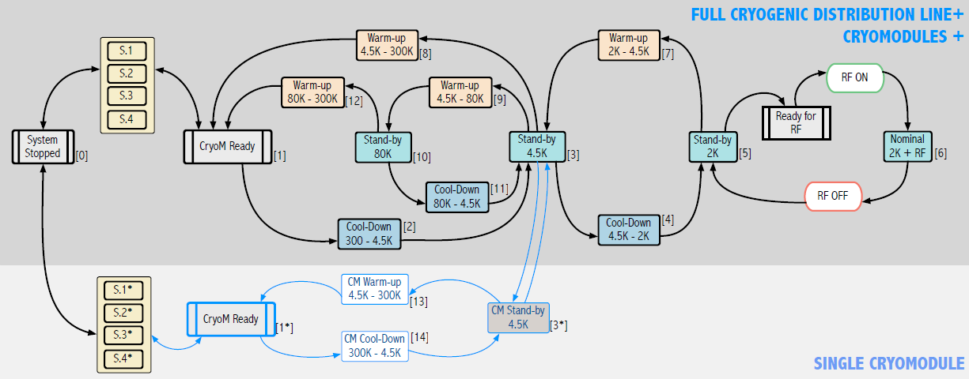

The program block has been designed according the [1] Definition of the operation mode document.

## Alarm

Alarm design principles

The ESS standard Alarm designed principles are applied in the project.

Alarms are triggered by the PLC via Process Variables (PVs) on the front-end computers (IOCs). The Alarm Server generates the actual alarms. The Control System Studio (CS-Studio) Alarm Graphical User Interface (GUI) displays the alarms with a description, guidance information. The CS-Studio Alarm GUI chosen is BEAST, and is intended for the Control Room operators.

The used alarm concept is according ESS standard. More details in [6] ESS Alarm Philosophy

## Interlocks

A designated software block going to be responsible for the interlock functionality what is a part of the PLC- program. The interlock block has a graphical interface what indicates the interlock activity on the OPI and also let the operator parametrize the configurable interlock limits.

Applied interlocks must be defined in the Interlocks and limits documentation provided by ESS.

# OPI Design

C3S design based on the ICS system’s design philosophy, architecture and equipment standards defined in the ICS-Handbook [4]. Therefore, it is consisted of EPICS at top application layer and PLCs at system control layer.

For the purpose of better visibility and control, the layout of the visual objects inside the OPI may differ from system P&ID, or one system can be represented with several linked OPIs.

## Monitoring and control

### Monitoring

There are at least one numerical and one visual control in the device OPI faceplate to monitor the value of the output control variable.

There are at least one numerical and one visual control in the device OPI faceplate to monitor the value of the process variable of the device’s feedback.

### Control

There are separate visual controls in the device OPI faceplate to modify and activate the value for output control variable in manual and/or forced mode.

For the analogue actuation devices, there is setpoint/ramping control for output control variable.

For the analogue actuation devices, there are visual controls in the device OPI faceplate to modify ramping parameters for output control variable.

## Screen philosophy

In the followings the operator screen philosophy represented with the available functions

### Main Screen

The main screen is going to contain the full system layout with all 43 valveboxes and belonging cryomodules and the valvebox.

### Valvebox and cryomodule screen

This screen going to contain digitalized version of the P&ID drawings, where the Operator are able to operate the valves and check measurements. Each individual valvebox and cryomodule will have thier own screen. For this a dynamised faceplate object has been used per unit type with macros to make the modifications, upgrades of the screens even easier.

### Mode selection screen

This screen going to contain the collection of the operation modes where the operator can select transition between defined modes.

### Interlock screen

This screen going to show the existing interlocks in the system and also indicate the active ones. And let the operator configure the different interlock limits.

### Parameter screen

From this screen all configurable software component parameter list are going to be reachable. Wide range of parameters of the chosen component can be configure by the operator to provide system flexibility.

### Diagnostic screen

The diagnostic screen with some sub screen is going to indicate the status of the system component as the PLC-s and other network components.

## Archiver

An archiving service is a channel access client that automatically records PVs as a function of time and then stores them to disk. The archiver function used by the ESS standard according [4] ICS-Handbook.

## Alarm Setup and Indication

### Device Error

There are visual controls on OPI faceplate to indicate presence at least of following device alarms:

* Input Module Error – Error in PLC input card where the analogue/digital signal(s) from the device are wired.
* IO Error – Error in processing of analogue/digital input signal(s) from the device.
* Interlock – Device has an interlock that prevents its operation.

### Limit Alarms

For the analogue measurement devices, there are visual controls in the device OPI faceplate to view and specify/modify the limits (thresholds) for Low-Low, Low, High, High-High alarms.

For the analogue measurement devices, there are visual controls in the device OPI faceplate to indicate presence of device alarms:

* Underrange – The electrical measurement signal is under the lowest value of the signal range.
* Overrange – The electrical measurement signal is above the highest value of the signal range.
* High-High – The value of measured process variable is above High-High threshold.
* High – The value of measured process variable is between High and High-High thresholds.
* Low – The value of measured process variable is between Low and Low - Low thresholds.
* Low-Low – The value of measured process variable is below Low - Low threshold.

### Discrepancy Alarms

For the analogue actuation devices, there are visual controls in the device OPI faceplate to specify parameters for device’s discrepancy monitoring:

* Discrepancy Time – Time delay to allow device’s process feedback propagation.
* Discrepancy Tolerance – Alarm threshold of the discrepancy value at the end the Discrepancy Time.

For the analogue actuation devices, there are visual controls in the device OPI faceplate to indicate presence of device alarm:

* Discrepancy – There is a discrepancy between the device output and input variables. The used alarm concept according ESS standard. More details in [4] ICS-Handbook.

### Timeout Alarms

For the system processes there are a visual controls in the device OPI faceplate to specify parameters for processes timeout monitoring:

* Timeout - Time delay to allow a process feedback propagation.

# Glossary

| Term | Definition |
| --- | --- |
| BEAST  C3S  CCDB  CDR  EPICS  ESS  GUI  ICS  IOC  MPS  OPI | Best Ever Alarm System  Cryomodule and Cryodistribution Control System  Controls Configuration Database  Critical Design Review  Experimental Physics and Industrial Controls System  European Spallation Source  Graphical User Interface  Integrated Control System  Input Output Controller  Machine Protection System  OPerator Interface, EPICS based GUI |

# references

1. Definition of the operating mode ([Link](https://confluence.esss.lu.se/display/ATS/TS2+Controls?preview=/247648518/247648632/Definition%20of%20the%20operating%20mode%20v3.docx))
2. EPICS and IOC Guideline ([Link](https://confluence.esss.lu.se/display/HAR/EEE+%3A+How-To%3A+Creating+EPICS+control+software+and+IOC+for+a+system))
3. ESS Guideline for PLC Code Development ([Link](https://confluence.esss.lu.se/display/ATS/TS2+Controls?preview=%2F247648518%2F247648644%2FESS+Guideline+for+PLC+Code+Development+updatedv3.docx))
4. ICS-Handbook ([ESS-0067637](https://chess.esss.lu.se/enovia/link/ESS-0067637/21308.51166.29440.2158/valid))
5. System Requirements Specification ([ESS-1407413](https://chess.esss.lu.se/enovia/common/emxNavigator.jsp?objectId=21308.51166.47872.16530))
6. ESS Alarm Philosophy [Link](https://confluence.esss.lu.se/display/HAR/ESS+Alarm+Philosophy)

Document Revision history

| Revision | Reason for and description of change | Author | Date |
| --- | --- | --- | --- |
| 1 | First issue for CDR#1 | Zoltan Madi | 2019-09-09 |
|  |  |  |  |