|  |
| --- |
|  |
|  |
|  |
| Control System of LINAC Cryogenics - |
|  |

|  | Name | Role/Title |
| --- | --- | --- |
| Owner | Peter Tálas | C3S Control System Engineer |
| Reviewer | Thilo Friedrich  Wojtek Fabianowski  Peter Temesvari | Systems Engineering and Engineering Process Coordinator  Work Unit Leader  Technical Leader |
| Approver | <<Name>> | <<Role/ Title>> |

|  |
| --- |
| **NOTE: The authoring instruction box should be deleted from the document before it is finalised**  Authoring instruction   * This document is a standard template. Please remove any headings not needed * Instruction text is placed between text entry points shown as << >>. * Header and Footer information in Controlled Documents are mandatory and must not be changed manually. It contains document attributes which will be updated automatically when document is checked in to Chess. * Title field between the two bold lines on first page must not be changed as that contains similar attribute information which will display the title. * Follow the ESS Authoring Guide [ESS-0025989](https://chess.esss.lu.se/enovia/tvc-action/showObject/dmg_Guideline/ESS-0025989/valid) * Please use Insert Cross-reference when referring to references. |

|  |  |
| --- | --- |
| Table of content | Page |

1. Introduction 4

1.1. Purpose of the document 4

2. SYSTEM CHARACTERISTICS 4

2.1. System purpose 4

2.2. System overview 4

3. VERIFICATION IDENTIFICATION 5

3.1. Test cases 11

3.1.1. Support Environment 11

3.1.2. Configuration 12

3.1.3. Setup 13

3.1.4. Procedure 13

3.2. Detailed test cases 15

3.2.1. Simulation test cases with petenv (FAT) 15

3.2.1.1. C3S.VEP-1010 – Ethernet communication tests 15

3.2.1.2. C3S.VEP-1020 – Simulating Analog/Digital Input data to the PLC 15

3.2.1.3. C3S.VEP-1030 – Simulating Analog/Digital Output data to the IOC PVs 15

3.2.1.4. C3S.VEP-1040 – Alarm and limit test 15

3.2.1.5. C3S.VEP-1050.xx – Interlock tests 16

3.2.1.6. C3S.VEP-1060.xx – PLC Logic tests 16

3.2.1.7. C3S.VEP-1070 – PLC Cycle time check 16

3.2.1.8. C3S.VEP-1080 – Trending and Archiving test 16

3.2.1.9. C3S.VEP-1090 – OPI cycle time measurement 16

3.2.2. On site test cases (SAT) 17

3.2.2.1. C3S.VEP-2010 – Cable test 17

3.2.2.2. C3S.VEP-2020 – Profibus test 17

3.2.2.3. C3S.VEP-2030 – IO card failure check 18

3.2.2.4. C3S.VEP-2031 – Physical IO check 18

3.2.2.5. C3S.VEP-3010 – Valves check 19

3.2.2.6. C3S.VEP-3020 – Scaling test 20

3.2.2.7. C3S.VEP-3030.xx – Interlock test 20

3.2.2.8. C3S.VEP-3040.xx – Functional test 20

4. Major Life Cycle Test 21

4.1. Valve Box commissioning 21

4.1.1. Offsite (office) test (FAT#1) 21

4.1.2. Onsite integration test (SIT#1) 21

4.1.3. Commissioning 21

4.1.4. Site Acceptance Test (SAT#1) 22

4.2. Cryomodule commissioning 22

4.2.1. Offsite (office) test (FAT#2) 22

4.2.2. Onsite integration test (SIT#2) 22

4.2.3. Commissioning 23

4.2.4. Site Acceptance Test (SAT#2) 23

5. Glossary 24

6. references 24

7. Document Revision history 24

list of tables

Table 1 Verification Identification 5

Table 2 Support Environment 11

Table 3 Software Configuration 12

Table 4 Hardware Configuration 13

Table 5 Test cases 13

list of Figures

Figure 1 evopro development environment 11

Figure 2 Test process 12

# Introduction

The verification plan specifies the necessary activities to determine whether the system complies with requirements.

## Purpose of the document

The main goal of the verification process is to check whether the Cryomodules and Cryo-distribution Control System meets a set of design requirements.

The goal of the validation process is to ensure a product, service, or system meets the operational needs of the user.

# SYSTEM CHARACTERISTICS

## System purpose

*The main function of the Spoke and Elliptical Cryosystem is cooling down to 2K the Spoke and Elliptical RF modules during operation sequences.*

## System overview

This verification and validation plan specify the necessary activities to ensure that the Cryomodules and Cryo-distribution Control System complies with:

* System’s requirements according to ref [1]

Refer to SDD [2] for the complete solution description.

# VERIFICATION IDENTIFICATION

Requirements according to SRD-Req, ESS-1407413 [1]

| Table 1 Verification Identification | | | | |
| --- | --- | --- | --- | --- |
|  | Req. Id.nr. | Requirement description | Note | Requirement verification |
| **TOP LEVEL REQUIREMENTS** | | | | |
| **System context allocated functions** | | | | |
|  |  | Stakeholders |  | Design review |
|  |  | Interfaces |  | Design review |
|  |  | System functions |  | Design review |
| **FUNCTION DESIGN REQUIREMENTS** | | | | |
| **General requirements related to the C3S applicable for the system** | | | | |
|  | C3S.REQ-GR.1010 | The C3S shall be designed, developed, tested and commissioned according to ESS Engineering Guidelines. |  | Design review, Visual check, Measurements |
|  | C3S.REQ-GR.1020 | The C3S shall be designed using ESS Standardised PLC Equipment concerning the automation elements. |  | Design review, Visual check |
|  | C3S.REQ-GR.1030 | The C3S shall be developed using PLC-Factory tool to have ESS-wide unified PLC code blocks. |  | Design review, Visual check |
|  | C3S.REQ-GR.1040 | The C3S shall be designed using Experimental Physics Integrated Control System (EPICS) software platform with its associated applications and services. Graphical user interfaces shall be implemented in Control System Studio. |  | Design review, Visual check |
|  | C3S.REQ-GR.1050 | The C3S shall be structured according to the ESS Breakdown Structures (FBS, LBS). |  | Design review |
|  | C3S.REQ-GR.1060 | The electrical drawings of C3S shall be made in EPLAN P8 design tool according to ESS standards. |  | Design review |
|  | C3S.REQ-GR.1200 | The C3S automation HW shall be designed with at least 20% of reserves (Power consumptions, Computing capacities, Network bandwidth, I/O modules). |  | Design review, Visual check |
|  | C3S.REQ-FRS.203x | C3S OPI screens shall be easy to understand and well structured. |  | Visual check on the OPI |
| **REQUIREMENTS ON SYSTEM LEVEL** | | | | |
| **System related functional requirements** | | | | |
|  | C3S.REQ-FRS.1010 | C3S will be structured into 44 units, 30 Elliptical (VB+CM), 13 Spoke (VB+CM) and 1 EndBox. All of the units shall have an own, individual control PLC. |  | Design review, Plan review |
|  | C3S.REQ-FRS.1020 | Units of the a section (Ell.,Spk.,EB) shall be unified concerning system design, HW and SW components. |  | Design review, Plan review |
|  | C3S.REQ-FRS.1030 | All units of C3S shall operate independently from each other. |  | Design review, Software review |
|  |  |  |  |  |
|  |  |  |  |  |
| **Hardware related functional requirements** | | | | |
|  | C3S.REQ-FRH.1010 | All automation components and front-end electronics shall be fit in the existing electrical (automation) cabinets on Klystron Gallery. |  | Design review, Visual check |
|  | C3S.REQ-FRH.1020 | All electrical components of an Elliptical unit (VB+CM) shall be fit in 1 electrical (automation) cabinet. |  | Design review, Visual check |
|  | C3S.REQ-FRH.1030 | All electrical components of a Spoke unit (VB+CM) shall be fit in 2 electrical (automation) cabinet. |  | Design review, Visual check |
|  | C3S.REQ-FRH.1040 | All electrical components of the EndBox unit shall be fit in 1 electrical (automation) cabinet. |  | Design review, Visual check |
|  | C3S.REQ-FRH.1050 | Cables from field devices shall be routed to the automation cabinets through a field distributor box in case of ValveBoxes and EndBox. |  | Design review, Visual check |
|  | C3S.REQ-FRH.1060 | Cables from field devices shall be routed to the automation cabinets directly in case of Cryomodules. |  | Design review, Visual check |
|  | C3S.REQ-FRH.1070 | All automation cabinets shall have an own, individual power supply. |  | Design review, Visual check |
|  |  |  |  |  |
|  |  |  |  |  |
|  |  |  |  |  |
|  |  |  |  |  |
|  |  |  |  |  |
| **Software related functional requirements** | | | | |
|  | C3S.REQ-FRS.1010 | C3S PLC programs shall read measurement data of the field devices of the unit. (Analog inputs) |  | C3S.VEP-1020, C3S.VEP-2010, C3S.VEP-2030 |
|  | C3S.REQ-FRS.1020 | C3S PLC programs shall control the control valve positioners. (Profibus PA) |  | C3S.VEP-1030, C3S.VEP-2010, C3S.VEP-3010 |
|  | C3S.REQ-FRS.1030 | C3S PLC programs shall read feedback of control valves. (Profibus PA) |  | C3S.VEP-1020, C3S.VEP-2010, C3S.VEP-3010 |
|  | C3S.REQ-FRS.1040 | C3S PLC programs shall read values of limit switches. (Digital inputs) |  | C3S.VEP-1020, C3S.VEP-2010, C3S.VEP-2030 |
|  | C3S.REQ-FRS.1050 | C3S PLC programs shall have at least 50 ms cycle time. |  | C3S.VEP-1070 |
|  | C3S.REQ-FRS.1110 | C3S PLC programs shall have an Automatic operation mode, in which the control valves are controlled by SW control loops based on measurement data according to the operation specification. Interlocks are allowed. |  | C3S.VEP-1060.xx, C3S.VEP-3040.xx |
|  | C3S.REQ-FRS.1120 | C3S PLC programs shall have a Manual operation mode, in which the control valves are controlled by operators via OPI. Interlocks are allowed. |  | C3S.VEP-1060.xx, C3S.VEP-3040.xx |
|  | C3S.REQ-FRS.1130 | C3S PLC programs shall have a Forced operation mode, in which the control valves are controlled by operators via OPI. Interlocks are not allowed. |  | C3S.VEP-1060.xx, C3S.VEP-3040.xx |
|  | C3S.REQ-FRS.1200 | C3S PLC programs shall handle interlocks according to the interlock specification. (Interlocks are not specified yet!) |  | C3S.VEP-1050.xx, C3S.VEP-3030.xx |
|  | C3S.REQ-FRS.1300 | C3S PLCs have to synchronize their clock to a common NTP server provided by ESS. |  | Visual check on the OPI |
|  | C3S.REQ-FRS.2010 | C3S OPI screens shall visualize the system’s operation mode, all of the measurement data, states of all control valves. |  | Visual check on the OPI |
|  | C3S.REQ-FRS.2020 | C3S OPI visualization shall have a cycle time at least 1 second. All values shall be refreshed within 1 second. |  | C3S.VEP-1090 |
|  | C3S.REQ-FRS.2040 | C3S OPI visualization shall use block icon and faceplate HMI objects for all measurements and control loops. |  | Visual check on the OPI |
|  | C3S.REQ-FRS.2050 | C3S OPI screens shall visualize trends of measured values. |  | Visual check on the OPI, C3S.VEP-1080 |
|  | C3S.REQ-FRS.2060 | C3S OPI shall have a diagnostic screen with information about automation HW components. |  | Visual check on the OPI |
|  | C3S.REQ-FRS.2070 | C3S OPI shall have a diagnostic screen with alive bit / counter from each PLCs to monitor the connection. |  | Visual check on the OPI |
|  | C3S.REQ-FRS.3010 | C3S shall handle alarms generated by PLC programs. |  | Visual check on the OPI, C3S.VEP-1040, C3S.VEP-3020 |
|  | C3S.REQ-FRS.3020 | C3S shall generate adequate alarm in case of loss of network connection. |  | Visual check on the OPI, C3S.VEP-1010 |
|  | C3S.REQ-FRS.3030 | C3S shall generate adequate alarm in case of fieldbus failure. |  | Visual check on the OPI, C3S.VEP-2020 |
|  | C3S.REQ-FRS.3040 | C3S shall generate adequate alarm in case of I/O module failure. |  | Visual check on the OPI, C3S.VEP-2030 |
|  | C3S.REQ-FRS.3050 | C3S shall generate adequate alarm in case of an interlock event. |  | Visual check on the OPI, C3S.VEP-1050.xx, C3S.VEP-3030.xx |
|  | C3S.REQ-FRS.3060 | C3S shall generate adequate alarm if a measured process value exceeds the HH or LL limit threshold. |  | Visual check on the OPI, C3S.VEP-1040, C3S.VEP-3020 |
|  | C3S.REQ-FRS.3070 | C3S shall generate adequate alarm if a control valve does not reach the desired position within the adjusted monitoring time. |  | Visual check on the OPI, C3S.VEP-1060.xx, C3S.VEP-3010 |
|  | C3S.REQ-FRS.3080 | C3S shall generate adequate warning if a measured process value exceeds the High or Low limit threshold. |  | Visual check on the OPI, C3S.VEP-1040, C3S.VEP-3020 |
|  | C3S.REQ-FRS.3090 | C3S shall generate adequate warning in case of discrepancy between setpoint and process value as soon the adjusted period is expired. |  | Visual check on the OPI, C3S.VEP-1060.xx, C3S.VEP-3040.xx |
|  | C3S.REQ-FRS.4010 | C3S shall provide data for EPICS Archive services. |  | Visual check on the OPI, C3S.VEP-1080 |
|  |  |  |  |  |

## Test cases

### Support Environment

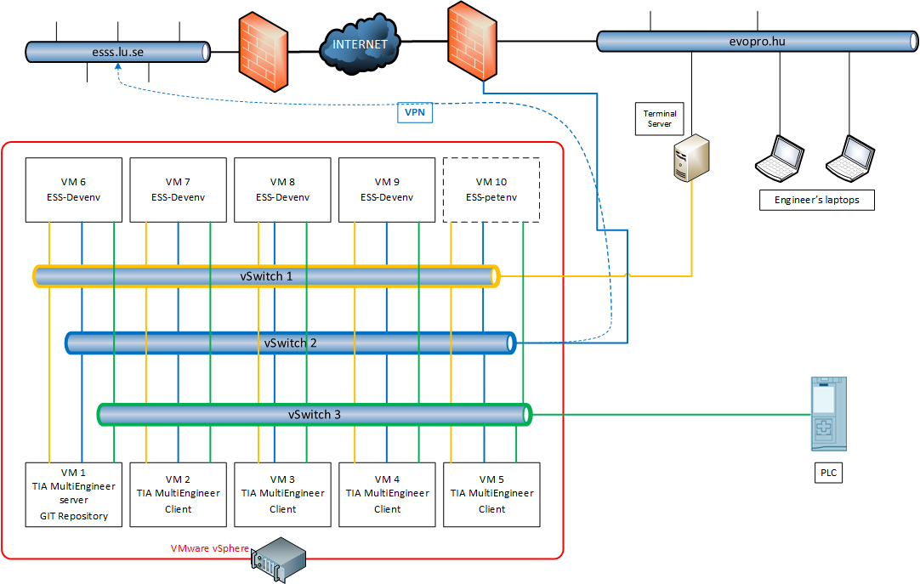

Figure 1 evopro development environment

We are using a VMWare ESXi environment for running the CentOS based ESS Dev.env machines and the Windows 10 based Siemens TiA Portal Dev. machines. The ESXi has 3 virtual switches, one for the RDP connections to the Dev. machines, one for the internet connection and one for the PLC and any external device connection.

The Dev. machines are behind the ESS-TS we can reach them from here with RDP connection.

| Table 2 Support Environment | | |
| --- | --- | --- |
| Location | Involved person | Responsible officer |
| Office | Control System Engineer | ??? |

### Configuration

*For the Office site test we are using the* Figure 1 evopro development environment*. The petenv is runing on the VM10 which is an Ubuntu 19.04 machine with Python 3.7.4 and the latest version from petenv.*

Testing can begin after the program code has been generated.

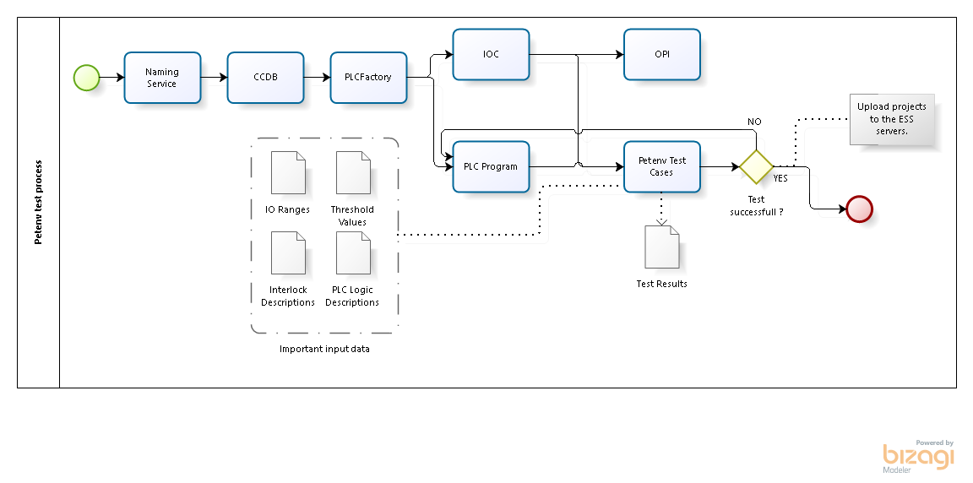

Figure 2 Test process

| Table 3 Software Configuration | | |
| --- | --- | --- |
| Software | Version | Note |
| Windows 10 | 1903 |  |
| CentOS | 7.6 |  |
| Ubuntu | 19.04 | Just for running petenv. |
| TiA Portal | V14.1 |  |
| Python2 | 2.7.5 |  |
| Python3 | 3.7.3 |  |
| Petenv | ?? |  |
| PlcFactory | ?? |  |
| IOC | ?? |  |
| EPICS | R3.15.4-2016-05 |  |
| CSStudio | ?? |  |
|  |  |  |

| Table 4 Hardware Configuration | | |
| --- | --- | --- |
| Hardware | Order/Serial Nr. | FW Version |
| PLC S7-1511 | 6ES7 511-1AK01-0AB0 | 2.1 |
| PLC S7-1516 | 6ES7 516-3AN01-0AB0 | 2.1 |
|  |  |  |

### Setup

IOC is generated and running, PLC software downloaded and the PLC is in RUN.

Starting the test script on the petenv machine (Any machine which are in the same network with the PLC and the IOC. Petenv must be installed first!)

Do not need any other initial parameter or configuration, all of the parameters are set by the petenv test scripts.

### Procedure

All of the IOs and Input ranges are described in the IO List.

Every petenv test result will write into a log file: “testname-actualdate-time-LOG.txt”

We create a summary in excel from these petenv LOG files. This sheet will be the Verification documentation. Every “Visual check” case will be documented into a pre-defined checklist.

All of the test source codes and the source codes documentation will be attached to the Verification reports. All test cases are created in python using the petenv by Johannes Kazantzidis.

| Table 5 Test cases | |
| --- | --- |
| Test ID | Short Description |
| C3S.VEP-1010 | Communication  Testing the communication between the PLC, IOC and the petenv. Checking the communication error signals. |
| C3S.VEP-1020 | PLC IO to EPICS |
| C3S.VEP-1030 | EPICS to PLC IO |
| C3S.VEP-1040 | Alarm and limit test |
| C3S.VEP-1050.xx | Interlock tests |
| C3S.VEP-1060.xx | PLC Logic tests |
| C3S.VEP-1070 | PLC Cycle time check |
| C3S.VEP-1080 | Simulating inputs for testing the Trend and Archive functions. |
| C3S.VEP-1090 | OPI cycle time measurement |
| C3S.VEP-2010 | Cable test |
| C3S.VEP-2020 | Profibus test  Checking the Profibus DP/PA Connections. |
| C3S.VEP-2030 | IO card failure check |
| C3S.VEP-2031 | Physical IO check  Simulating the input signals and checking these on the PLCs. |
| C3S.VEP-3010 | Valves check  Moving the valves. |
| C3S.VEP-3020 | Scaling test  Check the measured data scaling. |
| C3S.VEP-3030.xx | Interlock tests |
| C3S.VEP-3040.xx | Functional tests |
|  |  |
|  |  |

## Detailed test cases

Why good to make these test cases?

Because we can check in the office:

* IOs and the handler blocks are connected and configured,
* PLC and IOC connection is configured,
* OPI block icons and faceplates are connected correctly to the appropriate PV,
* analog signals are scaled as described,
* PLC logics and interlocks are works as described.

### Simulation test cases with petenv (FAT)

#### C3S.VEP-1010 – Ethernet communication tests

Testing the communication between the PLC, IOC and the petenv.

- Ping all elements of the network (PLC, IOC)

- Check the telnet connection to the PLCs port 2000.

- Check the PLCs OPC UA connection

- Check the EPICS/IOC connection

Break the Ethernet connection between the PLC and IOC and check the Network Failure signal active in the both systems.

#### C3S.VEP-1020 – Simulating Analog/Digital Input data to the PLC

The Analog values range must be defined!

Simulating data to the PLC inputs (IWx, IBx) with petenv.

The Digital data are simulated as bit or byte depends from the data application.

The Analog data are simulated as Integer values and need to check the data is scaled correctly.

Check the PV value for the IO.

#### C3S.VEP-1030 – Simulating Analog/Digital Output data to the IOC PVs

The Analog values range must be defined!

Simulating data to the PV inputs with petenv.

The Digital data are simulated as bit or byte depends from the data application.

The Analog data are simulated as Integer real or Integer values depends from the application and need to check the data is scaled correctly on the PLC side.

Check the IO value for the PV.

#### C3S.VEP-1040 – Alarm and limit test

Simulating data to the PLC inputs (IWx, IBx) with petenv.

Checking all of the configured alarms and limits on the PVs.

Alarm and limit levels are configured and handled by the PLC software.

#### C3S.VEP-1050.xx – Interlock tests

After the exact specification of the Interlocks.

#### C3S.VEP-1060.xx – PLC Logic tests

After the exact specification of the automatic operation modes. This will be prepared for the CDR#2.

#### C3S.VEP-1070 – PLC Cycle time check

The PLC Cycle time will be checked in the TIA Portal.

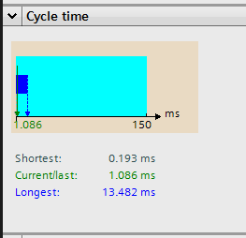

#### C3S.VEP-1080 – Trending and Archiving test

Simulating inputs for testing the Trend and Archive functions.

The input simulation must be run minimum 30 minutes. The longer you run the simulation of the inputs, the better because the Trend and Archive functions have more data. So, we can filter out if there is a loss of communication between devices or some data are not displayed correctly.

#### C3S.VEP-1090 – OPI cycle time measurement

Data is simulated every 1 second on the inputs and the time at which the value changes on the display surface is measured with a stopwatch.

### On site test cases (SAT)

The SAT test cases will be elaborated and presented in the validation plan!

**Prerequisite for all tests: There is no helium in the system during the tests.**

#### C3S.VEP-2010 – Cable test

Testing all of the cables before they are terminated to the PLCs.

Checking all of the terminations after the cabling is completed.

This is a Visual Checking mainly.

This case is successful if:

* the cables are not damaged,
* the connectors are mounted correctly to the cables (e.g.: Profibus connectors)
* the terminations are good, not floppy,
* the cables are connected as defined in the electrical plan.

This case is failed if:

* the cables are damaged or missing,
* the connectors are not mounted correctly or missing,
* the terminations are loose or open,
* the cables are not connected as defined in the electrical plan, or not documented why connected to a different terminal.

#### C3S.VEP-2020 – Profibus test

Checking the Profibus DP/PA Connections.

Preconditions:

* Cabling is completed, Profibus devices are connected as defined in the electrical plan,
* Profibus addresses are configured in the devices.

This case is successful if:

* all devices are in their place, e.g.: DP/PA coupler, PA segment protector or field barrier, Field devices with Profibus connection,
* the addressing is completed,
* all devices are shown when we go online to the PLC with TIA Portal.

This case is failed if:

* some devices are missing or damaged,
* the addressing is wrong, e.g.: on same Profibus lane two or more devices have the same address,
* a device is not shown in the TIA Portal when we are online on the PLC.

#### C3S.VEP-2030 – IO card failure check

Pull out the IO card and checking the error signal on the PLC and the OPI.

Preconditions:

* PLC program downloaded and running, IOC and OPI are working.

This case is successful if:

* Diagnostic is indicating the IO card is missing.

This case is failed if:

* Diagnostic is not working correctly, not indicates the IO card error,

#### C3S.VEP-2031 – Physical IO check

Simulating the input signals and checking these on the PLCs.

Digital Inputs can be simulated with 24V DC voltage.

Analog Inputs can be simulated with multi meter which has 4-20mA output.

Digital and Analog outputs is measured on the terminals with multi meter.

Preconditions:

* PLC program downloaded and running

This case is successful if:

* Inputs are indicating on the PLCs Tag table
* Output voltage/current is measured on the terminals and the measured value is correct

This case is failed if:

* Inputs are not indicating on the PLCs Tag table
* Output voltage/current is measured on the terminals and the measured value is not correct

#### C3S.VEP-3010 – Valves check

Open and close the valves from the OPI.

Switch valves test procedure:

* Check the valve is closed,
* Open the valve,
* Close the valve.

Control valves test procedure:

* Check the valve is closed,
* Open to 25%,
* Open fully,
* Close to 50%,
* Close fully.

Preconditions:

* C3S.VEP-2010 – Cable test is succeeded,
* C3S.VEP-2020 – Profibus test is succeeded,
* C3S.VEP-2031 – Physical IO check is succeeded,
* PLC program downloaded and running, IOC and OPI are working.

This case is successful if:

* the valve is moving to the correct way,
* on the OPI the valve position is indicating correctly.

This case is failed if:

* the valve is not moving or not moving to the correct way,
* on the OPI the valve position is not indicating or not correctly.

#### C3S.VEP-3020 – Scaling test

Test the scaling methods of the Analog signals, like pressure, temperature… etc.

Procedure:

* Got some well-known pressure, temperature, level etc. values.
* Compare these values with the values on the OPI and the PLC program.

Preconditions:

* C3S.VEP-2010 – Cable test is succeeded,
* C3S.VEP-2031 – Physical IO check is succeeded,
* PLC program downloaded and running, IOC and OPI are working,
* We have well-known pressure, temperature, level etc. values.

This case is successful if:

* The separately measured value is equal with the value on the OPI and the PLC.

This case is failed if:

* The separately measured value is NOT equal with the value on the OPI and the PLC.

#### C3S.VEP-3030.xx – Interlock test

After the exact specification of the Interlocks.

#### C3S.VEP-3040.xx – Functional test

After the exact specification of the automatic operation modes.

This test case will include all test procedure to testing the PLC logics.

# Major Life Cycle Test

## Valve Box commissioning

### Offsite (office) test (FAT#1)

Before the Onsite commissioning, each PLC system will be tested by the following test cases in order to procedure Factory Acceptance Test (FAT):

* C3S.VEP-1010 – Ethernet communication test
* C3S.VEP-1020 – PLC IO to EPICS
* C3S.VEP-1030 – EPICS to PLC IO
* C3S.VEP-1040 – Alarm and limit test
* C3S.VEP-1050.xx – Interlock tests
* C3S.VEP-1060.xx – PLC Logic tests
* C3S.VEP-1070 – PLC Cycle time check
* C3S.VEP-1080 – Simulating inputs for testing the Trend and Archive functions
* C3S.VEP-1090 – OPI cycle measurement

All of the test scripts will be documented and attached to the FAT report.

### Onsite integration test (SIT#1)

Before the Valve Box commissioning, each installed PLC system will be tested by the following test cases in order to procedure Site Integration Tests (SIT):

* C3S.VEP-1010 – Ethernet communication tests (*here: Production Environment but same test* case)
* C3S.VEP-2010 – Cable test
* C3S.VEP-2030 – IO card failure check
* C3S.VEP-2031 – Physical IO check
* C3S.VEP-2020 – Profibus test

### Commissioning

During commissioning, it is recommended that you perform the following tests in the following order. All tests can be interrupted and restarted during commissioning. The tests in this phase help to detect the errors.

* C3S.VEP-1040 – Alarm and limit test (*here: Production Environment but same test* case)
* C3S.VEP-3020 – Scaling test
* C3S.VEP-3010 – Valves check
* C3S.VEP-3030.xx – Interlock test
* C3S.VEP-3040.xx – Functional test

### Site Acceptance Test (SAT#1)

During the Valve Box commissioning, each installed PLC system will be tested by the following test cases in order to proceed to Site Acceptance Test:

* C3S.VEP-1040 – Alarm and limit test (*here: Production Environment but same test* case)
* C3S.VEP-3020 – Scaling test
* C3S.VEP-3010 – Valves check
* C3S.VEP-3030.xx – Interlock test
* C3S.VEP-3040.xx – Functional test

## Cryomodule commissioning

### Offsite (office) test (FAT#2)

Before the Onsite commissioning, each PLC system will be tested by the following test cases in order to procedure Factory Acceptance Test (FAT):

* C3S.VEP-1010 – Ethernet communication test
* C3S.VEP-1020 – PLC IO to EPICS
* C3S.VEP-1030 – EPICS to PLC IO
* C3S.VEP-1040 – Alarm and limit test
* C3S.VEP-1050.xx – Interlock tests
* C3S.VEP-1060.xx – PLC Logic tests
* C3S.VEP-1070 – PLC Cycle time check
* C3S.VEP-1080 – Simulating inputs for testing the Trend and Archive functions
* C3S.VEP-1090 – OPI cycle measurement

All of the test scripts will be documented and attached to the FAT report.

### Onsite integration test (SIT#2)

If a new device is installed, the following tests should be performed in order to procedure Site Integration Tests (SIT):

* C3S.VEP-1010 – Ethernet communication tests (*here: Production Environment but same test* case)
* C3S.VEP-2010 – Cable test
* C3S.VEP-2030 – IO card failure check
* C3S.VEP-2031 – Physical IO check
* C3S.VEP-2020 – Profibus test

If you have not installed a new device, you can skip this step.

### Commissioning

During commissioning, it is recommended that you perform the following tests in the following order. All tests can be interrupted and restarted during commissioning. The tests in this phase help to detect the errors.

* C3S.VEP-1040 – Alarm and limit test (*here: Production Environment but same test* case)
* C3S.VEP-3020 – Scaling test
* C3S.VEP-3010 – Valves check
* C3S.VEP-3030.xx – Interlock test
* C3S.VEP-3040.xx – Functional test

### Site Acceptance Test (SAT#2)

During the Cryomodule commissioning, each installed PLC system will be tested by the following test cases in order to proceed to Site Acceptance Test:

* C3S.VEP-1040 – Alarm and limit test (*here: Production Environment but same test* case)
* C3S.VEP-3020 – Scaling test
* C3S.VEP-3010 – Valves check
* C3S.VEP-3030.xx – Interlock test
* C3S.VEP-3040.xx – Functional test

# Glossary

| Term | Definition |
| --- | --- |
| C3S | Cryomodule and Cryodistribution Control System |
| CSStudio | Control System Studio |
| EPICS | Experimental Physics and Control System |
| IO | Input, Output |
| IOC | Input / Output Controller |
| petenv | Python EPICS Test Environment |
| PLC | Programable Logic Controller |

# references

1. System Requirements Document, ESS-1407413
2. Software System Description, ESS-1408068
3. System Engineering Management Plan for C3S, ESS-1406553

# Document Revision history

| Revision | Reason for and description of change | Author | Date |
| --- | --- | --- | --- |
| 1 | First issue for CDR#1 | Peter Tálas | 17/09/2019 |
|  |  |  |  |