|  |
| --- |
|  |
|  |
|  |
|  |
|  |
|  |
|  |
|  |
| DTL Cavity Controls - Concept of Operation |
|  |
|  |

|  | Name | **Role/Title** |
| --- | --- | --- |
| **Owner** | Mauro Giacchini | IK Work Unit Coordinator (local coordinator) |
| **Author** | Thomas Fay | ICS Division – Hardware and Integration Group: Control System Engineer |
| **Reviewer** | Thomas Fay | ICS Division – Hardware and Integration Group: Control System Engineer |
| **Reviewer** | Janet Schmidt | AD – Accelerator Engineer |
| **Approver** | Thilo Friedrich | ICS Systems Engineering and Engineering Process Coordinator |

|  |  |
| --- | --- |
| Table of content | Page |

1. Scope 3

2. Issuing organisation 3

3. Context 3

4. Concept of Operation 5

4.1. Background 5

4.2. Operating Modes 5

4.2.1. Installation and RF Conditioning 5

4.2.2. Operation 6

4.2.3. Maintenance 7

5. Design Constraints and Assumptions 7

6. Glossary 8

7. references 8

Document Revision history 8

# Scope

The document presents the Concept of Operations for the Design of the Cavity Controls for the Drift Tube Linac (DTL) - the fifth Machine Section of the of the ESS linear accelerator.

This document describes the operational concept, architecture design and gives an overview of the system implementation. This document can therefore be a future reference for maintenance, adaptations and new implementation activities.

# Issuing organisation

This document is issued by Istituto Nazionale di Fisica Nucleare – Laboratori Nazionali di Legnaro (INFN-LNL).

Please note that this document was produced in 2018-10-30 but the first revision was only loaded to CHESS in Feb 2019, so this is the reason for the date discrepancy between revision history and aumatically generated document date in the header.

# Context

ESS is an accelerator driven neutron spallation source. The linear accelerator, or Linac, is thus a critical component.

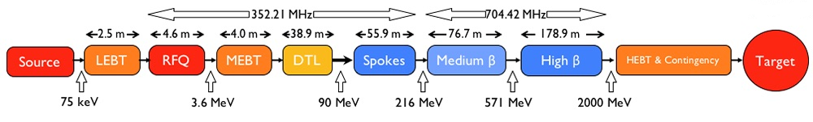

Figure 1 - Schematic picture of the different parts of the ESS machine.

This document describes the control architecture for the drift tube linac (DTL) named ESS DTL. This DTL will accelerate a proton beam with a 62.5 mA pulse peak current from 3.62 to 89.91 MeV. The DTL is designed to operate at 352.21 MHz, with a duty cycle of 4% (2.86 ms pulse length,14 Hz repetition period). Permanent magnet quadrupoles (PMQs) are used as focusing elements in a lattice scheme that is, with half of the drift tubes left empty, leaving space for steerers and beam diagnostics. Figure 2 shows a general side view of the DTL apparatus.

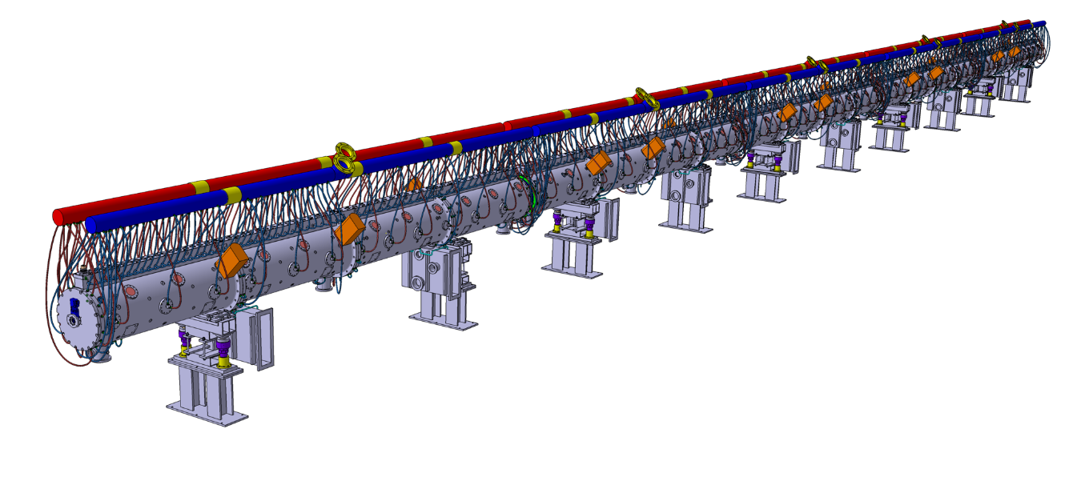

Figure 2 – 3D Mock-up of the DTL apparatus.

The entire Linac accelerator and, as consequence, the DTL require dedicated equipment and strategies for the control. Figure 3 is a schematic synthesis of whole systems.

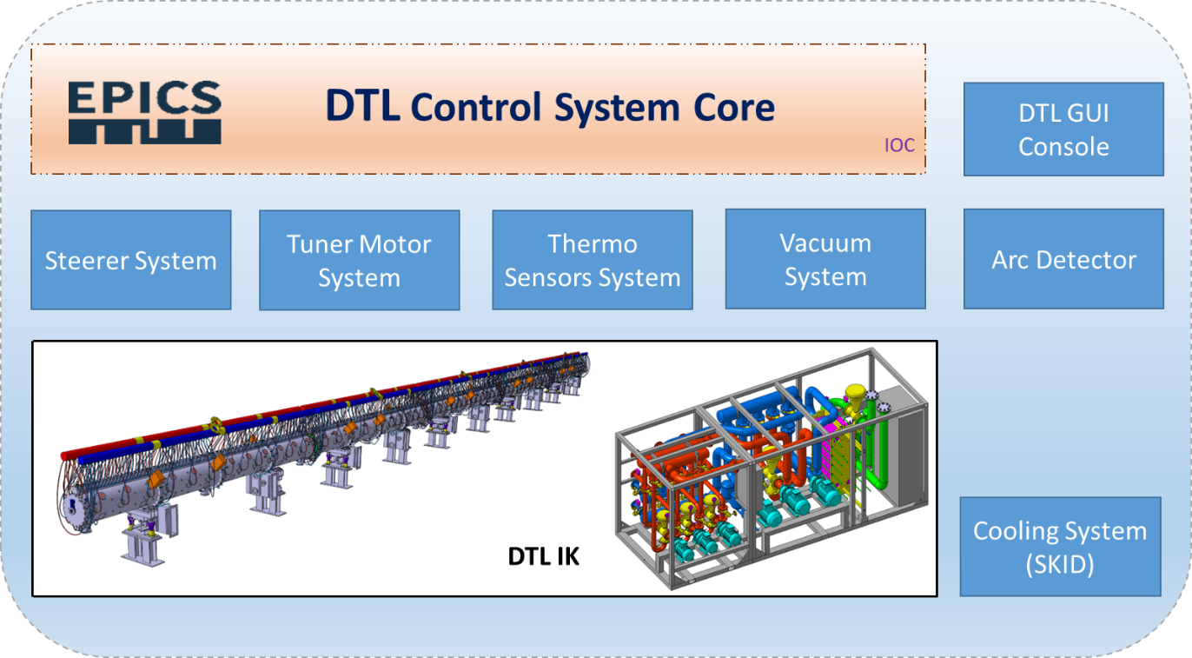

Figure 3 - A schematic picture of sub-systems composing the DTL apparatus’ interfaces.

DTL is a system interfaced with other different apparatus composing the Normal Conducting Linac and transversal systems and services, such as RF System, Vacuum, Water Cooling, Machine Protection System and Personal Protection System, required to operate the accelerator.

The first step required to design the control system is to define the concepts of how the DTL will operate and the interfaces with other sub-systems. Through this analysis and the usage of the Project’s documentation, the design of a control system architecture is possible.

# Concept of Operation

## Background

The DTL is an accelerating section of the ESS Linac Machine that accelerates the proton beam through a resonant RF cavity kept under vacuum and feed with RF power.

The equipment required to be controlled/monitored by the DTL Cavity Controls System is broadly stated as follows:

1. Temperature monitoring of the cavities to prevent component over-temperature.
2. Tuner motors are a positioning system that provides movement of a linear plunger system to affect the cavity’s frequency response to the incoming RF power.
3. Steerer magnet system serves to provide “steering” of the beam position. The control systems provides the interfaces to control the current of the power supplies driving the electro-magnet system.
4. Arc detector system serves to provide an interlocking of the incoming RF power based on observed frequency of electrical arcing in the cavity.
5. Water cooling skid serves to maintain the correct operation temperature of the cavity.
6. Vacuum system serves to maintain the required vacuum pressure in the cavities. This is an interfaced system which means that it is not controlled by the DTL Cavity Controls hardware but there will be monitoring software links to the relevant Process Variables in the higher levels of the DTL Cavity Controls Software.

## Operating Modes

The DTL apparatus has to be managed in different configurations:

* Installations and RF conditioning.
* Operation.
* Maintenance.

Every single configuration requires particular characteristics for every single sub-system composing the DTL controls and the main information will be described in the following paragraphs.

### Installation and RF Conditioning

This configuration will be used for the DTL, during its integration in the final position. In this situation, during RF conditioning DTL Temperature can provoke critical issues to the apparatus’ functionality. In this case different scenarios can appear:

* In case of single temperature sensor’s error
  + Possible channel failure
* In case of multiple temperature sensors’ error
  + Possible IO module failure.
  + RF or Flux issues.

The vacuum system HW and control, designed by ESS-ERIC, must provide the vacuum as per requirement and, in this stage, it must be checked before starting the RF conditioning. The entire DTL has to be in vacuum for executing next stages. In particular, different devices must guarantee their functionalities:

* Vacuum pumps: in case of damage, spare pumps must be enabled.
* Vacuum gauges: in case of damage, guarantee DTL machine safety.

The water cooling system is a critical system to manage during installation because air has to be evacuated out of the SKID system in order to avoid bubbles in RF conditioning. A good feedback is fluxes and pressures related to the cooling system: these parameters are not critical in this stage but they must be supervised.

Arcs can appear during RF conditioning and they can be destructive for the cavity if their magnitude is big or if they are too frequent. For this reason, arc detectors have been located in the waveguide, on both side of each RF window which are the most critical components. In parallel, vacuum must be strictly controlled to detect the effects of arcs phenomena in the cavity.

### Operation

This configuration will be used for normal Linac usage. DTL temperature affects steering performance and, as consequence, they must be under control. In case of temperature failure, the entire DTL must be put in stand-by operational condition.

The DTL stand-by operational condition is a working status where:

* The beam is OFF (not present)
* The RF is OFF (not present)

Other functional sub-systems don’t have particular restrictions but they have to be monitored.

Also vacuum plays an important role for the machine safety: if the apparatus has pressure increments (not related to transient), the RF has to be switched off and DTL vacuum system integrity must be confirmed through leak tests and devices’ checks (pumps, gauges, valves, etc.).

SKID water cooling temperatures and fluxes have to guarantee the proper functionalities in order to absorb the correct amount of power to keep constant the DTL temperature and frequency.

Arc system is more critical than in RF conditioning stage: while during conditioning arcs can appear (in minimum amount), during operation the DTL apparatus must not provoke this phenomenon. In case of arcs, vacuum parameter must be kept under control.

### Maintenance

Normal maintenance has to follow the common rule and restrictions related to every single device composing the control system.

Particular attentions must be paid for arc detector fibres.

# Design Constraints and Assumptions

The design of the DTL Control System is aligned with the ICS Handbook [1], with the following exceptions:

* Motors and potentiometers used the tuner controls;

This choice is motivated by preliminary studies and user cases already in production in similar applications.

The Control System is built based on EPICS (Experimental Physics and Industrial Control System) software toolkit and Control System Studio (CSS) is the standard tool for the OPI screens [2]. All the applications and services required by the DTL system and provided by ESS-ERIC will be integrated and all the specifications (such as services’ configurations) will be properly provided during the installation stage.

# Glossary

| Term | Definition |
| --- | --- |
| AD | Accelerator Division |
| CF | Conventional Facilities |
| CS | Control System |
| CSS | Control System Studio |
| CWH | Cooling Water High temperature |
| CWL | Cooling Water Low temperature |
| CWM | Cooling Water Medium temperature |
| DTL | Drift Tube Linac |
| EPICS | Experimental Physics and Industrial Control System |
| HBL | High Beta Linac |
| ICS | Integrated Control Systems |
| IKC | In-Kind Contract |
| MBL | Medium Beta Linac |
| MPS | Machine Protection System |

# references

1. ICS Handbook (ESS-0067637)
2. ESS OPI Style Guide is (ESS-0341654)

Document Revision history

| Revision | Reason for and description of change | Author | Date |
| --- | --- | --- | --- |
| 1 | First issue | Mauro Giacchini | 2018-10-30 |
|  |  |  |  |