|  |
| --- |
|  |
|  |
|  |
|  |
|  |
|  |
|  |
|  |
|  |
|  |
|  |

|  | Name | **Role/Title** |
| --- | --- | --- |
| **Owner** | Mauro Giacchini | IK Work Unit Coordinator (local coordinator) |
| **Reviewer** | Thomas Fay | ICS Division, Control System Engineer |
| **Approver** | <<Name>> |  |

|  |  |
| --- | --- |
| Table of content | Page |

List of Abbreviations 3

1. Scope 4

2. Description 4

3. DTL Control System 6

3.1. General Description 6

4. Interfaces 7

5. RF systems Interface Requirements 7

6. references 8

Document Revision history 8

List of Abbreviations

| Abbreviation | Definition |
| --- | --- |
| ICS | Integrated Control Systems |
| EPICS | Experimental Physics and Industrial Control System |
| PLC | Programmable Logic Controller |
| CF | Conventional Facilities |
| MBL | Medium Beta Linac |
| HBL | High Beta Linac |
| SPK | Spoke (cryomodule) |
| CWL | Cooling Water Low temperature |
| CWM | Cooling Water Medium temperature |
| CWH | Cooling Water High temperature |
| WP16  DTL  CS  IKC | ACCSYS Work Package 16  Drift Tube Linac  Control System  In-Kind Contract |
| MPS  RFLPS  ADM | Machine Protection System  RF Local Protection System  Arc Detector Module |

# Scope

This document defines the Drift Tube Linac (DTL) control system interfaces with all the other sub-systems and ancillaries composing the normal conducting LINAC.

# Description

ESS is an accelerator driven neutron spallation source. The linear accelerator, or Linac, is thus a critical component.

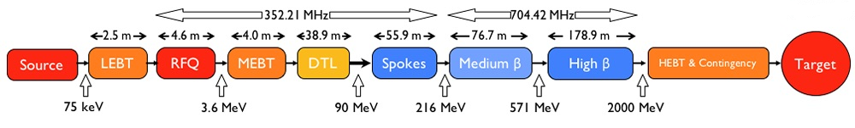

Figure 1 - Schematic picture of the different parts of the ESS machine.

This document describes the control architecture for the drift tube linac (DTL) named ESS DTL. This DTL will accelerate a proton beam with a 62.5 mA pulse peak current from 3.62 to 89.91 MeV. The DTL is designed to operate at 352.21 MHz, with a duty cycle of 4% (2.86 ms pulse length,14 Hz repetition period). Permanent magnet quadrupoles (PMQs) are used as focusing elements in a lattice scheme - that is, with half of the drift tubes left empty, leaving space for steerers and beam diagnostics. Figure 2 shows a general side view of the DTL apparatus.

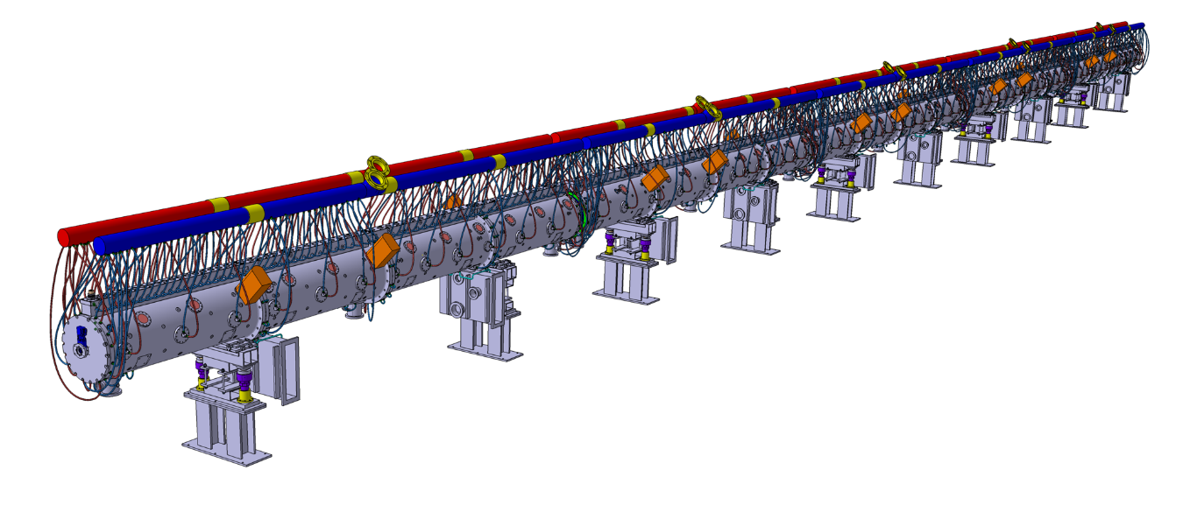

Figure 2 – 3D Mock-up of the DTL apparatus.

The entire Linac accelerator and, as consequence, the DTL require dedicated equipment and strategies for the control. Figure 3 is a schematic synthesis of whole systems.

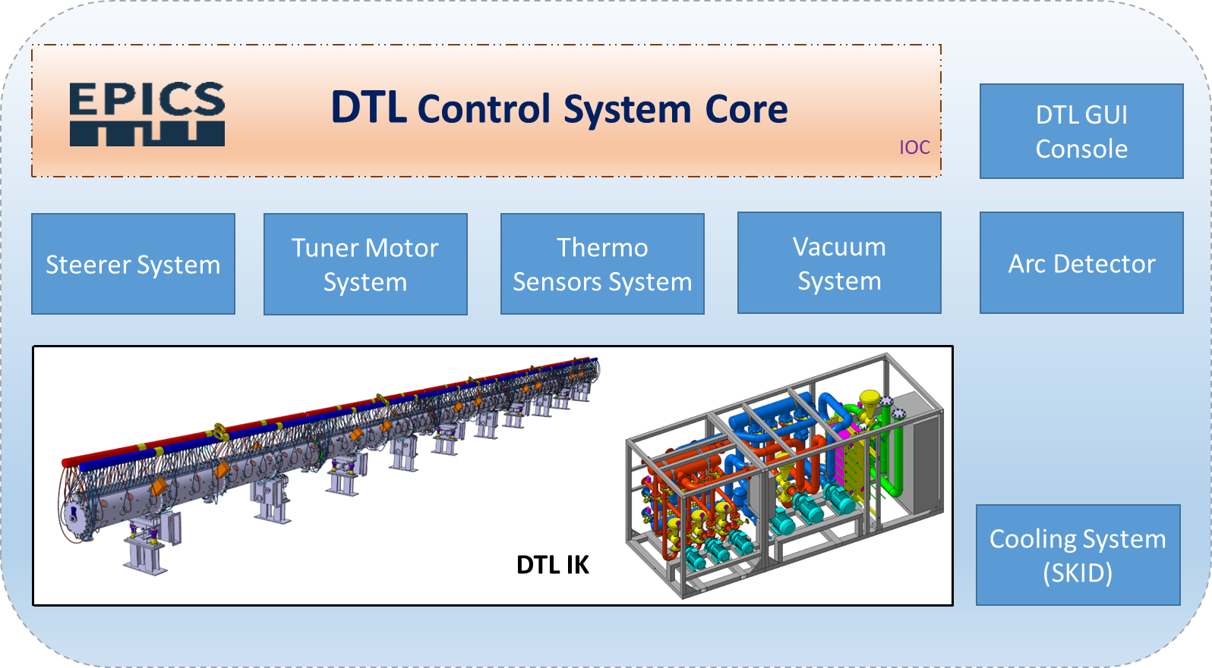

Figure 3 - A schematic picture of sub-systems composing the DTL apparatus’ interfaces.

DTL is a system interfaced (directly or indirectly) with other different apparatus composing the Normal Conducting Linac and transversal systems and services, such as vacuum and RF system , Machine Protection System and Personal Protection System, required to operate the accelerator in safety. Because of the complexity of the Project and the number of persons involved at different layers, the DTL control system design and implementation must follow precise strategies and solutions. This approach can optimize costs and time during the stages of the installation campaign.

The first step required to design the control system is to define the concepts of how DTL operated and the different information and data exchanged with other sub-systems. Through this analysis and the usage of the Project’s documentation, the design of a control system architecture is possible.

# DTL Control System

## General Description

The DTL control system provides the hardware and software layers required to operate the DTL cavities. The following systems fall within the remit of this Cavity Control System.

The control system implementation includes:

* Hardware selection and installation
* EPICS base controls software
* Interconnection of the controls network within the DTL Cavity Controls equipment.
* Configuration of the system with the ESS Lund ICS services, archiver, alarms, post-mortem.

The sub-systems included within the DTL Cavity Control System is

**Hardware and Software**

* Water Cooling Controls – releases the cooling system required to maintain the cavity and normal operating temperature and the rough tuning of the cavity frequency response.
* Tuning Motor System – implements the fast closed loop control to regulate the cavity frequency response (frequency fine tuning) based on frequency detuning feedback from the RF system.
* Steerer Magnet Power Supply Controls – the DTL has a set of steerer magnetics positioned along the beam axis of the cavity to allow “steering” of the beam. Dedicated power supplies must control the magnetic field generated by every single element.
* Arc Detector – monitors the presence of arc on the RF window for preservation of the DTL equipment.

**Software Only**

* EPICS driver for QPC vacuum controller.
* The control system orchestration for DTL commissioning.
* The Control System Studio operator interfaces required for DTL. ESS Lund will provide the required EPICS PV names for this task.

# Interfaces

Dedicated interfaces are mandatory to realise an operational control system for the DTL apparatus. In particular, integrations with Radio Frequency (RF) systems – Low Level RF (LLRF) and RF Local Protection System.

# RF systems Interface Requirements

The interfaces with the RF system concern mainly protection functions for the DTL apparatus and frequency tuning of the cavities. For details in hardware connections refer to [3]. For details in software data exchange, refer to [4].

| Id | I/O (DTL side) | Text | Interfaced System | |
| --- | --- | --- | --- | --- |
| DTL.IFC.RF.HW.01 | Output | Tank1 DTL Temperatures OK Status | RF LPS Slow | |
| DTL.IFC.RF.HW.02 | Output | Tank2 DTL Temperatures OK Status | RF LPS Slow | |
| DTL.IFC.RF.HW.03 | Output | Tank3 DTL Temperatures OK Status | RF LPS Slow | |
| DTL.IFC.RF.HW.04 | Output | Tank4 DTL Temperatures OK Status | RF LPS Slow | |
| DTL.IFC.RF.HW.05 | Output | Tank5 DTL Temperatures OK Status | RF LPS Slow | |
| DTL.IFC.RF.HW.06 | Output | Movable Tuners Tank 1 OK Status | RF LPS Slow | |
| DTL.IFC.RF.HW.07 | Output | Movable Tuners Tank 2 OK Status | RF LPS Slow | |
| DTL.IFC.RF.HW.08 | Output | Movable Tuners Tank 3 OK Status | RF LPS Slow | |
| DTL.IFC.RF.HW.09 | Output | Movable Tuners Tank 4 OK Status | RF LPS Slow | |
| DTL.IFC.RF.HW.10 | Output | Movable Tuners Tank 5 OK Status | RF LPS Slow | |
| DTL.IFC.RF.HW.11 | Input/Output | Connections between ADM to RFLPS | RF LPS Fast | |
| DTL.IFC.RF.HW.12 | Output | Water cooling temperature Status | RF LPS Slow | |
| DTL.IFC.RF.SW.01 | Input | Frequency detuning value [kHz] (one per tank) | LLRF | |
| DTL.IFC.RF.SW.02 | Input | DTL Cavity electrical field value [kV] (one per tank) | Definition not required for soft signal. | |
| DTL.IFC.RF.SW.03 | Output | RF output parameters set-up during conditioning (Analog: pulse width, period and amplitude; Binary: frequency follower mode and amplitude and phase loop mode) | Definition not required for soft signal. |

Note: when a problem occurs in the DTL or a dangerous scenario is performing, the RF has to be switched off in one or more DTL tanks.

# references

1. DTL Cavity Controls – System Requirements [ESS-1273818]
2. DTL Cavity Control – Core Software [ESS-1274083]
3. ESS DTL_LCS_HW_Interfaces [ESS-1274080]
4. ESS_DTL_LCS_SW_Interfaces [ESS-1274082]
5. DTL interface flow chart [ESS-0177541]
6. DTL block diagram [ESS-0115057]

Document Revision history

| Revision | Reason for and description of change | Author | Date |
| --- | --- | --- | --- |
| 1 | First upload to CHESS following critical design review in Legnaro | Mauro Giacchini | 2019-06-27 |
|  |  |  |  |
|  |  |  |  |