|  |
| --- |
|  |
|  |
|  |
| DTL Cavity Controls - System Integration Plan |
|  |

|  | Name | Role/Title |
| --- | --- | --- |
| Owner | Mauro Giacchini | IK Work Unit Coordinator (local coordinator) |
| Reviewer | Thomas Fay | ICS Division, Control System Engineer |
| Approver | <<Name>> | <<Role/ Title>> |

|  |  |
| --- | --- |
| Table of content | Page |

List of Abbreviations 3

1. Scope 4

2. Issuing Organisation 4

3. System Aggreation Views 5

4. Interfaces View 7

5. IntegratioN-Related Risks 9

5.1. Delivery delays of devices and hardware components shipped from ESS Lund to INFN-LNL 9

5.2. Cooling system integration into PLC Factory 9

5.3. Preliminary test bench with ESS Lund standards 9

5.4. Final Rack substitution on construction site invalidates the FAT 9

5.5. SAT test delay 10

6. references 10

7. Document Revision history 10

list of tables

**No table of figures entries found.**

list of Figures

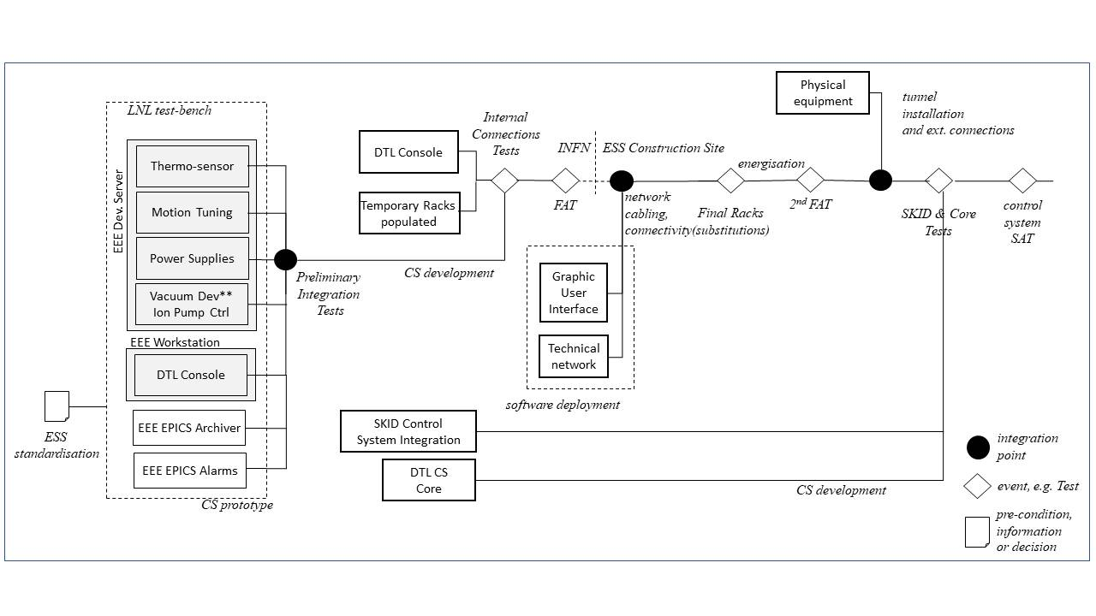Figure 1 - System Aggregation Diagram 6

Figure 2 - DTL apparatus interfaces 7

# Scope

This document contains the system integration plan for the Drift Tube Linac (DTL) Control System.

This document describes the integration activities for the control system. These comprise the step-wise merging of hardware and software components, controlled equipment and enabling systems and eventually their incorporation into the ESS facility.

In this sense:

* the result of integration activities are functional systems of increasing size and complexity.
* the purpose of integration activities is to identify problems early so they can be resolved early.
* it can include, calibrations, user training, IT security measures, etc.

# Issuing Organisation

This document is issued by Istituto Nazionale di Fisica Nucleare – Laboratori Nazionali di Legnaro (INFN-LNL).

# System Aggreation Views

The purpose of this plan is to give an encompassing view on all of these integration activities centred on the DTL control system, which is shared with the other contributors of this system.

The diagram shows the integration activities following the time line of the In-Kind Contract. The LNL test-bench has the scope of being a proof of concept for the most significant control system and automation solutions. This task has to be done in order to acquaint with the ICS framework for both hardware and software profiles.

The test bench is based on the modularity of the system: it doesn’t contain all the channels and signals necessary to control the entire DTL apparatus, but it has a general overview of the principal functionalities.

The FAT performed at LNL has the scope of cross-checking between the system developed and the documentation provided. Particular attention will be put for verification in:

* DTL Core system: from high level interface to the low level logic
* Low level electrical checks

Figure 1 - System Aggregation Diagram

# Interfaces View

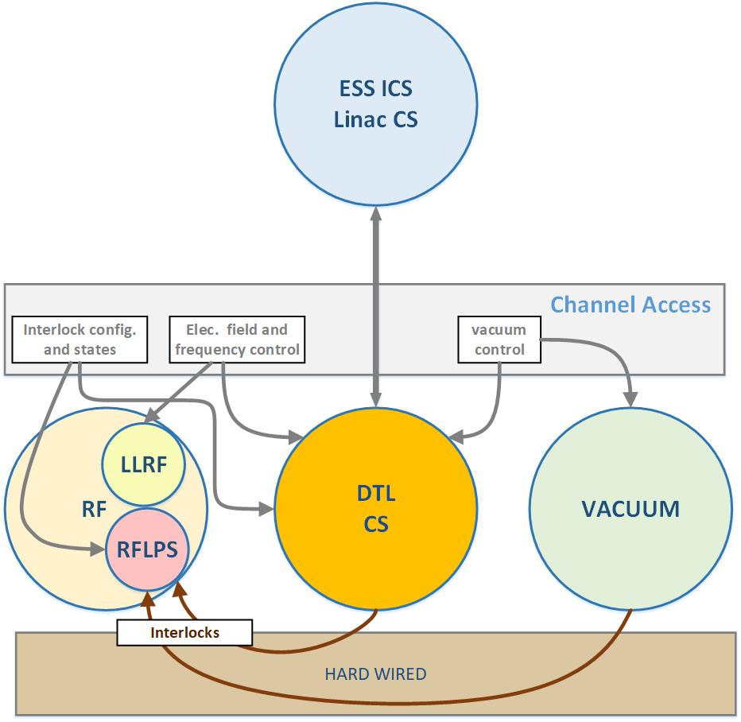

Figure 2 - DTL apparatus interfaces

The DTL CS is part of a more complex system which has to be interfaced with other different apparatus composing the Normal Conducting Linac and transversal services, such as Machine Protection System and Personal Protection System.

This articulated interface, constituted of wired signals and software channel connections, requires a special attention from the design to the final installation. The SAT test on construction site should include a matrix test for performing an exhaustive validation. Every signal has to be verified the perfect alignment with the control system project. The list of the defined hardware and software connection is:

* ESS_DTL_LCS_InOUT_HW_list
* ESS_DTL_LCS_InOut_SW_List

Documents are indicated in [2] and [3].

# IntegratioN-Related Risks

The DTL apparatus has different risks related to the integration activities.

## Delivery delays of devices and hardware components shipped from ESS Lund to INFN-LNL

The possible delivery delays from ESS-ERIC could be caused by procurement process and cannot be mitigated. The IKC estimates in six months the time required to prepare the control system at INFN-LNL. The DTL control system working plan consists of:

* racks population and
* the control system software automation development.

The second point could be critical due to lack of manpower; the mitigation plan for this task is in action and it consists of recruiting two control system / computer science technicians.

## Cooling system integration into PLC Factory

The Skid control system is going to be realized by a tender. Software and hardware selected to make this automation follow the ESS standardization [1]. During the software development process, INFN-LNL engineers with the ESS ICS experts have to collaborate to support the tender winner in order to realize the necessary software integration. In case this task won’t be properly executed, additional time for software integration is necessary, delaying the final DTL integration stage.

## Preliminary test bench with ESS Lund standards

The preliminary integration test closes the first stage of the DTL CS development. It will be done at ESS-ERIC to verify the correct adoption of all the integration rules defined by ICS division. This test reduces the possibilities of discrepancies and misalignments from the standard defined and simplify the SAT part related to the integration.

This test has the scope to formally verify the design following the ESS-ERIC standards and it can be estimated as 25% of the entire work. The development has to be continued to create the entire control system with special attention to the DTL core control system. The last one is devoted to orchestrate all the various subsystems.

## Final Rack substitution on construction site invalidates the FAT

ESS-ERIC is responsible of the final rack substitution on site and this could generate risks. The strategy to reduce this risk, which was not included into the IKC, is based on execute a second FAT test at ESS-ERIC. This test will certify the correct rebuild of the racks and is mandatory before the next stage of connections with the external control system components.

## SAT test delay

The final integration has been based on SAT test execution which can be done only if all the parent systems are already available in ESS-ERIC. More than this, uncertainties on the timely availability of enabling systems (power, network, tools, etc.) can provoke delays.

# references

1. ICS Handbook [ESS-0067637]
2. DTL Cavity Controls – Hardware Interfaces [ESS-1274080]
3. DTL Cavity Controls – Software Interfaces [ESS-1274082]

# Document Revision history

| Revision | Reason for and description of change | Author | Date |
| --- | --- | --- | --- |
| 1 | First issue uploaded to CHESS following Critical Design Review in Legnaro. | Mauro Giacchini | 2019-06-27 |
|  |  |  |  |
|  |  |  |  |