### 指标查询接口

接口功能：

本接口用于查询数据库各指标表中的数据，并以JSON格式返回。

请求地址：

<http://127.0.0.1:5000/api/mysql/query/%{table_name}>

请求方式：

POST

请求参数：

以查询活动补贴率为例，参数为 dt=2024-08-27 activity_id=ACT006

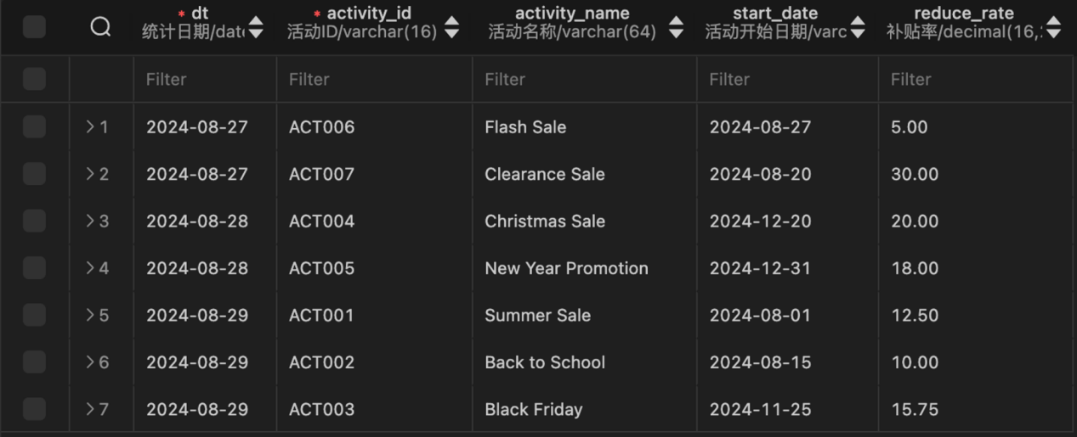

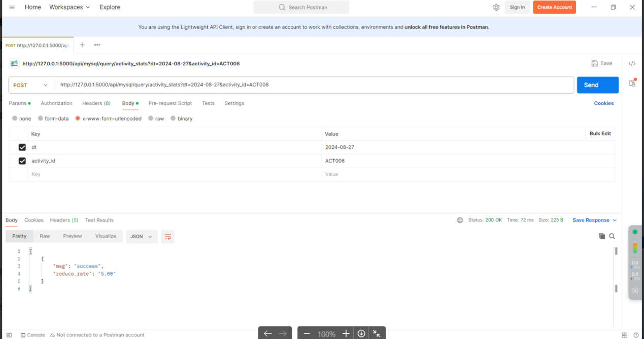

响应：

| **HTTP 状态码** | **状态码描述** | **响应示例** |
| --- | --- | --- |
| 200 | 成功 | {msg=”success”, reduce_rate=’5.00’} |
| 400 | 请求参数异常 | {msg=”wrong”} |
| 401 | 授权失败 | {msg=”wrong”} |
| 500 | 系统异常 | {msg=”wrong”} |

ps:其他指标查询和示例一样，post参数为能够唯一确定指标值的主键或联合主键，尽量以Id字段优先。

|  |  |  |
| --- | --- | --- |
| 表名 | POST参数 | 正确响应示例 |
| activity_stats | dt, activity_id | {msg: "success", reduce_rate: 5.00} |
| coupon_stats | dt，coupon_id | {msg: "success", reduce_rate: 12.50} |
| new_buyer_stats | dt，recent_days | {msg: "success", new_order_user_count: 150, new_payment_user_count: 120} |
| order_by_province | dt，recent_days，province_id | {msg: "success", order_count: 150, order_total_amount: 12500.50} |
| page_path | dt，recent_days，source，target | {msg: "success", path_count: 150} |
| repeat_purchase_by_tm | dt，recent_days，tm_id | {msg: "success", order_repeat_rate: 25.50} |
| sku_cart_num_top3_by_cate | dt，category1_id，category2_id，category3_id，sku_id | {msg: "success", cart_num: 120,rk: 1} |
| trade_stats | dt，recent_days， | {msg: "success", order_total_amount: 15000.00,order_count: 200,order_user_count: 180,order_refund_count: 5,order_refund_user_count: 4} |
| trade_stats_by_cate | dt，recent_days，category1_id，category2_id，category3_id | {msg: "success", order_count: 200,order_user_count: 180,order_refund_count: 5,order_refund_user_count: 4} |
| trade_stats_by_tm | dt，recent_days，tm_id | {msg: "success", order_count: 200,order_user_count: 180,order_refund_count: 5,order_refund_user_count: 4} |
| traffic_stats_by_channel | dt，recent_days，channel | {msg: "success", uv_count: 200,avg_duration_sec: 180,avg_page_count: 5,sv_count: 4,bounce_rate: 35.50} |
| user_action | dt，recent_days， | {msg: "success", home_count: 200,good_detail_count: 180,cart_count: 5,order_count: 4,payment_count: 35.50} |
| user_change | dt | {msg: "success", user_churn_count: 12,user_back_count: 1} |
| user_retention | dt，create_date | {msg: "success", retention_count: 12,new_user_count: 1,retention_rate: 24.50} |
| user_stats | dt，recent_days | {msg: "success", new_user_count: 500,active_user_count: 400} |