# CG-490 Design

The design goals set out for our project in ELEC 390 were to accelerate an 18g projectile to a velocity of 30 m/s with a kinetic energy of 8J. Through the use of magnetic simulators and circuit simulators we will investigate the requirements for such a device and build off of the knowledge gained last year.

## MOSFET vs. IGBT

MOSFET’s are resistive devices whereas IGBT’s have a semiconductor junction. This means that a mosfet will have a variable Vds depending on the current Id in its saturated state. An IGBT behaves more like a BJT with a relatively fixed voltage drop. Power losses in a FET are I^2*R whereas in the IGBT they are Vce*I. This makes IGBT’s better suited for high voltage applications

Vcesat is the same thing for Transistors. Its the Vce-Voltage that is reached as soon as the basis-current is high enough so that Vce will not decrease anymore. Your IGBT has a 2.5V Vcesat. So it doesnt mater much, how much current you apply you will always measure the voltage around 2.5V. Sometimes less, (low current) somtimes more (high current)

The onyl thing is certain: by using IGBTs you waste 2-3V of your Battery-Voltage in your IGBT. This is a expected loss >10%. This will lower your effective Voltage at the coils -> you need lower inductance -> less turns -> less force -> less speed.

## Switching Circuit Selection

The switching circuit is used to pulse current through the coils was simulated using LT Spice, a popular free SPICE simulator tool. Several designs were tested to determine the optimal configuration. These configurations are discussed below:

### Config 1

The first configuration tested consists of only a few key components including the Mosfet, Coil (inductor), Battery and a switching source. 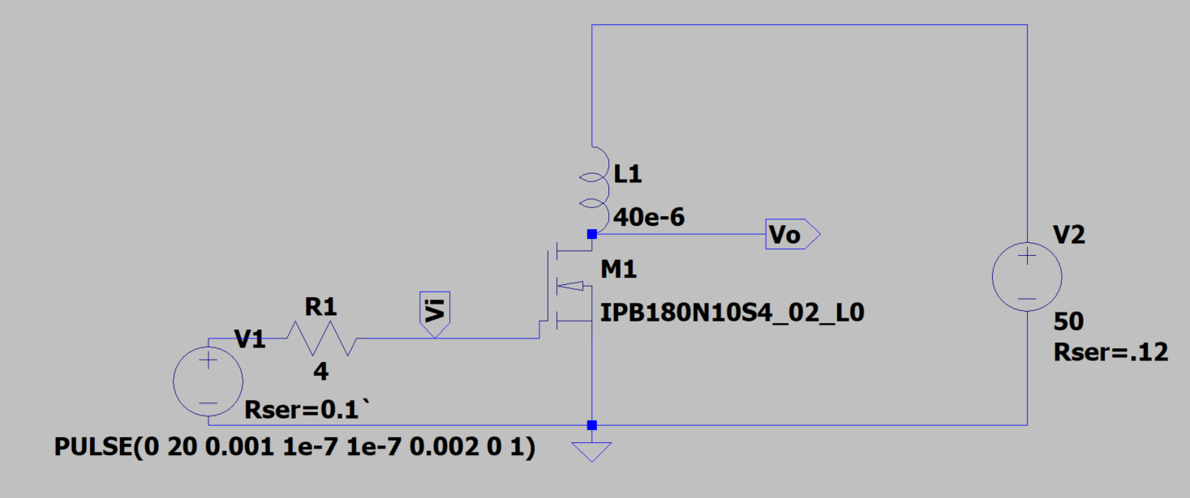

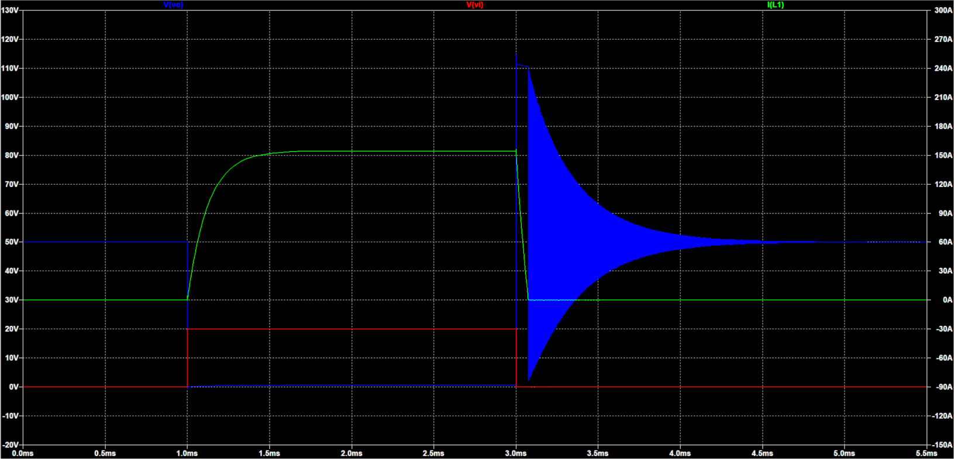

It can be seen that the inductor current (green) ramps to its final value (set by resistances) as defined by the equation V = L di/dt 🡪 I = . To summarize, the current changes slower for coils of higher inductance but this is not important for the scope of this simulation. The main issue with this circuit configuration is the massive voltage spikes present at the end of the current pulse. When the MOSFET switch ‘opens’ there is a very large change in current in a small window of time (large di/dt), resulting in a very large voltage spike. The simulator shows this voltage spike as clipping at 110V because that is the voltage breakdown of the FET. This is bad. MOSFET goes bye bye aka dead af..

We can get around that problem by using an antiparallel diode or a Zener diode to provide an alternate current path for the coil to dissipate energy into. We could potentially collect this energy using capacitors and feed it back into the system but that is outside the scope of this project.

### Configuration 2

In order to solve the problem with large voltage spikes, an antiparallel diode was added to the circuit to absorb the current from the coil.

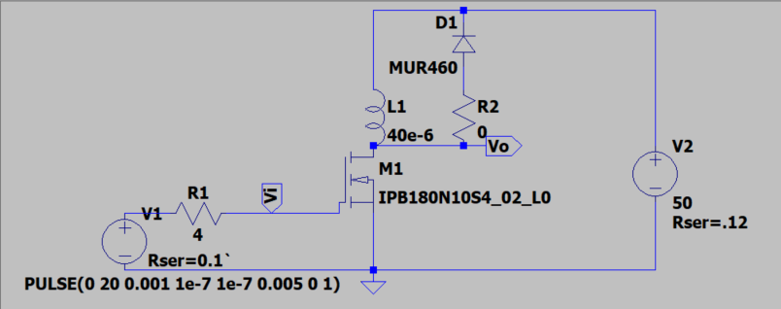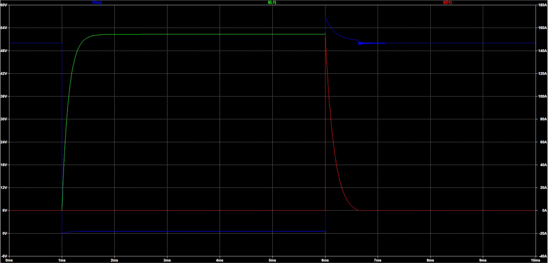

The effect of adding the diode is very clear as the voltage spike seen earlier is no longer present. It should be noted however that the coil current takes about 3 times longer to fall to zero. This has the effect of adding a suck-back effect to the projectile as there is still residual current in the coil which will cause acceleration in the negative direction.

### Configuration 3

The problem of delayed turn off can be combatted through the use of a Zener diode to clamp the Vds to a safe value. The large voltage drop across the Zener diode allows it to dissipate power more quickly than the standard anti parallel diode configuration.

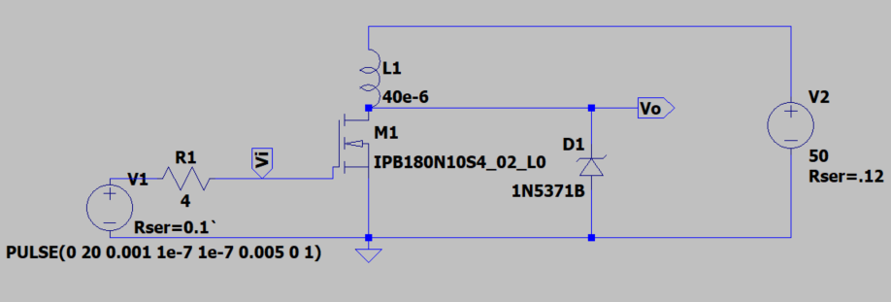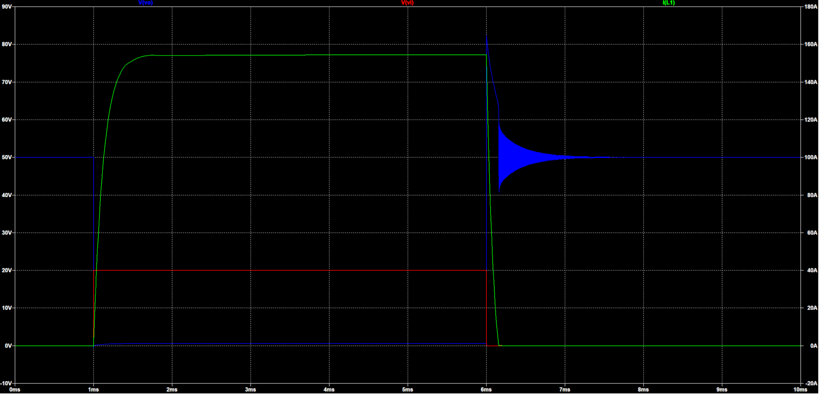

### Configuration 4

A common topology used in switched mode power supply designs is the push-pull configuration. This configuration uses a second MOSFET to replace the antiparallel diode to actively sink current from the coil. 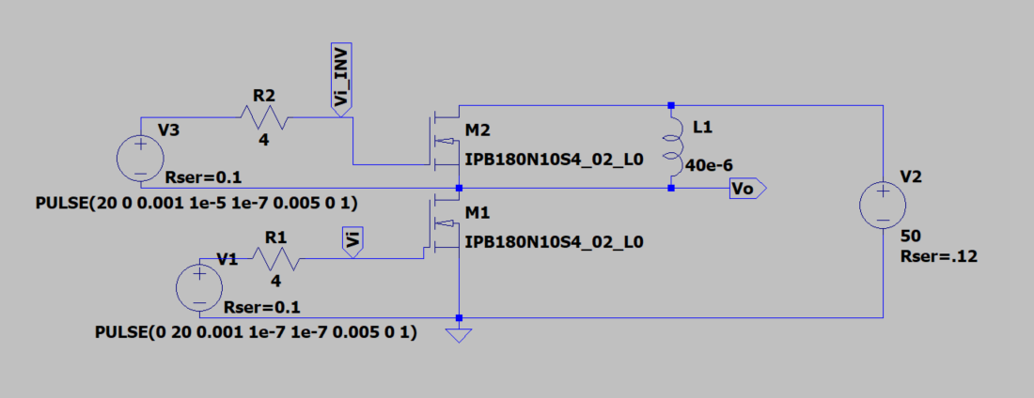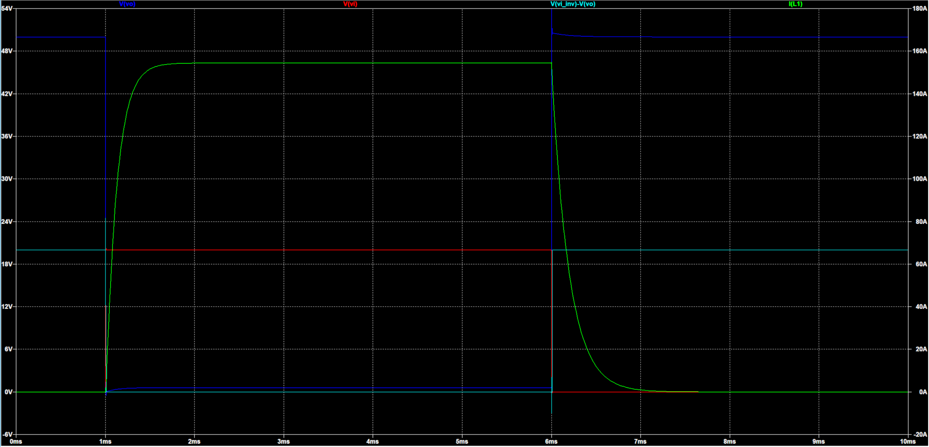

This configuration yielded similar results to the antiparallel diode used in configuration 2 and is significantly more expensive to build, thus will be ignored.

## Switching Circuit Design

It was decided that configuration 3 should be used since it yielded the best performance and minimizes complexity of the circuit. Subsequent simulations will be based around this configuration to determine the optimal component values and gain a better understanding of its limitations.

### MOSFET

In order to avoid failure in the MOSFET, there are many factors to consider, including the Drain-Source breakdown voltage, thermal limitations, current limitations and power dissipation limitations. Conveniently, these parameters are all included on the SOA (Safe Operating Area) plot on the Mosfet’s 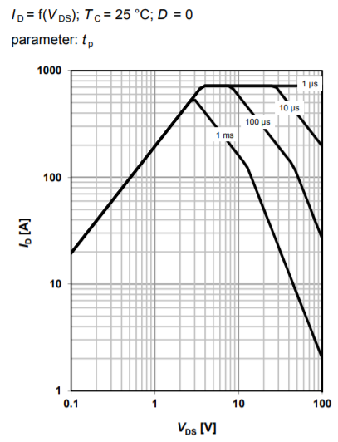datasheet.

Using the SOA diagram, we can determine the maximum safe current and voltage drop for different pulse lengths. Segment 1 shows Id vs. Vds as limited by Rdson. We will be operating our MOSFET in saturation meaning that our Id and Vds will be somewhere along this line. The Rdson Line ends at the horizontal line representing the maximum current the package can handle. The figure also shows maximum ratings for different pulse lengths. If we know that our MOSFET won’t be conducting for longer than 1ms, we can see that the maximum allowable current is 400 Amps and occurs in the ohmic region of the device. If we were to operate the MOSFET in its linear region (NOT SATURATED) we would follow this line along further to the right to find the maximum allowable current for each Vds. This region is limited by the maximum power dissipation of the package and assumes the use of an ideal heatsink. After this line, we arrive at the secondary thermal breakdown line where the temperature coefficient of the device becomes negative. This means that as the FET gets hotter, it allows more current to flow for a specific Vds, thus creating more heat and starting a thermal runaway ending in device destruction.

Using a maximum on time for our coilgun of 10 ms, we can extrapolate the pulse length lines on the graph to reach a maximum saturation current of approximately 300 Amps! It is important to turn the FET on and off as quickly as possible to minimize the heat generated during the switching cycle (especially at turn off!) As long as we do not exceed this current for a duration longer than 10 ms, and we successfully snub the voltage spikes during switching we will avoid failure of the MOSFET.

### Zener Diode

The purpose of the Zener diode is to prevent massive voltage spikes from killing the MOSFET when the current is switched off in the coils. An appropriate Zener diode must be selected to ensure that it prevents voltage breakdown of the MOSFET, it only conducts when the coil is switched off, and that it is capable of handling the large surge currents flowing through the coil at turn off. In order to prevent breakdown of the MOSFET, the Zener voltage needs to be below the breakdown voltage of the MOSFET. To ensure the Zener diode only conducts when the coil is switched off, the Zener voltage must be greater than the battery voltage used in the circuit. If a Zener voltage lower than the battery voltage is selected, the Zener diode provides an alternate current path through the coil meaning that it will always be energized and will likely result in the failure of the diode as well as poor performance of the coilgun. To ensure the long-term reliability of the Zener diode, we must select a diode rated to handle large surge currents of approximately 300 amps (max current of MOSFET) for a maximum of 1 ms. Fun fact they don’t make Zener diodes that can handle this kind of current LOL..

Trying TVS diodes now because they are rated for massive surge currents.

It was decided to use TVS (Transient Voltage Suppression) Diodes in place of standard Zener diodes since they are designed with high surge currents in mind. There are four main factors to consider when selecting a TVS diode. The reverse standoff voltage represents the voltage at which only 1 uA of current flows through the diode. The steady state voltage of the circuit should be below this threshold to avoid excessive power loss. The reverse breakdown voltage of the diode represents the voltage at which the diode starts conducting 1mA of current. This is the voltage where the diode begins clamping. The final factor is the maximum clamping voltage Vc which occurs at the peak clamping current the diode is rated for. This value needs to be below the breakdown voltage of the MOSFET at the peak clamping current. The peak clamping current required in the diode must also not be exceeded to avoid risk of failure.

To save on costs, two less expensive TVS diodes will be used together to meet the demands of the circuit. The diodes will be placed in series meaning that the standoff voltage must be greater than Vbat/2, and the clamping voltage must be less than Vdsbreakdown/2. The diodes are placed in series to ensure even conduction of current between the two diodes. If a parallel configuration was used, one diode may conduct most of the current if it has a slightly different Vbreakdown which could result in catastrophic failure of the circuit. The diode selected must be able to handle a peak clamping current equal to the current flowing through the coil in its active state. The time spent at this peak current is dependent on the voltage drop of the Zener diodes as power dissipated is equal to V*I. Through simulation, the optimal pulse width (defined as the time it takes for clamping current to go from peak to peak/2) was found to be 65 uS with a voltage drop of 100 V on the Zener diodes, a coil current of 250 amps and a coil inductance of 40 uH.

