# Conflict Scenario

## **Review**

### Interpersonal Conflict Management Styles

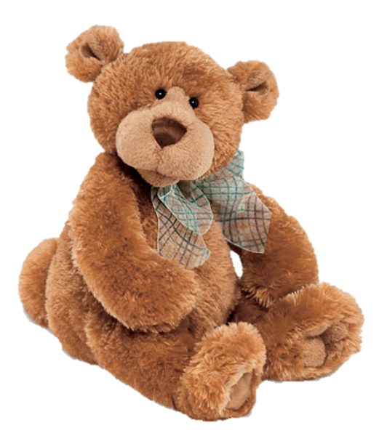

[CC 2.0 BY Matthew](https://www.flickr.com/photos/falcon1961/3304306800/)



[CC SA 3.0 Unported BY Jonathan Zander](https://en.wikipedia.org/wiki/File:Florida_Box_Turtle_Digon3.jpg)



[CC 3.0 BY Superawesomevectors](https://superawesomevectors.deviantart.com/art/Shark-Cartoon-Free-Vector-Illustration-643399222)



[CC0](https://pixabay.com/en/urban-lost-hiding-afraid-1002149/)

Low to High Concern for Other

Concern for Self

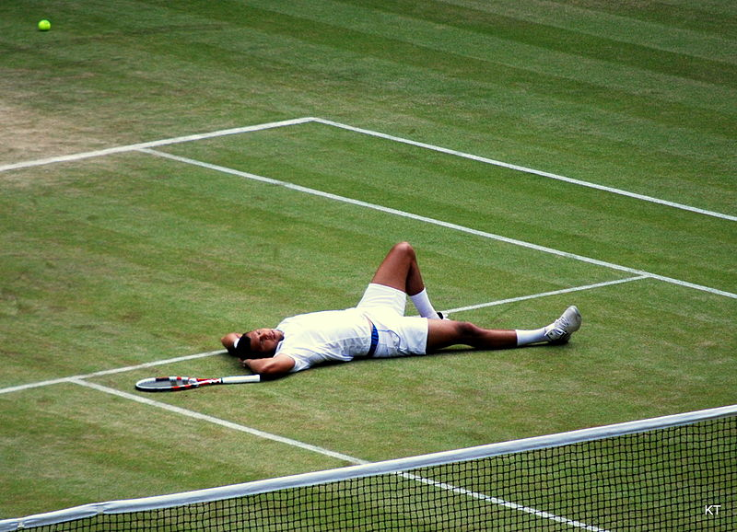

CC SA 2.0 Generic BY [Carine06 from UK](https://commons.wikimedia.org/wiki/File:Flickr_-_Carine06_-_%22I_give_up.%22.jpg)



CC 2.0 BY [Zabara Alexander](https://www.flickr.com/photos/zabara_tango/6955720271)



[CC0](https://commons.wikimedia.org/wiki/File:US_Army_53525_Soldiers_compete_in_Tae_Kwon_Do_tournament_for_Warrior_Country_level.jpg)

### **Interpersonal Conflict Resolution**

The following diagram shows a process that can be followed when trying to resolve interpersonal conflict.

### Listening

A considerable proportion of our communication involves listening, yet little attention is devoted to improving listening. HURIER is an acronym for tips that can be used to improve listening.

### “I” Phrases for Conflict Resolution

The “I” phrase is used during conflict resolutions to avoid attacking others. Open the conversation with a statement in first person, passive voice: “I feel … when … because … I would like …”

Adapted from (Dwyer 2012, p. 40)

## **Student Name and ID:** Thomas Kurkowski S0287944

## **Student Name and ID:** Kathryn Linderberg S12194396

## **Scenario**

Find a partner. Read the scenario below. Choose one partner to be Joe Bloggs, and the other to be Jane Doe. Together, answer the following to help prepare you for the role play.

## **Scenario: Joe did not complete a task by the deadline**

Joe and Jane are working on a report that is due today. Joe was assigned the task of writing the executive summary. Unfortunately, Joe has not completed the task.

What is the most appropriate conflict management strategy for Jane to use in this situation? (Choose one)

Compete/Force

Compromise

Avoid/Withdraw

Collaborate/Confront

Accommodate/Smooth

Why did you choose the above conflict management strategy?

I chose to accommodate because it would allow Jane to work out why the work wasn’t completed and come to an alternative arrangement that would better suite Joe.

### **Listen and Understand**

How could Jane start the conversation?

Ask if the task has been completed. He will reply no. She will reply why not? She may prompt him for an explanation or an excuse.

Describe the purpose of the discussion. Describe the conflict. What questions could Jane ask to determine Joe’s perspective of the situation?

The purpose of the discussion is to work out why the executive summary has not been completed. The conflict is that the executive summary was not completed when it was supposed to be done. Jane should ask if there were extenuating circumnstances or difficulties, ask if he knew what he was obligated to do, and see if there is anything she could do to help.

Write sentences that features the “I” phrase, such as in the example below:

“I feel *[your feeling]* when *[their behaviour]* because *[effects on you]*. I would like *[alternative behaviour]*”.

I feel frustrated when you do not complete your work on time because it will make me complete my work late as well. I would prefer it if you would tell me in advance if you don’t believe it will be completed on time.

Invent a reason why Joe did not complete the executive summary by the deadline.

I did not know how to read table 10.4 in the results section of the report. I believe this is critical in understanding the results of our analysis. I therefore could did not feel comfortable completing the executive summary.

How could Jane paraphrase Joe’s reason for missing the deadline to ensure that she understands Joe’s perspective?

Joe’s main issue is that he did not understand the table. He possibly did not feel like he could talk to other members of the team or how to work it out on his own.

### **Empathise**

Now that Jane understands Joe’s perspective, how could Jane empathise with Joe? Write a response that shows that Jane identifies with Joe’s emotions.

“I understand that reading the tables can be difficult. Remember, we are a team. We need to feel comfortable talking to one another, even through our weaknesses. If you needed to talk to one of us, we are available.” – Jane believes that Joe may be uncomfortable with talking to others or may be shy about his shortcoming.

### **Apologise**

Include an apology if it is appropriate.

Not appropriate.

### **Offer Solution**

What question could Jane ask to help build Joe’s involvement with potential solutions?

What do you need?

What is it that you do not understand?

Come up with a way for Jane and Joe to settle on a solution.

* Face-to-face meeting
* Individual workshop
* Talk about it over lunch
* Zoom him meetings
* Give them notes/textbook chapters.

### **Resolution**

How could Jane resolve the conflict? Jane needs to ensure that Joe agrees. Write a response that outlines appreciation for the solution.

For a compromise solution, you could allocate time or resources to help him understand the problem so that they could complete the activity by themselves. Joe’s participation is his contract. This understanding should be confirmed verbally. Jane would be happy because the work will be done by Joe. Joe is happy because time is allocated to help with him with his issues and is still able to show that he is a member of the team.

### **Reconciliation**

How could Joe reconcile the relationship and let Jane know that she is important to him?

Joe would reconcile with Jane by completing the work now that he has had his issues resolved in a prompt and timely manner. After he does this, it might be a good idea to do a team break-up party, on the assumption that the executive summary is the last thing to be written.

How can Jane let Joe know she is listening while Joe is talking?

Eye contact, non-verbal cues, chin stroke, note-taking.

What could Jane do if Joe started to withdraw from the conflict at any stage?

Cause of withdrawal:

1. Discomfort – “Would you prefer to speak to someone else?”
2. Lack of understanding post-explanation – Try explaining at a lower level or shift the duty to another member of the team.
3. Shyness – try to talk one-on-one.
4. Intimidation – ask a third party to mediate who is out of line.