SmartCare v0.3 - Domain Model Workbook
Week 6 student resource

Requirement-to-Concept Trace
Requirement | Concept | State/behaviour | Decision
FR-04, FR-08 | Patient | State: patient information or patient record.  Behaviour: basic validation of patient information | Accept as class
FR-04, FR-07 | Practitioner | State: practitioner information, availability.  Behaviour: provide/check availability | Accept as class
FR-01, FR-02, FR-03, FR-04, FR-05, FR-06, FR-09 | Appointment | State: appointment details, time, status, history. Behaviour: create, reschedule, cancel, change status, check duplicate bookings | Accept as class
FR-09 | Appointment Status | State: status of an appointment | Reject as class, make it an attribute or state of Appointment
FR-06 | Appointment History | State: previous appointment information | Reject as class, make it a part of Appointment
FR-07 | Practitioner Availability | State: whether a practitioner is available | Reject as class, make it apart of Practitioner
FR-04, FR-08 | Patient Record | State: patient information | Reject as class, represented by Patient

CRC Cards

Patient
Responsibilities | Collaborators
Store patient information | Appointment
Provide patient record information | Appointment
Validate basic patient information | Appointment

Practitioner
Responsibilities | Collaborators
Store practitioner information | Appointment
Provide practitioner availability | Appointment
Relate to appointments | Appointment

Appointment
Responsibilities | Collaborators
Create/book appointment | Patient, Practitioner
Store appointment details | Patient, Practitioner
Connect patient and practitioner | Patient, Practitioner
Maintain appointment time and status | Patient, Practitioner
Reschedule and cancel appointments | Patient, Practitioner
Maintain appointment history | Patient, Practitioner
Support duplicate booking check | Patient, Practitioner

Optional class
Responsibilities | Collaborators

UML Class Diagram
Insert/draw UML here. Include defensible relationships and multiplicities.
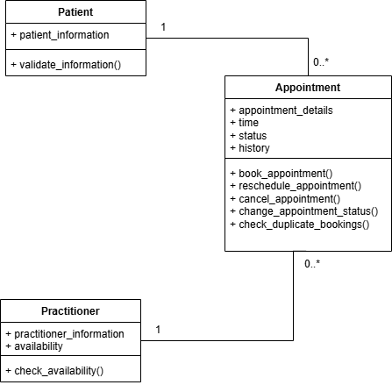

Design Rationale
Explain class selection, responsibility allocation and key relationships.
The domain model will use Patient, Practitioner and Appointment because these are the main concepts consistently supported by the SmartCare requirements. The Patient class represents the patient information and records, Practitioner class represents the practitioner information and availability, and Appointment class represents the booking itself, containing its details like time, status and history. The Responsibilities were allocated to the class that owns the relevant state and behaviour, such as appointment rescheduling cancellation belong to Appointment, while availability goes with Practitioner/ Patient and Practitioner are both linked with Appointment because each appointment involves one patient and one practitioner. A patient and practitioner could have zero or many appointments, so it makes sense the multiplicity is 1 to 0…*. No additional classes right now since the requirements haven’t provided enough evidence.

AI Design Review Record
AI suggestion | Evidence | Decision | Reason | Model change
Patient, Practitioner and Appointment should be classes | FR-01, FR-04, FR-07, FR-08 | Accept | These are supported by the confirmed requirements | None
AppointmentStatus should be a separate class | FR-09, US-04 | Modify | Status is required but it isn’t enough evidence to be its own class | Keep status but as an attribute in Appointment
Add NotificationManager | Mentioned in the Scope table | Reject | Reminders are not confirmed requirements | None

