Notes recherche détection mouvement avec python et caméra :

Bigger picture:

<https://www.kdnuggets.com/2022/08/perform-motion-detection-python.html>

Example of code and explanation: simple

<https://medium.com/@gowtham180502/motion-detection-and-tracking-using-opencv-python-ea75ef927e72>

<https://pyimagesearch.com/2015/05/25/basic-motion-detection-and-tracking-with-python-and-opencv/>

youtube to see what can be done: simple

<https://www.youtube.com/watch?v=731tP7t1BOc>

other detection : usable

<https://www.youtube.com/watch?v=gsktsIc4Fjs>

these will be good ref:

<https://www.youtube.com/watch?v=pG4sUNDOZFg>

<https://www.youtube.com/watch?v=9iEPzbG-xLE&list=PLMoSUbG1Q_r8jFS04rot-3NzidnV54Z2q>

<https://www.youtube.com/watch?v=7wsY6Roehe0>

[https://www.youtube.com/watch?v=7KV5489rL3chttps://www.youtube.com/watch?v=7KV5489rL3c](https://www.youtube.com/watch?v=7KV5489rL3c)

other cool :

<https://www.youtube.com/watch?v=JPCIg0IIgpQ>

<https://www.youtube.com/watch?v=J2bv6BGSIXk&list=PLBg7GSvtrU2OaYp2F-FqqZk0RUB4IUvvb>

<https://www.youtube.com/watch?v=_cueQFM_AzY>

<https://www.youtube.com/watch?v=h8Di-NDkCGs>

How to download stuff for pycharm :

First setup new project

Then python interpreter:

Then add

You will need these:



Then you go in terminal

And write lines :

pip install opencv-python

And

Pip install mediapipe (python 3.8-3.11 not 3.12)

To choose python 3.11 it must be installed before creating project

Super Super interesting (this dude is doing our project)

[AI Pose Estimation with Python and MediaPipe | Plus AI Gym Tracker Project (youtube.com)](https://www.youtube.com/watch?v=06TE_U21FK4)

[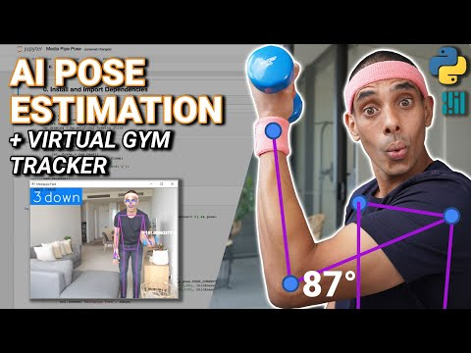](https://www.youtube.com/watch?v=06TE_U21FK4)

