Test 1 Sample 1: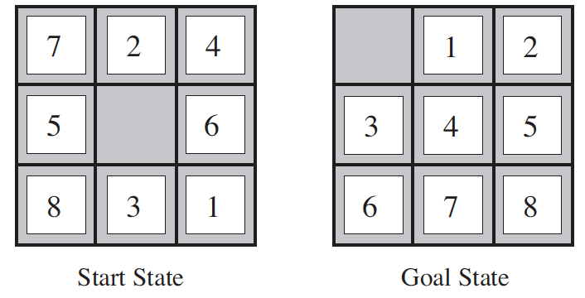

1. Manhattan distance: the sum of the distances of the tiles from their goal positions. h2 for the start state = 3 + 1 + 2 + 2+ 2 + 3+ 3 + 2 = 18. The distance we count is the sum of the horizontal and vertical distances, because tiles cannot move along diagonals.
2. Uniform Cost Search: priority queue is D7, B10, E45, F55, G65 → the UCS algorithm will choose D7. For GreedyBestFirst Seach we do not know the end state so we can not do it; we need a heuristic funciton and goal state._________________________________________________________
3. 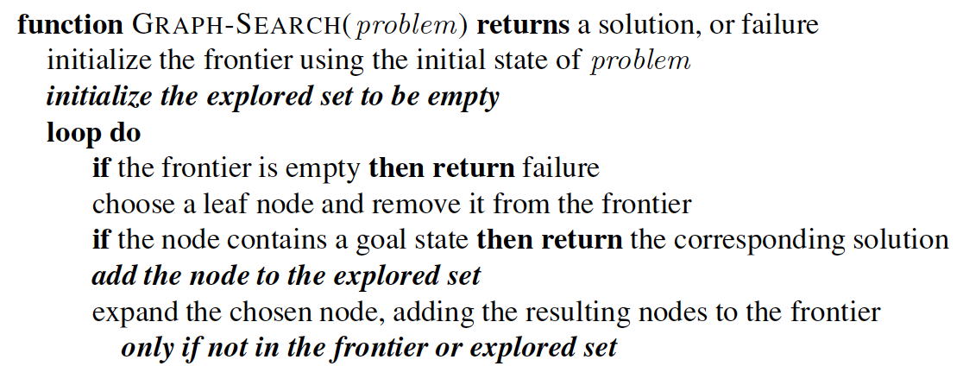

**For above: LINE2: CHANGE “FRONTIER” TO “STACK”; LINE6: CHANGE “CHOOSE A LEAF NODE AND REMOVE IT FROM FRONTIER” → TO “POP THE STACK”; LINE9: CHANGE “ADD THE RESULTING NODES IN FRONTIER” → TO “PUSH THE NODES TO THE STACK”**

1. O(BD)→ O(BreadthDepth )→ Breadth is the number of branching nodes from root node; Depth is the level of the tree.
2. Graph Search Algorithm has an explored set. Tree Search Algorithm does NOT have an explored set. Tree search may go into an endless loop if used on a graph.
3. 6.1 → 23= 8 world states

6.2 → initial state = could be any state; arbitrary based on given state

6.3 → left, right, or suck

6.4 → The actions have expected effects, except that moving Left in leftmost square, moving Right in rightmost square and sucking in a clean square have no effect

6.5 → Check whether all the squares are clean

6.6 → For the vacuum problem each step costs 1… so each path costs is the number of steps in the path.

7. **Agent** is anything that can be viewed as perceiving the **environment** through **sensors** and acting upon the environment through **actuators**.

**Rational Agent**: For each possible percept sequence, a rational agent should select an action that is expected to **maximize its performance measure**, given the **evidence provided by the percept sequence** and whatever built-in **knowledge the agent has**.

8. Worry more about data and less picky about algorithms. Want quality data.

9. Back Propagation Algorithm

10. STUDY THIS →

Test 1 Sample 2:

1. The performance of heuristic search algorithms depends on __**QUALITY**__.
2. Uniform Cost search uses ONLY G(n). A* search uses G(n)+H(n).
3. Greedy Best First search uses ONLY H(n).
4. No time complexity on slides!
5. Possible actions in a given random state are: if in corner:: move up/down OR left/right; if an edge:: move left/right/up/down depending on position; if in middle can move left/right/up/down
6. In touring problem state keeps track of previous cities(states/nodes) visited. In route finding problem state only holds current location.
7. Frontier is the expanded set of next possible states. A leaf node is a node with no children. A leaf is part of the frontier, but the frontier is not a leaf.
8. **AGENT FUNCTION** - describes agent’s behavior by mapping any given percept sequence to an action. To describe any given agent, we have to tabulate the agent function - and this will typically be a very large table (potentially infinitely large table). We can, in principle, construct this table by trying out all possible percept sequences and recording which actions the agent does in response. This table is **external characterization** of the agent. Agent function is abstract mathematical description. 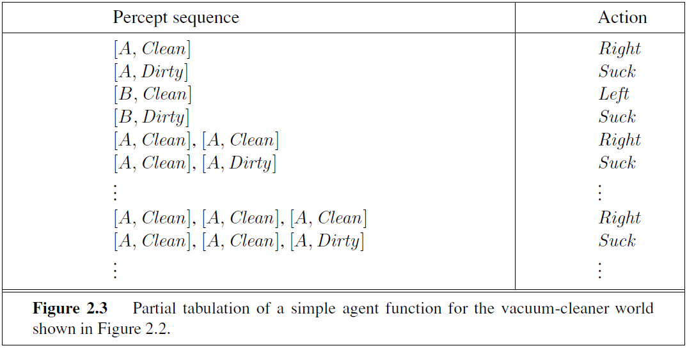

**AGENT PROGRAM** - is an internal implementation of the agent function for an artificial agent. It is a **concrete implementation**, running within some physical system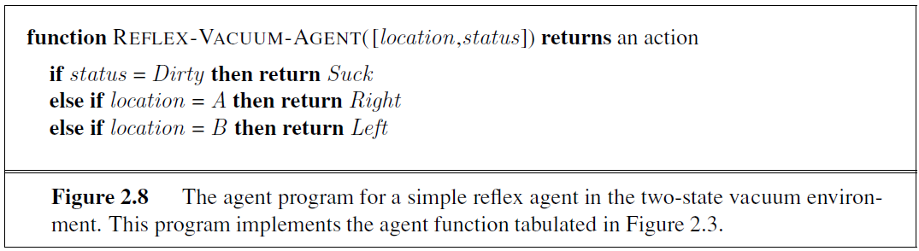

1. Look at

Test 1 Sample 3:

1. To update Breadth First Search code to make it Uniform Cost Search → Change the FIFO queue of BreadthFirstSearch to a priority queue for UniformCostSearch. Also, BFS is recursive and UCS is not recursive.
2. G(n) is the path cost.
3. BreadthFirstSearch uses FIFO queue. DepthFirstSearch uses LIFO stack. UniformCostSearch uses priority queue (go to next node with lowest path cost).
4. *Initialize the explored set to be empty*

*\*\*Add the node to the explored set\*\**

*Only if not in the frontier or explored set*

1. Performance; Environment; Actuators; Sensors
2. 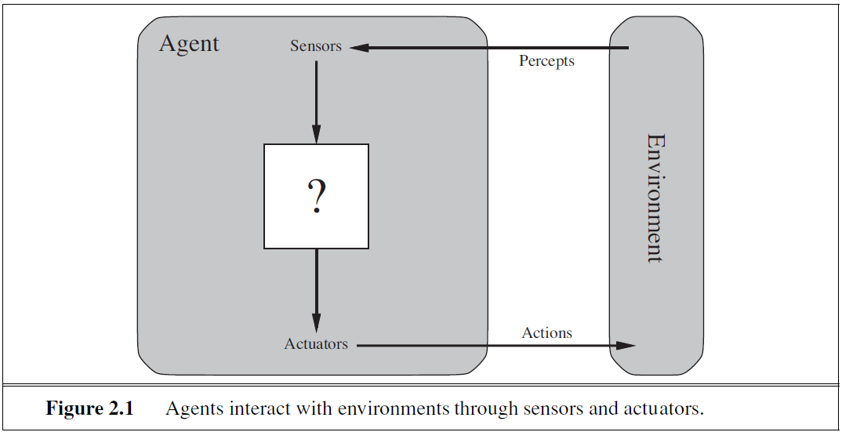
3. **Turing Test:** The program is to have a conversation (via online typed messages) with an interrogator for five minutes. The interrogator has to guess if the conversation is with a program or a person. The program passes the test if it fools the interrogator 30% of the time.
4. Acting Humanly (bottom left); Thinking Humanly (top left); Thinking Rationally (top right); Acting Rationally (bottom right). Acting is BOTTOM row; Thinking is TOP row; HUMANLY is left; RATIONALLY is right.