1. Four main approaches to AI: acting humanely, thinking humanely, thinking rationally, and acting rationally.
2. Thinking humanly models the human thinking process; thinking humanely is observed through introspection, psychological experiments, and brain imaging. Thinking rationally is modelling thinking after a rational process. Humans do not think rationally all the time.
3. Acting humanely is acting like a person. Acting rationally is performing actions that increase the state or agent of the environment. A machine acting humanely could pass the Turing test, which would make another human think that a machine is acting humanely.
4. The turing test is a program that has a conversation (via online typed messages) with an interrogator for five minutes. The interrogator has to guess if the conversation is with a program or a person. The program passed the test if it fools the interrogator 30% of the time.
5. The Turing Test was designed by Alan Turing in 1950 to provide a satisfactory operational definition of intelligence.
6. The Loebner prize competition is the longest running Turing test like competition. It has been held since 1991.
7. The turing test deliberately avoids physical interaction between the interrogator and the computer. However, the total turing test includes a video signal so that the interrogator can test the subjects perceptual abilities, and the opportunity for the interrogator to pass physical objects through the hatch.
8. The three ways to understand how humans think are: introspection (writing our own thoughts down as they come), psychological experiments (observing a person in action), and brain imaging (observing the brain in action).
9. The cognitive modelling approach to AI brings together computer models from AI and experimental techniques from psychology to construct precise and testable theories of human mind.
10. An example of a syllogism: Major premise: all cars have wheels; minor premise: I drive a car; conclusion: my car has wheels.
11. By **1965**, programs existed that could, in principle, solve any solvable problem described in logical notation.
12. 1. More general than the ‘laws of thought’ approach because correct inference is just one of several possible mechanisms for achieving rationality. 2. It is more amenable to scientific development than are approaches based on human behavior or human thought.
13. Electroencephalograph (EEG) and functional magnetic resonance imaging (fmri) measure brain activity.
14. The average human brain has about 1011 neurons or 100 million neurons.
15. R1 was the first successful commercial expert system. It used a Match system to problem solve. For DEC R1 noticed what components were missing from an order needed for system functionality, and add those missing parts to the order.
16. Some of the founders of AI believe that AI should return to its roots of striving for “machines that think, that learn and that create.” This effort is known as **human-level AI** or HLAI, and it requires very large knowledge bases. They believe AI should get away from focusing on domain specific tasks such as self driving cars.
17. Artificial General Intelligence - AGI looks for a universal algorithm for learning and acting in any environment. AGI is a subfield of artificial intelligence.
18. The problem of filling holes in a photograph is a success story based on the availability of large data sets.
19. I would like to focus my career on data! But in general the focus will be partially determined by the problem. If there is not large datasets for the problem I am trying to solve, then I will focus on algorithms. There are different approaches to AI with different goals in mind.
20. Examples of state of the art AI in various fields are: robotic vehicles, speech recognition, autonomous planning and scheduling, robotics, and logistics planning.
21. Agent is anything that can be viewed as perceiving the environment through sensors and acting upon the environment through actuators.
22. A rational agent is an agent “that does the right thing.” If the sequence and resulting state of the environment is better than when it began the task, the agent did the correct thing. The state of the environment is the signal that the agent is acting rationally because the agent could delude itself to thinking it did the correct thing even when it did not. For each possible percept sequence, a rational agent should select an action that is expected to maximize its performance measure, given the evidence provided by the percept sequence and whatever built-in knowledge the agent has.
23. 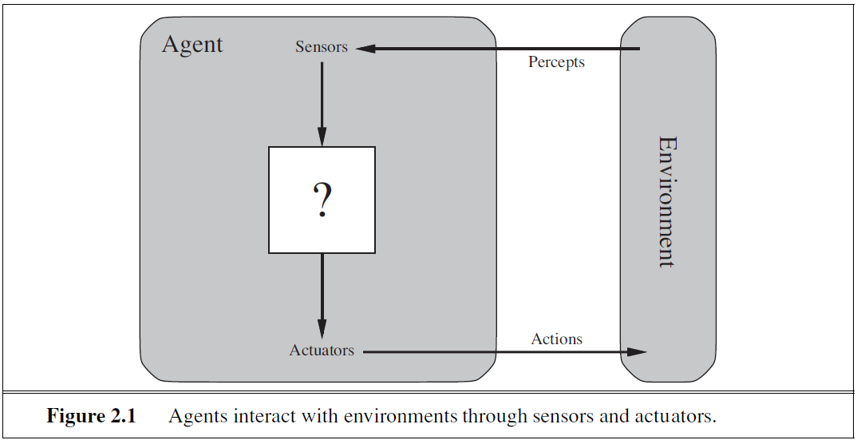
24. Percept is the agent’s perceptual input at any given instant, and percept sequence is the complete history of everything the agent has ever perceived.
25. Agent function - describes agent’s behavior by mapping any given percept sequence to an action. Agent program - is an internal implementation of the agent function for an artificial agent. Agent program is concrete implementation running within a physical system.
26. For the vacuum world problem, the agent function is either suck or move to the other square. The agent function describes the agent’s actions after the precepts of being on a clean or dirty square. The agent program is an if statement followed by two else if statements. The agent program is an implementation of the agent function.
27. What is rational at any given time depends on four things: the performance measure that defines the criterion of success; the agent’s prior knowledge of the environment; the actions that the agent can perform; the agent’s percept sequence to date.
28. Task environment is the description of Performance, Environment, Actuators, and Sensors (PEAS).
29. **For Vacuum Cleaner Agent: Performance:** ~~cleans dirt up, does not damage floor, alert human when dirt bag is full and needs to be emptied.~~ Award one point for each clean square at each time step, over a lifetime of 1000 time steps. **Prior Knowledge:** the agent knows that there are two squares but it does not know the dirt distribution **Agent Actions:** suck, move right, move left, or do nothing. **Precept Sequence:** ~~Is the square the agent is on clean or dirty? If dirty, then suck. If clean then move to the other square, and start the precept sequence over. Is the bag full?~~ Agent correctly perceives its location and whether that location contains dirt
30. PEAS for taxi driver: **Performance**: safe, affordable for customer, profitable for operator, legal. **Environment**: roads, sidewalks, pedestrians, other traffic, road signs, construction workers. **Actuators**: steering, brake, horn, display, accelerator. **Sensors**: camera, speedometer, GPS, engine sensors, keyboard, light sensors, accelerometer.