1. Consider a tic tac toe game. MAX moves first followed by MIN. The optimal solution is a series of actions leading to a goal state in a normal search problem, but we are doing an adversarial search problem because MIN interferes the series of actions of MAX. This optimal strategy can be determined from the minimax value of each node. For a reduced tic-tac-toe game, the possible moves for MAX at the root are a1, a2, & a3. MIN may respond to move a1 by MAX with b/c/d 1/2/3. MINIMAX(n) for the user MAX is the utility of being in the corresponding state. MAX will always prefer to move to a state of maximum value. The utility function for MAX is to choose the node in the next level that is MAXIMUM while the utility function for MIN tells MIN to choose the node in the next level that is MINIMUM. So for the pictured tree and for player MAX at root node A, the MINIMAX function tells MAX to choose the max value of the set {3,2,2} which is 3. MAX chooses 3 which is the minimax value for a non leaf node.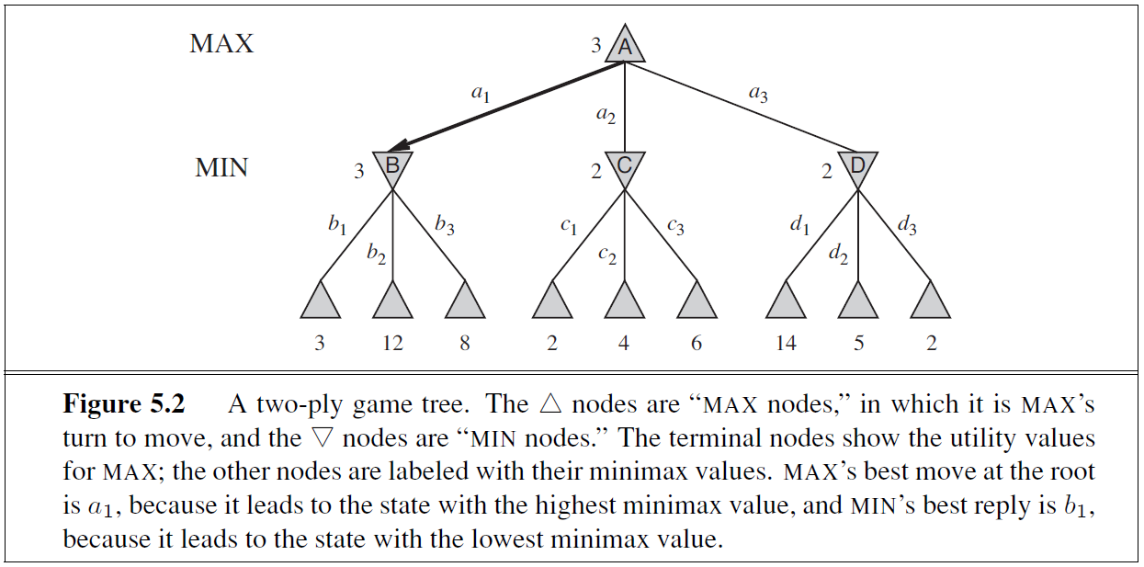
2. The utility function defines the final numeric value for a game that ends in a terminal state s for player p. The minimax function defines the numeric values at all other nodes.
3. The time complexity of the minimax algorithm is O(bm) because the minimax algorithm performs a complete depth-first exploration of the game tree. If the maximum depth of the tree is ‘m’ and there are ‘b’ legal moves at each point, time Complexity = O(bm) which is impractical.
4. Principle for pruning: Consider a node ‘n’ somewhere in the tree, such that Player has a choice of moving to that node. **If Player has a better choice ‘m’ either at the parent of node ‘n’ or at any choice point further up**, then ‘n’ will never be reached in actual play. Once we know enough about ‘n’, to reach such a conclusion, **we can prune it.** Calculate the minimax values for the non-leaf nodes in the search tree.
5. The tree to prune is on the next page. MAX is the first player. MAX wants the MAXIMUM values from levels 1, 3, and 5. MIN is the second player, and wants the MINIMUM values from levels 2 and 4. The trees outlines in RED will be pruned by the alpha beta pruning algorithm.

