Matchmaking
Purpose
To display a list cinderellas and godmothers
To display the matched cinderellas and godmother pairs at the top of the list
To clearly indicate the matched pairs.
To sort the unpaired cinderellas and godmothers, by appointment time followed by when they arrived
GUI Features
Personal Shoppers column
Cinderellas Column
Collumn Layout
The pairs are indicated by the line that they are on.
For example: A paired Cinderella or godmother if paired will have their pair listed directly across from them
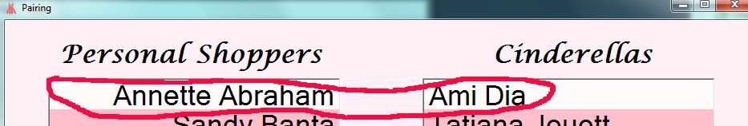
Limitations
Due to screen size only the first 24 cinderellas and godmotehrs are displayed.

