By : Thomas Pedneault

ANDROID SSH CLIENT

USER MANUAL

Table of contents

Minimum Requirements 2

Server List Activity 2

Adding a New Connection 2

Editing / Removing an Existing Connection 5

Accessing the Terminal 6

Connection States 7

Terminal Activity 7

Running Commands 7

Saving Commands 7

Running Saved Commands 7

Deleting Saved Commands 8

# Minimum Requirements

* A device running Android version 23 or greater.
* An active internet connection (must set permissions in Android).
* Server allowing SSH traffic via port 22 (custom ports not supported).

# Server List Activity

## Adding a New Connection

To add a new connection to the list, press the ‘+’ button located in the bottom right of the screen.

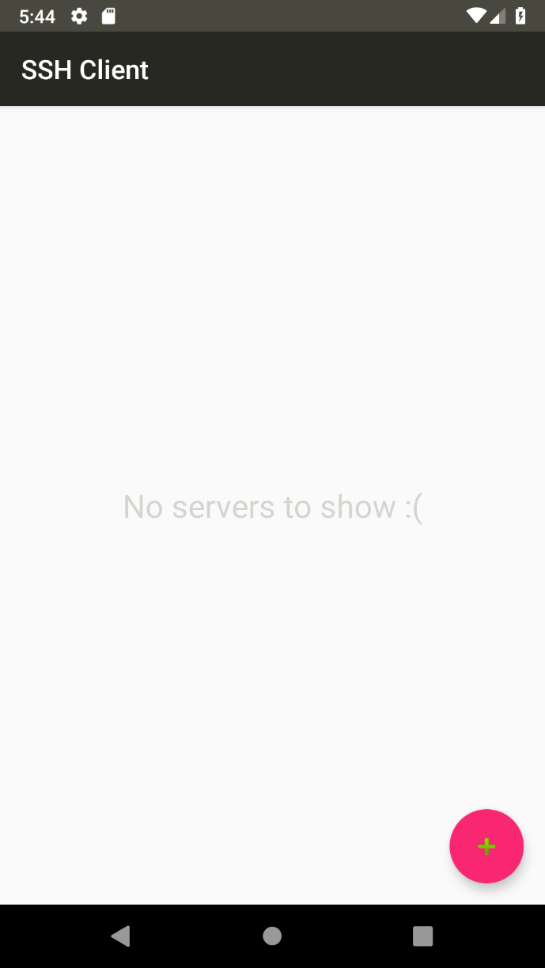

Figure . Server list without any connections

Once the button is pressed, the focus will change to a form that needs to be filled. The required information is:

Figure . Server List without connections

* Server IP: IP Address of the server to connect to.
* Server Name (Optional): Optional nickname to represent the server.
* Username: Username to log in the server. Must be a valid user on the server.
* Password: Password required to log in the server.

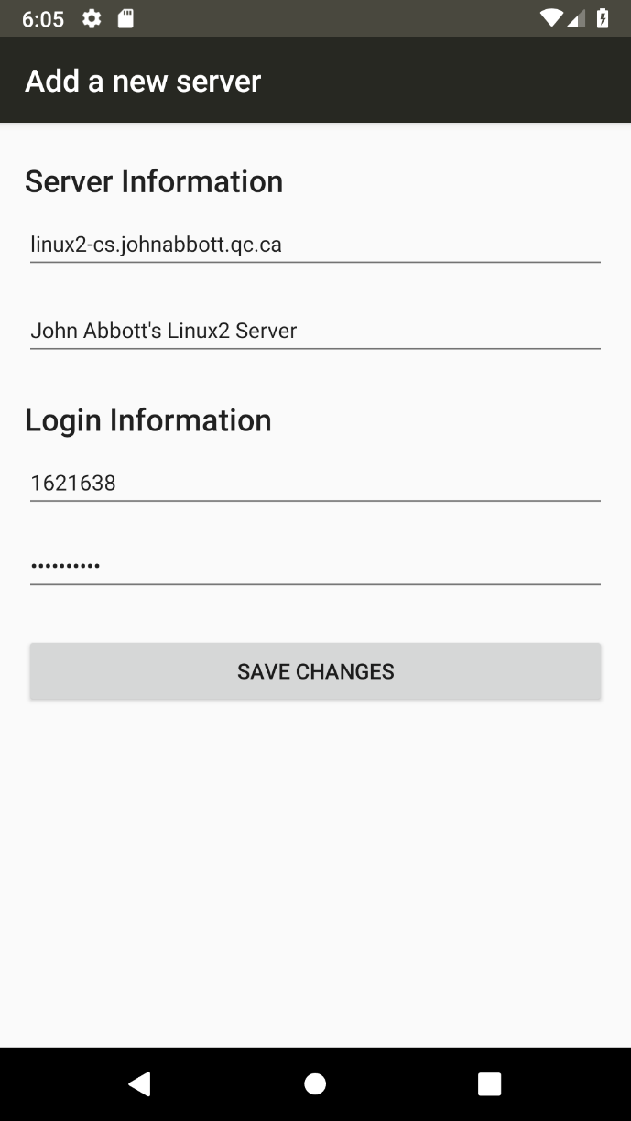

Figure 2. Adding the server’s information

Once the information has been filled out, press the ‘Save Changes’ button at the bottom of the screen. This will redirect you to the server list activity where your new connection will now be added.

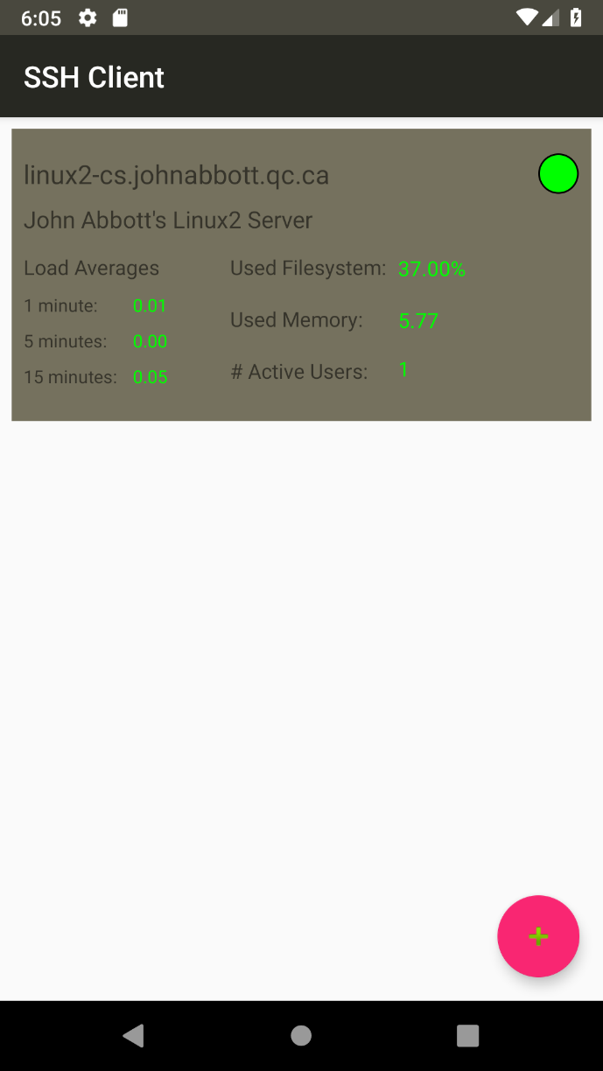If the information added in the previous step was invalid, the connection will fail and instead of viewing the server’s information, a message explaining the error will be displayed instead.

Figure 3. Server List with the newly added connection.

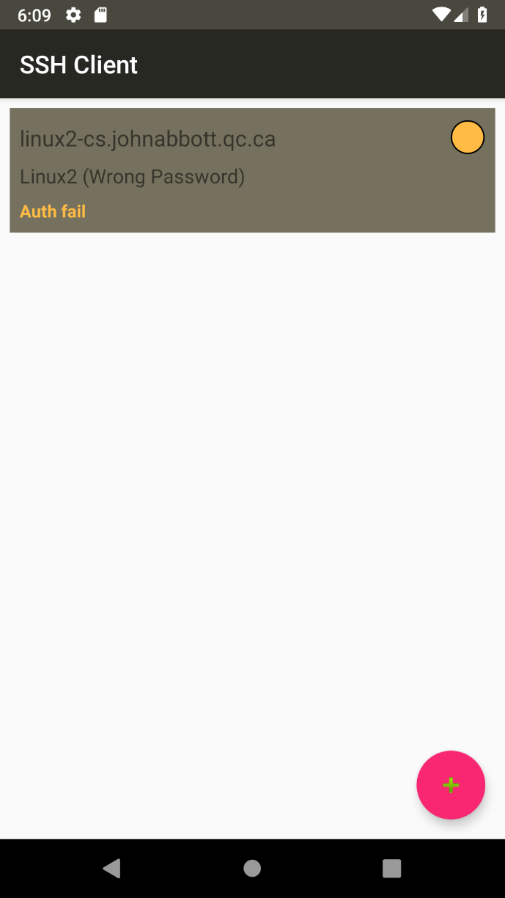

Figure 4. Failed server connection with invalid password

## Editing / Removing an Existing Connection

To modify an existing connection’s information, press down on the connection until a message pops up. The options are as follows:

* EDIT: Prompts the user to modify an existing connection’s information.
* DELETE: Removes the connection from the list.
* CANCEL: Returns to the list without making any changes.

If the EDIT option is selected, the user will be redirected to a form where the server’s information can be modified. Once the changes are made, press the ‘Save Changes’ button to save the changes and return to the list of connections. To return to the list without making changes, press the back button.

## Accessing the Terminal

Figure 5. Menu to select action to perform on the connection

To open a terminal, click once on the connection you wish to interact with. To access the terminal, the state of the connection MUST be connected (green).

## Connection States

There are 3 possible states for the connection.

1. Connected (Green Circle): The server is available, and the connection was successful.
2. Warn (Yellow Circle): The server is available, but the connection attempt failed.
3. Not Available (Red Circle): The server is not available. Either the server is not on the network, or the server is shut down.

# Terminal Activity

## Running Commands

To run a command on the server, type your command at the bottom of the screen in the ‘Enter a command’ textbox. To send the command, you can either: press the return key on the keyboard or press the ‘Send’ button next to the textbox.

## Saving Commands

For commonly used commands, you have the option to save the command to quickly access it. To do so, write the command to save in the textbox and save the ‘Save’ button next to it.

## Running Saved Commands

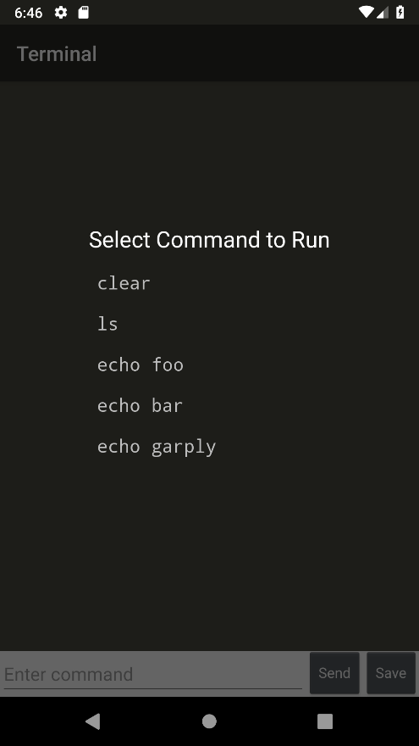To run a saved command, hold down on the command output section until a menu appears.

Click on the command to run, the menu will close, and the command will be executed. To exit the menu, click outside of the command selection menu.

## Deleting Saved Commands

To delete a saved command, open the command selection menu, and hold down on the command to delete. A popup will appear confirming if you want to delete the command. Press DELETE to remove the command or CANCEL to cancel changes.