**ShopAdmin Requirements Specification**

Version 1.0

28.11.2015

**Product Owner:** Iuliia Guk, Kateryna Pryshchepa

**Scrum Master:** Thomas Röhl

**Development Team:** Thomas Röhl, Tetiana Lavrynovych, Sascha Zepf, Iuliia Guk, Kateryna Pryshchepa, Roger Nabinger

**Stakeholder:** Thomas Röhl, Tetiana Lavrynovych, Sascha Zepf, Iuliia Guk, Kateryna Pryshchepa, Roger Nabinger

**Introduction**

The goal of this project is to create an Android Application to control expenses based on Tesseract library. This document describes the requirements for specifying required usage of ShopAdmin application.

**Use Cases**

UC-0 Create Account

UC-1 Login

UC-2 Scan Receipt

UC-3 Edit Scan Results

UC-4 Show Timeline Report

UC-5 Logout

UC-6 Verify Data

UC-7 Rescan Receipt

UC-8 Show Detailed Receipt Results

UC-9 Create Filter

UC-10 Rescan Receipt

UC-11 Save Scan Results

**UseCase Diagram**

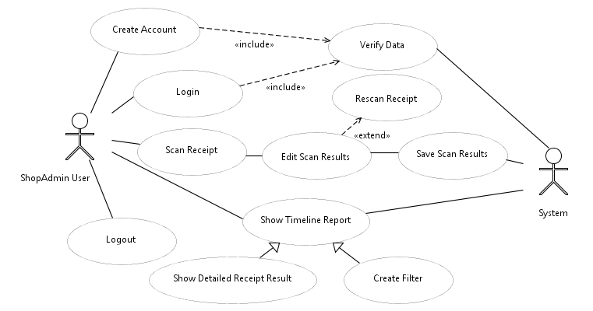

|  |  |  |
| --- | --- | --- |
| Number | 0 | |
| Name | **Create Account** | |
| Summary | User creates a new account with his desired registering data for later usage | |
| Priority | 2 | |
| Preconditions | User has installed the app on his mobile | |
| Postconditions | Account is created | |
| Primary Actor(s) | User | |
| Secondary Actor(s) | System | |
| Trigger | App is started | |
| Main Scenario | Step | Action |
|  | 1 | System shows loginscreen |
|  | 2 | Create new account is choosen by the user |
|  | 3 | User enters his desired username |
|  | 4 | Availability of the username is checked |
|  | 5 | In case of username already present on database an alternate username has to be entered |
|  | 6 | User has to enter E-Mail |
|  | 7 | User has to enter his desired password |
|  | 8 | User has to confirm the password |
|  | 9 | User has to complete registration by pressing the corresponding button |
|  | 10 | System stores account information in Database |
|  | 11 | In case of error, user has to try again |
|  | 12 | System shows main view |
| Extensions | Steps | Branching Action |
|  | 10a | System shows feedback of success |
|  | 6a | E-Mail is used for Password reset, E-Mail is not verified |
|  | 8a | No rules |
| Open Issues | Steps | Branching Action |
|  | 1 | Will the user be able to use the app locally without registration |
|  | 2 | Possibility to change account data (i.e. E-Mail) is needed? |

|  |  |  |
| --- | --- | --- |
| Number | 1 | |
| Name | **Login** | |
| Summary | User logs in with his/her registration data | |
| Priority | 3 | |
| Preconditions | User has to be registert in ShopAdmin with an user account | |
| Postcondtions | User is able to log in and see the main view | |
| Primary Actor(s) | User | |
| Secondary Actor(s) | ShopAdmin system | |
| Trigger | Correct username and password and pressing the loginbutton | |
| Main Scenario | Step | Action |
|  | 1 | System shows loginscreen |
|  | 2 | User enters username |
|  | 3 | User enters password |
|  | 4 | User clicks loginbutton |
|  | 5 | System compares userinput with registration data |
|  | 6 | If userinput is wrong, System asks for repeat userinput |
|  | 7 | System shows main view |
| Extensions | Steps | Branching Action |
|  | 5a | System shows feedback of success |
| Open Issues | Steps | Branching Action |
|  | 1 | Should the System ask, if the User want to register |
|  | 2 | Should the System send Userinformation per mail |

|  |  |  |
| --- | --- | --- |
| Number | 2 | |
| Name | **Scan Receipt** | |
| Summary | The User can scan a receipt and get results of the scanning process | |
| Priority | 5 | |
| Preconditions | User has to be logged into ShopAdmin | |
| Postcondtions | The scan results can be stored in the database | |
| Primary Actor(s) | User | |
| Secondary Actor(s) | Mobile phone camera | |
| Trigger | User clicked on scan button | |
| Main Scenario | Step | Action |
|  | 1 | System shows main view with scan button |
|  | 2 | User presses the scan button |
|  | 3 | System starts mobile phone camera |
|  | 4 | User takes a picture with mobile phone camera |
|  | 5 | System shows edit view |
| Extensions | Steps | Branching Action |
|  | 5a | User can start rescan → Step 3 |
|  | 5b | System shows main view |
| Open Issues | Steps | Branching Action |
|  | 1 | Should System ask to go back to main view? |
|  | 2 | Should System help taking a picture? |

|  |  |  |
| --- | --- | --- |
| Number | 3 | |
| Name | **Edit Scan Results** | |
| Summary | The retrieved data from the receipt is displayed and can be adjusted by the user | |
| Priority | 4 | |
| Preconditions | An image is scanned | |
| Postcondtions | User is satisfied with the data | |
| Primary Actor(s) | User | |
| Secondary Actor(s) | System | |
| Trigger | Scan results from image retrieved | |
| Main Scenario | Step | Action |
|  | 1 | Display data |
|  | 2 | Data can be adjusted in a convenient way. |
|  | 3 | User confirms data by pressing Save |
|  | 4 | Data is stored |
| Extensions | Steps | Branching Action |
|  | 2a | System shows main view |
|  | 3a | User inputs are treated as always valid. |
| Open Issues | Steps | Branching Action |
|  | 1 | Is data first stored locally? |
|  | 2 | UseCase for retrieval of group data? |
|  | 3 | UseCase for data alignment necessary? |

|  |  |  |
| --- | --- | --- |
| Number | 4 | |
| Name | **Show Timeline Report** | |
| Summary | A User can see all results in general or from a specific timeline | |
| Priority | 5 | |
| Preconditions | A User must logged to ShopAdmin | |
| Postcondtions | - | |
| Primary Actor(s) | User | |
| Secondary Actor(s) | ShopAdmin Data | |
| Trigger | click on Table on main view | |
| Main Scenario | Step | Action |
|  | 1 | show table of results with all shops names, account and total |
|  | 2 | show filters: timefilter, categoryfilter, shopfilter |
|  | 3 | chose filter and show filtered result |
| Extensions | Steps | Branching Action |
|  | 1 | buttonclick back to main view |
| Open Issues | - | |