ShopAdmin



# Management Summary

## Where are we now?

Just in time for the start of the holiday season the work on the prototype of the android app was finished. Whereas no business function was actually implemented the basic screen flow is available. Also this might not sound much the past weeks figured out that it was necessary to gain first insights in app development with android. Furthermore in the early days of ShopAdmin we faced massive problems as the common development on few technical components wasn’t suitable for the project team. To solve this impediment a major technical redesign was necessary (check out section technical details for in-depth information) what leads to a formally termination of our first sprint (see also section project management).

Nevertheless we were able to achieve our goals for Q4/2015:

* Establish the technical foundation of the app
* Align and get used to the SCRUM methodology

## Technical Status

As stated from the beginning the basic technical concept is stamped by implementing the Model-View-Controller Pattern. To achieve a comfortable working environment for everybody we established following guideline:

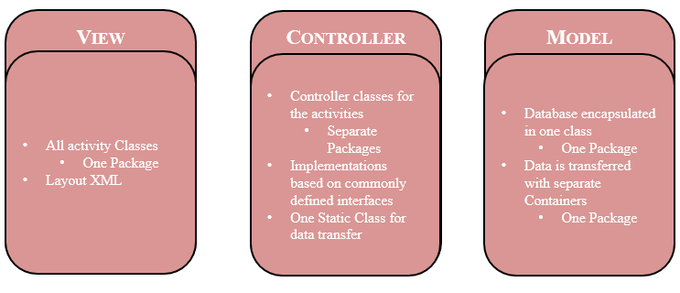

Besides that the implemented screen flow of the app is as follows:

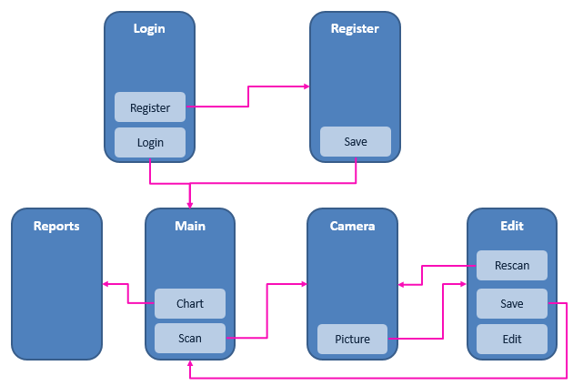

Please note that the “Camera” screen reuses the build in functionalities of the users mobile. No separate layout is defined for that.

Also an impediment in the beginning was the missing specification of an android SDK. Due to that we agreed on Android SDK 16 as leading platform for ShopAdmin during our reorganization.

## Project management Status

For the realization of ShopAdmin we agreed on using SCRUM as methodology. Key Aspect for this decision was the incremental approach which faces best to our main challenge of gathering knowledge in app development. Initially we planned following the general SCRUM approach:

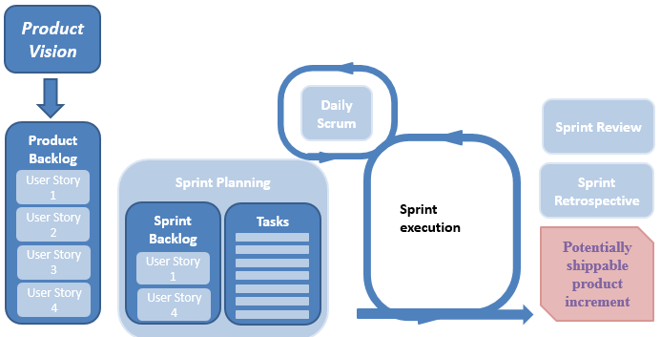

The defined characteristics of our SCRUM approach:

* Common workdays for the project are Friday and Saturday as these are the only days the team can meet personally
* Every Sprint has a duration of two weeks to achieve a remarkable number of sprints and gain maximum insights in the “inspect and adopt” principle as well as the increase of velocity to which SCRUM should lead to.
* Fridays either one of the events take place:
  + Sprint planning
  + Daily Scrum
  + Sprint Retrospective
* During lecture days the presentation of the actual project status is treated as sprint review.

Whereas the approach was performing well on transferring the product vision in the product backlog and the planning of the first sprint some problems occur in the sprint execution as we figured out that we will not be able to deliver the complete implementation of a user story in one sprint. Especially when the development of the image scanning functionality with tesseract will start. This can mainly be reduced to the fact that there is roughly only a 3PT contribution of every individual to a sprint. To solve this problem we transform the defined user stories into smaller pieced user stories cramped by epics representing the original user story. (See section requirements for further details)

Therefore unfortunately it was necessary to terminate the first sprint formally. As the full transformation of the product backlog items still is in progress intermediate user stories pointing to the desired deliverable where formulated and the existing sprint in our SCRUM tool was reused.   
Also due to the fact that the transformation is not yet completed the existing sprint will be extended over the holiday season and the new sprint will start on 9th of January.

# Timeline

## What has happened till now?

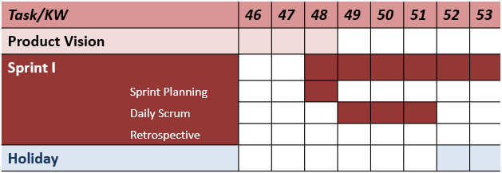

## Forecast 2016

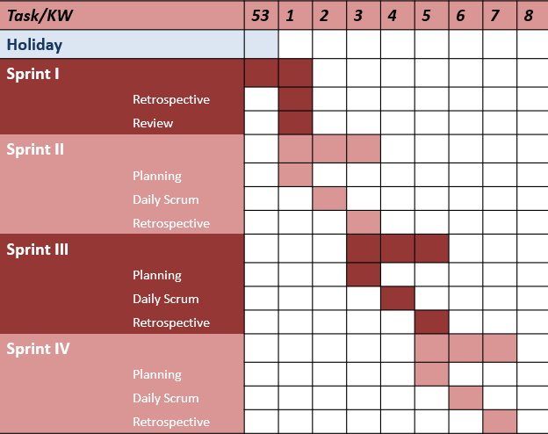

# Requirements Overview

As briefly mentioned in the above sections within our SCRUM approach we had to transform the representation of our initial user stories to let them fit into our approach. Nevertheless our basic requirements, which have been presented in the last report, are still valid and are just briefly recaptured here:

|  |  |  |  |
| --- | --- | --- | --- |
| **Requirement** | **Description/User story** | **Acceptance criteria** | **UseCase available** |
| Create Account | As a User I want to register a new account to use the full functionality provided by ShopAdmin | * Persistent * Password * Username * Feedback of successful account creation | Yes |
| Login | As a user I want to login into my existing account. | * One Session * Username and password fit with registration * Feedback of successful login | Yes |
| Scan Receipt | As a user I want to scan my recent receipt to store the data. | * Picture with mobile camera * Show the retrieved results | Yes |
| Edit Scan Results | As a user I want to be able to alter the scanned receipt data before save. | * Ability to change the scanned data | Yes |
| Show (timeline) report | As a user I want to see my receipt data driven by different reports as i.e. all results from a specific timeline(purchase history) | * Show table of results * Table contents only receipt information of the given timeline | Yes |
| Logout | As a user I want to be able to push a logout button | * Button available * Login after Logout necessary |  |
| Verify Data | As a user I want that my given account data is properly verified with my registered account. | * Successful account creation * Successful login |  |
| Rescan Receipt | As a user I want to be able to rescan a receipt to fix bad quality pictures | * Button to rescan instead of only being able to edit wrong data * Old picture and old data are not taken into account anymore |  |
| Show detailed receipt results | As a user I want to see the detailed receipt result of one scan | * Out of compressed table results single results must be accessible |  |
| Create Filter | As a user I want to define specific filters to the presented table overviews | * Ability to define certain filters |  |
| Save Scan Results | As a user I want to be able to save the taken picture with the recognized results | * Ability to review results * Save results in database * Feedback of successful save |  |

The transformation of the original user story towards one epic consisting of multiple user stories is demonstrated in the following diagram:

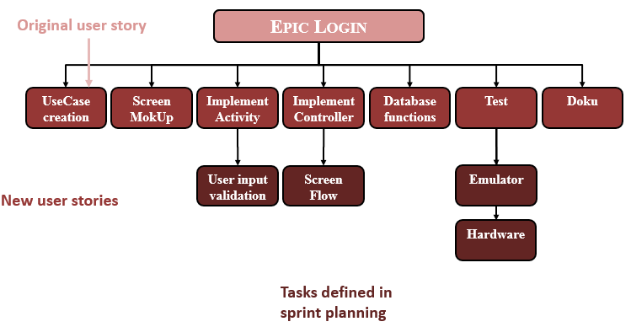

This new structure of the product backlog grants the necessary flexibility for the project. As new functionalities can be added as epics to the project and out of this epics manageable user stories can be chosen to be completely implemented in one sprint.

# Structure of the artifacts

Within this section a short overview used tools and their structure should be given.

* **GitHub**  
  Two repositories are used by the project to share the developments. Both are private.
  + Repository *ShopAdmin*  
    Contains Dokumentations, Reports, MokUps, etc.
    - Relevant folders of repository
      * Dokumentation
        + Various general documents i.e. steady growing Powerpoint
      * MokUp
        + Screen MokUps an Pigs
      * Reports
        + Report 1

First deliverable use cases and UML-diagram

* + - * + Report 2

This report

* + Repository *ShopAdminAndroid*

The app to be used with the development platform AndroidStudio

* **GoogleGroup ShopAdmin**  
  Mailing list for communication
* **ScrumDesk**  
  WebBased tool to drive the scrum process.