Beginning:

Nowadays, twitter is an indispensable tool in the daily life of popular politicians. For this reason, we used the latest methods of natural language processing to extract information from tweets by members of the Bundestag in order to draw conclusions about their character and the party they belong to. In the following video we describe our approach and the results we obtained.

Collecting the data from twitter:

After some research we found a file containing all twitter account names for members of the German Bundestag with their respective party. This file had some formatting errors which we had to clean up before using it.

For downloading the required data from twitter we decided to use the opensource framework selenium in combination with google chrome as web browser. This setup allowed us to download as many tweets as we wanted with all of the metadata visible on Twitter.

(Selenium part_2): Because the twitter page is not loaded all at once but continuously as you scroll down, we had to imitate a real user scrolling down the page. For implementing this, we used selenium to scroll to the end of the current view and wait a certain amount of time for the page to load new content. To find the ideal time to wait we had to assess the trade-off between increasing the runtime and the risk of losing some tweets because they weren’t loaded in that short amount of time. We still noticed that we didn’t get all of the tweets in the first run so we decided to do another run in a different network and combine the results.

(Selenium Part 3): Here you can see our setup in action while it is scrolling down the page and saving the data.

(Evaluation of the database): Here is an overview of the two runs which shows doing a second run increased the total number of tweets by 5%. Because this value is so low, we assume that we got nearly all the data.

(All_Tweets_3): For every politician we created an own CSV-file containing the username, post date, text of the tweet, the number of replies, retweets and likes. From these files we created several numpy arrays for training and testing, in which we deleted all retweets to guarantee that all texts were written by the politician.

(Parties): In our first step we wanted to train a model to detect which political party the sender of the tweet belongs to. The model therefore has to process the text of a tweet and predict to which of the following seven parties the tweet belongs to: ['CDU', 'LINKE', 'FDP', 'GRÜNE','SPD', 'CSU', 'AFD'] .

(Keras_Tuner_Confusion): To tune the hyperparameters for our model we decided to use the keras tuner. The result we got was 16500 neurons for the hidden layer and a learning rate of 0.001. We then used these hyperparameters to fully train a model, which reached an accuracy of about 55%. This is quite a high value considering the relatively small differences between certain parties. To visualize the difficulties the model had with classifying the tweets, we used it to predict the party for every tweet in our test dataset. Out of these results we created the following confusion matrix. It shows that the model has the highest accuracy for identifying tweets belonging to the AfD party. Tweets from the party “Bündnis/90 die Grünen” however seem harder to classify as the model confuses a relatively large percentage with the SPD and LINKE. It also shows that the model is biased against the CSU which we already expected since there are way less tweets from the CSU in our dataset than from the other parties.

(LKR_Explenation_Big5_start): We were also curious how our model would respond to tweets by members of the LKR party which it had never seen before. The result is very interesting as the model can’t clearly decide to which party the LKR-tweets belong to. Looking up which political orientation the LKR has, we found out that it characterizes itself as a party of the center which matches the prediction of our model.

(Big5_Beginning): In the next part of our project we wanted to use our dataset to analyse the Big5 personality traits of the politicians and examine the differences. We were also interested in whether there is a noticeable difference between the parties.

(Big5_Explanation): We decided to train a model using a data set containing English essays with their big5 personality trait scores because we couldn’t find any German dataset containing psychological data about texts. To carry out the big5analysis on our German tweets we therefore had to translate them into English. Since these translated texts could contain less information, we had to check if the big5 analysis is even possible on machine translated text. For this purpose we needed some sort of bi-directional translation between German and English. The first thing we thought of was training the transformer model we discussed during the meetings on translated TED talk transcripts.

(Tokenizer): To use this model, we had to create our own tokenizer for German words since the TensorFlow tutorial only provided a Portuguese and English tokenizer. We modified the code from the tutorial to work for our dataset and save the tokenizer for later use.

(Translation_results): The translation model itself is a transformer model using multi-head attention as its core principle. After training the model for one day we got the following results for our test sentences. As you can see the model did improve slightly over time but we didn’t have strong enough hardware available to train it to a usable degree. Considering that a good translation is the foundation for the rest of our project, we decided to use google translate for translating purposes instead.

(Google_translate): As our database contains over 250000 tweets and google translate only supports translating files up to 10MB this turned out to be very time consuming. We had to split the data into 15 files with nearly 10MB and translate them one by one. During this process, we noticed that we were only able to translate .docx files even though google translate claims to support .txt files up to 10MB. During our attempts, our network got blocked by google so we had to use TOR to continue our translations. We also considered using deepl but the limited access made it impractical for our use case.

(Big5_Results): For carrying out the big5 analysis we tried BERT models with different sizes from tensorflow-hub and trained them for 30 epochs each. As expected, the largest model we could run on our hardware performed the best. It has 8 hidden layers, a hidden size of 512 and 8 attention heads. We used this model for two different approaches. In the first one we trained it on the original essays dataset and in the second one we used the retranslated essays dataset which we translated with google translate to check if the big5 analysis is even possible on machine translated text. We tracked our training process with tensorboard which shows that both models stopped improving their validation accuracy after 7 epochs.

Tensorflow_graphic: For comparing these two models, we tested both of them with the test datasets from the original essays dataset and the retranslated one. The following table contains our results:

|  |  |  |
| --- | --- | --- |
|  | **Train Original** | **Train Retranslated** |
| **Test Original** | 0.827 | 0.688 |
| **Test Retranslated** | 0.749 | 0.868 |

Against our expectations, retranslating the texts improved the accuracy the model could reach. One explanation could be that translating the texts reduced the complexity of the language making it easier to understand for our model.

(Saving_The_results:) Considering these results we decided to use the model trained on the retranslated data to carry out the big5 personality traits analysis. Because predicting the output of all tweets took more than one hour we decided to save the results to reuse and analyse them later.

(Discussion of the results)

In the first analysis step we calculated the arithmetic mean of the score of each big5 category for each party which can be seen here:

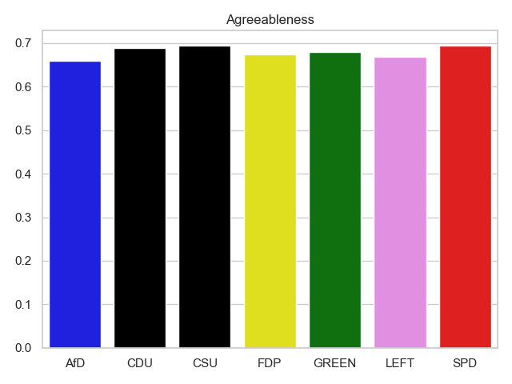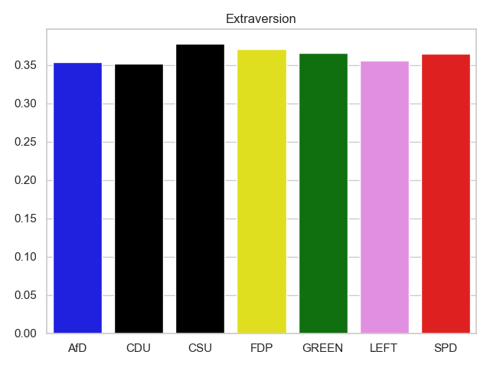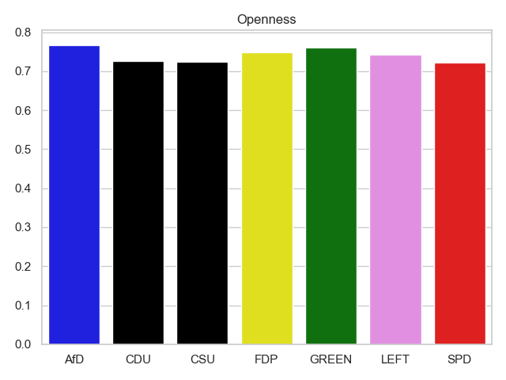

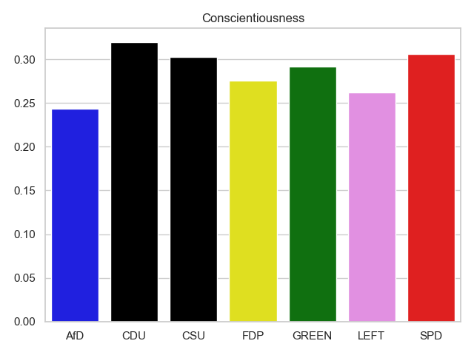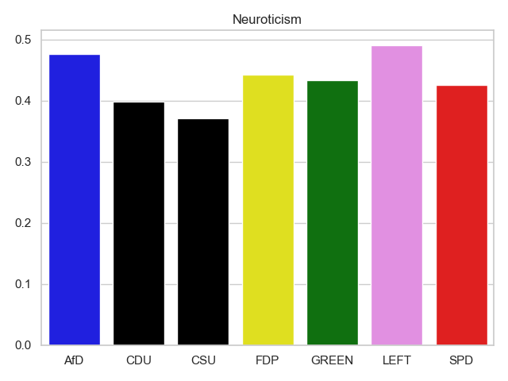

(Description_of_the_boxplot):

To test whether these differences between the mean values are significant, we created the following boxplot for visualizing the statistical variance for one of the categories:

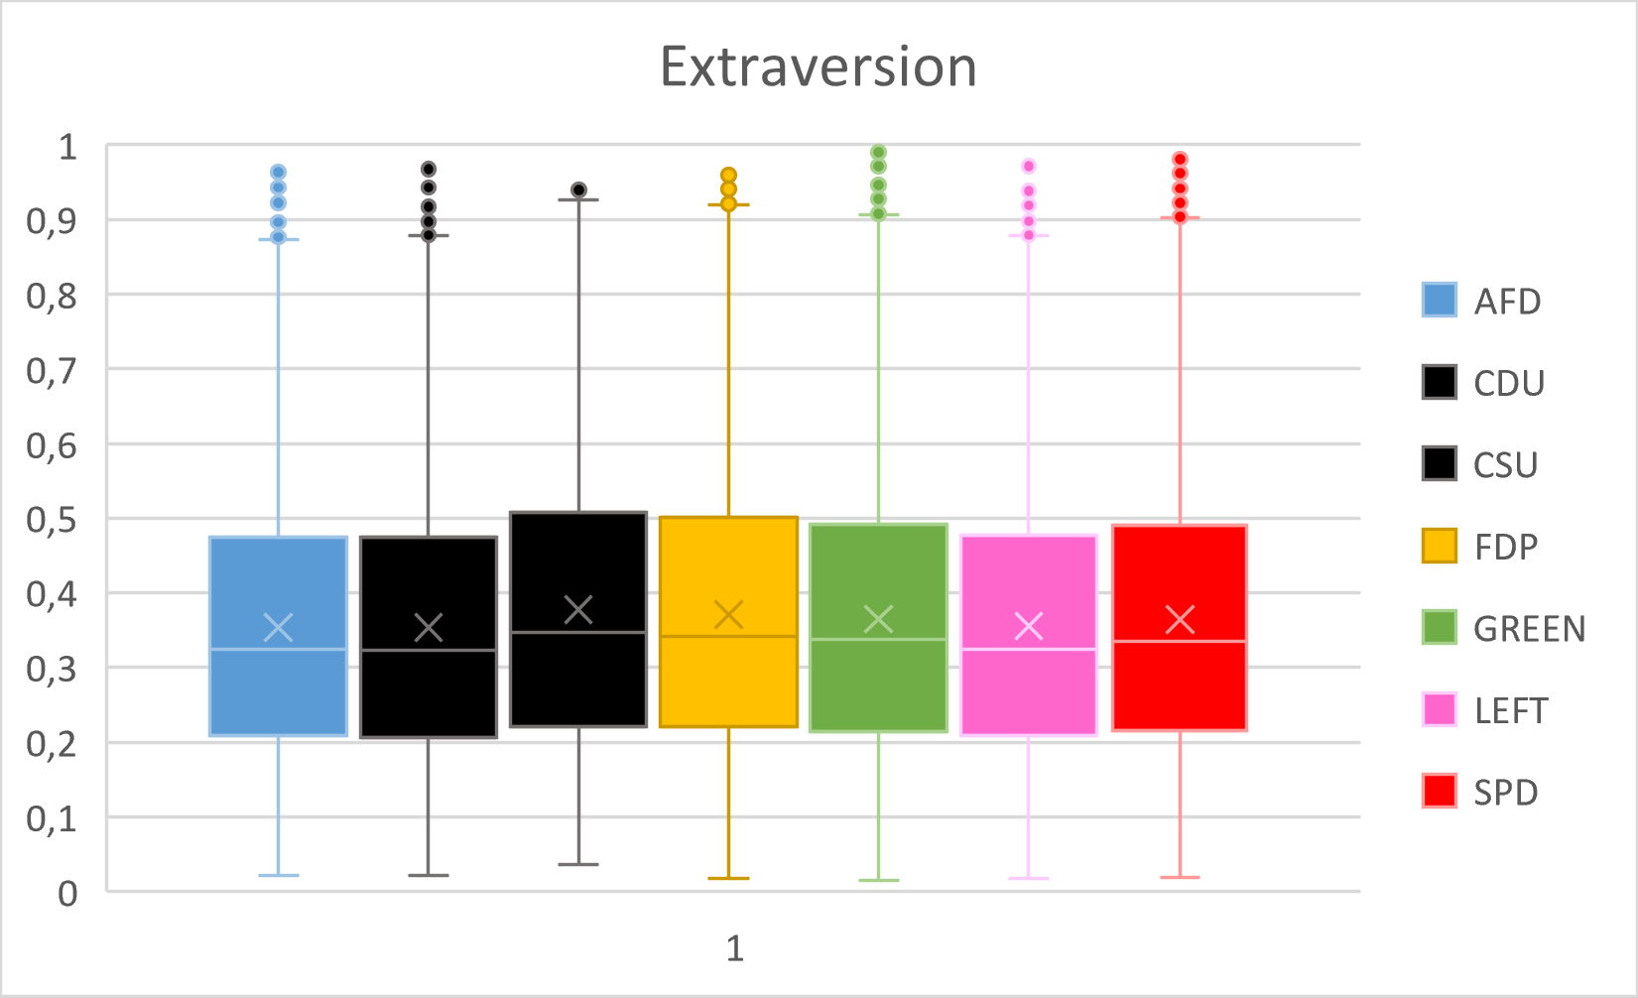As you can see, the deviations from the mean are very high. We could therefore conclude that this approach does not yield meaningful results. We are aware that a more detailed statistical analysis would be necessary to be able to draw more profound conclusions.

(Discussion_of_the_policians_result):

We also wanted to give an overview of the big5 criteria for the individual politicians. Therefore we calculated the mean for each criterium and plotted only the outliers which differ more than 5 percent from the mean in order to reduce the amount of data. Again, we are aware that the result only provides a rough overview and does not represent a detailed analysis.

End

We were able to build a relatively light weight classifier for determining the party, politicians belong to, based on their tweets. Furthermore we showed that the big5 personality traits analysis is also possible on machine translated texts which in our case even improved the classification accuracy. It was very interesting to see how well the latest methods of Natural language processing work to analyse a large amount of complex text data. We hope you enjoyed our video.