Talk about what they know ( 10 minutes )

Talk about what they want to learn / goals of the class ( 10 minutes )

~~Option 1:~~

~~a.)1 hour on lesson on Creating the “Execute Function” ( 60 minutes )~~

~~b.)Intro to QR codes. (40 minutes play with the program , try to get Zumi to move forward )~~

Option 2:

a.)30 min of intro

b.) 30 min write a function that gets Zumi through a intersection

c.) 30 min on pseudo code

Programming Languages?

Python

Data types (String, int, Char, ect ) ?

Just string and int

How to write if statements (If) ?

Yes

How to write if-elif statements ?

Yes

How to define functions ?

Yes

How to make global variables ?

No

For loops ?

Kind of but youd need help

While loops ?

Kind of but youd need help

Nested Loops ?

No

How to overload a function ?

No

Pass by Value ? NO

Pass by Reference ? NO

Pointers? NO

How to make and use Classes?

Kind of but youd need help

How to make and use Lists?

No

How to download Jupyter notebooks ?

yes

How to upload photos to Zumi ?

yes

How to create Jupyter cells that halt and assert ?

no

How to make play noise from Zumi ?

yes

How to use IR-sensor on Zumi ?

no

How to use the camera on Zumi (QR) ?

no

Objective Oriented Programming ?

no

Procedural Programming ?

no

What’s the biggest program you’ve made ?

Zumi Comp code

**What do the students want out of the class ?**

1. Machine Learning ? 5
2. How to use the Artificial Intelligence Stuff ? 5
3. How to write big programs ? 8
4. How to use Zumi Camera to read QR codes ? 3
5. How to use the IR-Sensor ? 3
6. How to make a theme song ? 0
7. How to make a Zumi Face with ? 2

I would rather learn more about programming than Zumi ? 5

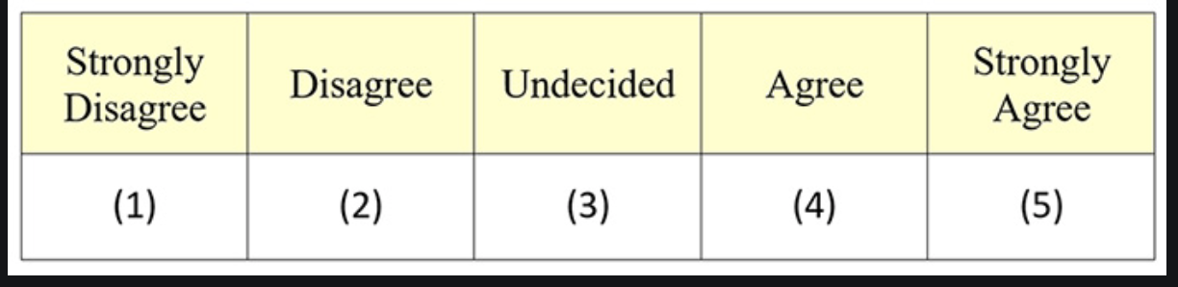

I would rather have fun classes than ones that are hard but helpful ? 1



I would like to be tested on some of the material (Quizzes ) ? 3



I want to be #1 in the Competition rather than enjoy my time ? 5

