TP3 Thomas Truffier-Blanc Nathan Reliaud

1. Création des tables

CREATE TABLE MODELE_BUS (
id_modele INT PRIMARY KEY,
nom_modele VARCHAR(50),
nb_places INT,
autonomie INT,
poids INT
);

CREATE TABLE BUS (
numero_immat VARCHAR(20) PRIMARY KEY,
depot VARCHAR(50),
id_modele INT,
FOREIGN KEY (id_modele) REFERENCES MODELE_BUS(id_modele)
);

CREATE TABLE PERSONNEL (
matricule INT PRIMARY KEY,
nom VARCHAR(50),
adresse VARCHAR(100),
tel VARCHAR(20),
salaire DECIMAL(10,2)
);

CREATE TABLE MECANICIEN (
matricule INT PRIMARY KEY,
specialite VARCHAR(50),
FOREIGN KEY (matricule) REFERENCES PERSONNEL(matricule)
);

CREATE TABLE CONDUCTEUR (
matricule INT PRIMARY KEY,
visite_medicale DATE,
FOREIGN KEY (matricule) REFERENCES PERSONNEL(matricule)
);

CREATE TABLE HABILITATION (
id_modele INT,
matricule INT,
date_debut DATE,
date_fin DATE,
PRIMARY KEY (id_modele, matricule),
FOREIGN KEY (id_modele) REFERENCES MODELE_BUS(id_modele),
FOREIGN KEY (matricule) REFERENCES MECANICIEN(matricule)
);

CREATE TABLE TRAJET (
numero_trajet INT PRIMARY KEY,
numero_immat VARCHAR(20),
matricule INT,
ville_dep VARCHAR(50),
ville_arr VARCHAR(50),
h_dep TIME,
h_arr TIME,
FOREIGN KEY (numero_immat) REFERENCES BUS(numero_immat),
FOREIGN KEY (matricule) REFERENCES CONDUCTEUR(matricule)
);

CREATE TABLE CONTROLE (
numero_controle INT PRIMARY KEY,
nom VARCHAR(50),
seuil INT,
date_controle DATE,
etat VARCHAR(20),
numero_immat VARCHAR(20),
FOREIGN KEY (numero_immat) REFERENCES BUS(numero_immat)
);

2. Insertion de valeurs

INSERT INTO MODELE_BUS VALUES
(1,'Iveco',50,600,12000),
(2,'Mercedes',55,650,13000),
(3,'Volvo',60,700,13500);
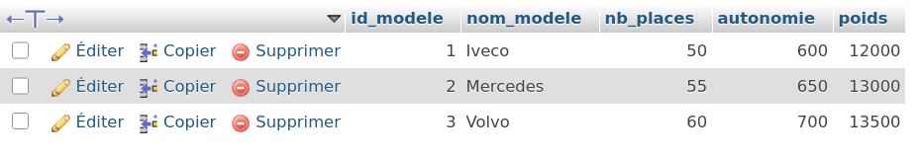
INSERT INTO BUS VALUES
('FF-132-BM,'Clermont-Ferrand',1),
('JE-456-RN','Paris',2),
('BA-789-YL','Lyon',3);

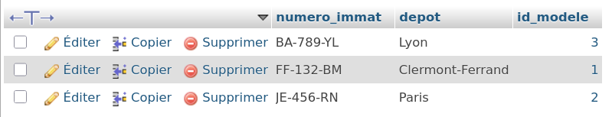
INSERT INTO PERSONNEL VALUES
(101,'Ramos','Paris','0600000001',2200),
(102,'Dupont','Lyon','0600000002',2100),
(201,'Jalibert','Paris','0600000003',2500),
(305,'Bielle-Biarrey','Clermont-Ferrand','0600000004',2600);
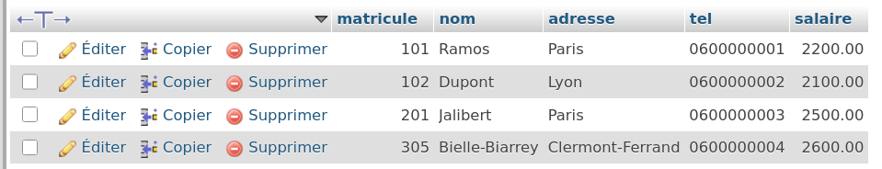
INSERT INTO CONDUCTEUR VALUES
(201,'2025-05-10'),
(305,'2025-03-12');
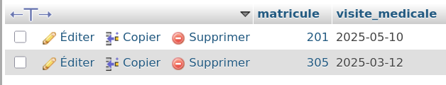

INSERT INTO MECANICIEN VALUES
(101,'moteur'),
(102,'freins');
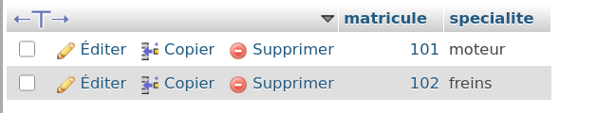

INSERT INTO HABILITATION VALUES
(1,101,'2024-01-01','2026-01-01'),
(2,102,'2024-01-01','2026-01-01');
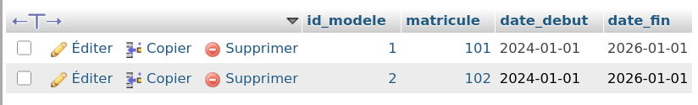
INSERT INTO TRAJET VALUES
(1,'FF-132-BM,201,'Clermont-Ferrand','Paris','19:00:00','22:00:00'),
(2,'JE-456-RN',305,'Paris','Lyon','09:00:00','12:00:00'),
(3,'FF-132-BM,305,'Clermont-Ferrand','Lyon','14:00:00','17:00:00');
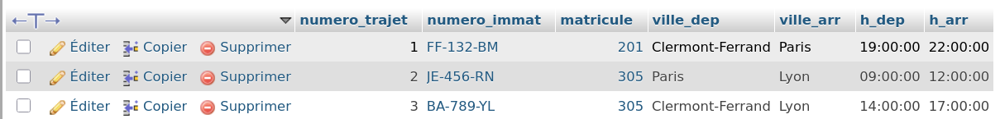

INSERT INTO CONTROLE VALUES
(1,'freinage',80,'2025-01-10','OK','FF-132-BM),
(2,'pollution',60,'2025-02-12','OK','FF-132-BM),
(3,'freinage',80,'2025-01-15','OK','JE-456-RN');

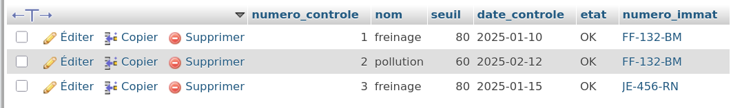
3. Insertion de valeurs

1.
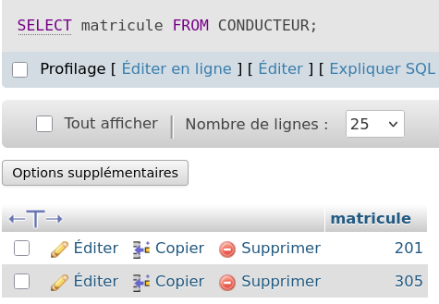

2.
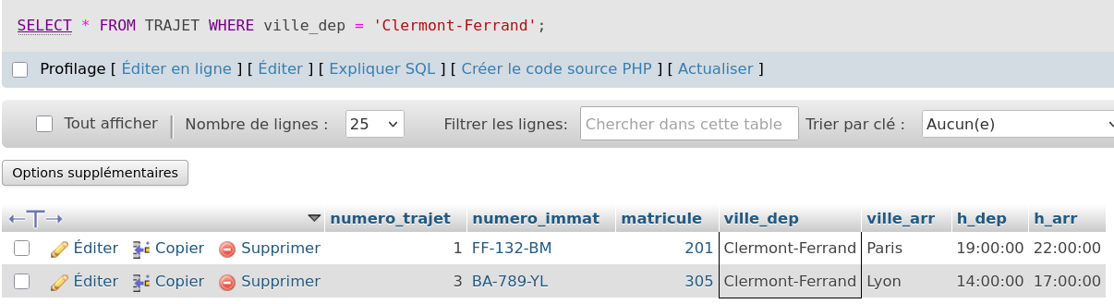

3.
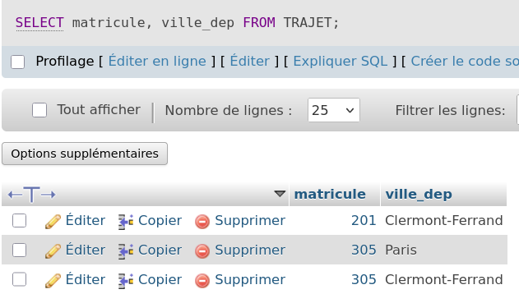

4.
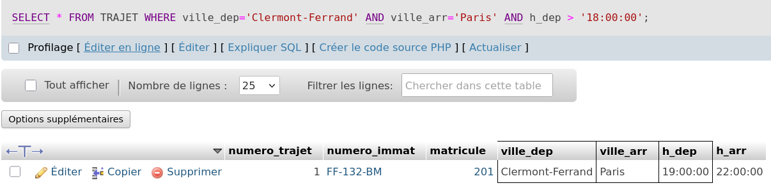

5.
SELECT P.nom
FROM PERSONNEL P
JOIN CONDUCTEUR C ON P.matricule=C.matricule
JOIN TRAJET T ON C.matricule=T.matricule
JOIN BUS B ON T.numero_immat=B.numero_immat
JOIN MODELE_BUS M ON B.id_modele=M.id_modele
WHERE P.adresse='Paris'
AND T.ville_dep='Paris'
AND M.nom_modele='Iveco';

6.
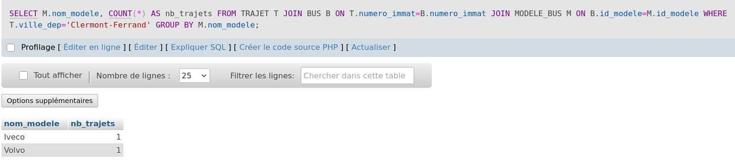

7.
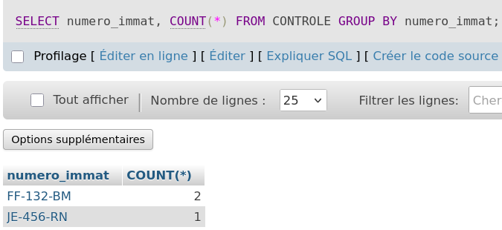

8.
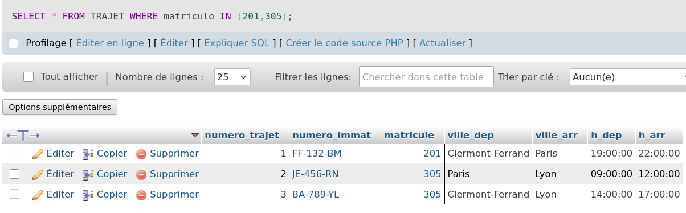

9.
