Thomas Truffier-Blanc
Nathan Reliaud

TP 4

1.
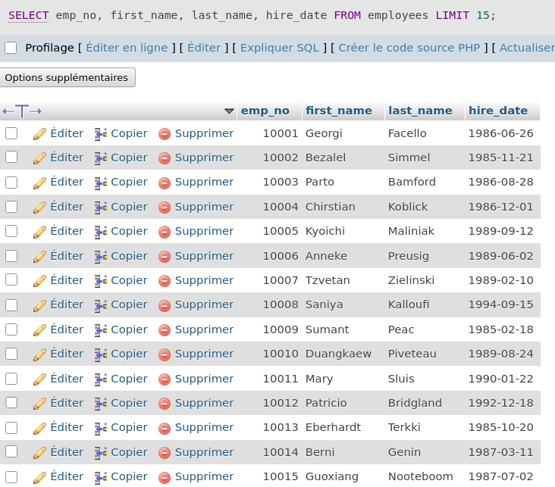

2.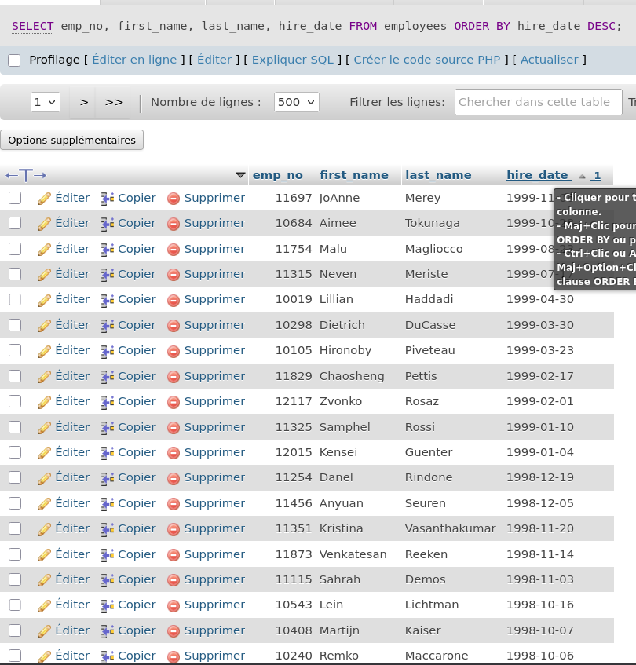

3. Le % est obligatoire sinon ça marche pas
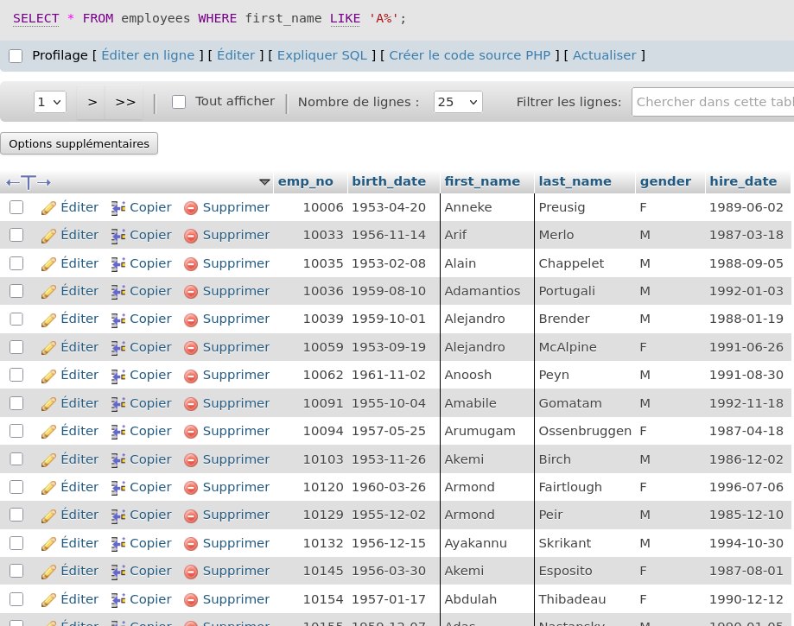

4.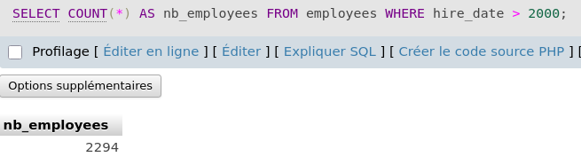

5.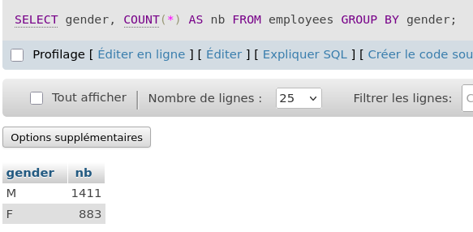

6. 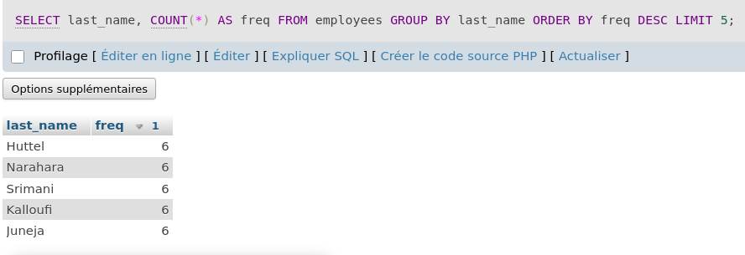

7.
SELECT
employees.first_name,
employees.last_name,
departments.dept_name
FROM employees
JOIN dept_emp ON employees.emp_no = dept_emp.emp_no
JOIN departments ON dept_emp.dept_no = departments.dept_no
WHERE dept_emp.to_date = '9999-01-01';

J’utilise la date 9999-01-01 ar c’est une valeur spéciale ou sentinelle qui signifie, en cours / actuel / pas encore terminé.
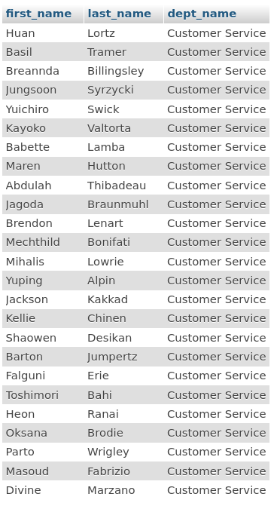

8. SELECT
e.first_name,
e.last_name
FROM employees e
JOIN dept_emp de ON e.emp_no = de.emp_no
JOIN departments d ON de.dept_no = d.dept_no
WHERE d.dept_name = 'Sales'
AND de.to_date = '9999-01-01';
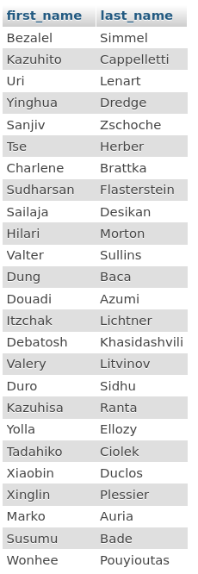

9.
SELECT
d.dept_name,
COUNT(*) AS nb_employees
FROM dept_emp de
JOIN departments d ON de.dept_no = d.dept_no
WHERE de.to_date = '9999-01-01'
GROUP BY d.dept_name;
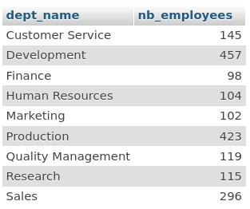
10.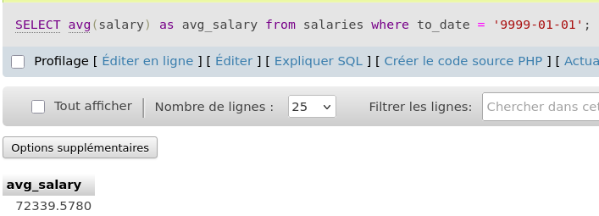

11.
SELECT d.dept_name, MAX(s.salary)
FROM departments d
JOIN dept_emp de USING (dept_no)
JOIN salaries s USING (emp_no)
WHERE de.to_date = '9999-01-01'
AND s.to_date = '9999-01-01'
GROUP BY d.dept_name;

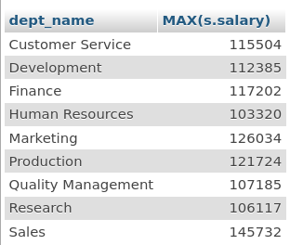

12.
SELECT
e.emp_no,
e.first_name,
e.last_name,
d.dept_name
FROM current_employees ce
JOIN employees e ON ce.emp_no = e.emp_no
JOIN departments d ON ce.dept_no = d.dept_no;

