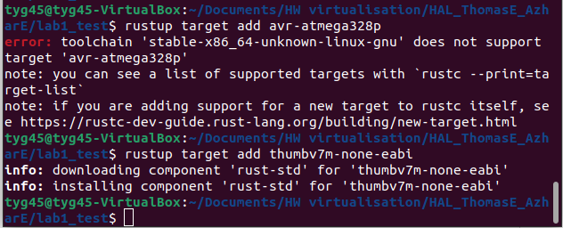
As you can see here, even after many hours spent trying to find the right version of rustup, I can't find atmega328p... Whereas thumbv7m is easily supported by rustup.

