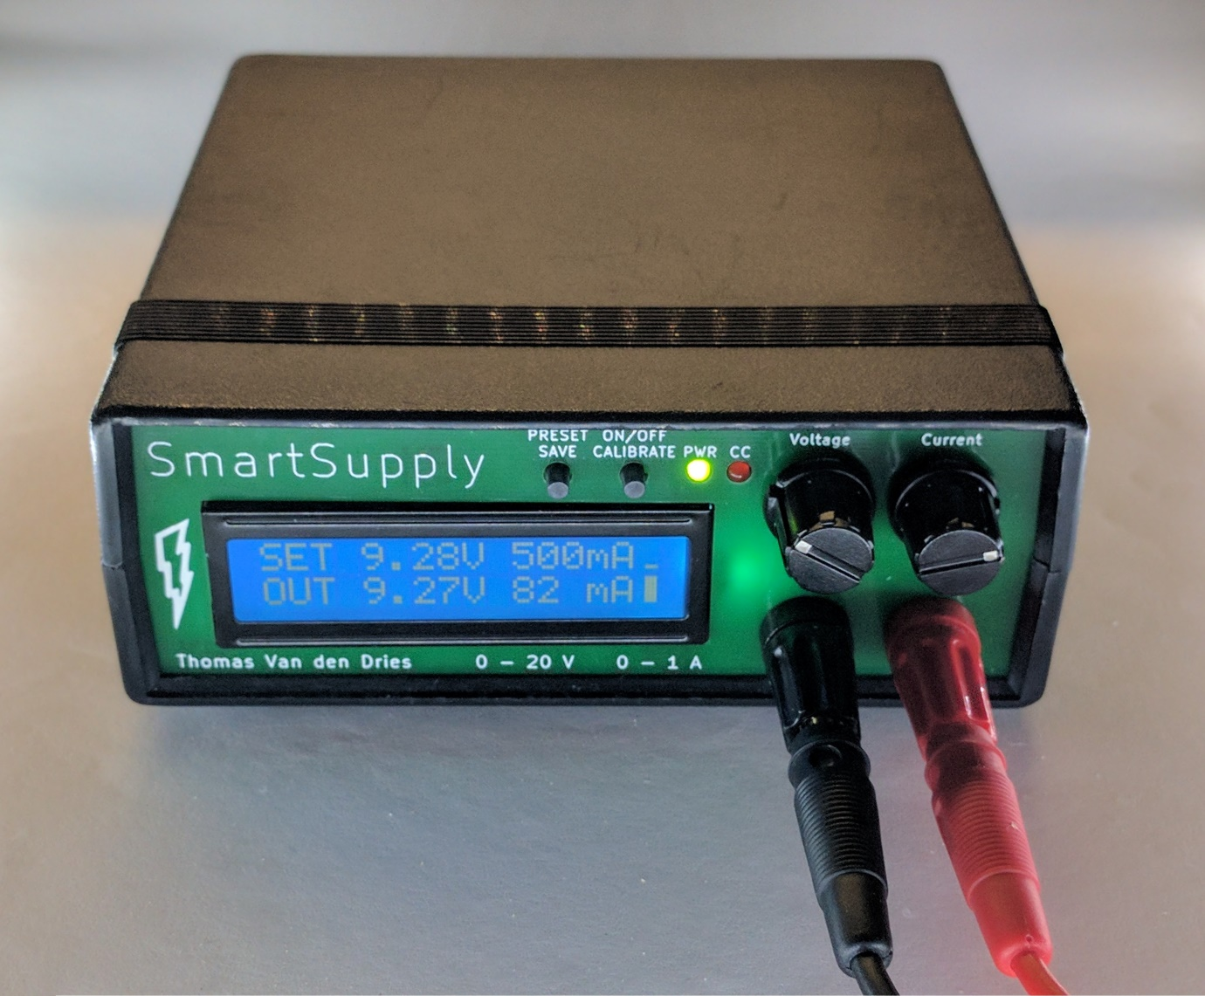

Battery powered

PC controllable

Arduino compatible

**PowerSupply**