**USB C  
PowerSupply**

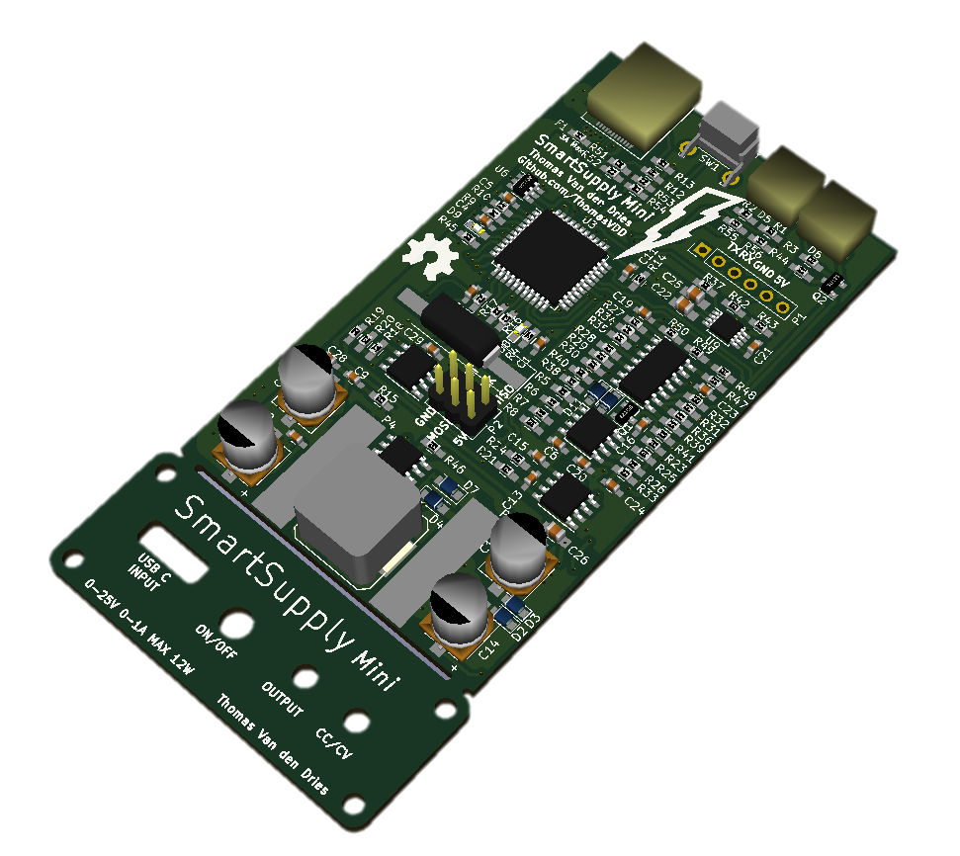

**SmartSupply   
Mini**