Requirements Object Detection Application

Inputs

- Camera images

The camera images we are going to process will be simple cameras providing their footage. When given the footage we will need to build some kind of smart system that could return the objects that are detected in that image.

Most common image formats are: JPG, JPEG, PNG, GIF, BMP

- RGB-D Point Clouds

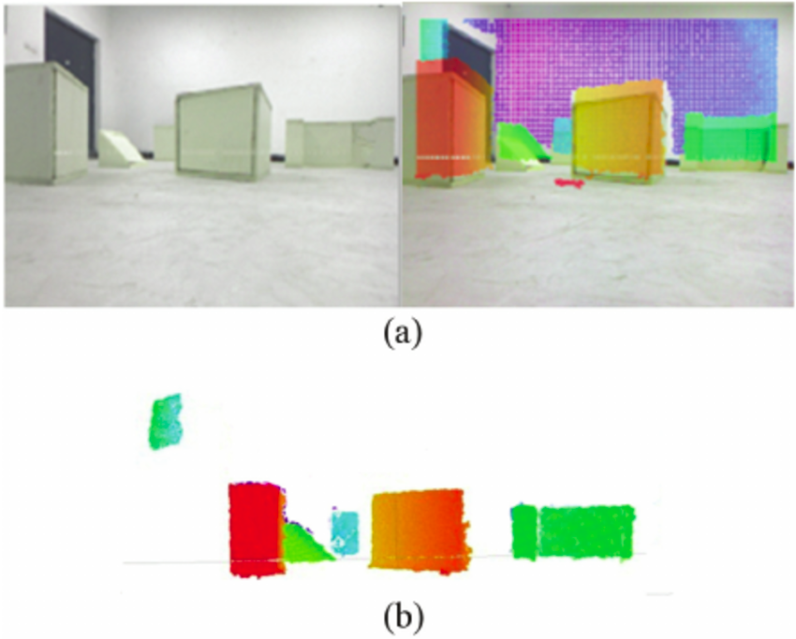
RGB-D Point Clouds are images (left) combined with some information about the depth in the image (right). When adding these, we could generate a point cloud (bottom).

- LiDAR Point Clouds

Lidar stands for Light Detection and Ranging. A lidar sensor mostly has a laser built-in which could be spinned around 360 degrees. Since the laser returns back to the sensor, with the speed of the laser known, we could make up some distances. When we are combining all of these distance points we have, we can build up some maps or recognize the shape of objects.

The point cloud data is often saved in .las format.

- Intermediate Featuremaps

A feature map is the output of one filter applied to the previous layer. A given filter is drawn across the entire previous layer, moved one pixel at a time. Each position results in an activation of the neuron and the output is collected in the feature map.

- Video feeds

A video feed is simply a live-stream of photo images. We will get the photo’s at a certain time interval, giving us the FPS (Frames Per Second) of the videostream. The use of the videostream (which gives us some information about photo’s in time) could make for us some interesting predictions.

- SONAR data

Sonar is most likely like LiDAR data, but works with sound. By transmitting sound at specific frequencies, we can build up a map or do some object detection.

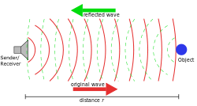
Sonar data can be provided in the .cwb, .midi, .tpl or other file formats.

- RADAR data

RADAR is another type of data like LiDAR and SONAR, but this time it works using electromagnetic waves. The reflections of these waves (echo) can be received back in an antenna, building up again a map of information.

- Graph Data (GCN’s)

Graph convolutional network: example is using the Cora dataset.
https://stellargraph.readthedocs.io/en/stable/demos/node-classification/gcn-node-classification.html

- Random Latent Space Noise (GANs)

https://towardsdatascience.com/understanding-latent-space-in-machine-learning-de5a7c687d8d

- Arbitrary RL Data

Important note: When the input type of a network, and the given input match (for example, both are images), it is important that the ODT platform matches these (ex: rescaling the size of the input image to match the size of the network). This should happen in an automatic fashion.

Outputs

- Image classification

Image classification is the simply recognizing the images, seeing some figures in the image.

- Object Detection

Object detection is the image classification simply done on an image. We will get some coordinates (x,y, x_width, y_width) of the object and a chanse of prediction (which is a %) on how sure the model is.

- Image segmentation

Image segmentation is the process of partitioning a digital image into multiple segments. he goal of segmentation is to simplify and/or change the representation of an image into something that is more meaningful and easier to analyze.[1][2] Image segmentation is typically used to locate objects and boundaries (lines, curves, etc.) in images. More precisely, image segmentation is the process of assigning a label to every pixel in an image such that pixels with the same label share certain characteristics.

- General classification

- General regression

Important to ensure that the classes match the network output matches the classes the output expected.

Cross platform support:
- Ability to use CUDA accelerators (ex. Jetson Nano)
- Ability to use TPU accelerators (ex. EdgeTPU)
- Ability to run networks completely on a CPU

Supported model types:
- ONNX
- Torch State Dicts
- TensorFlow models
- TensorFlow Lite models

Should be capable of running a number of different model types.

Automatic Docker Build System:
- network will be distributed as a Docker Container

Profiling:
- Inference time
- Memory use
- Power use

About the inputs:

Camera images:

- to take live input images: can make use of SimpleCV
https://softwarerecs.stackexchange.com/questions/18134/python-library-for-taking-camera-images

-

ImageAI:
https://stackabuse.com/object-detection-with-imageai-in-python/

ImageAI is a Python library containing deep learning and Computer Vision capabilities using few lines of straight forward code. Implementation of state-of-the-art deep learning algoritms like RetinaNet, Yolov3 and TinyYolov3.

ObjectDetection class of ImageAI library contains functions to perform object detection on any images or set of images, using pre-trained models.

Install keras, install tensorflow

https://nl.mathworks.com/help/deeplearning/ug/pretrained-convolutional-neural-networks.html

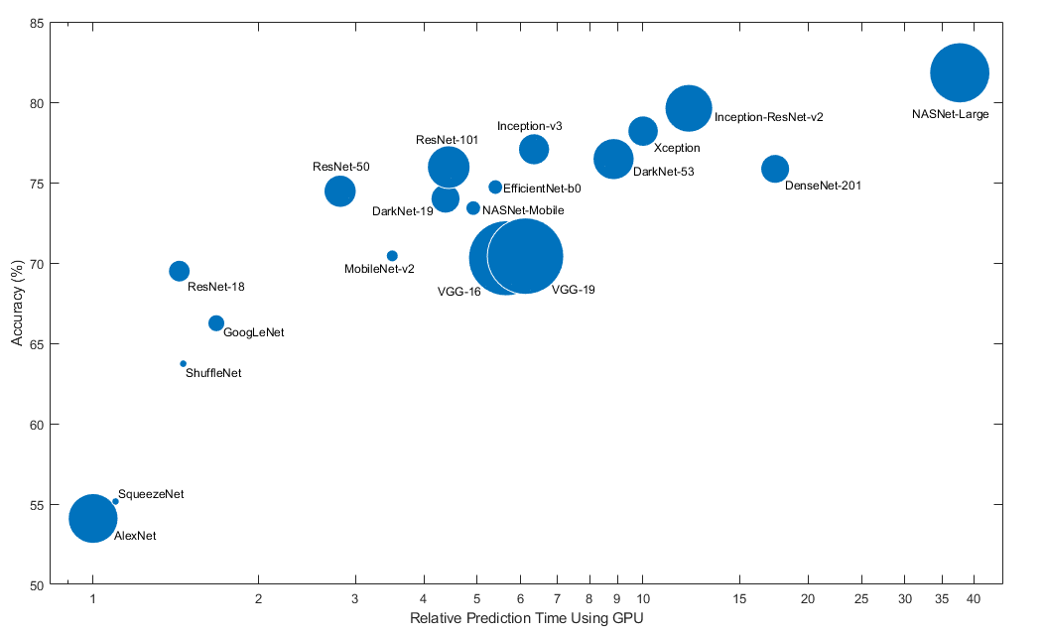

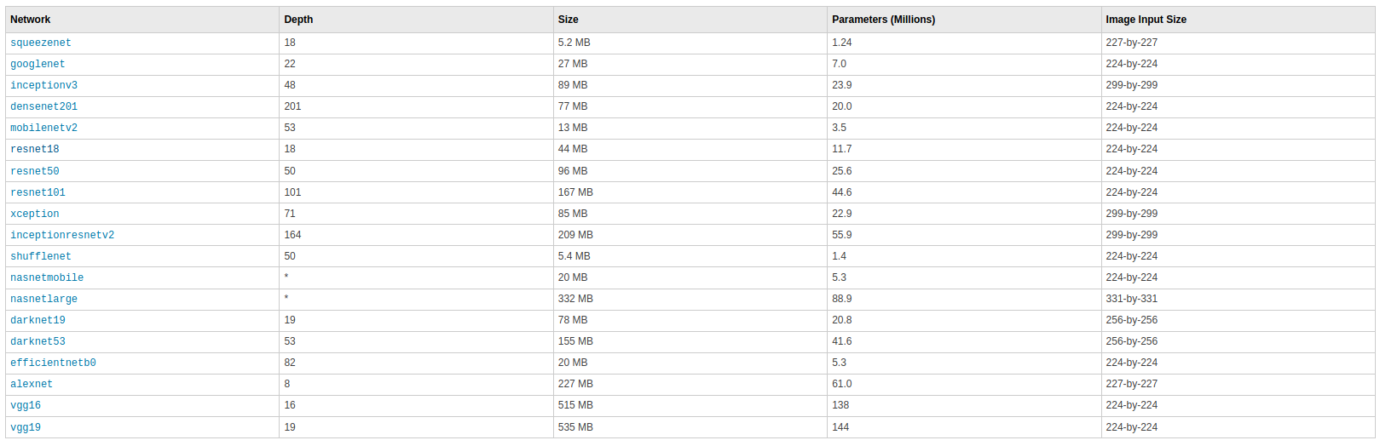
Segmentatie: die pixel dat..
Niet enkel focussen op foto’s → lidar…
Niet altijd zelfde soort netwerk!
Afhankelijk van taak ander algoritme
Gewoon classificatie CNN
Detectie, steeds CNN, maar ander
segmentatie Encoder/Decoder
Idealiter voor elk soort netwerk onnx beschrijving: dit netwerk om die taak daar te gaan doen

Preprocessing vooraleer verwerking: config file. Preprocessing block data transformeren vooraleer we het in het netwerk steken

alle opdrachten kunnen in eender welke input worden uitgevoerd. Niet dynamisch kunnen switchen
ONNX runtime library: https://github.com/microsoft/onnxruntime
PyTorch favor
https://pytorch.org/hub/nvidia_deeplearningexamples_ssd/
https://pytorch.org/hub/
https://github.com/QingyongHu/SoTA-Point-Cloud
Kitty dataset → lidar
Waymo dataset

Methodes hoe ze het doen: point based, …
Pytorch heeft al goede ondersteuning: https://github.com/eriklindernoren/PyTorch-YOLOv3
ONNX gaan exporteren…

Mogelijk om ONNX te visualiseren:
https://github.com/microsoft/onnxruntime
Probleem?
Regular Neural Net: 32-bit floating point values
Quantized Neural Network: 8-bit integer values
→ speeds up, minimal loss in accuracy

.tflite model:

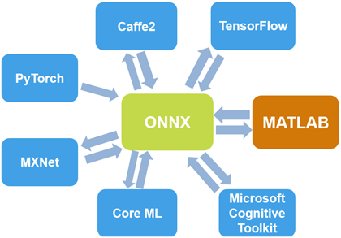
Eerder focussen op lightweight modellen/zware? Alles focussen?

VoxelNet is een point based 3D object detectie algoritme
Stap 1: Processing KITTI dataset om model te trainen

