**4. Deliverables and Project Plan** (deliverables paraphrased from www.duo.dur.ac.uk)

The main deliverables of the project are as follows, with any deadlines not detailed in the section for the relevant deliverable shown in the Gannt chart below:

Requirements Specification

This shall be a complete, well-structured and unambiguous document adhering to the template on duo. It will contain sections that will, as defined by the requirements specification document template on www.duo.dur.ac.uk, in order;

* Describe the purpose and context of the project, as well as the structure of the requirements specification document.
* Outline the scope of the project, along with its benefits, objectives and stakeholders.
* Explore the domain area of the project and provide references to similar systems.
* Show the project plan, with realistic, clearly defined activities attributed to team members.
* Discuss the potential risks of the project, enlisting all hardware and software used, the limitations of these software/hardware and issues concerning ongoing maintenance.
* Clearly entail and describe requirements, including non functional requirements, with a good numbering system.
* Define all terms used and contain references.

The first five sections of this document shall be drafted by Freddie Keen, Quentin Lam, Will Taylor, Tom White and Tom Willshaw respectively with a soft deadline of 24/11/2015, before being proof read, discussed and edited by the team in a meeting on 24/11/2015. The remaining two sections will then be written collaboratively before the draft deadline for this document on 02/12/15, and edited between this date and the final deadline for the requirements specification on 28/01/2015.

A Classification and filtering web system

This shall be a webpage or set of webpages that use an implementation of an algorithm to ‘decide’ when a photo has been classified with certainty, per Swanson et al. (2015) and to associate species with images where this has been decided.”(quotation from [www.duo.dur.ac.uk](http://www.duo.dur.ac.uk)). This will be worked on by the entire team with a soft deadline of 01/02/2016, beginning after the completion of the draft requirements specification.

This shall involve a method to store the results from the basic classification algorithm such that the algorithm is run only when additional classifications are added by users of the system, (paraphrased, www.duo.dur.ac.uk). This will be worked on by the whole team between 01/01/2016 and 10/02/2016. This shall allow “users [of the system] to select images based on filter criteria including species, favourite status, date/time, habitat, type … site” ([www.duo.dur.ac.uk](http://www.duo.dur.ac.uk)).

This shall also contain an interface for the scientists behind the MammalWeb project to search through and filter the images based on criteria such as species, whether an image has been classified by the algorithm yet, the location in which the image was taken or the time when it as taken. The scientists shall be able to download classified data in .csv format. This shall be compatible for analysis by programs written in Python or R.

The final part of this deliverable shall be a web dashboard visible to a user of the system implementing as many as possible of the following:

- Showing the user their favourite photos

-Showing the user a timeline of their uploads and classifications a chord diagram of relationships.

-Showing the user an interactive map based on data selected using the filter detailed in ‘functionality for users of the system to select and filter images’.

Design and Implementation Demo

This shall be a short presentation on the design and implementation of the project, worked on by the whole team and completed between 01/05/2016 and 31/05/2016.

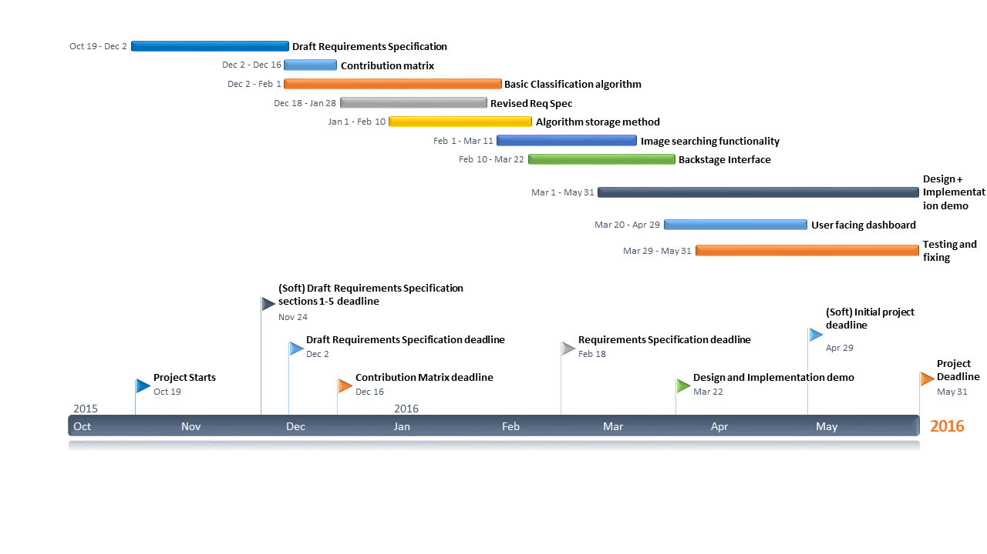An initial soft deadline for all of the above deliverables except the design and implementation demo to have been implemented has been set at 29/04/2016, to leave time for testing the system, making sure that it works, and finishing the presentation about implementation and design. The overall project plan, with hard and soft deadlines, is shown graphically in the Gantt chart below.

Gannt chart depicting the planned order of tasks as well as hard and soft deadlines for team 5’s MammalWeb Group project, Durham University 2nd year computer science Group Project Module, 2015-2016.