CLINIC
( Show a patient room and a washing station.beside the washing station there are medications labeled differently. They represent a certain type of cancer medicines to treat this disease that will be described next)
The minute you enter the patient room where he usually sees his patients, the nurse is so excited to see you.
Nurse: I am so excited to see you . I can’t find Dr. Hemo and I am so scared. I accidentally mixed up the medications that are near the washing station and don’t know to which patient they should belong.
Here are the medications : Fludarabine, cyclophosmide , rituximab,
Nurse: To which patient case chart do these belong to.
(These medications should be for case 1 . )
Chart of patient 1
(CLL case)
A 69-year-old female presents with fatigue and dyspnea that have been progressing for the past month. Physical exam reveals no abnormalities.

Laboratory results:
- WBC 68,000/ uL
- Hb 7.0 g/dL
- Platelet count 264,000/ uL

Her peripheral smear is shown below.

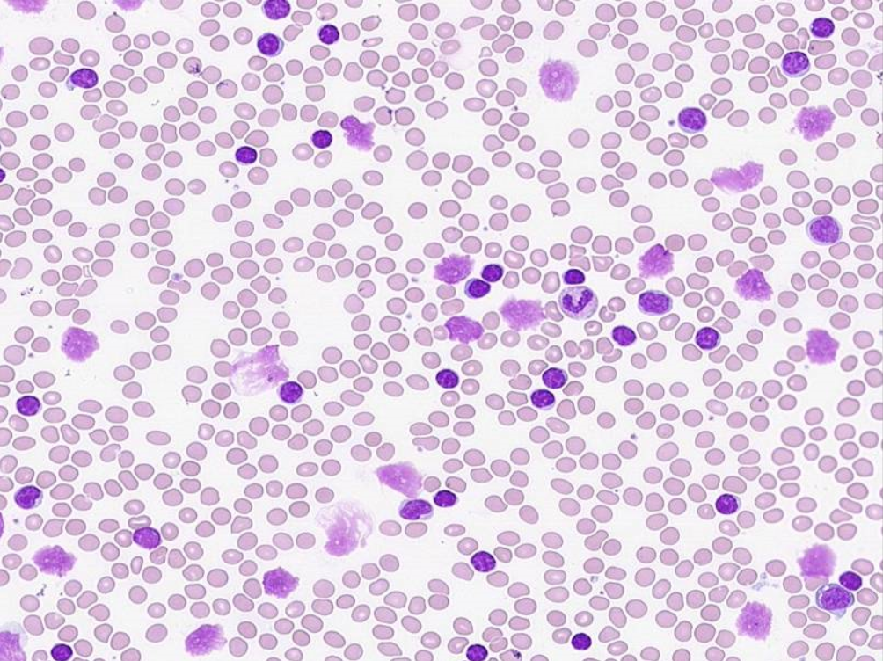
Hint

(smudge cells are very common on a smear in CLL)

Chart of patient 2
(CML case)
A 69-year-old male presents with left-sided abdominal pain, diffuse bone pain, and progressive fatigue for the last several months.
On physical exam, he has splenomegaly.
Laboratory results show:
- WBC 168,000/uL
- Hb 9 g/dL
- platelet 600,000 /uL
Peripheral smear is shown below.
