Sprint Plan
Producer Product Listing and Inventory Management

Project Duration
6th October – 10th December 2026

- Team size: 5 members
- Platform: Camunda + GitHub/GitLab
- Goal: Model, automate, test and demonstrate the producer product listing and inventory workflow
Assessment reviews: 12 October, 2 November and 23 November. Final submission: 10 December, before 14:00 UK time.

Sprint Overview

Sprint | Dates/Review | Main Objective | Assessment Weighting
Sprint 1 | 12 Oct | Project analysis and setup | 20%
Sprint 2 | 13 Oct – 2 Nov | Detailed modelling and initial automation | 30%
Sprint 3 | 3-23 Nov | Complete implementation, integration and demonstration | 50%
Final Preparation | 24 Nov – 10 Dec | Check repository, documentation and submission readiness | N/A

The table above sets the review dates in the brief as milestones and confirms working periods to ensure productivity. The assessment requires 2 major functionalities to be confirmed and agreed upon among the team.

Team roles and responsibilities

Team Member | Preferred areas / interests | Agreed role and responsibilities | Backup / shared tasks

Team meetings — twice per week

Meeting | Day and time | Format / location | Suggested focus

Sprint 1 – Project analysis and setup
Review – 12th October

Goal: Gain an understanding of the marketplace, define project scope and establish team’s working process.

Task | Owner | Deliverable
Analyse the case study and identify stakeholders |  | Requirements and stakeholder list
Create the BPMN model |  | Strategic BPMN diagram
Identify the two major functionalities |  | Defined functional scope
Create the initial product backlog |  | Backlog
Create the sprint plan |  | Sprint plan
Set up the GitHub/GitLab repository and contribution tracking |  | Repository and project Structure

Sprint 1 is complete once the group has a strategic BPMN model, an initial backlog, agreed roles and tasks, a collaborative repository with meaningful activity and a clear plan for the next sprint.

Sprint 2 — Detailed modelling and initial automation
Review – 2nd November

Goal: Develop in-depth business process models and get the initial Camunda workflow running.

Task | Owner | Deliverable
Create i* Strategic Dependency and Strategic Rationale business process models |  | I* SD and SR Business Process Models
Model the full product listing and inventory management process |  | Operational BPMN diagram
Develop producer submission and amendment forms. |  | Amendment forms made with Camunda
Implement validation for necessary fields and process gateways |  | An executable process
Build a simulated certification verification service |  | Verification service
Test the happy path and basic validation failures |  | Test cases and results
Review the models against requirements and prepare for demo |  | Sprint 2 demo

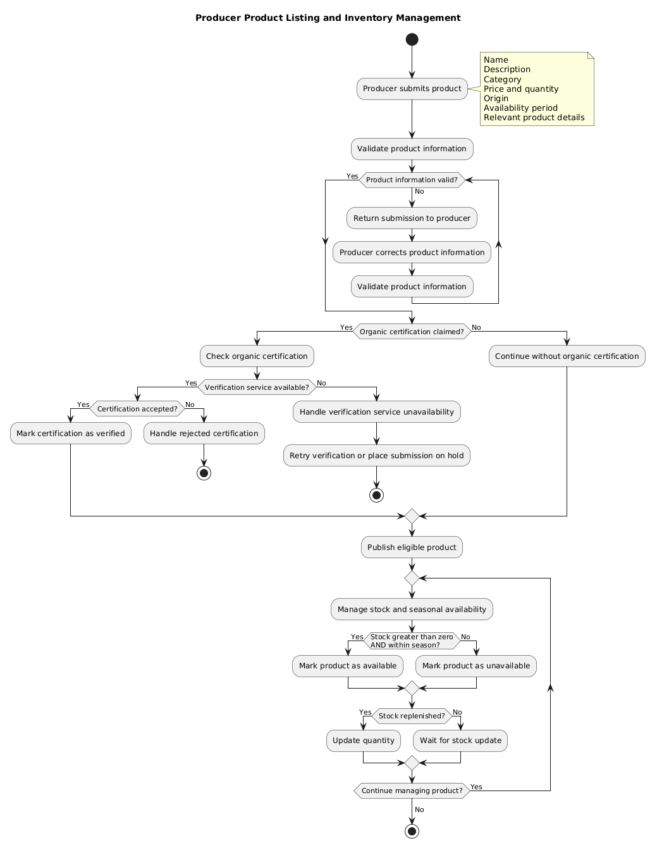
Planned Producer Product Listing Workflow
Sprint 2 is done when the business process models and operational BPMN are complete, the initial Camunda process is executable, forms collect required data and have at least the core validation and service-task logic to be demonstrated.

Sprint 3 — Implementation, integration and testing
Review – 23rd November

Goal: Make a reliable workflow, demonstrate other paths and prepare both functionalities for assessment.

Task | Owner | Deliverable
Complete product publication and correction flows |  | Working Camunda process
Complete certification verification and failure handling |  | Working service task and exception paths
Implement quantity updates and seasonal availability |  | Inventory business rules
Validate the operational BPMN against the implementation |  | Updated process model
Execute functional, integration and exception tests |  | Test results and defect list
Integrate the second agreed functionality |  | Two demonstrable workflows
Prepare demonstration, setup guide and final review |  | Rehearsed demonstration and repository evidence

Testing Checklist
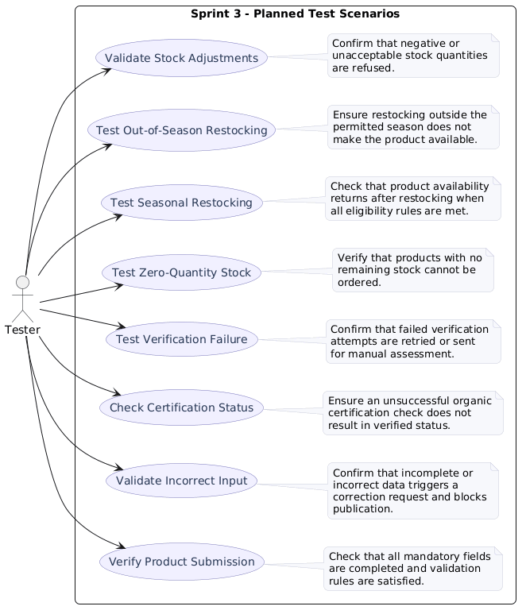
Sprint 3 is done when both functionalities execute end-to-end; forms, gateways, service tasks and process variables work; all paths have been tested and how the models connect to the implementation can be explained

Final preparation — 24th November to 10th December

Task | Owner | Target
Resolve remaining bugs and improve reliability |  | 30th November
Verify model-to-code consistency and integration readiness |  | 3rd December
Check README, setup instructions, test evidence and commit history |  | 5th December
Rehearse individual explanations and the group demonstration |  | 7th December
Check repository contents, access and signed Contribution Matrix |  | 9th December
Submit before the deadline |  | 10th December, 14:00

