Trello Link -> https://trello.com/invite/b/6ada01928d0f5f22e315af10/ATTI26603b00661897affb50fe0bc63d950e2F6A7D55/dded3

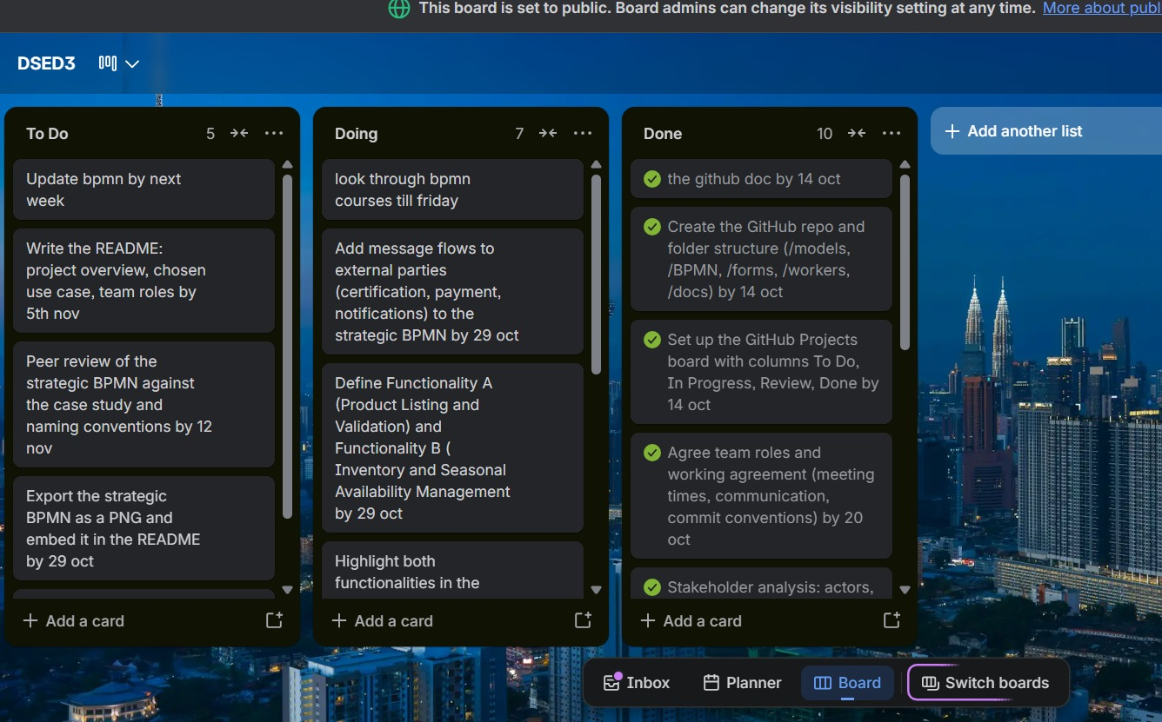

GitHub Repo Link: https://github.com/ThomasYeo305/DSDGroup17

