Exclusive vs. Inclusive Cache Hierarchies
ECE 475 Final Project Report
Generated from measured simulator results
Benchmarks: vvadd, cmplx-mult, masked-filter, bin-search, conflict-miss

1. Abstract
In this project, we studied the performance tradeoffs between exclusive and inclusive three-level cache hierarchies for a RISC-V processor simulator. The provided codebase already contained a riscvlong core and two cache hierarchy implementations: an exclusive hierarchy using a SWAP-style protocol and an inclusive hierarchy using an INCL-style protocol. Our goal was to evaluate how hierarchy organization and cache parameters affected benchmark performance, and to determine whether one hierarchy consistently outperformed the other. We measured performance using cycle count and IPC across a set of microbenchmarks. In the first phase, we established a reproducible benchmarking framework and compared the default exclusive and inclusive hierarchies on the provided benchmarks. In the second phase, we expanded the study by automating cache parameter sweeps, adding a new conflict-heavy benchmark, and evaluating how L1, L2, and L3 cache configuration changes affected each hierarchy. Our results showed that the exclusive hierarchy performed slightly better on the original four benchmarks under the default cache configuration, but the inclusive hierarchy significantly outperformed the exclusive hierarchy on the new conflict-heavy benchmark under the default small-L1 setup. We also found that L1 capacity was by far the most important parameter for this benchmark set, while L2 associativity and L3 capacity had almost no effect.

2. Design
Our project focused on experimental evaluation of cache hierarchy behavior rather than designing a new processor core. The processor front end, datapath, and memory interfaces were already implemented in the provided riscvlong simulator. The two major cache systems we studied were the exclusive hierarchy in cache-ExclusiveCacheHier.v and the inclusive hierarchy in inclcache-InclusiveCacheHier.v. Both systems used three cache levels, but they differed in how cache lines were propagated and stored across levels. In the exclusive hierarchy, the design maintained the invariant that a valid line existed in exactly one cache level at a time, so misses required swapping lines between levels. In the inclusive hierarchy, every line in L1 was also present in L2 and L3, so lower levels replicated upper-level contents.
To support a systematic study, we built an automated experiment framework. The runner generated temporary simulator wrappers with different parameter settings, compiled them, ran all available benchmarks, and wrote cycle count, instruction count, and IPC into a CSV file. We also built a plotting script that converted the experiment CSV into summary plots and tables. This let us compare multiple cache configurations without manually editing Verilog and rerunning make targets by hand.
We varied several L1, L2, and L3 parameters. Specifically, we swept L1 capacity by halving and doubling the number of sets, added a configuration that enabled a one-entry L1 victim-buffer experiment, varied L2 associativity, and varied L3 capacity. We also added a new benchmark, ubmark-conflict-miss, which repeatedly alternates between two memory locations that map to the same L1 index under the default cache geometry. This benchmark was intended to magnify conflict-miss effects and make differences in cache organization easier to observe.

3. Testing
Our testing methodology focused on correctness first and then on performance measurement. We first verified that both cache hierarchies ran the existing microbenchmark suite successfully under the default configuration. The benchmark suite included ubmark-vvadd, ubmark-cmplx-mult, ubmark-masked-filter, and ubmark-bin-search. For each benchmark, we confirmed pass/fail behavior through the simulator output and extracted the reported num_cycles, num_inst, and ipc values.
After establishing a known-good baseline, we validated the experiment harness by comparing its output against manually run results. The automated framework reproduced the exact same baseline cycle counts and IPC values as the manual runs, confirming that the generated wrappers and CSV parsing were correct. We then expanded the experiment matrix and ran all configurations across both hierarchies. This produced a total of 80 real simulation runs once the fifth benchmark, conflict-miss, was added.
We also tested the victim-buffer experiment path itself. We added parameter hooks in both the exclusive and inclusive L1 cache modules and confirmed that the simulator compiled and ran successfully with the victim-buffer configuration enabled. However, the measured cycle counts for the victim-buffer configuration were identical to the default configuration across all tested benchmarks, including conflict-miss. This told us that while the feature path compiled and executed, it did not produce a measurable performance change in its current form, so we did not rely on it as a main conclusion.

4. Evaluation and Discussion
Default benchmark comparison:
Benchmark | Exclusive Cycles | Exclusive IPC | Inclusive Cycles | Inclusive IPC
Binary Search | 5527 | 0.184006 | 5709 | 0.17814
Complex Multiply | 8771 | 0.196443 | 8984 | 0.191785
Conflict Miss | 61285 | 0.142253 | 53090 | 0.164212
Masked Filter | 22923 | 0.215111 | 23456 | 0.210223
Vector-Vector Add | 2879 | 0.157346 | 3030 | 0.149505
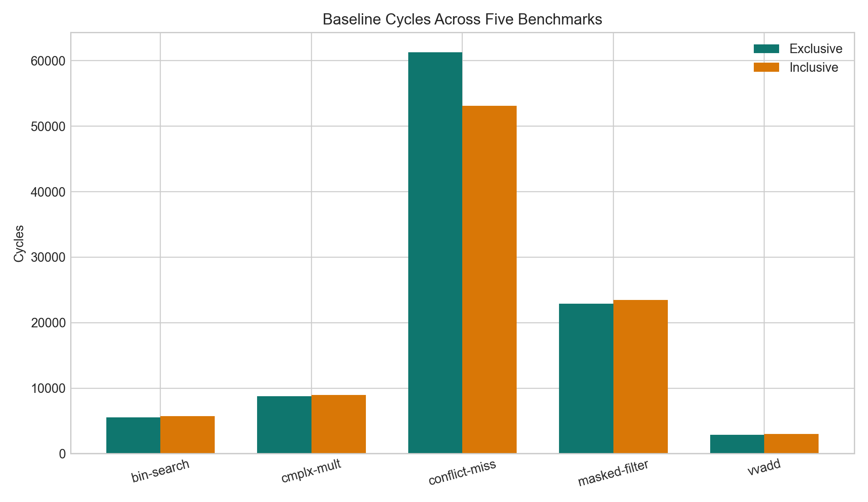
Figure 1: Baseline cycles across the five measured benchmarks.
For the original four benchmarks, the exclusive hierarchy outperformed the inclusive hierarchy in every case, but only by a small margin, roughly 2% to 5%. For example, exclusive reduced binary-search runtime from 5709 cycles to 5527 cycles, and reduced vector-vector add from 3030 cycles to 2879 cycles. This suggests that for these workloads, hierarchy organization matters somewhat, but not dramatically. The workloads do not appear to stress the cache system enough for the difference between exclusivity and inclusion to dominate execution time.
The new conflict-miss benchmark showed a much stronger effect. Under the default configuration, inclusive completed the benchmark in 53090 cycles, while exclusive required 61285 cycles. This is roughly a 13.4% performance advantage for the inclusive hierarchy. This result is important because it shows that the preference between exclusive and inclusive hierarchies is workload-dependent. On regular workloads with modest locality pressure, exclusive performed slightly better, but on a conflict-heavy workload, inclusive performed much better.
L1 capacity sensitivity:
Benchmark | Default Excl. | L1 Double Excl. | Default Incl. | L1 Double Incl.
Conflict Miss | 61285 | 27996 | 53090 | 28037
Masked Filter | 22923 | 22655 | 23456 | 23150
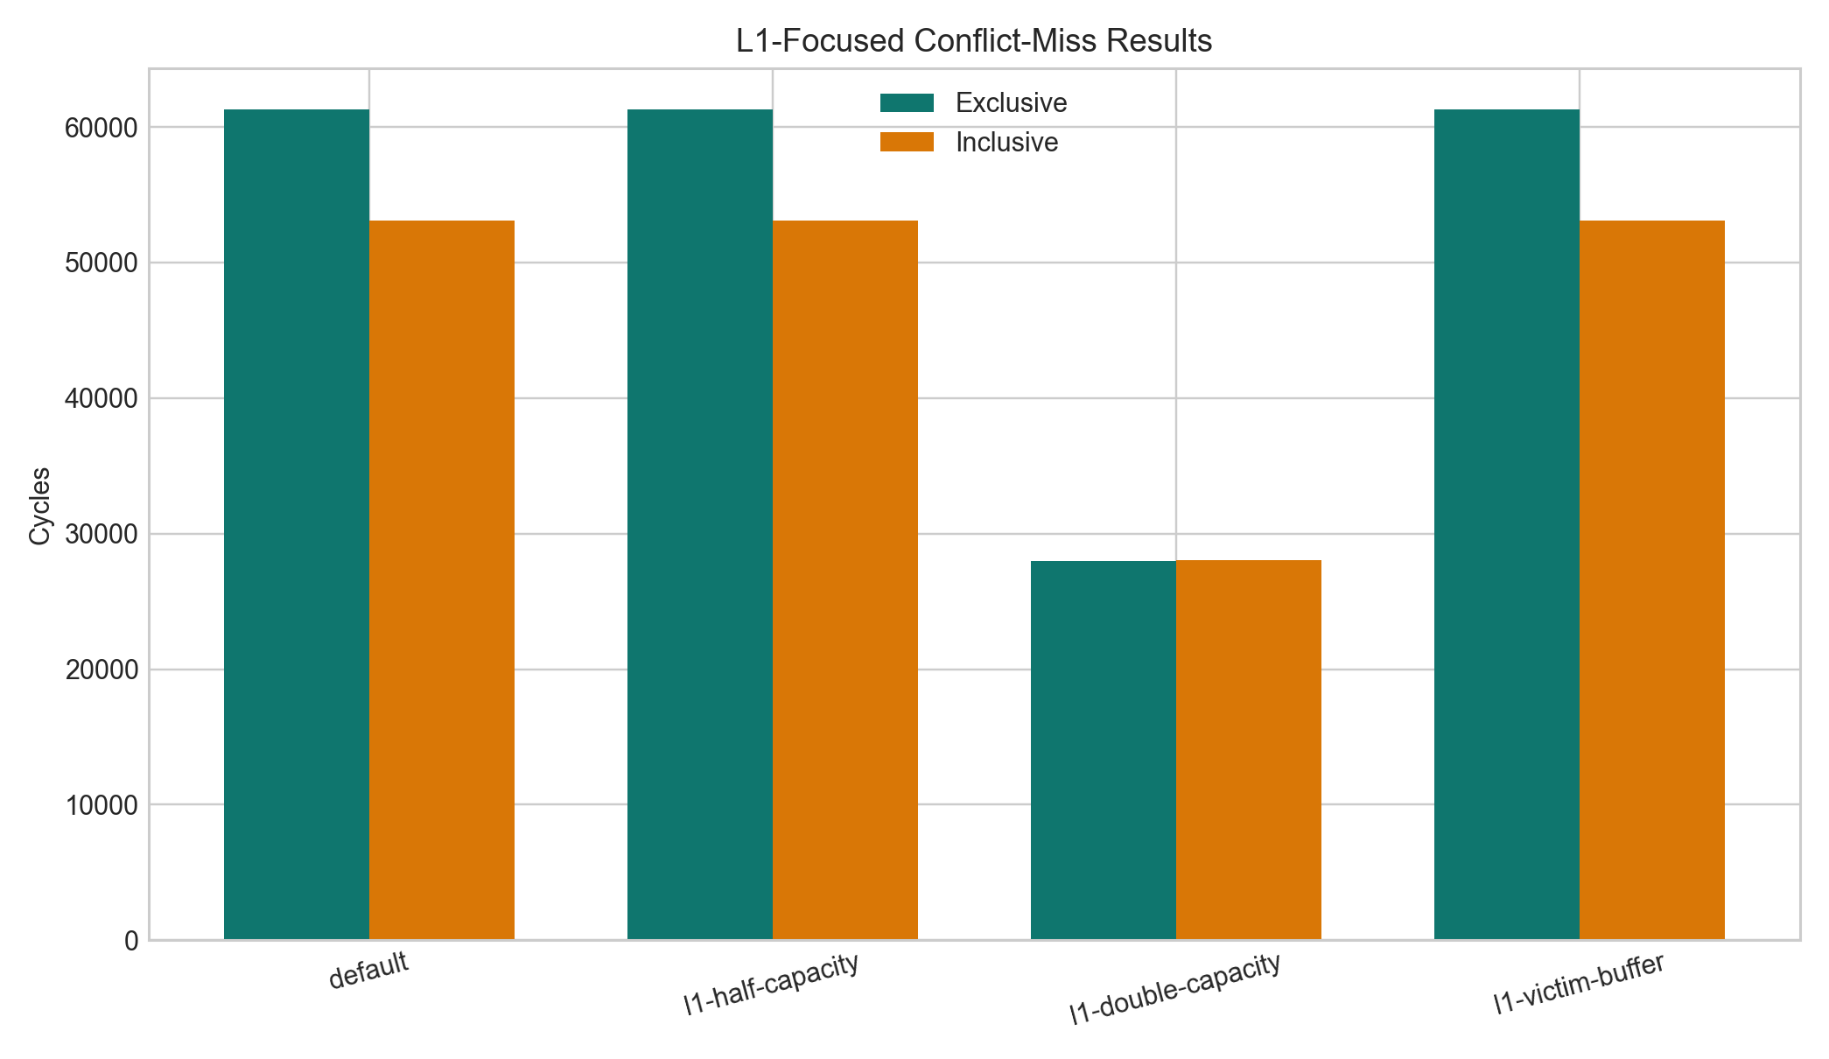
Figure 2: L1-focused comparison for the conflict-miss benchmark.
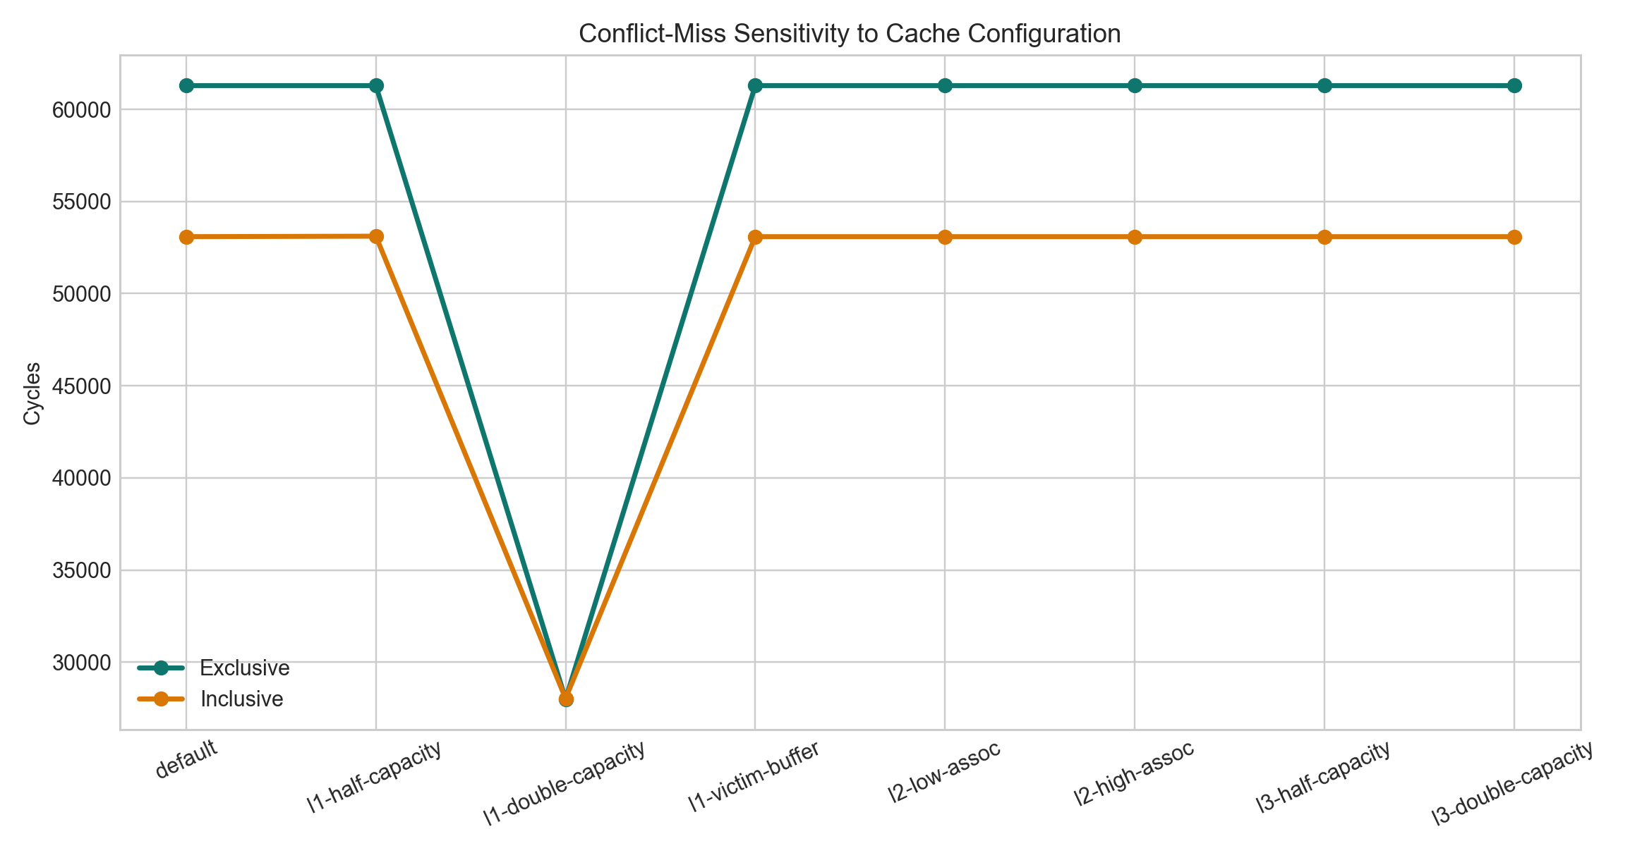
Figure 3: Conflict-miss sensitivity across the full cache sweep.
The most significant configuration effect came from L1 capacity. Doubling the L1 size had very little effect on bin-search, cmplx-mult, or vvadd, but it substantially improved masked-filter and dramatically improved conflict-miss. For conflict-miss, doubling the L1 size reduced exclusive runtime from 61285 cycles to 27996 cycles and reduced inclusive runtime from 53090 cycles to 28037 cycles. This is a massive improvement for both hierarchies, and it nearly erased the difference between them. This strongly suggests that the default conflict-miss behavior was dominated by L1 conflicts rather than by deeper cache behavior. Once those conflicts were relieved, the hierarchy organization itself became far less important.
The remaining sweeps had very small or negligible impact. Halving L1 capacity slightly worsened bin-search, which is consistent with some additional cache pressure in that workload. However, changing L2 associativity and changing L3 size produced almost no measurable change across the benchmark set. Even on conflict-miss, the cycle counts for l2-low-assoc, l2-high-assoc, l3-half-capacity, and l3-double-capacity were essentially unchanged from the default configuration. This suggests that for the working sets in our benchmarks, misses were determined primarily by L1 behavior rather than by L2 or L3 contention.
We also attempted to add an L1 victim-buffer style enhancement. This compiled successfully and could be toggled in the experiment runner, but it had no observable effect on any benchmark, including conflict-miss. Because the result was flat across all runs, we chose not to base our conclusions on this feature. Instead, we treat it as an incomplete exploratory extension.

5. Conclusion
In this project, we built a reproducible experimental framework for evaluating exclusive and inclusive three-level cache hierarchies on a RISC-V simulator. We automated benchmark runs, parameter sweeps, and result collection, and we added a new conflict-heavy benchmark to better stress the cache system. Our results showed that the exclusive hierarchy slightly outperformed the inclusive hierarchy on the original benchmark set, but the inclusive hierarchy significantly outperformed the exclusive hierarchy on the conflict-heavy benchmark under the default cache configuration. We also found that doubling L1 capacity dramatically improved the conflict-heavy workload and nearly eliminated the difference between the two hierarchies, showing that L1 capacity can matter more than hierarchy organization for some workloads. Future work could include debugging the victim-buffer extension, adding miss-rate and writeback counters, and designing additional benchmarks to isolate specific locality and conflict behaviors even more precisely.

