Web Development Project

# PHP Frameworks – Movies Store

By Thomas Behan x14450018

Group S

<https://github.com/Thomasbehan/2nd-Year-Web-Development-Project>

<http://2nd-year-web-development-project-thomasbehan440600.codeanyapp.com/>

Recommended to run on a PHP Ubuntu 14.04 Stack/Server

# Intro

The aim of this project was to create a movie upload site to allow users to sell their movies on the open online market.

# The project:

The project was based on html, css, jquery, xml, php technologies all of these technologies have been incorporated into the project in a useful way. For example for design and layout I used html and css, for the slideshow I used jquery and for the dynamic functions of the site I used php with xml to store appended data.

I included a submit page which allows the user to submit their selected movie along with a trailer link to a video, this page uses php and xml to submit data to the movies.xml file using simplexml from php

I also included a live latest movies tab at the bottom of the index page which collects its data from the xml file and then instantiates a selected code using a for loop and echo in php, this ensures that the right amount of code is generated.

You can see this in code below: (extracted from index.php line 139 to 158)

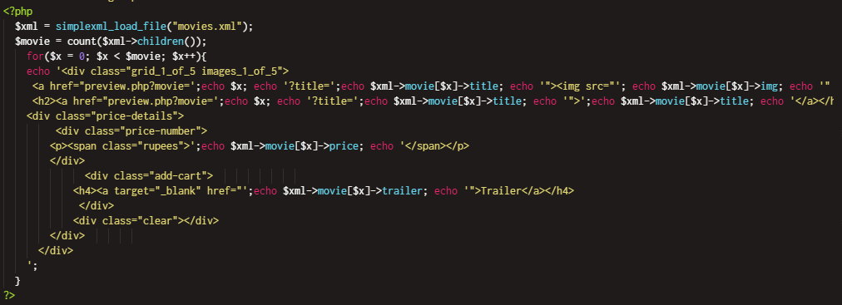

I did come across some cons to using xml on its own to store data this limited me to only strings. Given more time I would implement a image uploader using an image folder on the server along with mysql in a php function for example an image upload form after the submit form called imageUplaod.php which will contain a form with an attach file and will post call another php file which will connect to the mysql database and save the file in a folder on the server and store the link in both the xml and sql server