# Results

*Introduction:*

This section is organised as follows: …

# 4.1 General:

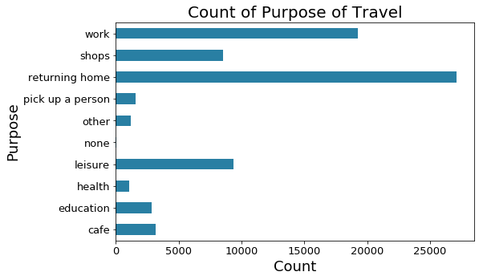

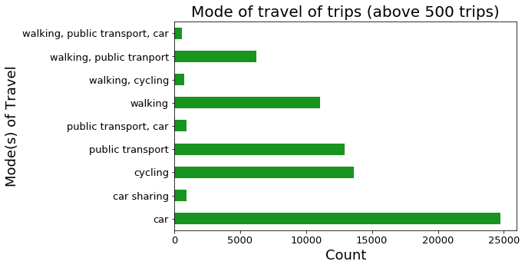

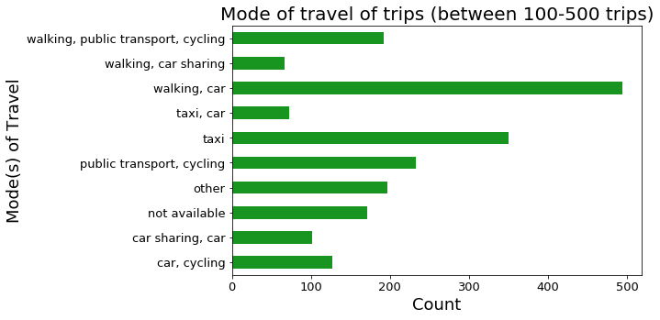

# 4.2 Exploratory Space-Time Data Analysis (ESTDA):

## 4.2.1 Spatial:

Example LISA:

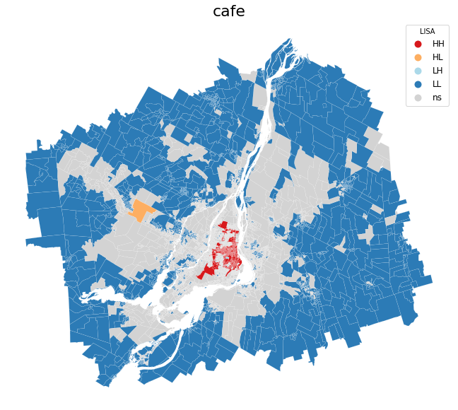

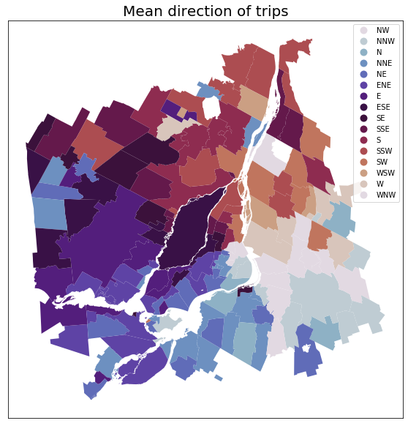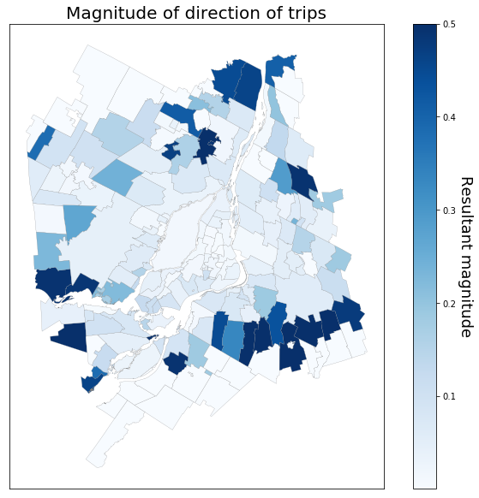

## 4.2.2 Temporal:

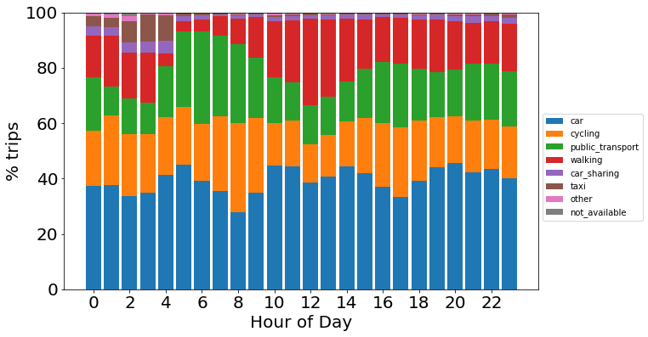

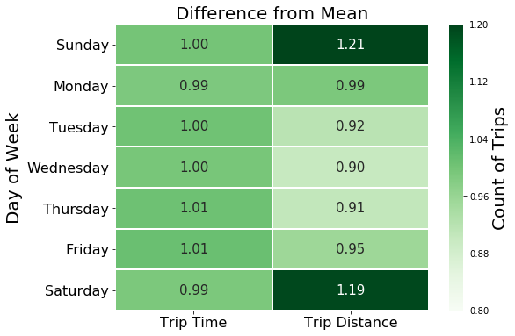

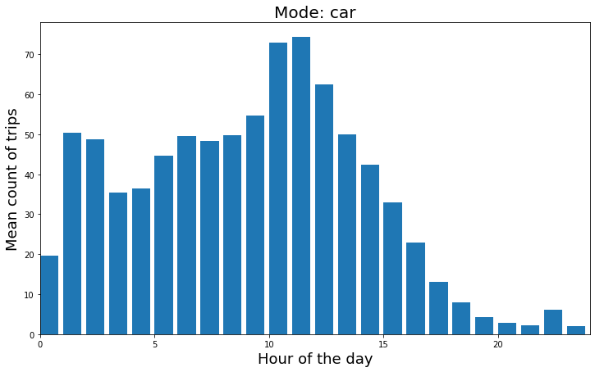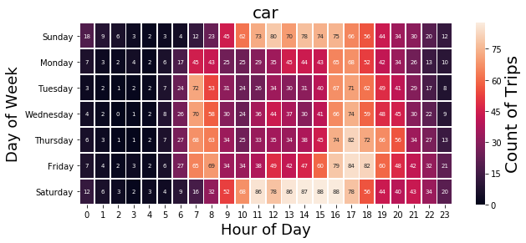

## 4.2.3 Spatio-temporal:

# 4.3 Modelling:

Examining the forecast-ability of the network: To build upon the structure and findings of the ESTDA

## 4.3.1 LDA:

|  |  |  |
| --- | --- | --- |
| Temporal Cluster |  |  |
| 0 |  |  |
| 1 |  |  |
| 2 |  |  |
| 3 |  |  |
| 4 |  |  |
| 5 |  |  |

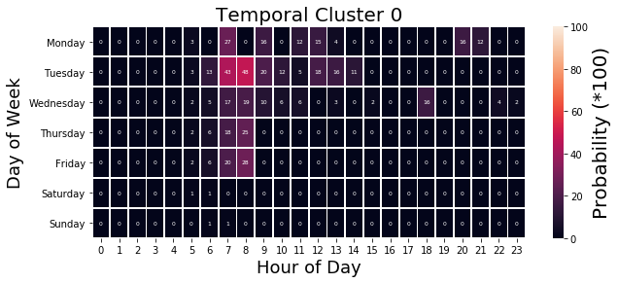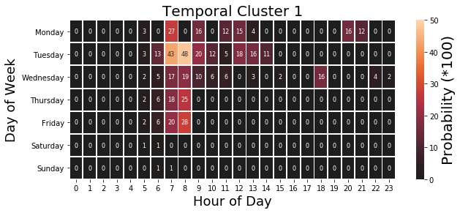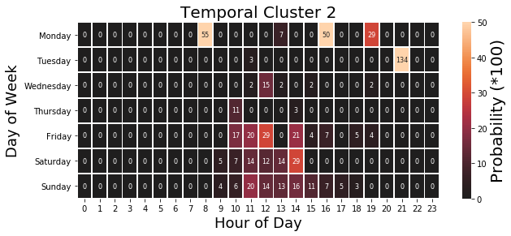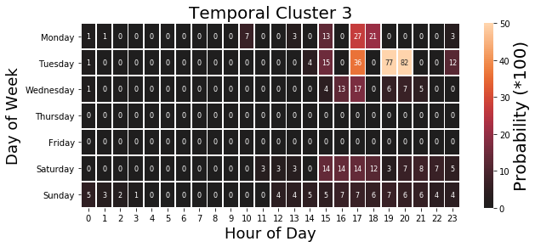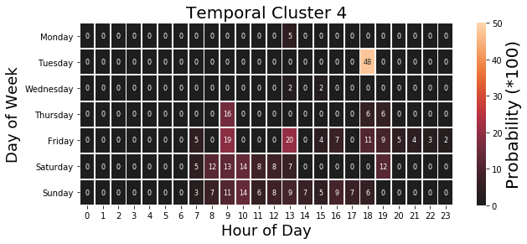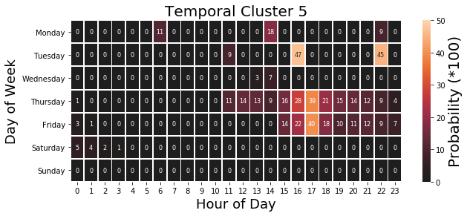

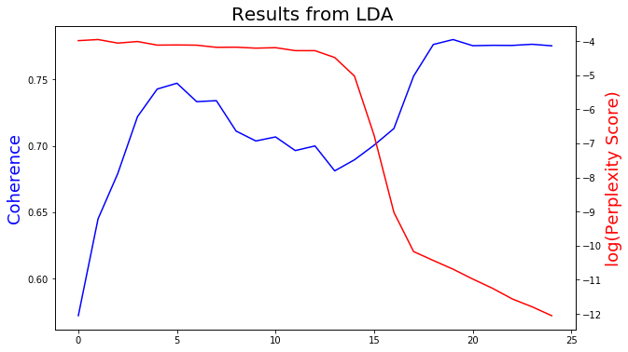

*Classification of purpose of travel?:*

Random Forest, SVG, LSTM, RNN–CNN.