*Study Area:*

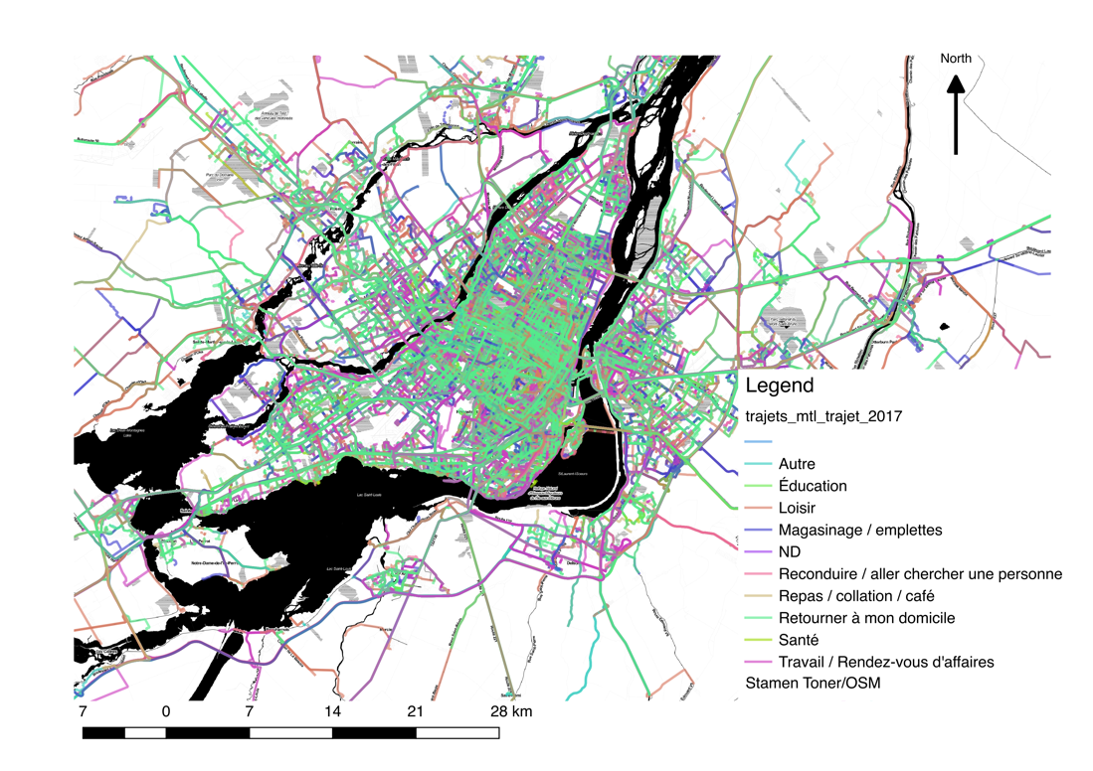

*Pre-processing:*

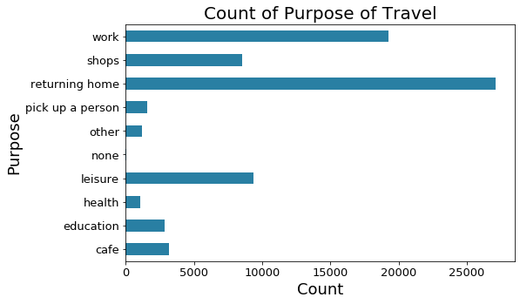

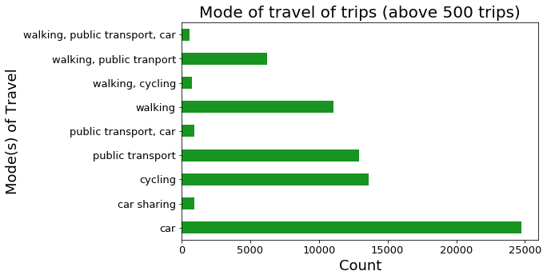

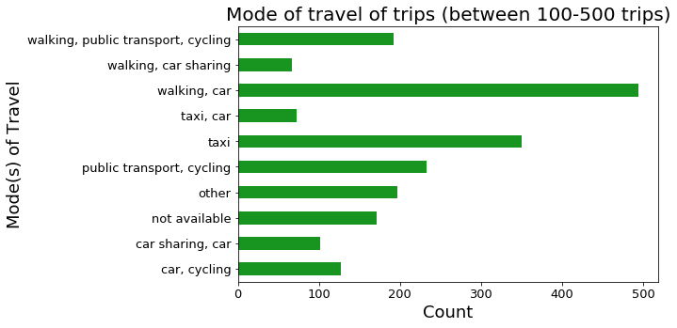

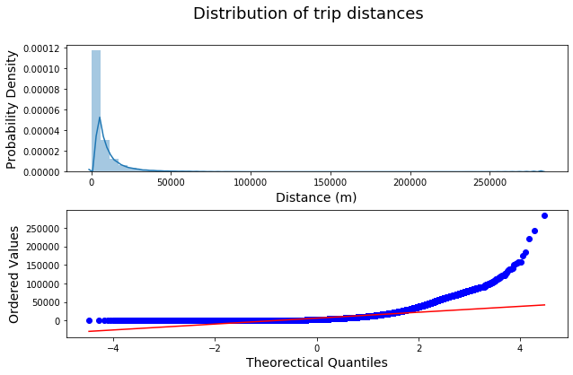

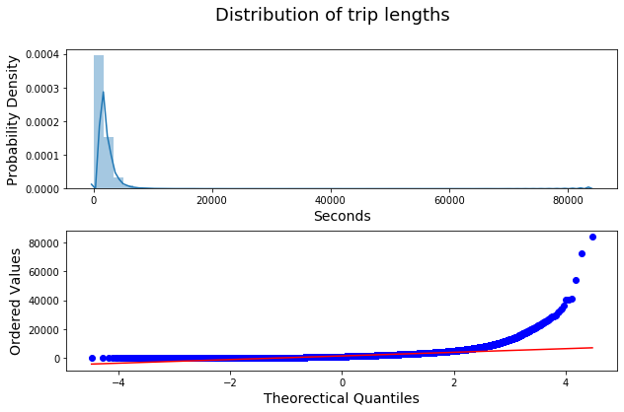

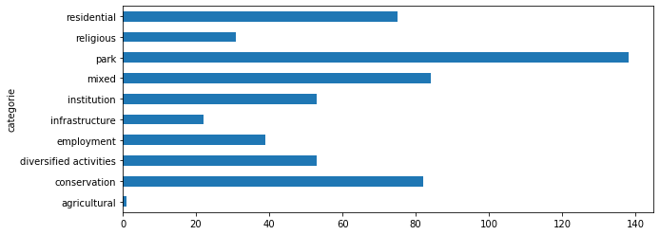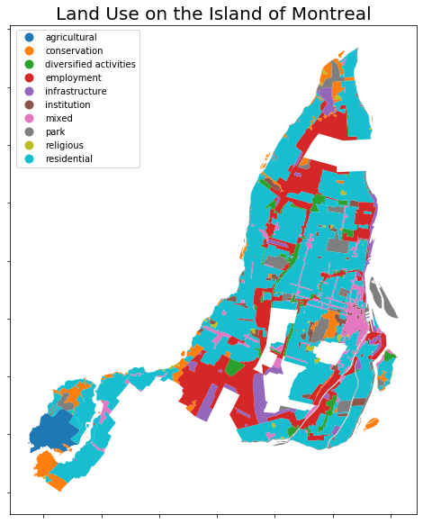

*Directionality:*

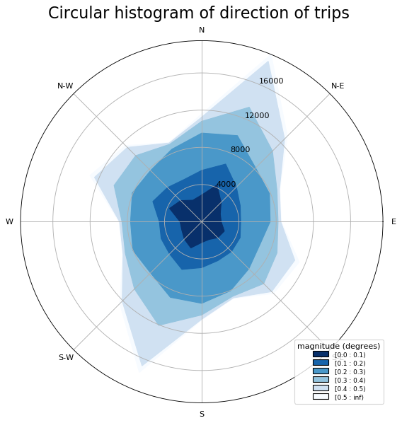

*Data Reference:*

## Potential Data Sources:

See <https://translate.google.com/translate?hl=en&sl=fr&u=http://donnees.ville.montreal.qc.ca/&prev=search>

Road Segment Speeds (2014-2019)

<https://translate.googleusercontent.com/translate_c?depth=1&hl=en&prev=search&rurl=translate.google.com&sl=fr&sp=nmt4&u=http://donnees.ville.montreal.qc.ca/dataset/temps-de-parcours-sur-des-segments-routiers-historique&xid=17259,15700023,15700043,15700186,15700190,15700256,15700259,15700262&usg=ALkJrhiD6b2E2xl6K6mR7yPZTw7LeTb6uQ>

### Useful

<https://www12.statcan.gc.ca/census-recensement/2011/geo/bound-limit/bound-limit-2011-eng.cfm>

<https://open.canada.ca/data/en/dataset?q=geobase&organization=nrcan-rncan&sort=>

<https://libraryguides.mcgill.ca/c.php?g=467943&p=4621105>

<http://rl.cs.mcgill.ca/comp598/fall2014/>

Geographical format:

Dissemination areas – around 4000 around Montreal

Census tract? Could be

Data is Not :

* Census met areas and agg

## MTL-Roads

Geobase is a filamentary network of right-hand segments commonly referred to as "sections" whose digitization is usually done at the street center. A section is then a portion of road with homogeneous characteristics described mainly by the following attributes: an official place name, address ranges and a reference to the administrative boundaries (boroughs, municipal boundaries, neighborhoods as appropriate).

Track Classification Table:

* Class 9 - Projected Street
* class 8 - Highways
* class 7 - Main arteries
* Class 6 - Secondary arteries
* Class 5 - Collectors
* class 4 - Private
* class 3 - Wharf
* class 2 - Business Places
* Class 1 - Certain pedestrian routes
* Class 0 - Local Streets

The street centers are digitized from ortho-photos, digital cartography and cadastre. The sense of digitization respects the increase in building numbers. The direction of flow is defined according to the scanning direction as follows:

* 1 -> one way in the direction of digitization
* -1 -> one way in the opposite direction of digitization
* 0 -> double meaning

The segmentation of roads into "sections" is mainly based on the following criteria:

a) Beginning or end of the route;

b) Intersection with another road;

(c) Change of administrative boundaries;

d) Physical change of the road;

e) Beginning and end of a work of art (bridge, viaduct, tunnel ...);

f) Section having the same node at the start as at the finish;

g) Change of place name;

h) Significant change in the sequence of civic numbers that may cause geocoding problems. (superposition of civic numbers);

i) Intersection level with a railway line.

• Id_troncon (Id_trc) - (Numeric): Unique, primary key Invariant Values ​​between 1 and 499,000 for Longueuil, between 500,000 and 999,999 for Laval and between 1,000,000 and 9,999,999 for Montreal. These values ​​are assigned sequentially without reuse.

• Type_voie (Typ_voie) - (Text variable): Generic official place names, without abbreviation

• Lien_voie (Lie_voie) - (Variable text): Particle of official place names, without abbreviation

• Nom_voie (Nom_voie) - (Text variable): Specific official toponymy, without abbreviation

• Direction_voie (Dir_voie) - (Text variable): Orientation of the official place names, without abbreviation

• Début_gauche (Deb_gch) - (Numeric): Actual civic number located at the beginning and the left of the section

• Fin_gauche (Fin_gch) - (Numérique): Actual civic number located at the end and to the left of the section

• Début_droite (Deb_drt) - (Numeric): Actual civic number at the beginning and the right of the stub

• Fin_droite (Fin_drt) - (Numeric): Actual civic number located at the end and to the right of the stub

• Limite_gauche (Lim_gch) - (Variable text): Administrative limit (municipality) located to the left of the section

• Limite_droite (Lim_drt) - (Variable text): Administrative limit (municipality) located to the right of the section

• Arrondissement_gauche (ARR_GCH) - (Texte variable): Administrative limit of the borough located on the left of the section (N / A if not applicable because outside the City of Montreal - For the cities of Longueuil and Montreal, these are the boroughs, for the city of Laval these are former cities)

• Arrondissement_droite (ARR_DRT) - (Text variable): Administrative limit of the district located on the right of the section (N / A if not applicable because outside the City of Montreal)

• Classe (CLASSE) (Digital): Class of the road (see description above)

• Sens_circulation (SENS_CIR) (Numeric): The direction of circulation is defined according to the sense of digitization as follows:

* 1 -> one way in the direction of digitization
* -1 -> one way in the opposite direction of digitization
* 0 -> double meaning

## MTL-Street-Parking:

Data set geolocating road signs regulating street parking. It should be noted that [road signs](https://translate.googleusercontent.com/translate_c?depth=1&hl=en&prev=search&rurl=translate.google.com&sl=fr&sp=nmt4&u=http://donnees.ville.montreal.qc.ca/dataset/panneaux-de-signalisation&xid=17259,15700023,15700043,15700186,15700190,15700256,15700259,15700262&usg=ALkJrhh498rUAg-QuN5ufL2ic0y4wLZW4g) as well as other additional files that provide more details on the coding of the signs are available in a separate set. The images and the visual catalog of all panels are also available.

Signage is a borough managed responsibility. Each borough is responsible for updating the data relating to on-street parking regulations. These are shared in a shared system (SIGNALEC).

It should be noted that the data for some boroughs are incomplete. In addition, no data is currently available for the borough of Île-Bizard-Sainte-Geneviève.

**IMPORTANT** : The data presented in this set is indicative for the best information available in the centralized system that is currently being redesigned. It is possible that there are some inconsistencies with the ground reality.

### Data Dictionary

**Signaling-Parking**

* POTEAU_ID_POT (Numeric): Identification number of the post
* POSITION_POP (Numeric): Number of the position of the panel on the post
* PANNEAU_ID_PAN (Numeric): Panel identification number
* PANNEAU_ID_RPA (Numérique): RPA identification number of the panel
* DESCRIPTION_RPA (Variable Text): RPA Panel Description
* CODE_RPA (Variable Text): Panel RPA Code
* FLECHE_PAN (Numeric): Code of the arrow of the panel
* TOPONYME_PAN (Variable text): Panel toponymy code
* DESCRIPTION_CAT (Variable text): Description of the panel category
* POTEAU_VERSION_POT (Numeric): Version of the post
* DATE_CONCEPTION_POT (Date): DATE_CONCEPTION_POT design date
* PAS_SUR_RUE (boolean): Indicates if the post is on the street
* DESCRIPTION_REP (Value List): REP description of the panel
* DESCRIPTION_RTP (Value List): Description RTP
* NOM_ARROND (Variable text): Rounding the panel
* Longitude (Numeric): Longitude (WGS84) of the post
* Latitude ( Latitude ): Latitude (WGS84) of the post
* X (Numeric): X coordinate (NAD83 MTM8) of the column
* Y (Numeric): Y coordinate (NAD83 MTM8) of the column

**Signage and RPA codification of signs**

* PANNEAU_ID_RPA (Numérique): Identifier of the RPA panel
* DESCRIPTION_RPA (Variable Text): RPA Description
* CODE_RPA (Variable text): RPA Code

**Signage-RTP coding of panels**

* DESCRIPTION_RTP (Numeric): Description of the RTP coding

## MTL-Land-Use

<https://translate.googleusercontent.com/translate_c?depth=1&hl=en&prev=search&rurl=translate.google.com&sl=fr&sp=nmt4&u=http://donnees.ville.montreal.qc.ca/dataset/affectation-du-sol&xid=17259,15700023,15700043,15700186,15700190,15700256,15700259,15700262&usg=ALkJrhjmsV04tnUQyW4dggMc1zalXZgxkg>

The land use shown in this map has ten categories. They are explained in [Section 3.1.1 (Land Use)](https://translate.googleusercontent.com/translate_c?depth=1&hl=en&prev=search&rurl=translate.google.com&sl=fr&sp=nmt4&u=http://ville.montreal.qc.ca/pls/portal/docs/PAGE/PLAN_URBANISME_FR/MEDIA/DOCUMENTS/180219_CARTE_3_1_1.PDF&xid=17259,15700023,15700043,15700186,15700190,15700256,15700259,15700262&usg=ALkJrhj-TBDkaVvKUbJ2BlQeZgiwTPLtPQ) of the Master Plan.

The first four are inclusive in nature and correspond to distinct urban environments (residential, mixed, diversified and employment sectors). The other five, essentially exclusive, apply to areas reserved for specific activities (large institutional equipment, convent, monastery or place of worship, agricultural, conservation, large green space or waterfront park, large right-of-way or large public infrastructure ).

Consult the [interactive](https://translate.googleusercontent.com/translate_c?depth=1&hl=en&prev=search&rurl=translate.google.com&sl=fr&sp=nmt4&u=http://ville.montreal.qc.ca/portal/page%3F_pageid%3D9517,142601883%26_dad%3Dportal%26_schema%3DPORTAL&xid=17259,15700023,15700043,15700186,15700190,15700256,15700259,15700262&usg=ALkJrhhep1hNxgmrkWD2EWAFz9wiH57agA) map of the Master Plan to view the thematic data.

Based on the orientations of the Plan, the land use map expresses the desired vocation in the sectors to be built or transformed and confirms that of the established sectors.

According to the concept adopted, the assignment categories reflect the general nature of the milieus, thus moving away from a form of assignment whose too normative character would lead to an unnecessarily thin division of the territory. Inclusive, these categories promote diversity and bring together a variety of activities that can take place within the same area, subject to the rules of complementarity or compatibility specified in the urban planning by-laws adopted by the boroughs.

## MTL-Cultural Sites:

List of libraries, museums, theaters and exhibitions (cultural centers, cultural centers), and other municipal places.

Export of data from the website: [http://ville.montreal.qc.ca/culture/cultural-centre](https://translate.googleusercontent.com/translate_c?depth=1&hl=en&prev=search&rurl=translate.google.com&sl=fr&sp=nmt4&u=http://ville.montreal.qc.ca/culture/lieu-culturel&xid=17259,15700023,15700043,15700186,15700190,15700256,15700259,15700262&usg=ALkJrhiPdxA99yp1bqA_5i9GYI_gPDYa1g)

## MTL Smart Cities Challenge:

<https://translate.googleusercontent.com/translate_c?depth=1&hl=en&rurl=translate.google.com&sl=fr&sp=nmt4&tl=en&u=https://www.donneesquebec.ca/recherche/fr/dataset/vmtl-sondage-defi-villes-intelligentes&xid=17259,15700023,15700043,15700186,15700190,15700256,15700259,15700262&usg=ALkJrhgW-mfRZ1gJ6vWmiEpdYJJMRpv-hg>

# MTL Taxis

<https://translate.googleusercontent.com/translate_c?depth=1&hl=en&rurl=translate.google.com&sl=fr&sp=nmt4&tl=en&u=https://www.donneesquebec.ca/recherche/fr/dataset/vmtl-postes-taxis&xid=17259,15700023,15700043,15700186,15700190,15700256,15700259,15700262&usg=ALkJrhgkrPgFoFZ0c5Hg4P9Q51F2UZ-4jw>