HydroPeak: a toolbox for hydropeaking detection and characterization in MATLAB and Python

Meili Feng1*, Yijun Yang2, 3, Jianfeng Ren2, Vladimir Brusic2

1 School of Geographical Sciences, University of Nottingham Ningbo China, 199 Taikang

East Road, Ningbo, China, 315100. (*meili.feng@nottingham.edu.cn)

2 School of Computer Science, University of Nottingham Ningbo China, 199 Taikang

East Road, Ningbo, China, 315100.

3 School of Computer Science, University of Nottingham, Wollaton Rd, Lenton, Nottingham, United Kingdom. NG8 1BB.

# Highlights

# HydroPeak is an open source toolbox in MATLAB and Python that aims for hydropeaking identification and its attribute characterisation.

# HydroPeak allows to quickly run large hydrologic dataset at various temporal resolutions.

# HydroPeak also enables identification of thermal alterations under hydropeaking effects.

# Application of the toolbox is demonstrated with hydropower plants in Switzerland.

# Abstract

This work presents an open-source tool to evaluate/predict hydropeaking attributes by quantifying the hydrograph variations that creates a paired matching the increase and decrease of the water level responses. The toolbox provides two user friendly versions with scripts and user manuals in MATLAB and Python, respectively. With this tool, we introduce the XXX based variance transformations which allows the method to be used in XXXX (forecasting) applications. The XXX model in the method is XXX. The main functionalities of the toolbox include: (1); (2); (3). Example of applications were illustrated in the 32 hydropower plants in Ningbo, China.

**Keywords:** Hydropeaking; Environmental model development; HydroPeak

**Software availability**

Software name: HydroPeak

Program language: Matlab, Python

Software required: MATLAB 2020a, Python 3.7

Developers: University of Nottingham Ningbo China

Available since: 2020

Access: via GitHub linkages:

Documentation: README in Github repository and guided example in the form of an editable Jupyter Notebook

Cost: Free

License: GPL-3.0

# 1. Introduction

Hydropower as one of the most important renewable energy sources is becoming increasingly demanding under the accelerated development globally. At the peak flow stages, river is carried with the highest water head to be released with powerful energy generation. This specific operational feature of the hydropower plant thus brings about regular anthropogenic alterations to the natural patterns of the riverine ecosystem. Impacts have also been identified on water quality status, ecological habitat suitability, and biodiversity sustainability. Furthermore, influence exerted by the hydropower operations on the downstream river section can be propagated to extended spatial ranges with profound impacts. To ensure the sustainable development of ‘green hydropower plant’, capturing the characteristics of hydropeaking at various temporal and spatial scales are vital for river basin management, river restoration, and hydropower management.

Hydrological alterations brought by the hydropower station that exerts rapid changes of the flow currents is well known as hydropeaking (Hauer et al., 2017). Hydropeaking related to hydropower production is often characterized by rapid increment of river stages and frequent changes within a short period of time that are associated with anthropogenic operations. Characterizing the features of varying hydrologic regime is one of the keys to identifying hydropeaking impacts at gauged stations. The modified hydrologic regime is critical to the sustainability of the ecosystem with altered thermal regimes, which is also called thermopeaking (Zolezzi et al., 2011). Quantifying the features of the hydro-and thermopeakings at the outlet of hydropower plant is challenging that requires high resolution of observations with the gauging stations but also good understandings of the operational practice from the hydropower station.

Changes of the discharge data had been developed from long-term and daily variations to sub-daily evaluations (Zimmerman et al., 2010; Carolli et al., 2015; Alonso et al., 2017). Rigorous statistics have been applied comprehensively to analyze the daily stream flow datasets (Richter et al., 1996; Carlisle et al., 2010; Dang et al., 2018). Previous studies on characterization of the hydropeaking are mostly developed from time series analysis that focusing on the magnitude, frequency, and rate of change for hydrologic observations (Zimmerman et al., 2010; Meile et al., 2011; Carolli et al., 2015; Vanzo et al., 2016). Computational methods for the analysis of hydrologic data, and hydropeaking characteristics packaged as software have become one of the essentials. Processes for these analyses are independently subject to index-based statistical calculations via various computational tools. There are limited methods that can generate comprehensive sets of evaluations on the hydropeaking characteristics but gives either single hydropeak event based results or statistical estimates from long-term time series data. Sauterleute and Charmasson (2014) characterized the peaking events through separated rapid increasing and decreasing events, but the integrated pairs are not specified to identify hydropoeaking. Advancement in the hydropeaking studies with publically available computational tools is imperative in terms of the characterization parameters, standardized applications, and thermal management incorporations that relates to the baseline/thresholds.

In this study, we developed the thermopeaking embodied hydropeaking toolbox that includes the water temperature variations for hydropeaking affected stations. We focus on automated characterization of the reservoir-induced hydropeaking and thermopeaking alterations to the river system at temporal scales that are crucial for defining remediation actions.

In the HydroPeak toolbox, a synthesis is given of the methods and results into a user-friendly toolbox in both MATLAB and Python. In this toolbox, it specifically focuse on the quantification of rapid fluctuations in river flows or stages that resulted with ecological implications. The programme HydroPeak is introduced with example case studies of hydropower plants in Switzerland.

# 2. General description of the toolbox

HydroPeak is an analytical toolbox that includes packages and user-friendly approach to detect hydropeaking impacts and to analyse the characteristics of the hydrograph under hydropower operations. The toolbox is written in Python and MATLAB programming languages that include built-in functions and examples of code for application. It consists of three sets of packages including: input data pre-processing, hydropeaking identification and feature characterization.

An overall schema of the framework is suggested for this toolbox – a flow chart here

## 2.1 Input data pre-processing

**Treatment of outliers:** After selecting time series, boxplot are used to visualize if there exists an outliers and it can be chosen whether to delete these outliers. In this case, points larger than 1.5 times the interquartile range are treated as outliers.

**Missing values:** If some missing values are identified with the time series, the toolbox provide several methods that can be chosen to fill the missing value: i) forward filling: fill the missing discharge value by the previous one. ii) backward filling: fill the missing value with the next discharge. iii) average filling: filling the missing value with the average of the previous and the next value.

**2.2 Searching hydropeaking pairs**

After data preparation, the ‘searchhydro() ’ function is applied to detect the hydropeaking with its beginning/ ending time and magnitude as the output. The ‘searchhydro()’ function detects hydropeaking by combining the neighboring increases and decreases. A single hydropeaking event is identified with a pair of rising and falling limbs. Once the rapid increase was detected, the next neighboring rapid decrease will be paired with it and make up a complete hydropeak event. The combined pairs will be labeled as ‘peak pair’ in the toolbox. After pairing all the increasing and decreasing events, the total number of hydropeaking within the selected time periods recorded.

Peaking identification tool is developed to identify the hydropeaking events and characteristic features afterwards.

**Separation of two events:** if successive phase of increase > a stated time interval Tint, and Magnitude of the first peak > p* (Sauterleute and Charmasson, 2014). Zolezzi: > 20% Peak

**Treatment of multiple increasing or decreasing events:** Comparison of the magnitude of two increasing and decreasing events are applied to separate multiple events (Julian et al., 2014). However, this method may miss recording the accurate starting point of hydropeaking. This is because the filtering method itself will create many increasing or decreasing events with small magnitudes when flatting the peak fluctuation. Simply ignoring the small magnitudes will lead to false recording of the later starting peak point. Therefore, in order to avoid missing the small increasing events, our function only ignore the events if the time interval between two events is beyond a certain threshold, which can be choosen between one to five hours.

**2.3 Filtering small fluctuations**

HydroPeak uses hourly time series by its default. After selecting the target period with starting and ending time, the number of timestamp was counted by the function and then temporal resolutions of the input data can be adjusted automatically. If the time series data provided are not hourly, HydroPeak will take the average to adjust of the temporal resolution into hourly dataset. HydroPeak also provide a customized version to let the users input the time resolution by hand.

The moving average approach is usually applied with environmental time series as the f**iltering method.** Zolezzi et al. (2011) used moving average method to filer hourly discharge dataset into daily resolution. But this method may lose information that minors the coarser temporal resolution of monitored stream flow data.

In previous studies, Zolezzi et al. (2011) used 20% as the threshold of the peak values. Sauterleute and Charmasson (2014) defined the threshold values as Cinc and Cdec (0.05-0.2) multiplied by the maximum rate of change. In HydroPeak, a degree of standard deviation is applied to eliminate natural causes via heavy rainfall or irregular release that leads to the increment of water levels. The filtering threshold was calculated by coefficient times the standard deviation based on all hydropeaking pairs detected in the first round. In this way, hydropeaking detected will be smoothed if the difference between the maximum and the minimum flow rate is within the threshold. In this case, only slight fluctuations caused by irrelevant impacts such as breezing will be filtered, which preserve most information. The circumstances for filtering will be classified in to nine circumstances in Table 1

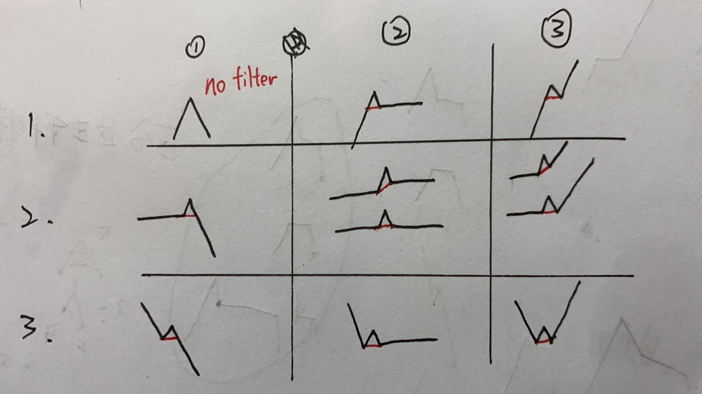

The plot after and before filtering will be shown in one plot with dash and solid line respectively, which allows the user to confirm whether the filtered plot is satisfying enough to move to feature classification parts. If the filtering output is not plausible, user can chose: i) Inputing a different rate of standard deviation to do the fiter again. ii) using the default/input standard deviation to do a second round fitering. Usually the plot seems plausible after trying two round of fitering.

**4**

Once filtering serval rounds to get rid of the small oscillations, the remaining variations are identified as hydropeaking. The information of each peaking will be recorded.

**2.5 Characterising hydropeaking and thermopeaking features**

If identified as a hydropeaking-affected station, HydroPeak calculates the characteristics for hydropeaking effects. For each pair of hydropeaking, from the perspectives of hydrological changes as well as ecologically relevant features. Quantification of hydropeaking employ 3 variables including hydropeaking magnitude, number of hydropeaks, peaking durations, and the rising and damping rates (Equation 1-4). In addition, the cumulative distribution functions (c.d.f) of the daily peak durations and paired hydropeaking numbers are plotted to reflect its frequency features.

1. : The magnitude of difference between the max and min flow discharge in the n-th hydropeaking pairs, where

This parameter indicates the magnitude of a peaking event n.

1. : The hydropeaking pair numbers in the nth day is given by

where represents the cumulative peak numbers at time t and represents the number of time interval in a single day based on the choosing time resolution. For example, for time resolution of 15 mins, we have 96 number of time interval in a single day.

: The average hydropeaking pair numbers in daily basis is:

These two parameters indicate the frequency of the occurring peaking during one day.

1. Peak durations are identified as the temporal distance from the starting point a rising limb to the start of decrease/drop in water level, during which the flow release is supposed to be continually discharged.

: The average peak duration in daily time scale:

where represents the peak duration in the nth hydropeaking pairs.

It describes the average peak duration for the peak appearing in one day.

1. : The average slope rising/damping rate for hydropeaking pairs in daily time scale is calculated by:

where n is the hydropeaking number in a single day. This parameter shows how rapid the flow changes.

Aside from hydropeaking characteristics, the toolbox also enables the option to evaluate the features of thermopeaking, which is highly associated with hydropeaking effects. Explain what exactly would be the output for thermopeakings?

# 3. Instructions on operational guide

# 4. Example of application

In this section, we provide example executives of the HydroPeak toolbox for two well- developed watersheds in Switzerland. These example sites are represented for riverine studies with hydropeaking effects, in which area is highly developed by hydropower operations. To help with the illustration of results, two representative gauging stations were selected with fully good river discharge and water temperature records. The input data used 15-mins as the temporal resolution, and the duration covers from 1st June to 31st August in 2001.

After inputting data and calculating the global standard deviation of the drop of each peaking pairs, the filtering script will be run. The following plots illustrate the filtering process and the results of the output. In the first case, 0.5 times standard deviation are selected as filtering criteria while 0.1 times standard deviation are selected. These plots illustrate that if the filtering threshold is too high, some of the rapid fluctuation will be smoothed. In the second plot, the filtering criteria was set too small so that only little fluctuation will be filtered. Therefore, 0.25 times standard deviation is usually chosen.

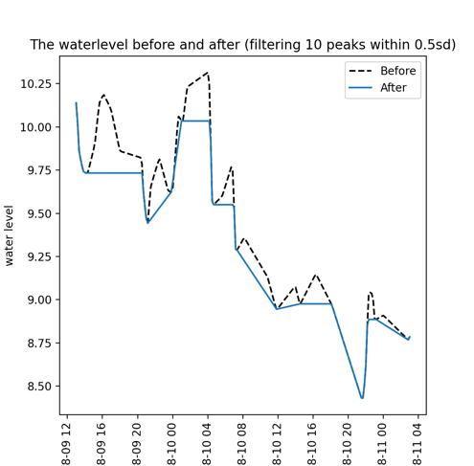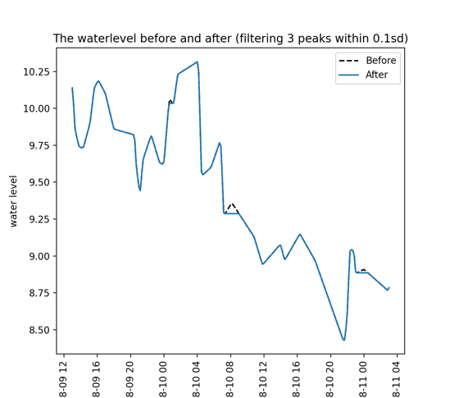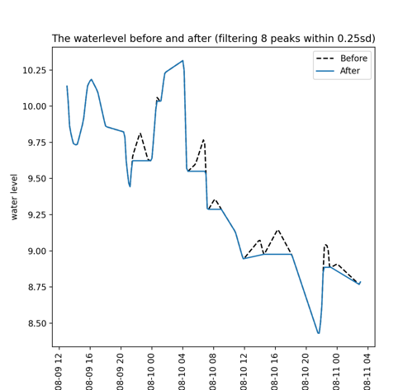

A second round filtering can be optionally applied if the first round is not satisfying, differences between two rounds are shown in the following plot.

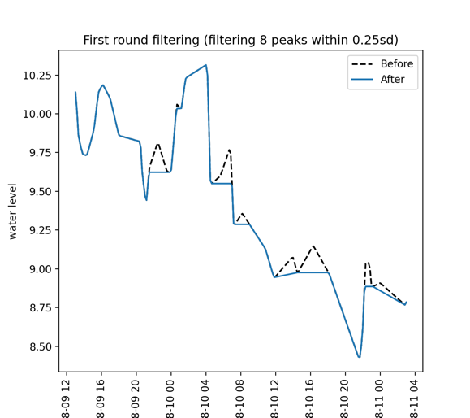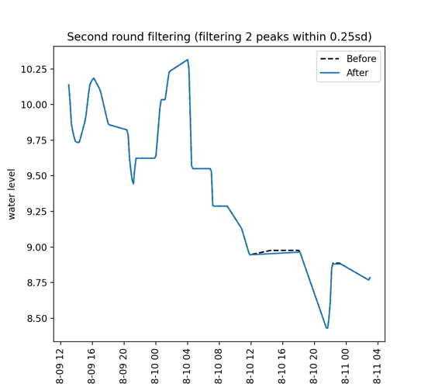

In the first case, since a suitable threshold is chosen, the second-round filtering does not have much effect. However, if the threshold is not so selected suitable or the plot looks poor, the second-round filtering can help further smoothing the data.

After smoothing the data, outputs are provided and the following plots illustrate dams with altered peaking trend and natural peak trend respectively. From these plots, great differences of the hydronum can be observed, which shows that altered peaking dams have more rapidly increasing and decreasing pairs. The differences will become more significant as the increase of time-resolution and time scales. In the case two, data from June to September and the same dam are used instead and greater differences can be observed.

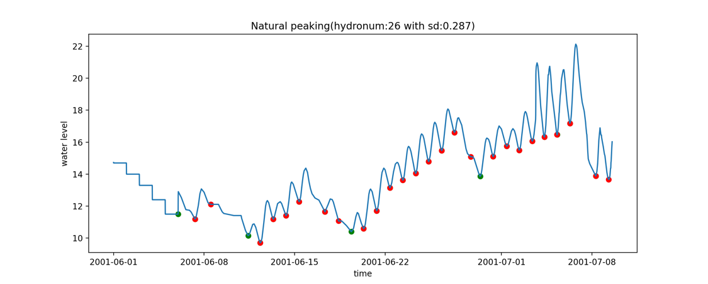

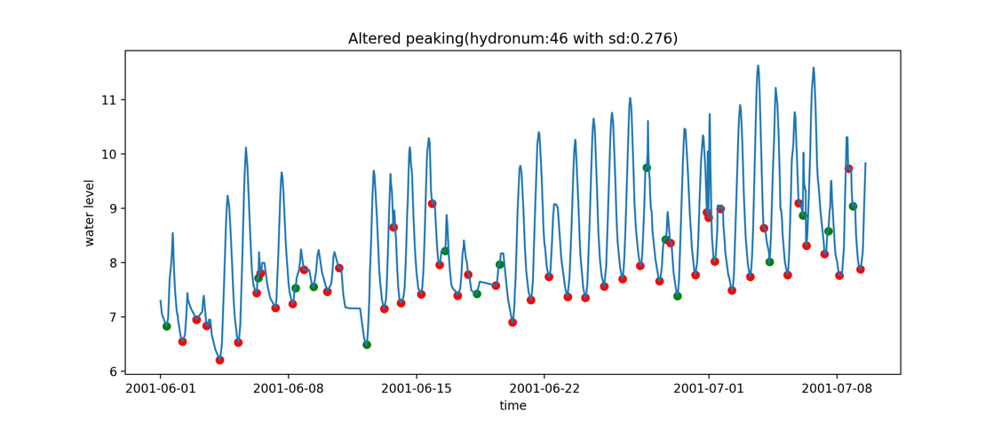

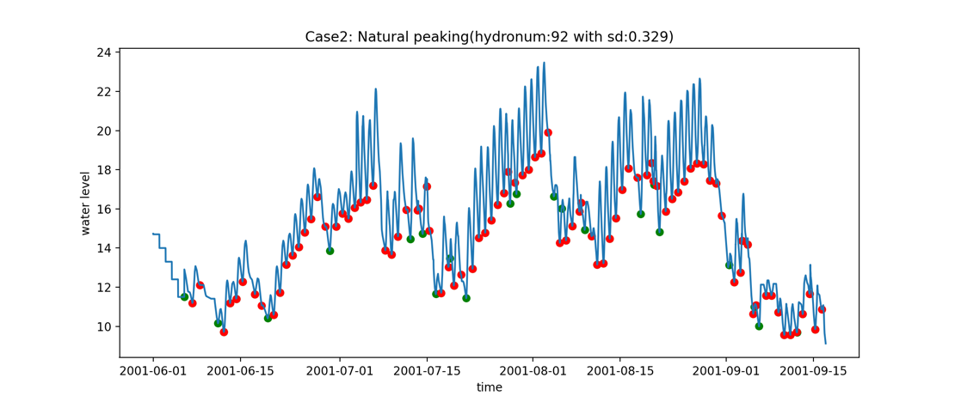

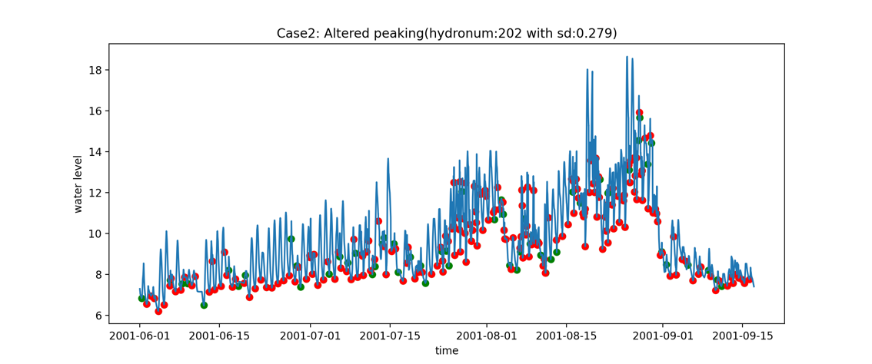

Meanwhile, the information of each peaking pairs are recorded and output as file [’output.csv’](Output.csv).

We also provide record of hydronum for each day and is named [’hydronum_daily’](Daily_hydronum.csv).

Similarly, it is optional to choose whether to apply the toolbox for themopeak analysis, the statistics and recording are provided the same as hydropeaking analysis.

Provide more details of the example case studies: **input data, results and analyses.**

# Conclusions

In this paper, we present a toolkit developed in both MATLAB and Python environment to extract the features of hydropeaking from streamflow records and associated them with hydropower operational events. A number of parameters/functions provide ….such as …. Results are shown for two watersheds in Switzerland, where manual hydropeaking characteristics were previously conducted. By applying HydroPeak to these two different catchments, the importance of …representation was shown. HydroPeak performs best in

Illustrate the potential for understanding the ecological effects of hydropeaking. This can be further analysed with ecohydrological and hydraulic-habitat approaches as modular platforms. In a management context, incorporation of multiple ﬂashiness thresholds in ﬂow recommendations may be advisable. Speciﬁc sites for ﬂow restoration can be chosen based on patterns of sub-daily ﬂow ﬂuctuations compared with unregulated sites.

In addition, it allows for strategic management options XXXXXX. This could be further enabled with environmental flows assessment with its ecological implications.

# Acknowledgement

The authors wish to acknowledge the efforts of XXXXX by helping with the setup of the programme at initial stage. Funding for this project was provided by the NSFC Youth Fund programme of “Environmental flows study for small green hydropower plants: integrated hydro-thermal regimes analysis” (project code 51909126), and the interdisciplinary study project IRC Flexible Fund “Integrating science and monitoring to predict emerging risks for water pollution and river ecosystem health” (budget code: E01200500006).

# References

Alonso, C., Román, A., Bejarano, M.D., de Jalon, D.G. and Carolli, M., 2017. A graphical approach to characterize sub-daily flow regimes and evaluate its alterations due to hydropeaking. Science of The Total Environment, 574, pp.532-543.

Carlisle, D.M., Falcone, J., Wolock, D.M., Meador, M.R. and Norris, R.H., 2010. Predicting the natural flow regime: models for assessing hydrological alteration in streams. River Research and Applications, 26(2), pp.118-136.

Carolli, M., Vanzo, D., Siviglia, A., Zolezzi, G., Bruno, M.C. and Alfredsen, K., 2015. A simple procedure for the assessment of hydropeaking flow alterations applied to several European streams. Aquatic sciences, 77(4), pp.639-653.

Dang, T.D., Cochrane, T.A. and Arias, M.E., 2018. Future hydrological alterations in the Mekong Delta under the impact of water resources development, land subsidence and sea level rise. Journal of Hydrology: Regional Studies, 15, pp.119-133.

Hauer, C., Siviglia, A. and Zolezzi, G., 2017. Hydropeaking in regulated rivers–From process understanding to design of mitigation measures. Sci. Total Environ, 579, pp.22-26.

Meile, T., Boillat, J.L. and Schleiss, A.J., 2011. Hydropeaking indicators for characterization of the Upper-Rhone River in Switzerland. Aquatic Sciences, 73(1), pp.171-182.

Richter, B.D., Baumgartner, J.V., Powell, J. and Braun, D.P., 1996. A method for assessing hydrologic alteration within ecosystems. Conservation biology, 10(4), pp.1163-1174.

Vanzo, D., Siviglia, A., Carolli, M. and Zolezzi, G., 2016. Characterization of sub‐daily thermal regime in alpine rivers: quantification of alterations induced by hydropeaking. Hydrological Processes, 30(7), pp.1052-1070.

Zimmerman, J.K., Letcher, B.H., Nislow, K.H., Lutz, K.A. and Magilligan, F.J., 2010. Determining the effects of dams on subdaily variation in river flows at a whole‐basin scale. River Research and Applications, 26(10), pp.1246-1260.

Zolezzi, G., Siviglia, A., Toffolon, M. and Maiolini, B., 2011. Thermopeaking in Alpine streams: event characterization and time scales. Ecohydrology, 4(4), pp.564-576.