Software Requirements Specification
for
Advanced Employee Management System
Version 1.0 approved
Prepared by Thomas Zundel
Centralia College
4/15/2022
Table of Contents
Table of Contents ii
Revision History ii
1. Introduction 1
1.1 Purpose 1
1.2 Document Conventions 1
1.3 Intended Audience and Reading Suggestions 1
1.4 Project Scope 1
2. Overall Description 1
2.1 Product Perspective 1
2.2 Product Features 1
2.3 User Classes and Characteristics 2
2.4 Operating Environment 2
2.5 Assumptions and Dependencies 2
3. System Features 2
3.1 Employee 2
3.2 Salaries 2
3.3 Reports 3
3.4 Calendar 3
4. External Interface Requirements 3
4.1 User Interfaces 3
4.2 Hardware Interfaces 4
4.3 Software Interfaces 4
5. Other Nonfunctional Requirements 4
5.1 Performance Requirements 4
5.2 Security Requirements 4
5.3 Software Quality Attributes 4
6. Other Requirements 4
Appendix A: Issues List 4

Revision History
Name | Date | Reason For Changes | Version

Introduction

Purpose
This employee management system will be designed for use in any small business setting for a manager and employees to easily keep track and schedule important employee details such as salary and vacation time.

Document Conventions
AEMS will stand for Advanced Employee Management System

Intended Audience and Reading Suggestions
This document is for users and developers to get in insight on the thought process taken in developing this program. This is a living document meaning it will be changing as the program develops and should be read as such.

Project Scope
This project is meant to be a 100-hour capstone with that in mind I have I think 4 major parts I want to incorporate: Employee, Salaries, Vacation time and a Report system. I think the largest problem I could face is in the vacation time set up.

Overall Description

Product Perspective
This product is intended for managers and employees to use together to better keep track of both pay and vacation time for employees.

Product Features
The AEMS will have 4 main features, the employee feature will have a list of your employees and their job positions along with a link to individual time off calendars. The salaries feature will be where you can set the pay for different positions. The report feature that will be able to do estimated cost of employees for each month. Finally, the calendar feature that will be the master calendar to set holidays and other time all for all employees or request time off as an employee.

User Classes and Characteristics
<Identify the various user classes that you anticipate will use this product. User classes may be differentiated based on frequency of use, subset of product functions used, technical expertise, security or privilege levels, educational level, or experience. Describe the pertinent characteristics of each user class. Certain requirements may pertain only to certain user classes. Distinguish the favored user classes from those who are less important to satisfy.>

Operating Environment
This will be a web-based site that will require login I will be using C# ASP.NET and MVC to build it.

Assumptions and Dependencies
The only thing I am assuming is the I might be able to use a part of a project I did a few quarters back to help me with the reporting system in this project but as of right now it’s unclear if It will be of much help to me.

System Features

Employee
3.1.1 Description and Priority
The employee feature will allow managers to see all employees and assignee them to separate roles and manage time off for individual employees
3.1.2 Stimulus/Response Sequences
The user will have the ability to navigate to the employee page and from there the user will be able to click on the individual employee calendar buttons.
3.1.3 Functional Requirements

REQ-1:
REQ-2:

Salaries
3.1.1 Description and Priority
This system will allow a manager to create and manage roles and adjust pay of employees
3.1.2 Stimulus/Response Sequences

3.1.3 Functional Requirements

REQ-1:

Reports
3.1.1 Description and Priority
This system will allow a manager to generate monthly or weekly employee pay reports
3.1.2 Stimulus/Response Sequences

3.1.3 Functional Requirements

REQ-1:

Calendar
3.1.1 Description and Priority
The calendar system will display holidays and dates employees have scheduled off and also will have a place employees can go to see PTO and schedule time off with PTO
3.1.2 Stimulus/Response Sequences
<List the sequences of user actions and system responses that stimulate the behavior defined for this feature. These will correspond to the dialog elements associated with use cases.>
3.1.3 Functional Requirements
<Itemize the detailed functional requirements associated with this feature. These are the software capabilities that must be present in order for the user to carry out the services provided by the feature, or to execute the use case. Include how the product should respond to anticipated error conditions or invalid inputs. Requirements should be concise, complete, unambiguous, verifiable, and necessary. Use “TBD” as a placeholder to indicate when necessary information is not yet available.>

<Each requirement should be uniquely identified with a sequence number or a meaningful tag of some kind.>

REQ-1:

External Interface Requirements

User Interfaces
See UI 1.1 – UI 1.5

Hardware Interfaces
This program will be a web-based application so it will require a computer with internet capabilities to be functional

Software Interfaces
This program will be made in Visual Studio 2022.

Other Nonfunctional Requirements

Performance Requirements
Performance will not be a priority, but I would obviously like to build a fast product as nobody likes load times.

Security Requirements
This product will need basic login security’s as it will be accessible as both a user and a admin.

Software Quality Attributes
I think the focus of this product will be simply use ability I want a simple design and easy use

Other Requirements
This area of the document will be used for small notes / reminders and a todo list assume notes passed here will be removed in the final SRS
Appendix A: Issues List
To-do:
Finish system features in SRS
Add project to git
Set up MVC project using identity
Make models for employee and salaries pages

UI 1.1 Home:

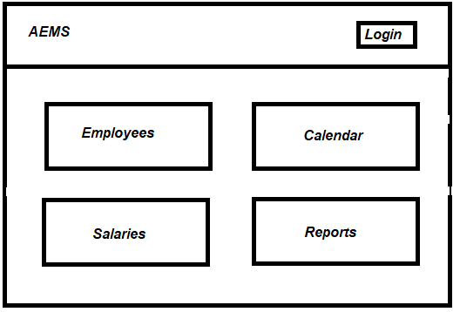

UI 1.2 Employees:

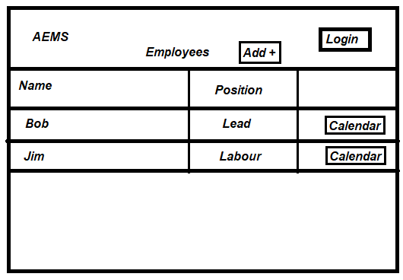

UI 1.3 Salaries:

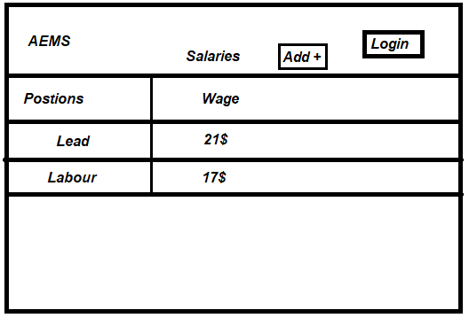

UI 1.4 Reports:

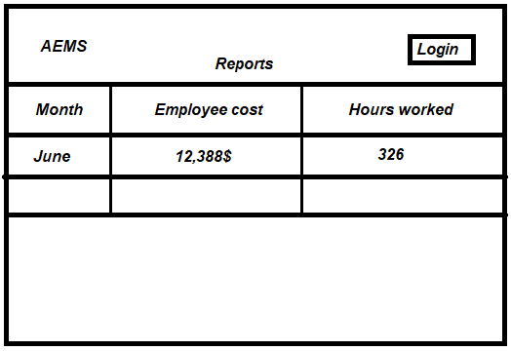

UI 1.5 Calendar:

