# 



SPENDING MANAGEMENT

Documentation

Authors : Lai Van Son (leader)

Member : Phung Van Tien

Nguyen Trong Hung

Luong Thanh Tung

Batch: C2110I

Introductor

**Index**

**1. General introduction to spending management application.**

**2. Business Function Diagram.**

**3. Synthesized data processing diagram.**

**4. Data Flow Diagram.**

**5. Entity Relationship.**

**6. Some Codes and Objects are specific to project operations.**

**7. Screen Demo.**

1. **General introduction to spending management application.**

Spending management application is the topic we choose when implementing the project 2. This application is very suitable for today's digital age, it will be of great help to everyone. Our application allows users to store their own money , control their spending by day , month , year through transactions added by users when using the application .

In the process of implementing the features of the application, we encountered certain difficulties, we received very timely help from Mr. Ngo Trung Kien. For successful implementation, we need the enthusiastic guidance of Mr. Ngo Trung Kien.

1. **Business Function Diagram.**

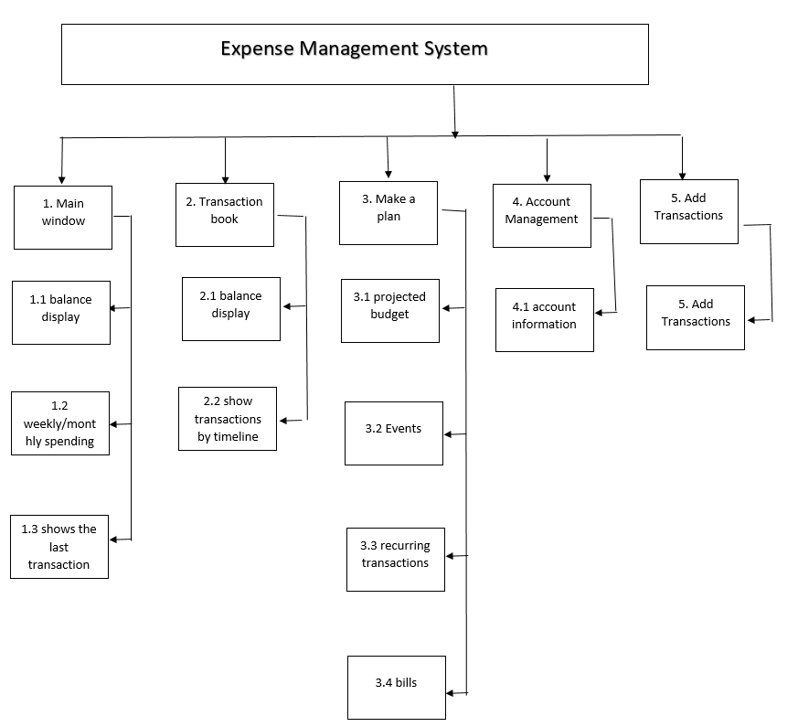

This is a chart that helps us to decentralize the functions included in the application so that I can divide work among team members and control the progress of the team in a simple way.

1. **Synthesized data processing diagram.**

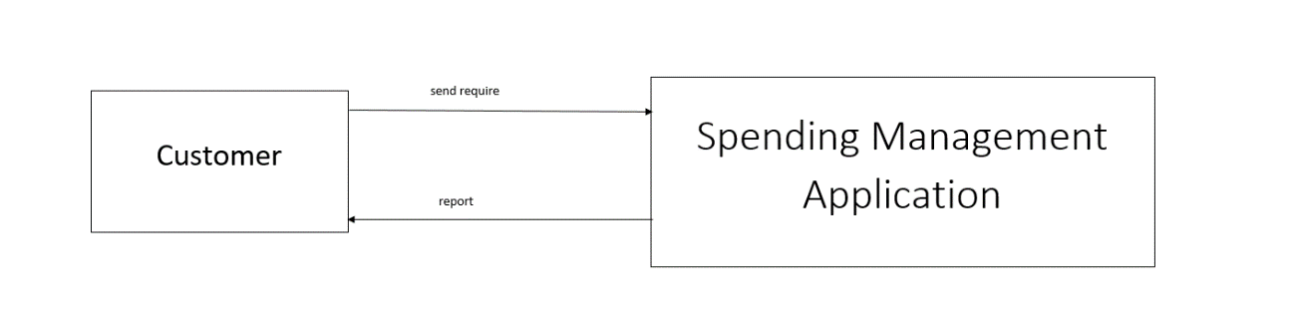

In general , our application represents the relationship between the customer and the system . Customers only need to make a request, our system will send feedback to the customer when the request is done.

For example, a customer can ask the system to enter another amount into an existing account, then the system will perform the act of adding that money and will display the new amount as a response for adding money. into the client's application.

1. **Data Flow Diagram.**
   1. Function Login

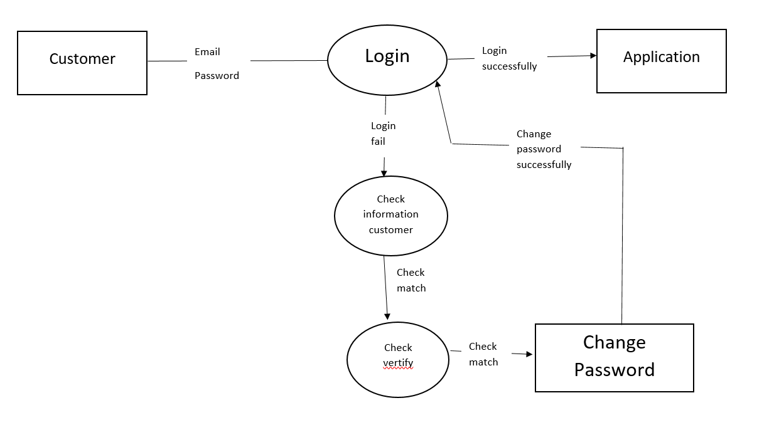

* 1. Function Register

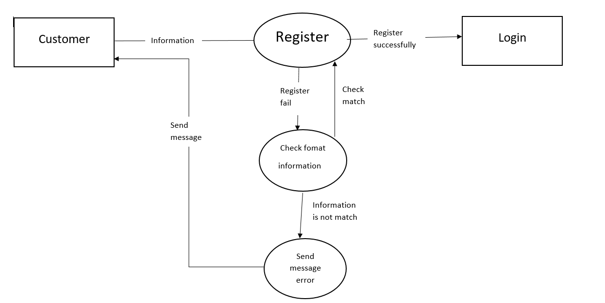

* 1. Add Transaction

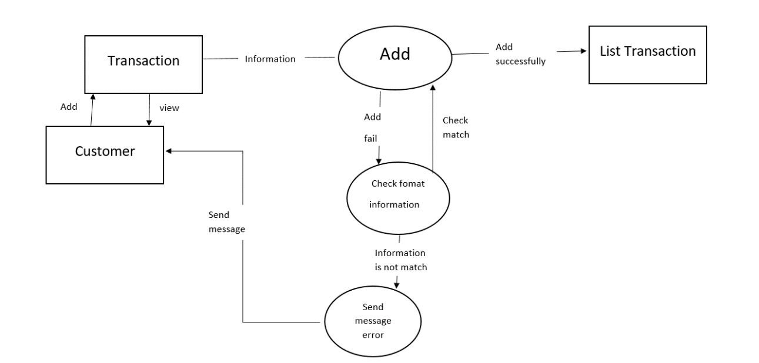

* 1. Search Transaction

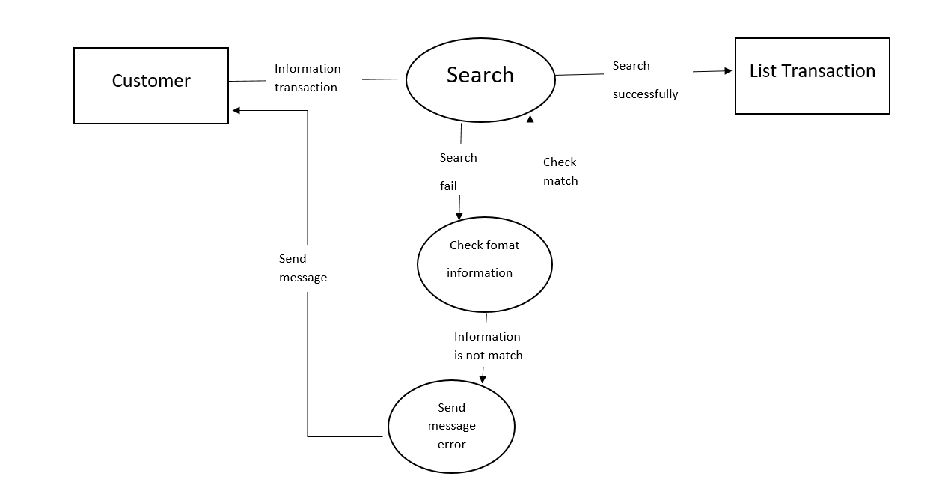

1. **Entity Relationship.**
   1. The relationship entity diagram

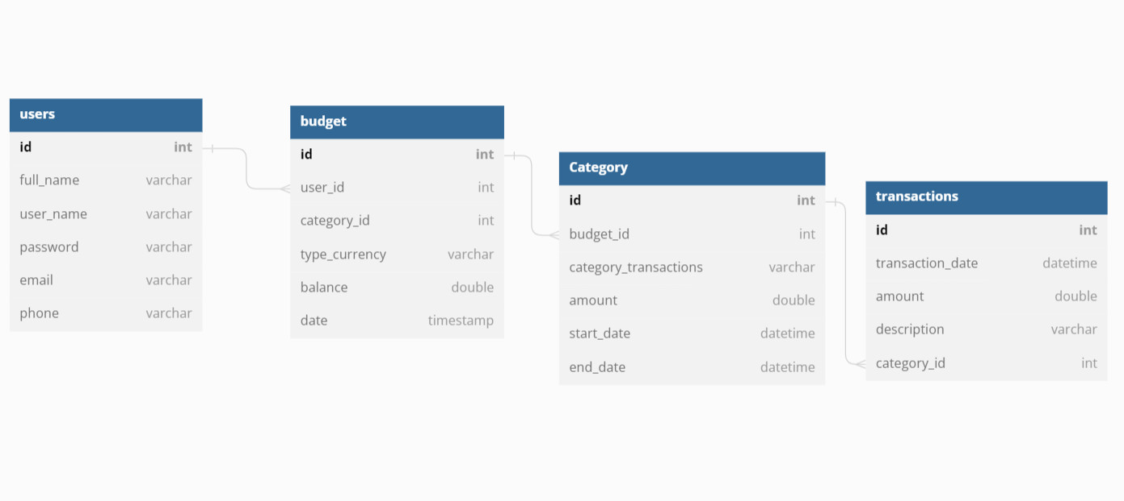

* 1. Detail Entity

Table Name : User