Not All Play is Equal: In-game Player Behaviour Predicts Wellbeing Differences
Thomas Hakman
Matti Vuorre
Andrew K. Przybylski
2026-10-19
Abstract
Large-scale studies using digital trace data consistently find that playtime alone is not meaningfully associated with wellbeing, yet these studies rarely examine what happens inside a game: the granular in-game behaviours that might differentiate players’ experiences. The Integrated Model of Player Experience implies that players who engage with the same game in qualitatively different ways may report different wellbeing outcomes. We tested this using telemetry-driven profiling of session-level behavioural data from 412 players of Plants vs. Zombies: Battle for Neighborville. Cluster analysis on 10 standardised performance and mode-preference metrics identified three playstyles: exploratory, high-performing, and competitive. Exploratory players reported greater wellbeing and enjoyment than competitive players. However, playstyle did not moderate the relationship between playtime and either outcome. These findings indicate that how players engage with a game’s mechanics and modes is associated with different average levels of wellbeing, even though playstyle does not appear to alter the playtime–wellbeing relationship.

Introduction
The debate about whether video games harm or improve wellbeing has persisted for decades, yet empirical findings remain mixed and often shift with the methodological approaches used to study them. Earlier studies relying on players’ retrospective estimates of their own playtime and behaviour produced contradictory findings. Several studies reported negative associations between self-reported playtime and measures of mental health or wellbeing (Ferguson & Colwell, 2019; Liu et al., 2019; Mathur & VanderWeele, 2019), with some reporting negative associations only among highly engaged players (Colder Carras et al., 2017; Przybylski & Weinstein, 2017). Other studies found positive associations (Halbrook et al., 2019; Villani et al., 2018), with some reporting these only for moderate usage (Przybylski & Weinstein, 2017) or specific game genres such as MMOs (Raith et al., 2021). This complexity extends to the clinical literature on internet gaming disorder (IGD). Gamers at risk of disordered gaming self-report markedly elevated playtime, averaging roughly 35 to 42 hours per week. Still, playtime alone remains a poor diagnostic marker: it shares only around 10% of its variance with IGD symptom counts, and a substantial proportion of heavily engaged gamers, averaging 26 hours of play per week, report no psychological distress at all (Katz et al., 2024; Pontes et al., 2022). To overcome the well-documented inaccuracy of self-reported measures (Johannes et al., 2021; Parry et al., 2021), later work utilised digital trace data (i.e., objective behavioural logs collected directly from game platforms). These studies demonstrated that associations between the average player’s playtime and wellbeing are small and unlikely to be practically meaningful (Ballou, Földes, Vuorre, et al., 2026b; Egami et al., 2024; Johannes et al., 2021; Larrieu et al., 2023; Vuorre et al., 2022). For example, merging publisher-logged playtime with survey responses in two titles revealed a small positive association between play and affective wellbeing (Johannes et al., 2021). Linking six weeks of logged play from 38,935 players across seven titles to three waves of self-reported wellbeing produced little to no evidence of a causal connection (Vuorre et al., 2022), and logged playtime showed no longitudinal effects on quality of life among intensive gamers (Larrieu et al., 2023). Even where causal evidence exists, from game console lotteries in Japan analysed as a natural experiment, increased play modestly improved rather than harmed mental wellbeing (Egami et al., 2024).
These small, mixed, and often null results do not necessarily imply that playing video games is irrelevant to wellbeing. Rather, they suggest that the most measured dimension of play, its quantity, might not be the most important factor. In a large-scale analysis of adult Nintendo players, playtime was indeed not meaningfully related to multiple wellbeing indicators, but players’ subjective evaluations of gaming’s life-fit (e.g., the perceived harmful or beneficial value of gaming across various life domains outside of play) were (Ballou, Vuorre, et al., 2025). The underlying problem is that, conceptually, ‘video game play’ does not capture a single phenomenon, but instead heterogeneous exposures such as ‘playing with friends’, ‘succeeding or failing at the game’s mechanics’, or ‘playing to alleviate study-related stress’. More generally, playtime can be thought to consist of context-centred exposures (e.g., when and with whom one plays), game-centred exposures (e.g., game modes, mechanics, and business models), and player-centred exposures (e.g., playstyles, motivations, and player experience) (Ballou, Hakman, et al., 2025). When studies collapse these layers into a single playtime variable, they conflate qualitatively distinct exposures and risk both theoretical ambiguity and empirical inconsistency (Ballou, Hakman, et al., 2025).
This highlights a crucial gap. Previous digital trace research has captured playtime across platforms and titles, but rarely what happens inside a game: the granular in-game behaviours (i.e., the decisions players make and the actions they perform during play) and experiences that might explain why some players benefit from play while others do not. Quantity alone is insufficient; two players can accumulate the same playtime yet have markedly different player experiences. To reconcile the mixed historical findings with the contemporary null results, research needs to start modelling the quality of play using in-game digital trace data. Nevertheless, how researchers should best study in-game player experience empirically without reverting to subjective self-reports remains an open question.
One theoretically grounded operationalisation comes from the Integrated Model of Player Experience (IMP) (Elson et al., 2014), which identifies three categories of game characteristics that shape the playing experience: narrative (story and setting), mechanics (rules, interaction demands, and feedback), and context (the social and situational embedding). Where user-centric theories such as self-determination theory (Ryan et al., 2006) and uses and gratifications (Ruggiero, 2000) focus primarily on motivations and player states, the IMP is game-centric and focuses on how interaction with specific in-game characteristics during play alters the play experience and subsequent wellbeing outcomes (Elson et al., 2014). In this sense, the IMP opens the “black box” of in-game behaviour by connecting the game characteristics players encounter during play to the outcomes that follow, thereby guiding empirically testable hypotheses about these relationships (Elson et al., 2014). Crucially, the IMP positions mechanics as the foundational element of player experience; without mechanics there is no play, whereas narrative and context contribute situationally. A conceptually meaningful operationalisation of play quality should therefore incorporate digital trace data on mechanics-relevant indicators (e.g., performance metrics), contextual indicators (e.g., mode selection), and narrative indicators (e.g., dialogue engagement), where appropriate.
Within game analytics research, a similar categorisation process is known as telemetry-driven profiling, where collections of in-game behaviours, events, and experiences are condensed into behavioural profiles, or playstyles, that describe how players engaged with a game during the measurement period (Drachen et al., 2014; Ravari et al., 2022). Playstyles are distinct from player types. Player types refer to stable individual characteristics assessed via self-reports, as in Bartle’s taxonomy (Bartle, 1996), which categorises players as Achievers, Explorers, Socializers, or Killers based on their preferences for achievement versus exploration and interaction with the game world versus other players; Yee’s motivation model (Yee, 2006), which identifies three primary components of player motivation (i.e., achievement, social, and immersion); and the Hexad framework (Tondello et al., 2016), which proposes six gamification user types grounded in self-determination theory. The utility of such typologies has, however, been called into question by recent evidence of their temporal instability. Santos et al. (2023) found that 72% of participants changed their player type classification over six months, suggesting that self-reported types may not reliably reflect actual in-game behaviour.
In contrast, telemetry-derived playstyles capture emergent behavioural patterns as they occur, providing a more ecologically valid representation of how players engage with games. As such, playstyles offer a quantifiable, data-driven way to characterise how players pursue a game’s objectives (Sifa et al., 2018). Previous work has used telemetry-driven profiling to examine the relationship between playstyles and personality (Bean & Groth-Marnat, 2016; van Lankveld et al., 2011), motivation (Melhart et al., 2019; Yee, 2016), national culture (Ravari et al., 2022), and individual and team performance (Jiang et al., 2021). However, whether and how playstyles relate to wellbeing and enjoyment has remained untested, in large part because datasets combining granular session-level behavioural telemetry with validated measures of wellbeing are exceedingly rare (Norwood et al., 2026).

The Present Study
In this study, we address three research questions using one such dataset (Johannes et al., 2021). One, can distinct playstyles be identified from in-game behavioural telemetry within a single game title? Through this primarily methodological question we examine whether the quality of play can be measured from behaviour alone rather than through self-reports, by applying telemetry-driven profiling (Drachen et al., 2014; Sifa et al., 2018) to the characteristics the IMP positions as central to the player experience, namely (a) mechanics, through in-game performance metrics, and (b) context, through mode preference (Elson et al., 2014). Two, do players with different playstyles report different levels of wellbeing or enjoyment? If, as the IMP proposes, interaction with a game’s characteristics shapes subsequent experience, then players who engage with the same game in qualitatively different ways should differ in these outcomes, even where average playtime effects are small. Three, does the association between playtime and wellbeing or enjoyment differ between playstyles? By answering this question, we test whether previously reported small average associations (Johannes et al., 2021; Vuorre et al., 2022) hold across different ways of playing or instead conceal offsetting differences between playstyles.

Methods
In this study, we analysed digital trace data and survey responses of 518 Plants vs. Zombies: Battle for Neighborville players originally reported in Johannes et al. (2021). The analysis code used in this study is archived on Zenodo (https://doi.org/10.5281/zenodo.23468927) and the dataset is available on the Open Science Framework (https://osf.io/cjd6z/).

Plants vs. Zombies: Battle for Neighborville
Plants vs. Zombies: Battle for Neighborville (PvZ) is an online third-person multiplayer shooter released by Electronic Arts (EA) in October 2019. Players can choose from 23 customisable gameplay classes, each with unique weapons, abilities, and movement styles. The game offers a range of competitive Player-versus-Player (PvP) modes, including objective-based matches, team deathmatches, and 2v2 arena matches. It also features several Player-versus-Environment (PvE) open zones with storylines, quests, collectables, and side missions. Players can earn experience points and in-game currencies, using the former to indicate progression and the latter to upgrade and buy new characters. The game was available on PC, PS4, Xbox One, and Nintendo Switch (Electronic Arts, 2019).

Participants
As detailed in Johannes et al. (2021), participants were recruited by Electronic Arts directly from its active player base via email invitations sent in two waves: the first in early August 2020 to 50,000 players, and the second in late September 2020 to 200,000 players. In total, 518 PvZ players completed the wellbeing survey (an approximate 0.21% response rate). For details on the full dataset, which also includes Animal Crossing: New Horizons players, see Johannes et al. (2021). Because our research questions concern mechanics-based playstyles, we applied several inclusion criteria to ensure the analytic sample consisted of players who actively engaged with the game’s core mechanics. We first excluded participants without matching telemetry data (n = 48). We then excluded 57 participants without telemetry across any activity (PvP or PvE). These players spent time in the game’s social hub, an idle space for navigation and character customisation, but did not participate in any gameplay and thus had no behavioural data from which to derive playstyle profiles. The final analytic sample consisted of 412 combat-active players (M age = 35, SD = 11.8; 318 male, 81 female, 1 other, 12 undisclosed), representing 79.5% of the original 518 respondents. Following the original paper’s methodology, values more than 6 standard deviations from a variable’s mean were replaced with NA on a case-by-case basis (Johannes et al., 2021). In this dataset, this procedure replaced 87 values (across 48 variables; 26 participants affected). One participant was excluded as a result, because their only mode-specific performance profile became incomplete (PvE damage per second flagged as an outlier).

Measures

Playtime
The first measure we calculated was playtime. Although prior work suggests that playtime alone is only weakly related to wellbeing, the quantity of play remains, at least, an important description of play. Still, calculating playtime from session telemetry is less straightforward than it might appear. For example, simply measuring the total time an account has been online does not distinguish between active and idle time. Idle time refers to periods when a player’s account is online but they are not actively engaging with the objectives or mechanics of the game. This can occur when a player is away from the keyboard, but it can also include time spent in home screens, customisation menus, lobbies, and social spaces. In this study, active playtime was calculated by aggregating session data. Sessions represent the different levels, game modes, or worlds a player can inhabit. Every player is always in a session and can only be in one session at a time; however, multiple players can be in the same session. For example, when a player launches PvZ, they enter the hub world, where they can choose which level or mode to play. Entering the hub world starts the session timer, which ends when they choose a level or leave to join a match; this, in turn, starts a new session timer for that level. In total, the 412 players in our sample played 25,162 sessions, of which 20,450 occurred in the two weeks prior to survey completion. These sessions took place across 19 different maps facilitating different forms of gameplay. We classified each session by the mode in which most of its time was spent: 10,577 were Player-versus-Player (PvP) sessions (51.7%), 3,186 Player-versus-Environment (PvE) sessions (15.6%), and 5,679 Social Hub sessions (27.8%). The remaining 1,008 sessions (4.9%) took place in other social spaces or on post-match podium screens, which were not assigned to a mode. After excluding the social hub sessions, this left 14,771 sessions, of which 71.6% were PvP, 21.6% PvE, and 6.8% other. Visual inspection suggested that players had distinctive preferences for which game modes they chose to play and when (Figure 1, Panel D).
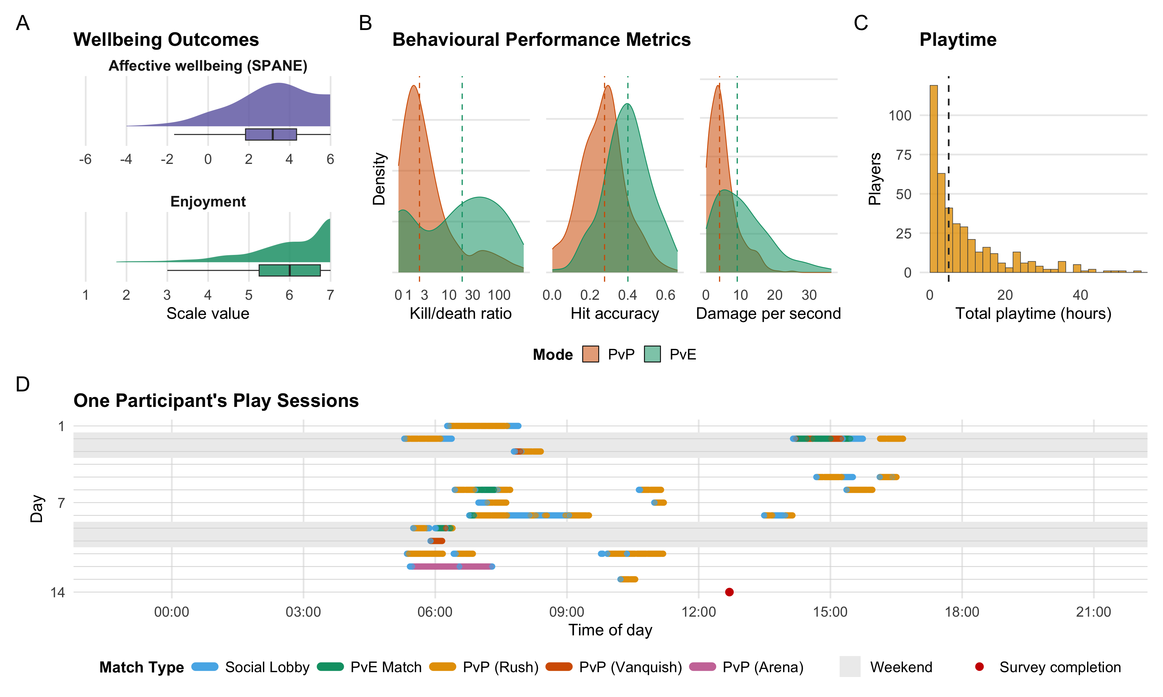
Figure 1: Overview of the Study Measures. (A) Wellbeing outcomes in the analytic sample (n = 412): game-related affective wellbeing (SPANE balance, -6 to 6) and enjoyment (1 to 7); curves are kernel density estimates, boxes show the median and interquartile range. (B) Three mode-specific performance metrics for PvP (n = 409) and PvE (n = 408) play: kill/death ratio (combat effectiveness), hit accuracy (aiming precision), and damage per second (sustained offensive output). Densities are normalised within mode (PvP or PvE), so heights show relative concentration only; dashed lines: medians; x-axes truncated at the 99th percentile; kill/death ratio on a pseudo-logarithmic axis. (C) Active playtime in the 14-day window (dashed line: median = 5.0 hours). (D) All sessions of one example participant from day 1 to day 14 (survey day), by time of day and match type; shaded bands: weekends; red dot: survey completion.

Behavioural Telemetry
The raw telemetry contained one record per player, session, level, and character class, each with counts of in-game events during that stint (eliminations, deaths, shots fired and hit, damage dealt, and score). We restricted these records to the 14 days before each player’s survey. From these records, we selected and computed metrics only if they had been previously validated as informative measures of player behaviour and performance in shooter games (Drachen et al., 2012; Lugrin et al., 2013; Melhart et al., 2019). Two principles guided the computation of the behavioural metrics. First, all performance metrics were constructed to be independent of total playtime. Common cumulative indicators such as ‘player level’ or ‘total kills’ were deliberately excluded because they conflate skill with playtime; a player’s level may simply be higher because they played more, not because they performed better. Second, every metric was computed separately for PvP and PvE modes, because the two contexts differ fundamentally in difficulty, objectives, and opponent type; eliminating a computer-controlled enemy in PvE is not comparable to eliminating a matchmade opponent of similar rank in PvP. Pooling across modes would obscure meaningful behavioural differences. For each mode, event counts were summed across all of a player’s records within the 14-day window and ratios were formed from these totals (e.g., PvP hit accuracy = total shots hit in PvP / total shots fired in PvP), rather than averaging per-session values. This resulted in 12 behavioural metrics plus one overall playtime measure (for descriptive statistics, see Table 1). Mode ratio captured the proportion of active playtime each player devoted to PvP and PvE modes, reflecting game-mode preference. Kill/death ratio indexed combat effectiveness as the number of eliminations per death, with higher values indicating greater survivability and lethality. Hit accuracy measured the proportion of shots that connect with a target, reflecting aiming precision. Damage per second captured sustained offensive output, indicating how efficiently a player dealt damage over time. Average damage per game reflected total offensive contribution within a match, encompassing both direct combat and area-of-effect output. Average score per game provided a composite performance indicator incorporating objectives completed, assists, and other in-game scoring events beyond raw combat. Each of these five performance metrics was computed separately for PvP and PvE, yielding 10 mode-specific indicators alongside the two mode-ratio variables. Of these 12 metrics, 10 entered the cluster analysis, as described under Data Analysis.
Table 1: Descriptive Statistics for Key Variables
Variable | M | SD | Min | Max
Demographics
Age | 35.01 | 11.77 | 18.00 | 99.00
Playtime
Total Hours Played | 9.47 | 11.70 | 0.15 | 69.33
Mode Preference
Proportion of PvP Playtime | 0.47 | 0.28 | 0.00 | 1.00
Proportion of PvE Playtime | 0.25 | 0.24 | 0.00 | 1.00
In-game Performance
PvP Kill/Death Ratio | 12.76 | 38.16 | 0.00 | 387.62
PvE Kill/Death Ratio | 55.18 | 88.75 | 0.00 | 725.00
PvP Hit Accuracy | 0.27 | 0.12 | 0.00 | 0.83
PvE Hit Accuracy | 0.40 | 0.13 | 0.00 | 0.87
PvP Damage per Second | 4.86 | 4.05 | 0.00 | 24.90
PvE Damage per Second | 11.80 | 12.61 | 0.00 | 124.62
PvP Average Damage per Game | 2,731.45 | 2,502.23 | 0.00 | 15,093.00
PvE Average Damage per Game | 8,231.29 | 6,501.59 | 0.00 | 34,232.25
PvP Average Score | 1,654.94 | 1,033.57 | 0.00 | 5,505.00
PvE Average Score | 2,620.90 | 2,404.79 | 0.00 | 20,725.00
Wellbeing Outcomes
Wellbeing (SPANE) | 2.95 | 1.91 | -4.00 | 6.00
Enjoyment | 5.82 | 1.11 | 1.75 | 7.00
N = 412. Gender distribution: Female: 81 (19.7%), Male: 318 (77.2%), Other: 1 (0.2%), Prefer not to say: 12 (2.9%)

Wellbeing
We assessed affective wellbeing with the Scale of Positive and Negative Experiences (SPANE) (Diener et al., 2010; Diener et al., 2018). Respondents were prompted to reflect on how they felt over the past two weeks and rated how often they experienced each of six positive (positive, good, pleasant, happy, joyful, contented) and six negative (negative, bad, unpleasant, sad, afraid, angry) feelings on a scale from 1 (Very rarely or never) to 7 (Very often or always). An overall wellbeing balance score was computed by subtracting the mean negative score from the mean positive score, yielding a possible range of −6 to +6, where higher values indicate more positive affect.

Enjoyment
Enjoyment was assessed with four items from the Player Experience and Need Satisfaction scale (PENS) (Ryan et al., 2006), validated by Johnson et al. (2018). The full PENS comprises subscales measuring autonomy, competence, relatedness, enjoyment, and extrinsic motivation; we used only the four-item enjoyment subscale, which captures hedonic appreciation of the play experience. Respondents were asked to reflect on their experience playing PvZ over the past two weeks and rated items such as “I think PvZ was fun to play” on a scale from 1 (Strongly disagree) to 7 (Strongly agree).

Data Analysis
Data were analysed in R version 4.5.1 (R Core Team, 2025). Key packages included fpc for cluster validation indices (Hennig, 2024), factoextra for multivariate visualisation (Kassambara & Mundt, 2020), and robustlmm for robust mixed-effects estimation (Koller, 2016).
Following initial data cleaning, all survey responses were screened for straightlining (e.g., when respondents give identical answers to all items) to identify records with low data quality commonly found in online surveys (Leiner, 2019); however, no unusual cases were identified. Afterwards, the telemetry records were matched to the same two-week window referenced by the survey items, and analyses were conducted on active players with mode-specific telemetry as described above.
To test whether clustering was appropriate before fitting any cluster model, we evaluated cluster tendency using three complementary approaches. First, we computed the Hopkins statistic (Banerjee & Dave, 2004), which compares distances in observed data to distances expected under spatial randomness; values near 0.5 indicate random structure, whereas larger values indicate clusterable structure. Second, we used Visual Assessment of Cluster Tendency (VAT) (Bezdek & Hathaway, 2002), which reorders the dissimilarity matrix so potential clusters appear as darker diagonal blocks. Third, we examined Principal Component Analysis (PCA) projections to assess whether separable groupings were visible in low-dimensional space relative to random reference data. Together, these diagnostics indicated non-random structure suitable for clustering.
We then identified playstyles with Partitioning Around Medoids (PAM) (Kaufman & Rousseeuw, 1990) on 10 standardised in-game behavioural features: the proportions of active playtime spent in PvP and PvE, and kill/death ratio, hit accuracy, damage per second, and average score per game, each computed separately for PvP and PvE. Average damage per game was not entered, because it captures the same offensive output as damage per second, which was already included. PAM was selected over k-means because it is less sensitive to extreme points and defines each cluster by an observed medoid (a real player profile), which improves robustness and interpretability for telemetry-derived behavioural profiles. Features were z-standardised before clustering, and missing mode-specific performance values were set to zero to encode no activity in that mode rather than dropping cases. The number of clusters was determined by maximising the Calinski-Harabasz index across k = 2 to 10 (Tibshirani et al., 2001), which selected a three-cluster solution; we then checked internal coherence with silhouette widths (Kaufman & Rousseeuw, 1990).
To examine associations between playstyle, playtime, and outcomes, we fit robust linear mixed-effects models (Koller, 2016). Robust estimation was preferred over standard maximum-likelihood mixed models because telemetry-derived playtime and performance metrics are characteristically right-skewed and prone to influential observations; a small number of highly engaged players can exert disproportionate leverage on ordinary least-squares estimates. Robust estimation downweights such influential cases automatically through iteratively reweighted least squares, yielding coefficient estimates that better reflect the bulk of the sample without requiring ad hoc outlier exclusion rules that introduce researcher degrees of freedom. This approach also maintains methodological consistency with our clustering strategy: PAM was selected precisely because it is less sensitive to extreme points, and using a robust estimator at the modelling stage carries that same design philosophy through the analytic pipeline. All models included random intercepts for country to account for baseline between-country differences; random slopes were not estimated because the number of countries was too small to support the additional parameters reliably. Outcomes were treated as continuous and approximately normally distributed, and playtime was entered on its raw scale. Approximate p-values were derived from the normal reference distribution for t-statistics, and 95% confidence intervals were computed as b ± 1.96 × SE. We used simple-slopes analyses to estimate within-playstyle playtime slopes and pairwise slope-difference tests to compare those slopes across playstyles. Statistical significance was set at p < .05.

Data, Materials, and Code
The present study was not preregistered. The analysis code reported in this study is archived on Zenodo at https://doi.org/10.5281/zenodo.23468927. The raw data and further details on the dataset shared by Johannes et al. (2021) can be found at https://osf.io/cjd6z/.

Results

RQ1. Player Clustering Analysis

Assessing Cluster Tendency
The Hopkins statistic computed from our player behavioural data was high (0.8573, 95% CI [0.8359, 0.8786]), substantially exceeding the 0.70 threshold and indicating strong cluster tendency. As a validity check, a random dataset with identical dimensions produced a substantially lower value (0.63), closer to the 0.5 benchmark expected under spatial randomness. VAT plots showed clear dark diagonal blocks for the player data, consistent with separable groups, while the random reference data showed no comparable block structure (Appendix 1; Bezdek & Hathaway (2002)). PCA visualisations converged on the same conclusion, with visible grouping in the player data but not in the random comparison. The convergence of these three independent assessments (Hopkins, VAT, and PCA) provided strong statistical evidence to reject the null hypothesis of spatial randomness, demonstrating that the player behavioural data contained meaningful, non-random structure amenable to clustering methods.

PAM Clustering
To select the number of clusters, we evaluated PAM solutions for k = 2 to 10 using the Calinski-Harabasz (CH) index, where higher values indicate better separation relative to within-cluster dispersion (Kaufman & Rousseeuw, 1990; Tibshirani et al., 2001). The CH index peaked at k = 3 (Appendix 2), supporting a three-cluster solution as the best trade-off between fit and parsimony.
Having selected k = 3 on the basis of the CH index, we assessed the internal validity of this solution using silhouette analysis (Kaufman & Rousseeuw, 1990), which quantifies how well each observation fits its assigned cluster relative to the nearest neighbouring cluster. The average silhouette width was 0.22. According to Kaufman and Rousseeuw’s interpretive guidelines, values above 0.25 indicate strong structure and values between 0.10 and 0.25 indicate weak but still meaningful structure; the overall value thus falls at the boundary, suggesting reasonable separation. Per-cluster silhouette widths ranged from 0.15 to 0.39, with one cluster exceeding the 0.25 threshold and the remaining two showing acceptable cohesion. No negative silhouette values were observed, confirming that every observation was assigned to its most appropriate cluster. The substantive interpretation of these three clusters is presented below.

Interpretation of Clusters
Following established approaches to telemetry-based player profiling (Bauckhage et al., 2015; Drachen et al., 2012; Drachen et al., 2014; Melhart et al., 2019; Sifa et al., 2018), we labelled the three clusters on the basis of their dominant mode preferences and performance levels (Figure 2). The labels reflect two dimensions that emerged from the data: the game mode players predominantly engaged with (PvE vs. PvP) and their overall performance level (casual vs. elite).
Casual PvP Players (the competitive playstyle; 22.1% of the sample) devoted the majority of their time to competitive PvP modes (70.7%), yet their performance was moderate (PvP K/D: M = 7.79; PvP Accuracy: M = 21.8%), falling well below Elite Allround Players. Performance in PvE was similarly modest. This pattern suggests a preference for competitive engagement that is not accompanied by correspondingly high skill, indicating a casual orientation to play within a competitive context.
Casual PvE Players (the exploratory playstyle; 19.9% of the sample) allocated the majority of their playtime to cooperative PvE modes (58.6%), achieving moderate performance within that context (PvE K/D: M = 63.59; PvE Accuracy: M = 40.2%) while showing markedly lower metrics in PvP. This profile suggests a specialisation in story-driven exploration and cooperative play over competitive engagement.
Elite Allround Players (the high-performing playstyle; 58.0% of the sample), the largest cluster, maintained high performance across both gameplay contexts, with kill-to-death ratios and accuracy rates substantially above the sample mean in both PvP (K/D: M = 17.19; Accuracy: M = 31.5%) and PvE (K/D: M = 71.91; Accuracy: M = 42.0%). Rather than specialising in one mode, these players engaged broadly and performed well regardless of context, distinguishing them as the most proficient segment.
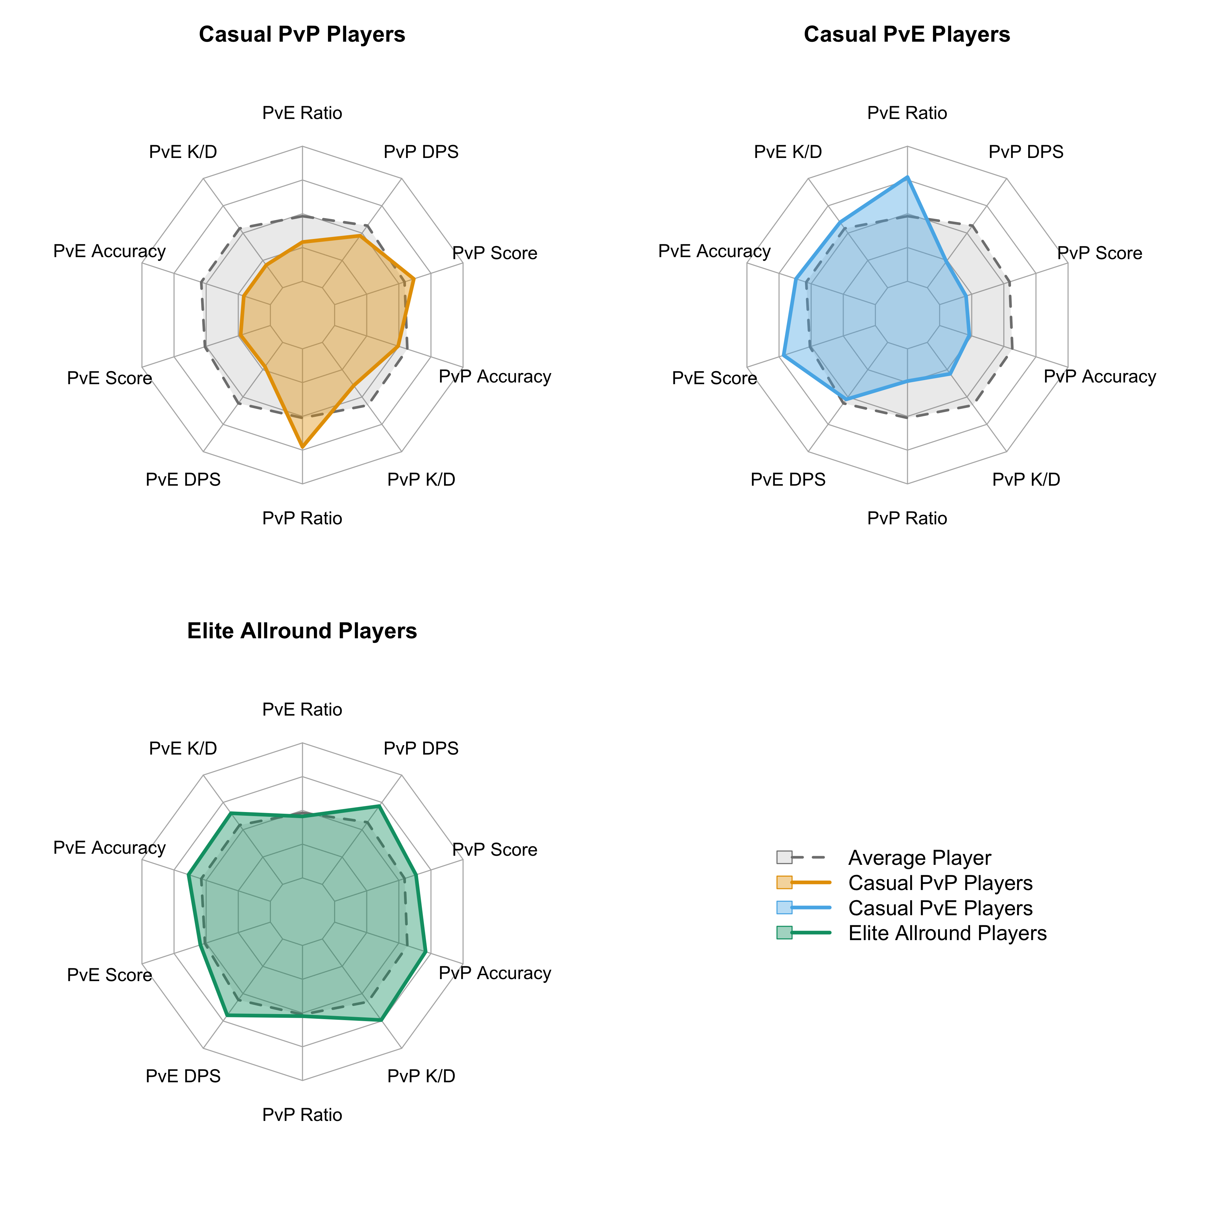
Figure 2: Radar charts showing performance and mode selection for each playstyle relative to the playstyle of the average player (dashed line). Values are standardised mean scores (z-scores converted to 0-1 scale). Mean values: Casual PvE Players (PvP Ratio: 0.17, PvE Ratio: 0.59, PvP K/D: 4.88, PvE K/D: 63.59); Elite Allround Players (PvP Ratio: 0.49, PvE Ratio: 0.22, PvP K/D: 17.19, PvE K/D: 71.91); Casual PvP Players (PvP Ratio: 0.71, PvE Ratio: 0.03, PvP K/D: 7.79, PvE K/D: 1.24). PvE = Player versus Environment; PvP = Player versus Player; K/D = Kill/Death ratio; DPS = Damage per second.

RQ2. Wellbeing Differences Between Playstyles
For each outcome (wellbeing and enjoyment), we estimated a main-effects model predicting the outcome from playstyle, hours played, gender, and age, with random intercepts for country (outcome ~ player_type + hours + gender + age + (1 | country); see Appendix 3). The fixed effects accounted for a modest share of outcome variance (wellbeing: marginal R² = 0.093, conditional R² = 0.093; enjoyment: marginal R² = 0.061, conditional R² = 0.061). Casual PvE Players served as the reference category. Relative to these players, both Casual PvP Players (b = -0.91, 95% CI [-1.48, -0.33], t = -3.11, p = .002) and Elite Allround Players (b = -0.89, 95% CI [-1.38, -0.40], t = -3.55, p < .001) reported significantly lower wellbeing. For enjoyment, Casual PvP Players again scored lower than Casual PvE Players (b = -0.47, 95% CI [-0.78, -0.15], t = -2.93, p = .003), and Elite Allround Players also scored lower than Casual PvE Players, though this difference was smaller and close to the conventional significance threshold (b = -0.28, 95% CI [-0.55, -0.01], t = -2.05, p = .040; see Figure 3).
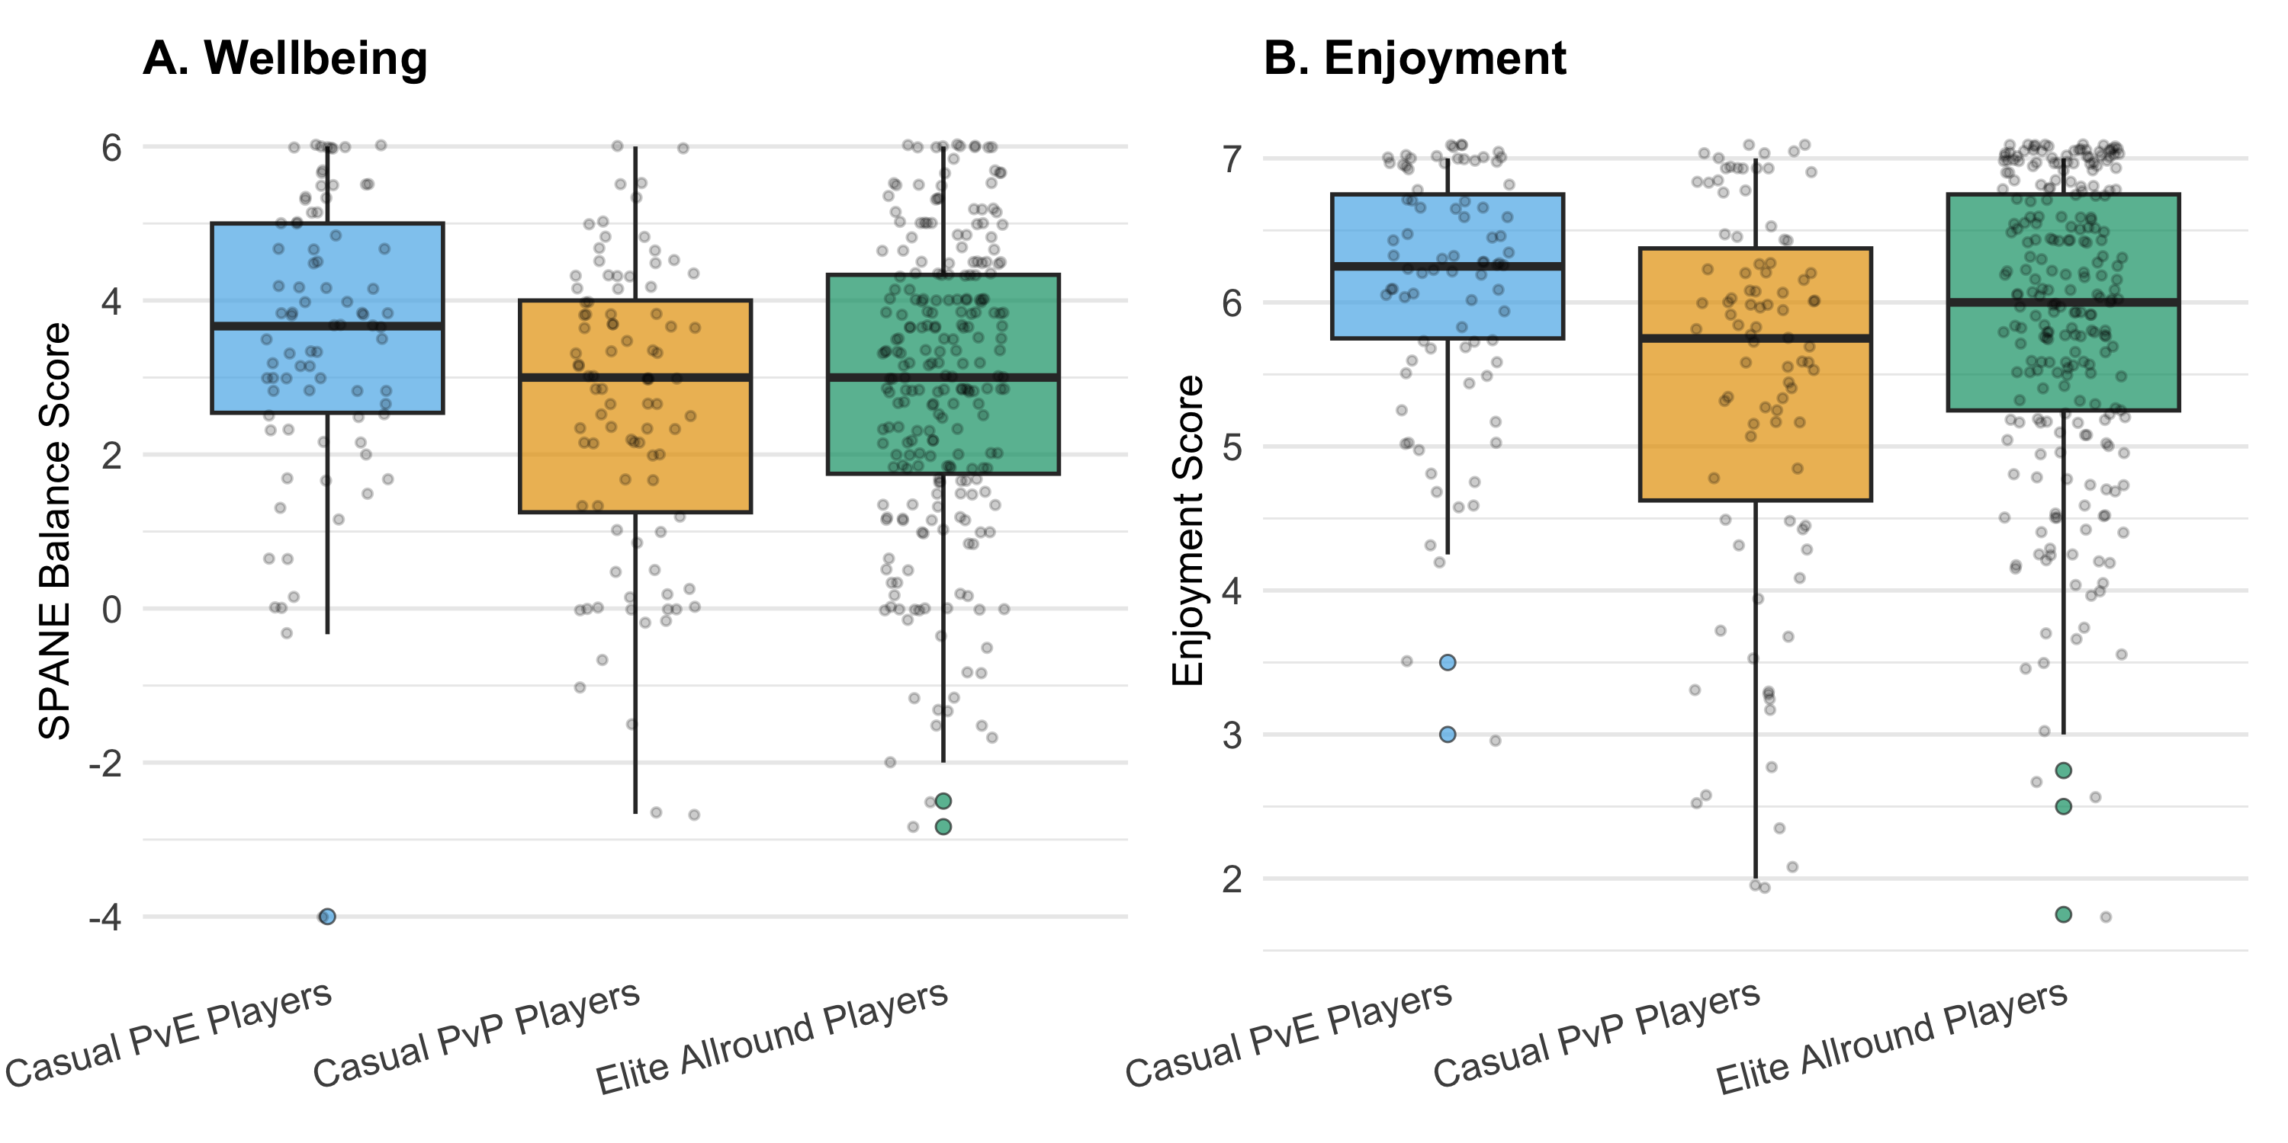
Figure 3: Distribution of wellbeing outcomes by playstyle. Panel A shows wellbeing (SPANE balance score); Panel B shows enjoyment. Boxes represent interquartile ranges with median lines; whiskers extend to 1.5 × IQR. Individual points show outliers.

RQ3. Does Playstyle Moderate the Playtime–Wellbeing Relationship?
To test whether the playtime–wellbeing association differed across playstyles, we extended the main-effects models by adding playstyle × hours interaction terms, retaining gender and age as covariates (outcome ~ player_type × hours + gender + age + (1 | country); see Appendix 3). Adding the interaction terms did not meaningfully increase variance explained (wellbeing: marginal R² = 0.093; enjoyment: marginal R² = 0.063). In the main-effects models, hours played was positively associated with both outcomes (wellbeing: b = 0.03, 95% CI [0.01, 0.04], t = 3.08, p = .002; enjoyment: b = 0.01, 95% CI [0.01, 0.02], t = 3.10, p = .002). Each interaction coefficient represents the difference in the playtime slope for a given playstyle relative to Casual PvE Players. None of the interaction terms reached significance: for wellbeing, neither Casual PvP Players ($Δb$ = -0.02, 95% CI [-0.08, 0.05], t = -0.52, p = .600) nor Elite Allround Players ($Δb$ = -0.00, 95% CI [-0.04, 0.04], t = -0.00, p = .998) had a playtime slope that differed from the reference group. The same held for enjoyment (Casual PvP: $Δb$ = 0.01, 95% CI [-0.02, 0.05], t = 0.69, p = .493; Elite Allround: $Δb$ = 0.00, 95% CI [-0.02, 0.03], t = 0.19, p = .851). Playstyle differences in intercepts remained in the interaction models, particularly for Casual PvP Players (wellbeing: b = -0.82, 95% CI [-1.48, -0.16], t = -2.44, p = .015; enjoyment: b = -0.54, 95% CI [-0.90, -0.17], t = -2.91, p = .004).
These playstyle differences were corroborated by one-way ANOVAs (wellbeing: F(2, 409) = 5.96, p = .003, η² = 0.028; enjoyment: F(2, 409) = 9.48, p < .001, η² = 0.044) and Tukey HSD post-hoc tests, which confirmed that Casual PvP Players scored lower than Casual PvE Players on both wellbeing (p = .002) and enjoyment (p < .001), and lower than Elite Allround Players on enjoyment (p = .001).
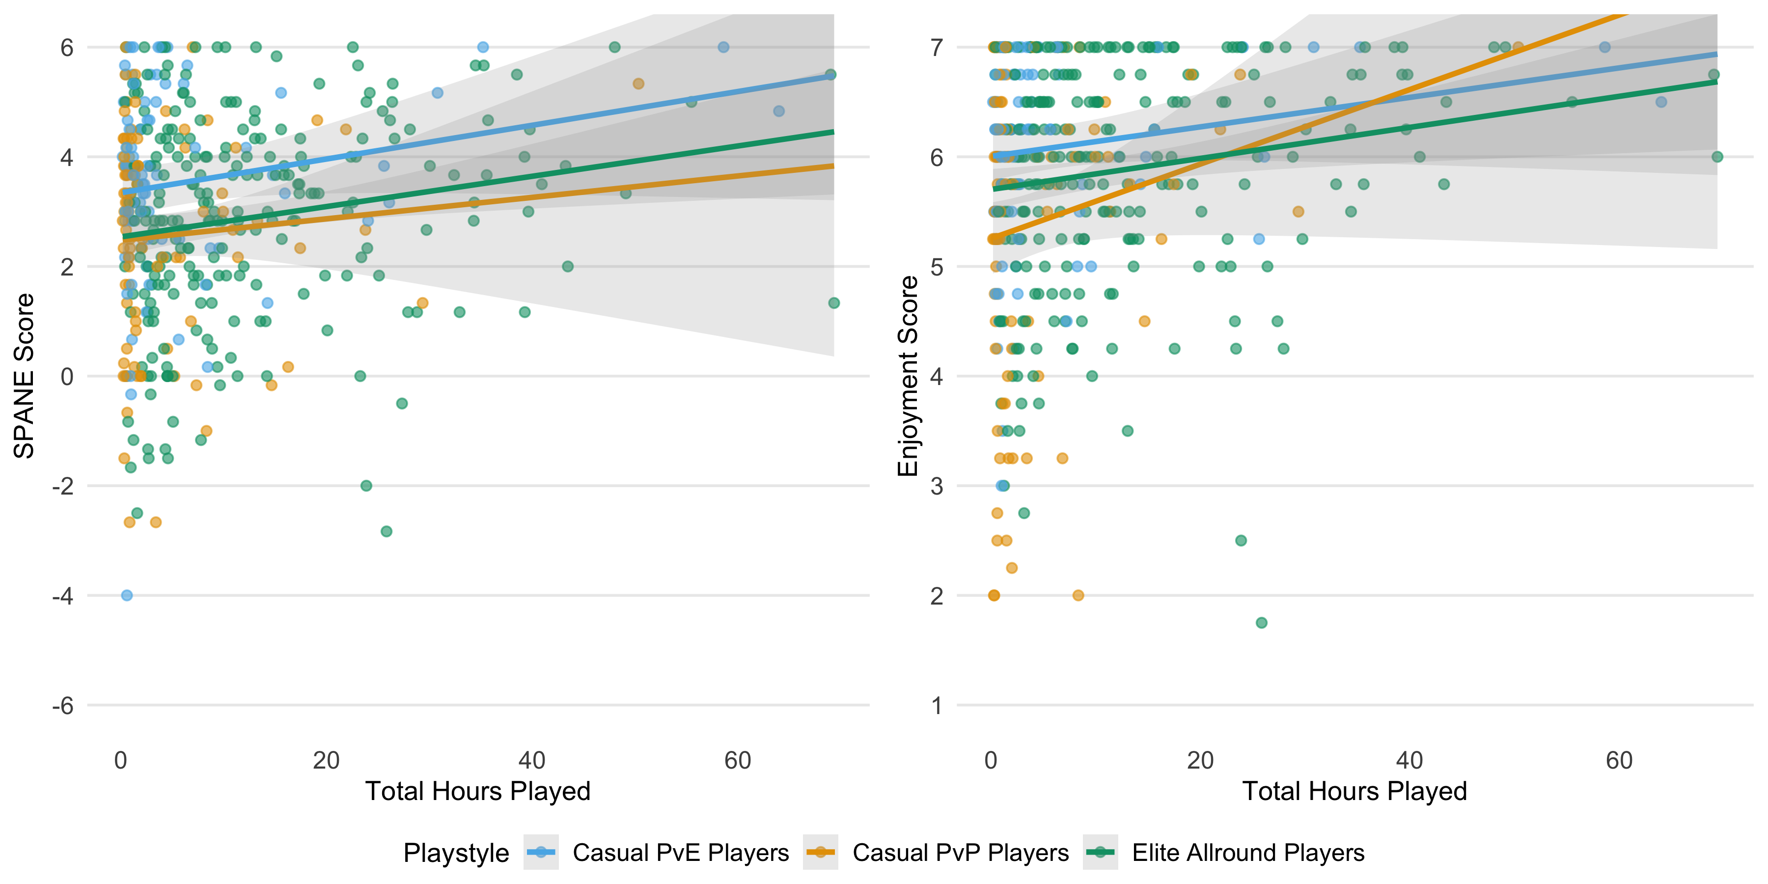
Figure 4: Interaction plots showing the relationship between hours played and psychological outcomes across playstyles. The left panel shows wellbeing (SPANE balance score), and the right panel shows enjoyment. Lines show unadjusted linear regression fits with 95% confidence intervals; simple slopes from the covariate-adjusted moderation models are reported in the text. Only the slope for Elite Allround Players reached statistical significance, and no pairwise difference between playstyle slopes was significant.
To further probe the interaction, simple slopes analyses decomposed the playtime–outcome association within each playstyle (Figure 4). Only Elite Allround Players showed a significant positive slope for both wellbeing (b = 0.028, p = .006) and enjoyment (b = 0.014, p = .013). Slopes for Casual PvE Players (wellbeing: b = 0.028, p = .137; enjoyment: b = 0.012, p = .258) and Casual PvP Players (wellbeing: b = 0.011, p = .682; enjoyment: b = 0.024, p = .102) were not significant. Critically, pairwise comparisons of slopes did not provide evidence that the playtime–outcome association differed between any pair of playstyles (all ps > .05), though the present sample may lack the power to detect small slope differences. Taken together, these results indicate that playstyle is associated with different average levels of wellbeing and enjoyment, but the data do not support the conclusion that the playtime–outcome relationship itself varies meaningfully across playstyles.

Discussion

Summary of Findings
The objectives of this study were twofold. First, we aimed to complement the breadth of platform-level playtime research with the depth of granular in-game playstyle analysis. Through telemetry-driven profiling, we aimed to demonstrate how players’ in-game behavioural heterogeneity can be modelled within a single game. Second, informed by the Integrated Model of Player Experience, we sought to explore how players’ interactions with game mechanics and preferences for different in-game modes shape their play experience and subsequent wellbeing, thereby providing greater insight into the conditions under which, and the players for whom, video game play might support or undermine wellbeing.
Accordingly, this study addressed three research questions: whether distinct playstyles can be identified from in-game behavioural telemetry within a single game; whether players with different playstyles report different levels of wellbeing and enjoyment; and whether the association between playtime and wellbeing outcomes differs across playstyles. In short, the findings support the first two questions but not the third. Three distinct playstyles were identified from behavioural telemetry and labelled to reflect two dimensions that emerged from the data: (1) preferred game mode (PvE vs. PvP) and (2) overall performance level (casual vs. elite). These playstyles were associated with meaningful differences in wellbeing and enjoyment, but we found no evidence that they moderated the relationship between playtime and wellbeing or enjoyment. The implications and limitations of these findings are discussed below.

Three Playstyles and Their Wellbeing Correlates
The participants in the first cluster, named “Casual PvE Players”, allocated the majority of their playtime to cooperative PvE modes, achieving moderate performance within that context while showing markedly lower metrics in PvP. This playstyle suggests a preference for story-driven exploration and cooperative play over competitive engagement, paralleling the “Adventurer” type identified by Melhart et al. (2019) in Tom Clancy’s The Division, who similarly focused on solo and cooperative mission content rather than competitive play. We hypothesise that these players adopt a more recreation-oriented approach to play, gravitating toward narrative content and cooperative challenges that offer immediate enjoyment without the sustained pressure of competitive evaluation. This interpretation is consistent with the view that playstyle captures not only goal-directed behaviour but also forms of engagement partly motivated by the enjoyment that a particular way of playing produces (Kalmanlehto, 2025). Within the IMP framework (Elson et al., 2014), this pattern is consistent with a preference for game contexts in which narrative and exploratory mechanics are foregrounded over adversarial mechanics, potentially affording greater perceived autonomy over how to engage with the game’s content and a lower threshold for competence satisfaction. Consistent with this interpretation, Casual PvE Players reported the highest wellbeing and enjoyment of the three groups. This finding is consistent with the observation by Melhart et al. (2019) that cooperative and exploratory play features were among the strongest predictors of need satisfaction in The Division.
The players in the second cluster, called “Elite Allround Players”, formed the largest cluster. They maintained high performance across all gameplay contexts, with kill-to-death ratios and accuracy rates substantially above the sample mean in both PvP and PvE. Rather than specialising in one mode, these players engaged broadly and performed well regardless of context, distinguishing them as the most proficient segment. This playstyle is conceptually consistent with the “Elite” type that Melhart et al. (2019) identified in The Division, characterised by top-tier progression metrics, and with the high-performing player segments identified by Drachen et al. (2012) in Battlefield 2: Bad Company 2. The breadth of their engagement suggests that mode preference alone does not define this group; rather, it is consistently high performance across contexts that characterises their play. This pattern would be consistent with a mastery- or achievement-oriented approach, in which players develop and exercise skill across the full range of available game content; however, telemetry alone cannot reveal the motivations underlying it, and future work should assess these directly by pairing behavioural profiles with self-reported motivations. Despite their superior performance, however, Elite Allround Players reported lower wellbeing and enjoyment than Casual PvE Players, though higher enjoyment than Casual PvP Players. This pattern is noteworthy because prior work suggests that competence satisfaction positively predicts wellbeing in gaming contexts (Klimmt et al., 2009; Przybylski et al., 2010; Ryan & Deci, 2001; Tamborini et al., 2011). However, if competence alone drove wellbeing, the most skilled players should report the highest wellbeing. Our findings do not support this, suggesting that the context in which competence is exercised matters as well, consistent with the IMP’s emphasis on both mechanics and context as jointly shaping player experience (Elson et al., 2014). Potentially, Elite Allround Players’ broad engagement across both cooperative and competitive modes may dilute the wellbeing benefits that cooperative PvE environments appear to afford. Furthermore, their high skill may buffer against the competence frustration that competitive environments can impose on less proficient players, though without direct measurement, this remains speculative.
Finally, the players in the third cluster, called “Casual PvP Players”, devoted the majority of their time to competitive PvP modes, yet their performance was moderate, falling well below that of Elite Allround Players. Their performance in PvE was similarly modest. This pattern suggests a preference for competitive engagement that is not accompanied by correspondingly high skill, indicating a casual orientation to play within a competitive context. A comparable playstyle appears in the analysis of Battlefield 2: Bad Company 2 by Drachen et al. (2012), where a segment of players engaged frequently in competitive modes without achieving high performance metrics, and it bears some resemblance to the “Social Dark Zone Player” that Melhart et al. (2019) described in The Division, a type that preferred competitive areas but were distinguished more by their social engagement than their skill. These players were potentially drawn to the multiplayer and competitive dynamics of PvP modes rather than to the mastery of competitive mechanics per se. This combination of competitive exposure and moderate skill may create a less optimal play experience. Competitive PvP environments are characterised by direct performance feedback, social comparison, and outcome uncertainty, conditions that could frustrate competence needs when players lack the skill to succeed consistently (Ballou, Hakman, et al., 2025). Consistent with this reasoning, Casual PvP Players reported the lowest wellbeing and enjoyment of the three groups. The finding that competitive engagement at moderate skill levels is associated with the poorest psychological outcomes aligns with evidence that need frustration in gaming contexts can undermine wellbeing (Ballou, Földes, Vuorre, et al., 2026a) and suggests that the experiential costs of competitive play may not be offset by the social or excitement-related benefits that may draw these players to PvP modes.

No Evidence of Playstyle-Dependent Playtime Effects
Turning to the third research question, we found no evidence that playstyle moderates the association between playtime and wellbeing or enjoyment. Although Elite Allround Players showed the only significant positive simple slope, this did not translate into a significant difference from the slopes of other groups. These findings align closely with Johannes et al. (2021), who tested whether self-reported player experiences moderated the playtime–wellbeing association in the same game, Plants vs. Zombies: Battle for Neighborville. They found that neither need satisfaction, nor enjoyment, nor extrinsic motivation significantly interacted with playtime in predicting wellbeing, concluding that player experience contributes to wellbeing independently rather than altering how playtime relates to it. Our study extends this result by testing moderation through an entirely different operationalisation, objectively measured behavioural playstyles derived from telemetry, rather than self-reported motivational experiences. That neither subjective player experience nor objective behavioural profile moderates the playtime–wellbeing association in this game strengthens the case that playtime alone is not meaningfully associated with wellbeing for most players (Ballou, Földes, Vuorre, et al., 2026b; Johannes et al., 2021; Vuorre et al., 2022).
It is worth noting, however, that the absence of moderation in our data does not constitute evidence that playtime is wholly irrelevant to wellbeing under all conditions. The playtime–wellbeing relationship is subject to a wide range of time-varying confounds, including physical health, grief, work stress, and leisure availability, that can bias observed associations in either direction (Ballou, Földes, Hakman, et al., 2026). Our cross-sectional design and limited set of covariates leave open the possibility that such confounds obscure true differential effects. Moreover, our study examines only one game; it remains possible that playstyle-by-playtime interactions exist in games with greater mechanical diversity, stronger competitive ranking systems, or more pronounced social features. The null moderation finding should therefore be interpreted as specific to the present context rather than as a general claim about the impossibility of such effects.

Implications for the Playtime Paradigm
What the data do show is that the playtime paradigm is incomplete in a critical respect; it misses qualitative differences in play that are associated with meaningful variation in average wellbeing. Playtime treats all minutes of play as equivalent, but players who devote their time to cooperative PvE gameplay report higher wellbeing than those who spend comparable time in competitive PvP modes. This between-group difference in levels, rather than in slopes, is the primary empirical contribution of the present study. In this respect, our results complement rather than contradict platform-level research; playtime may indeed be uninformative as a predictor of wellbeing, but the behavioural composition of that playtime is not.

Limitations and Future Work
Several limitations constrain the interpretation of these findings and point toward productive directions for future research. First, the study examines a single game with a specific player population recruited by the developer, and we lack evidence that the identified playstyles generalise to other games, genres, or player populations. Unlike personality traits, playstyles may be contextual and fluid, shaped by the interaction between a game’s design elements and the player’s ludic habitus, that is, their accumulated gameplay experiences and skills (Jaćević, 2022). As such, a player’s playstyle in one game may not predict their behaviour in another with different mechanics or competitive structures. This also means that playstyles should not be assumed to reflect stable personality characteristics (Kalmanlehto, 2025); the profiles identified here describe how players engaged with this particular game during the study period, not enduring individual differences.
Second, while our behavioural telemetry provided comprehensive metrics on core gameplay mechanics and performance, it captured only a subset of potential in-game behaviours. Notably absent were indicators of social interaction, which is an important dimension of multiplayer gaming experiences that the IMP identifies as part of the contextual layer of player experience (Elson et al., 2014). In this study, sessions spent in the game’s social hub were considered idle time and thus excluded from the playstyle analysis because these sessions generated no mechanics-relevant telemetry on which to cluster. Yet recent work has shown that ostensibly idle or non-interactive periods in games, including socialising between matches and exploring social spaces, can serve experiential functions such as community-building and strategic preparation that shape the broader play experience (Tepponen et al., 2025). Future work could address this gap by extending the playstyle profiling framework to incorporate social and communicative dimensions of gameplay. Gesture-based digital trace data, such as the ‘ping’ communication systems common in multiplayer games, have been demonstrated to be related to game context, team dynamics, and performance outcomes (Zheng & Farzan, 2023).
Third, the cross-sectional design precludes causal inference. The observed associations between playstyle and wellbeing may reflect selection effects (e.g., players with higher baseline wellbeing may gravitate toward cooperative play) rather than the influence of play behaviour on outcomes. This concern is not merely hypothetical; a wide range of time-varying confounds, from physical health conditions to work stress, plausibly affect both what players do in games and how they feel (Ballou, Földes, Hakman, et al., 2026). Our design cannot disentangle whether cooperative PvE play promotes wellbeing, whether wellbeing promotes cooperative play, or whether both are driven by unmeasured third variables.
Fourth, the temporality of when participants played was not considered. The session telemetry also captured when sessions occurred, how they were spaced, and how mode choices unfolded over time (illustrated in Figure 1, Panel D). These temporal contrasts, such as habitual versus binge-like session rhythms or daytime versus late-night play, may offer insightful avenues for future research.

Conclusion
This study demonstrates that players of the same game engage with it in qualitatively different ways and that these differences are associated with meaningful variation in wellbeing and enjoyment. However, we found no evidence that playstyle moderates the playtime–wellbeing relationship. These findings contribute to the growing body of digital trace research in two respects. First, they provide empirical support for the view that gameplay constitutes heterogeneous exposures with distinct psychological correlates, even within a single title. Second, they demonstrate a practical methodology, telemetry-driven profiling, for incorporating in-game behavioural depth into wellbeing research. At the same time, the null moderation results caution against overclaiming: the present data show that what players do is associated with how they feel, but not that different styles of play change how playtime itself relates to wellbeing. As richer forms of in-game data become available through industry-academia partnerships, researchers should continue to develop more granular, theory-driven approaches to understanding player experience and its relationship to psychological outcomes.

Acknowledgements
Claude (Sonnet/Opus 4.6; Anthropic) was used to assist with code development and minor text edits during the preparation of this manuscript. All AI-assisted contributions were reviewed, verified, and, where necessary, further revised by members of the author team, who maintain full responsibility for the final content.

Author Contributions
Conceptualization: TH, AKP; Data curation: TH, MV; Formal analysis: TH, MV; Funding acquisition: AKP; Investigation: TH; Methodology: TH, MV; Project administration: AKP; Supervision: MV, AKP; Visualization: TH; Writing – original draft: TH; Writing – review & editing: TH, MV, AKP

Conflicts of Interest
The authors declare no competing financial, intellectual, or institutional interests relevant to this research. The following disclosures are provided in the interest of full transparency. No authors have received funding or compensation from the tech companies or other industries connected to the work presented here. MV’s work is or has been funded by the European Research Council, the Economic and Social Research Council, Tilburg University, and the University of Oxford’s John Fell Fund. MV has provided in-kind consultations and served as a nonpaid panel member for Meta and K-Games. AKP has served in advisory or expert roles for the Sync Digital Wellbeing Program (2022–2024), the Google Expert Advisory on Youth and Technology (2025), the OpenAI Expert Council on Wellbeing and AI (2025), and UK Department for Science, Innovation and Technology–funded research on children’s smartphone and social media use (University of Cambridge, 2025). He is a member of the UK Department for Culture, Media & Sport College of Experts. Any industry fees are directly donated to charity, and his research is conducted in accordance with University of Oxford academic integrity policies.

Ethics
The study procedures were granted ethical approval by the University of Oxford’s Central University Research Ethics Committee (OII_C1A_23_107). The original data collection was approved under SSH_OII_CIA_20_043 (Johannes et al., 2021). All participants provided informed consent and reported being 18 years or older.

References
Ballou, N., Földes, T. A., Vuorre, M., Hakman, T., Magnusson, K., & Przybylski, A. K. (2026a). All BANG, little buck: Basic psychological needs are weakly linked with video gaming behavior. PsyArXiv preprint. https://doi.org/10.31234/osf.io/wqr6u_v4
Ballou, N., Földes, T. A., Vuorre, M., Hakman, T., Magnusson, K., & Przybylski, A. K. (2026b). Open Play: A longitudinal dataset of multi-platform video game digital trace data and psychological measures. PsyArXiv preprint. https://doi.org/10.31234/osf.io/nz96c_v2
Ballou, N., Földes, T., Hakman, T., & Przybylski, A. K. (2026). From breakups to lethargy: Player accounts of third variables affecting video game playtime and wellbeing. Proceedings of the 2026 CHI Conference on Human Factors in Computing Systems. https://doi.org/10.1145/3772318.3791417
Ballou, N., Hakman, T., Vuorre, M., Magnusson, K., & Przybylski, A. K. (2025). How Do Video Games Affect Mental Health? A Narrative Review of 13 Proposed Mechanisms. Technology, Mind, and Behavior, 6(2), 123–143. https://doi.org/10.1037/tmb0000152
Ballou, N., Vuorre, M., Hakman, T., Magnusson, K., & Przybylski, A. K. (2025). Perceived value of video games, but not hours played, predicts mental well-being in casual adult Nintendo players. Royal Society Open Science, 12(3), 241174. https://doi.org/10.1098/rsos.241174
Banerjee, A., & Dave, R. N. (2004). Validating clusters using the Hopkins statistic. 2004 IEEE International Conference on Fuzzy Systems (IEEE Cat. No.04CH37542), 1, 149–153. https://doi.org/10.1109/FUZZY.2004.1375706
Bartle, R. (1996). Hearts, clubs, diamonds, spades: Players who suit MUDs. Journal of MUD Research, 1(1). https://mud.co.uk/richard/hcds.htm
Bauckhage, C., Drachen, A., & Sifa, R. (2015). Clustering Game Behavior Data. IEEE Transactions on Computational Intelligence and AI in Games, 7(3), 266–278. https://doi.org/10.1109/TCIAIG.2014.2376982
Bean, A., & Groth-Marnat, G. (2016). Video gamers and personality: A five-factor model to understand game playing style. Psychology of Popular Media Culture, 5, 27–38. https://doi.org/10.1037/ppm0000025
Bezdek, J. C., & Hathaway, R. J. (2002). VAT: A tool for visual assessment of (cluster) tendency. Proceedings of the 2002 International Joint Conference on Neural Networks. IJCNN’02 (Cat. No.02CH37290), 3, 2225–2230. https://doi.org/10.1109/IJCNN.2002.1007487
Colder Carras, M., Van Rooij, A. J., Van de Mheen, D., Musci, R., Xue, Q.-L., & Mendelson, T. (2017). Video gaming in a hyperconnected world: A cross-sectional study of heavy gaming, problematic gaming symptoms, and online socializing in adolescents. Computers in Human Behavior, 68, 472–479. https://doi.org/10.1016/j.chb.2016.11.060
Diener, E., Lucas, R. E., & Oishi, S. (2018). Advances and Open Questions in the Science of Subjective Well-Being. Collabra: Psychology, 4(1). https://doi.org/10.1525/collabra.115
Diener, E., Wirtz, D., Tov, W., Kim-Prieto, C., Choi, D., Oishi, S., & Biswas-Diener, R. (2010). New Well-being Measures: Short Scales to Assess Flourishing and Positive and Negative Feelings. Social Indicators Research, 97(2), 143–156. https://doi.org/10.1007/s11205-009-9493-y
Drachen, A., Sifa, R., Bauckhage, C., & Thurau, C. (2012). Guns, swords and data: Clustering of player behavior in computer games in the wild. 2012 IEEE Conference on Computational Intelligence and Games (CIG), 163–170. https://doi.org/10.1109/CIG.2012.6374152
Drachen, A., Thurau, C., Sifa, R., & Bauckhage, C. (2014). A comparison of methods for player clustering via behavioral telemetry. https://arxiv.org/abs/1407.3950
Egami, H., Rahman, Md. S., Yamamoto, T., Egami, C., & Wakabayashi, T. (2024). Causal effect of video gaming on mental well-being in Japan 2020–2022. Nature Human Behaviour, 8(10), 1943–1956. https://doi.org/10.1038/s41562-024-01948-y
Electronic Arts. (2019). Plants vs. Zombies: Battle for neighborville. Electronic Arts.
Elson, M., Breuer, J., Ivory, J. D., & Quandt, T. (2014). More Than Stories With Buttons: Narrative, Mechanics, and Context as Determinants of Player Experience in Digital Games. Journal of Communication, 64(3), 521–542. https://doi.org/10.1111/jcom.12096
Ferguson, C. J., & Colwell, J. (2019). Lack of consensus among scholars on the issue of video game “addiction.” Psychology of Popular Media, 9(3), 359. https://doi.org/10.1037/ppm0000243
Halbrook, Y. J., O’Donnell, A. T., & Msetfi, R. M. (2019). When and How Video Games Can Be Good: A Review of the Positive Effects of Video Games on Well-Being. Perspectives on Psychological Science, 14(6), 1096–1104. https://doi.org/10.1177/1745691619863807
Hennig, C. (2024). fpc: Flexible Procedures for Clustering. R package version 2.2-13. https://doi.org/10.32614/CRAN.package.fpc
Jaćević, M. (2022). Play Your Own Way: Ludic Habitus and the Subfields of Digital Gaming Practice. Game Studies, 22(1).
Jiang, J., Maldeniya, D., Lerman, K., & Ferrara, E. (2021). The Wide, the Deep, and the Maverick: Types of Players in Team-based Online Games. Proc. ACM Hum.-Comput. Interact., 5(CSCW1), 191:1–191:26. https://doi.org/10.1145/3449290
Johannes, N., Vuorre, M., & Przybylski, A. K. (2021). Video game play is positively correlated with well-being. Royal Society Open Science, 8(2), 202049. https://doi.org/10.1098/rsos.202049
Johnson, D., Gardner, M. J., & Perry, R. (2018). Validation of the game experience questionnaire and player experience needs satisfaction scale in a large scale online survey. International Journal of Human-Computer Studies, 118, 1–12. https://doi.org/10.1016/j.ijhcs.2018.05.003
Kalmanlehto, J. (2025). Style Makes the Player? The Relation between Playstyle, Aesthetics and Subjectivity. ACM Games, 3(2), 13:1–13:15. https://doi.org/10.1145/3721120
Kassambara, A., & Mundt, F. (2020). factoextra: Extract and Visualize the Results of Multivariate Data Analyses. R package version 1.0.7. https://doi.org/10.32614/CRAN.package.factoextra
Katz, D., Horváth, Z., Pontes, H. M., Koncz, P., Demetrovics, Z., & Király, O. (2024). How much gaming is too much? An analysis based on psychological distress. Journal of Behavioral Addictions, 13(3), 716–728. https://doi.org/10.1556/2006.2024.00036
Kaufman, L., & Rousseeuw, P. J. (1990). Finding Groups in Data: An Introduction to Cluster Analysis. John Wiley & Sons, Inc. https://doi.org/10.1002/9780470316801
Klimmt, C., Blake, C., Hefner, D., Vorderer, P., & Roth, C. (2009). Player performance, satisfaction, and video game enjoyment. In S. Natkin & J. Dupire (Eds.), Entertainment computing – ICEC 2009 (Vol. 5709, pp. 1–12). Springer. https://doi.org/10.1007/978-3-642-04052-8_1
Koller, M. (2016). Robustlmm: An r package for robust estimation of linear mixed-effects models. Journal of Statistical Software, 75(6), 1–24. https://doi.org/10.18637/jss.v075.i06
Larrieu, M., Fombouchet, Y., Billieux, J., & Decamps, G. (2023). How gaming motives affect the reciprocal relationships between video game use and quality of life: A prospective study using objective playtime indicators. Computers in Human Behavior, 147, 107824. https://doi.org/10.1016/j.chb.2023.107824
Leiner, D. J. (2019). Too Fast, too Straight, too Weird: Non-Reactive Indicators for Meaningless Data in Internet Surveys. Survey Research Methods, 13(3), 229–248. https://doi.org/10.18148/srm/2019.v13i3.7403
Liu, D., Baumeister, R. F., Yang, C., & Hu, B. (2019). Digital Communication Media Use and Psychological Well-Being: A Meta-Analysis. Journal of Computer-Mediated Communication, 24(5), 259–273. https://doi.org/10.1093/jcmc/zmz013
Lugrin, J.-L., Cavazza, M., Charles, F., Le Renard, M., Freeman, J., & Lessiter, J. (2013). Immersive FPS games: User experience and performance. Proceedings of the 2013 ACM International Workshop on Immersive Media Experiences - ImmersiveMe ’13, 7–12. https://doi.org/10.1145/2512142.2512146
Mathur, M. B., & VanderWeele, T. J. (2019). Finding Common Ground in Meta-Analysis “Wars” on Violent Video Games. Perspectives on Psychological Science, 14(4), 705–708. https://doi.org/10.1177/1745691619850104
Melhart, D., Azadvar, A., Canossa, A., Liapis, A., & Yannakakis, G. N. (2019). Your Gameplay Says It All: Modelling Motivation in Tom Clancy’s The Division. 2019 IEEE Conference on Games (CoG), 1–8. https://doi.org/10.1109/CIG.2019.8848123
Norwood, S. F., Ballou, N., Földes, T. A., Hakman, T., Mansfield, K., Vuorre, M., AlJedawi, Y., Ellis, D. A., Etchells, P. J., Evans, A., Farmer, G., Ferguson, C. J., Ivory, J. D., Kaye, L. K., Larrieu, M., Nielsen, R. K. L., Parry, D. A., Pattison, A. B., Quandt, T., … Przybylski, A. K. (2026). Building collaborative digital behavioural science: A cross-sector agenda from video games research. PsyArXiv preprint. https://doi.org/10.31234/osf.io/w3pyn_v2
Parry, D. A., Davidson, B. I., Sewall, C. J. R., Fisher, J. T., Mieczkowski, H., & Quintana, D. S. (2021). A systematic review and meta-analysis of discrepancies between logged and self-reported digital media use. Nature Human Behaviour, 5(11), 1535–1547. https://doi.org/10.1038/s41562-021-01117-5
Pontes, H. M., Schivinski, B., Kannen, C., & Montag, C. (2022). The interplay between time spent gaming and disordered gaming: A large-scale world-wide study. Social Science & Medicine, 296, 114721. https://doi.org/10.1016/j.socscimed.2022.114721
Przybylski, A. K., Rigby, C. S., & Ryan, R. M. (2010). A Motivational Model of Video Game Engagement. Review of General Psychology, 14(2), 154–166. https://doi.org/10.1037/a0019440
Przybylski, A. K., & Weinstein, N. (2017). A large-scale test of the Goldilocks hypothesis: Quantifying the relations between digital-screen use and the mental well-being of adolescents. Psychological Science, 28(2), 204–215. https://doi.org/10.1177/0956797616678438
R Core Team. (2025). R: A language and environment for statistical computing. R Foundation for Statistical Computing. https://www.R-project.org/
Raith, L., Bignill, J., Stavropoulos, V., Millear, P., Allen, A., Stallman, H. M., Mason, J., De Regt, T., Wood, A., & Kannis-Dymand, L. (2021). Massively Multiplayer Online Games and Well-Being: A Systematic Literature Review. Frontiers in Psychology, 12. https://doi.org/10.3389/fpsyg.2021.698799
Ravari, Y. N., Strijbos, L., & Spronck, P. (2022). Investigating the Relation Between Playing Style and National Culture. IEEE Transactions on Games, 14(1), 36–45. https://doi.org/10.1109/TG.2020.3025042
Ruggiero, T. E. (2000). Uses and Gratifications Theory in the 21st Century. Mass Communication and Society, 3(1), 3–37. https://doi.org/10.1207/S15327825MCS0301_02
Ryan, R. M., & Deci, E. L. (2001). On Happiness and Human Potentials: A Review of Research on Hedonic and Eudaimonic Well-Being. Annual Review of Psychology, 52(1), 141–166. https://doi.org/10.1146/annurev.psych.52.1.141
Ryan, R. M., Rigby, C. S., & Przybylski, A. (2006). The motivational pull of video games: A self-determination theory approach. Motivation and Emotion, 30(4), 344–360. https://doi.org/10.1007/s11031-006-9051-8
Santos, A. C. G., Oliveira, W., Hamari, J., Joaquim, S., & Isotani, S. (2023). The Consistency of Gamification User Types: A Study on the Change of Preferences over Time. Proc. ACM Hum.-Comput. Interact., 7(CHI PLAY), 422:1253–422:1281. https://doi.org/10.1145/3611068
Sifa, R., Drachen, A., & Bauckhage, C. (2018). Profiling in Games: Understanding Behavior from Telemetry. In G. Sukthankar, K. Lakkaraju, & R. T. Wigand (Eds.), Social Interactions in Virtual Worlds: An Interdisciplinary Perspective (pp. 337–374). Cambridge University Press. https://doi.org/10.1017/9781316422823.014
Tamborini, R., Grizzard, M., Bowman, N. D., Reinecke, L., Lewis, R. J., & Eden, A. (2011). Media Enjoyment as Need Satisfaction: The Contribution of Hedonic and Nonhedonic Needs. Journal of Communication, 61(6), 1025–1042. https://doi.org/10.1111/j.1460-2466.2011.01593.x
Tepponen, N., Bhatnagar, P., Väkevä, J., & Hämäläinen, P. (2025). Towards Understanding Waiting in Video Games. Proc. ACM Hum.-Comput. Interact., 9(6), GAMES018:510–GAMES018:541. https://doi.org/10.1145/3748613
Tibshirani, R., Walther, G., & Hastie, T. (2001). Estimating the number of clusters in a data set via the gap statistic. Journal of the Royal Statistical Society: Series B (Statistical Methodology), 63(2), 411–423. https://doi.org/10.1111/1467-9868.00293
Tondello, G. F., Wehbe, R. R., Diamond, L., Busch, M., Marczewski, A., & Nacke, L. E. (2016). The Gamification User Types Hexad Scale. Proceedings of the 2016 Annual Symposium on Computer-Human Interaction in Play, 229–243. https://doi.org/10.1145/2967934.2968082
van Lankveld, G., Spronck, P., van den Herik, J., & Arntz, A. (2011). Games as personality profiling tools. 2011 IEEE Conference on Computational Intelligence and Games (CIG’11), 197–202. https://doi.org/10.1109/CIG.2011.6032007
Villani, D., Carissoli, C., Triberti, S., Marchetti, A., Gilli, G., & Riva, G. (2018). Videogames for Emotion Regulation: A Systematic Review. Games for Health Journal, 7(2), 85–99. https://doi.org/10.1089/g4h.2017.0108
Vuorre, M., Johannes, N., Magnusson, K., & Przybylski, A. K. (2022). Time spent playing video games is unlikely to impact well-being. Royal Society Open Science, 9(7), 220411. https://doi.org/10.1098/rsos.220411
Yee, N. (2006). Motivations for Play in Online Games. CyberPsychology & Behavior, 9(6), 772–775. https://doi.org/10.1089/cpb.2006.9.772
Yee, N. (2016). The Gamer Motivation Profile: What We Learned From 250,000 Gamers. Proceedings of the 2016 Annual Symposium on Computer-Human Interaction in Play, 2. https://doi.org/10.1145/2967934.2967937
Zheng, K., & Farzan, R. (2023). Understanding Player’s Gesture-Based Communicative Behavior in MOBA Games. Proc. ACM Hum.-Comput. Interact., 7(CHI PLAY), 415:1068–415:1090. https://doi.org/10.1145/3611061

Appendix

Appendix 1: Cluster Tendency Assessment
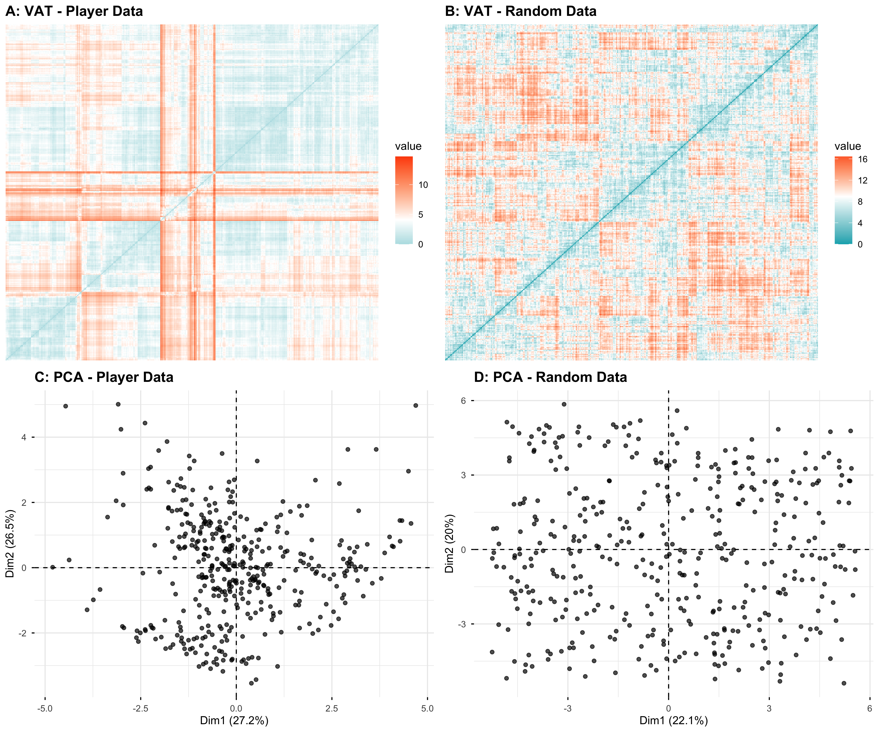
Cluster tendency assessment comparing player data (left column) to random data (right column). Top row: Visual Assessment of Cluster Tendency (VAT) ordered dissimilarity matrices. Bottom row: PCA visualisations. The player data shows clear clustering structure (dark blocks in VAT, visible groupings in PCA) while random data shows no such patterns.

Appendix 2: Cluster Validation Plots
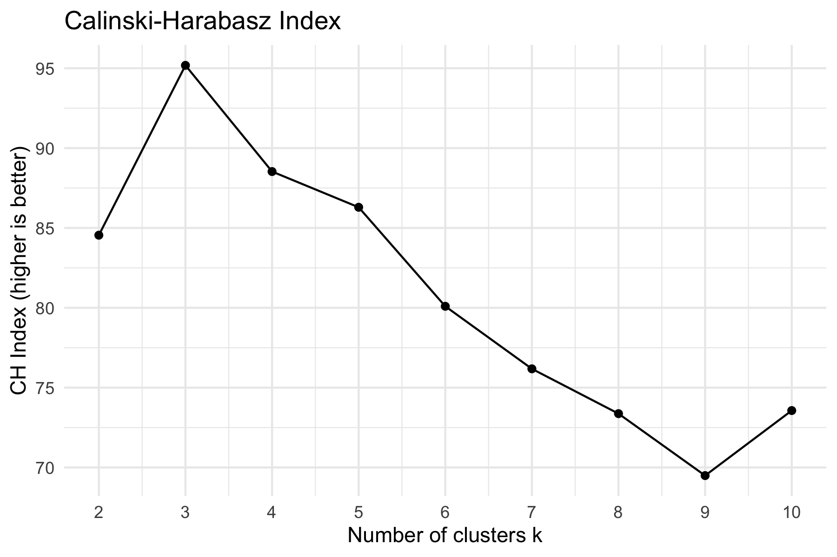
Cluster validation using the Calinski-Harabasz Index across k = 2 to 10.
The plot above shows the validation method used to determine the optimal number of clusters. The Calinski-Harabasz Index evaluates cluster validity based on the ratio of between-cluster to within-cluster variance, with higher values indicating better separation between clusters. The index indicated that k = 3 was the optimal number of clusters for our player data.

Appendix 3: Robust Mixed-Model Coefficients
Table 2: Fixed-effect coefficients from robust linear mixed-effects models (rlmer) with random intercepts for country. Approximate p-values derived from the normal approximation of t-statistics.
Model | Outcome | Term | b | SE | t | p
Main effects | Wellbeing | Casual PvP vs Casual PvE | -0.906 | 0.292 | -3.11 | .002
Main effects | Wellbeing | Elite Allround vs Casual PvE | -0.887 | 0.250 | -3.55 | < .001
Main effects | Wellbeing | Hours played | 0.026 | 0.008 | 3.08 | .002
Main effects | Wellbeing | Gender: Male (vs Female) | -0.788 | 0.239 | -3.30 | < .001
Main effects | Wellbeing | Gender: Other (vs Female) | -4.424 | 1.926 | -2.30 | .022
Main effects | Wellbeing | Gender: Undisclosed (vs Female) | -0.844 | 0.593 | -1.42 | .154
Main effects | Wellbeing | Age | -0.016 | 0.008 | -2.00 | .046
Main effects | Enjoyment | Casual PvP vs Casual PvE | -0.468 | 0.160 | -2.93 | .003
Main effects | Enjoyment | Elite Allround vs Casual PvE | -0.281 | 0.137 | -2.05 | .040
Main effects | Enjoyment | Hours played | 0.014 | 0.005 | 3.10 | .002
Main effects | Enjoyment | Gender: Male (vs Female) | -0.213 | 0.131 | -1.63 | .103
Main effects | Enjoyment | Gender: Other (vs Female) | -0.790 | 1.054 | -0.75 | .453
Main effects | Enjoyment | Gender: Undisclosed (vs Female) | -0.436 | 0.324 | -1.35 | .178
Main effects | Enjoyment | Age | -0.003 | 0.004 | -0.71 | .481
Moderation | Wellbeing | Casual PvP vs Casual PvE | -0.822 | 0.338 | -2.44 | .015
Moderation | Wellbeing | Elite Allround vs Casual PvE | -0.899 | 0.300 | -2.99 | .003
Moderation | Wellbeing | Hours played | 0.028 | 0.019 | 1.49 | .136
Moderation | Wellbeing | Gender: Male (vs Female) | -0.803 | 0.240 | -3.34 | < .001
Moderation | Wellbeing | Gender: Other (vs Female) | -4.421 | 1.932 | -2.29 | .022
Moderation | Wellbeing | Gender: Undisclosed (vs Female) | -0.865 | 0.595 | -1.45 | .146
Moderation | Wellbeing | Age | -0.016 | 0.008 | -1.97 | .048
Moderation | Wellbeing | Casual PvP × Hours | -0.017 | 0.033 | -0.52 | .600
Moderation | Wellbeing | Elite Allround × Hours | -0.000 | 0.021 | -0.00 | .998
Moderation | Enjoyment | Casual PvP vs Casual PvE | -0.537 | 0.185 | -2.91 | .004
Moderation | Enjoyment | Elite Allround vs Casual PvE | -0.292 | 0.164 | -1.77 | .076
Moderation | Enjoyment | Hours played | 0.012 | 0.010 | 1.13 | .257
Moderation | Enjoyment | Gender: Male (vs Female) | -0.203 | 0.132 | -1.54 | .123
Moderation | Enjoyment | Gender: Other (vs Female) | -0.799 | 1.058 | -0.76 | .450
Moderation | Enjoyment | Gender: Undisclosed (vs Female) | -0.413 | 0.326 | -1.27 | .205
Moderation | Enjoyment | Age | -0.003 | 0.004 | -0.71 | .475
Moderation | Enjoyment | Casual PvP × Hours | 0.012 | 0.018 | 0.69 | .493
Moderation | Enjoyment | Elite Allround × Hours | 0.002 | 0.012 | 0.19 | .851

This table presents the full coefficient estimates for all four robust mixed-effects models. ANOVA omnibus tests, Tukey HSD post-hoc comparisons, simple slopes, and pairwise slope-difference tests are reported in the main text.

