## **LINGER PROJECT**

BACKEND SYSTEM

This is a language Learining App. It works with the **Users** that subscribe to language to learn through **lesson** and **quizes** and their test score recorded in **finishedQuiz**. The User can subscribe to multiple languages and achieve different levels of proficiency recorded in **UserLanguage**. Obviously each quiz has different sets of questions and **answers**.

ER DIAGRAM

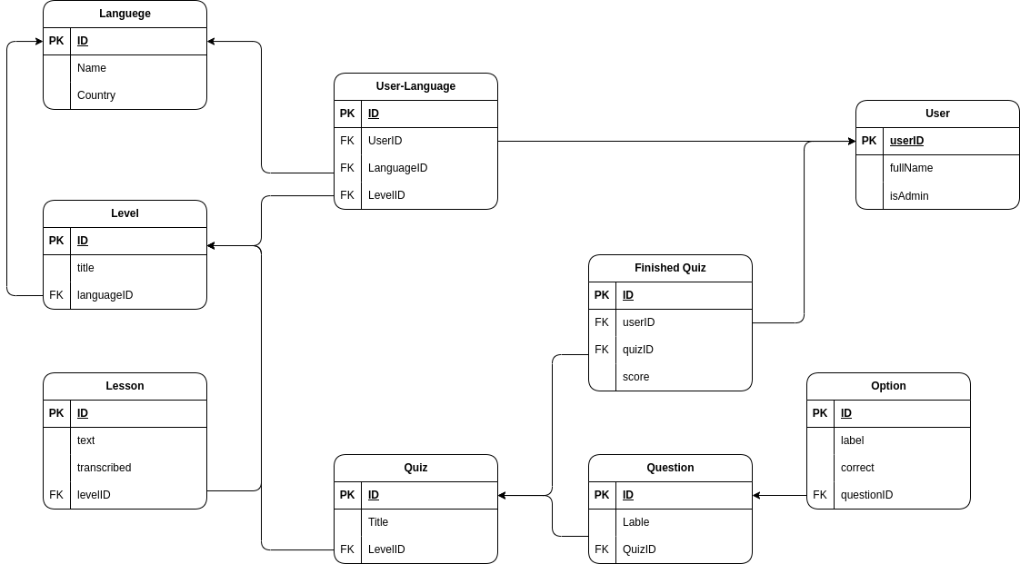

REST API STRUCTURE

USE CASE DIAGRAM

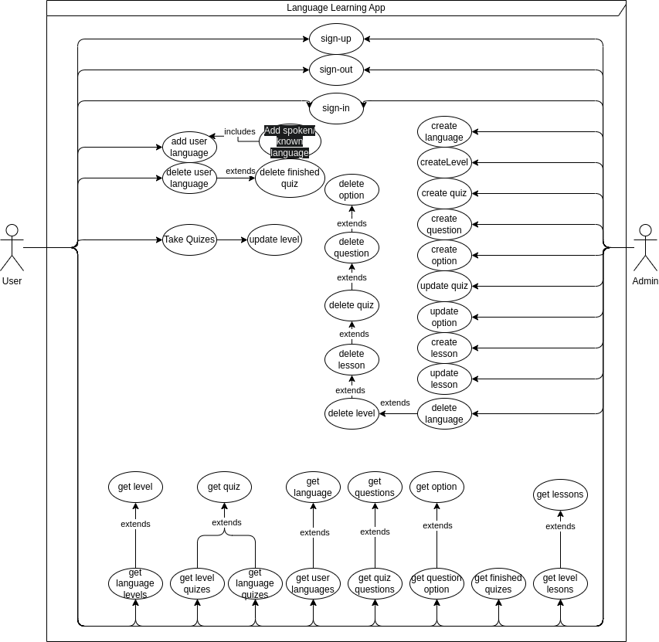

CLASS DIAGRAM

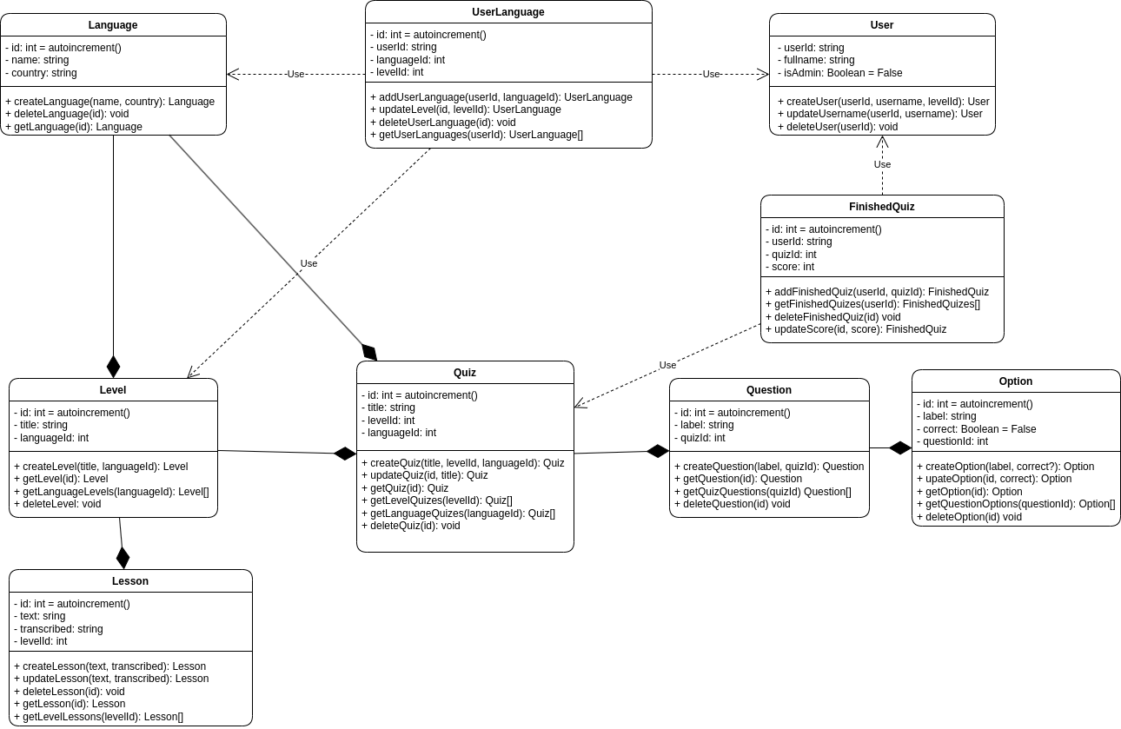

TASK ALLOCATION

Build Express Controllers and routes for the following Classes

|  |  |  |  |
| --- | --- | --- | --- |
| **Member** | **Task A** | **Task B** | **Task C** |
| Thomson | User |  |  |
| Emmanuel | Quiz | FinishedQuiz |  |
| Divad | UserLanguage | Question | Option |
| Delano | Level |  |  |
| Alan | Lesson |  |  |

You can easily perform your task by following the same process that has been done with the Language class. You can see that at server/src/controllers/languageController.ts for the controller and server/src/routes/language.ts for the routes.