**Group members**: Thomas Auer, Larissa Krainer, Kristina Liebhart

**Exercise 1**:

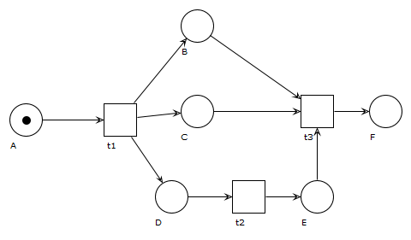

1. 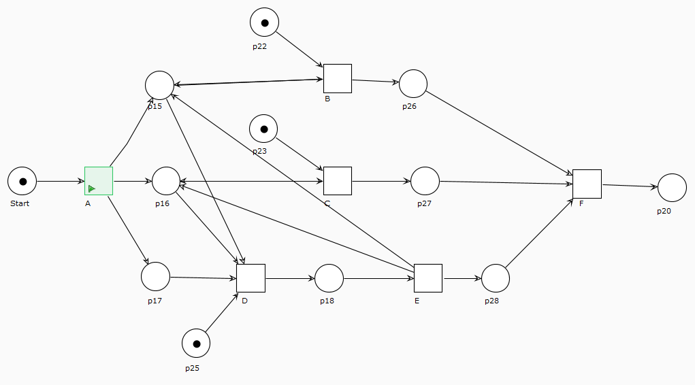

We decide to use A,B,C,D,E and F as transitions and not as places, because in the description they were specified as tasks.

**Exercise 2**

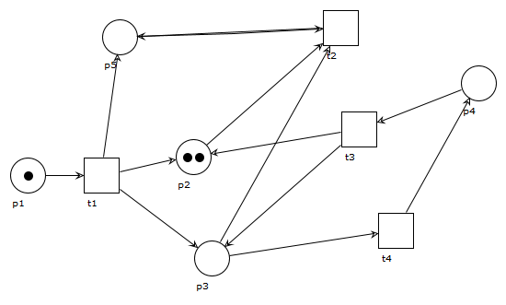

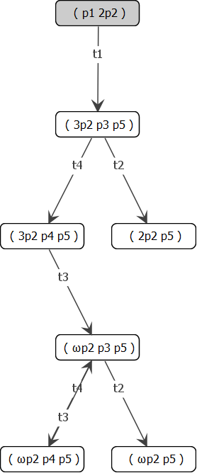

1. Boundedness: Because the whole petri net could be infinite, so it is unbounded

Safeness: The petri net is unsafe because it is not 1-bounded  
Conservativeness: It is not (strictly) conservative because the amount of tokens is infinite (not constant)  
liveness: t1 = L1-live, t3 and t4 = L3-live and t2 = special case, it can be dead L0-live or almost L1-live, but I depends on the firing sequence

1. T2 is our special case, it could be dead, but it depends on which firing sequence is chosen. It exists a firing sequence where t2 is L0-live, but not in every firing sequence.
2. No deadlocks, the petri net is infinite if t4 and t3 are chosen in every firing sequence or it stops after t2. So there are no deadlocks.
3. Our petri net is not a workflow net, because it exists only as an Input place but no Output place.

Exercise 3

