Luke Thompson
Investing Project
26 Nov 25

Introduction 11/25
My name is Luke Thompson. I have been actively trading options on the stock market since I was 16 years old. I employ a swing trading strategy where I enter long positions based on technical analysis, fundamental analysis, and macro sentiment. When this strategy works, it works well, but overall there are far numerous losses than gains. I have blown up my account multiple times due to trading on emotion and taking too big of risks. Whenever I blew up my account, I would take a long break from trading until I could fund my account again from my jobs. I have refined the strategy over time, and my most recent journey has shown great returns. Since June of 2025 until the time of writing, I have turned $700 into just shy of $20k back down to $5k. The reason for this drawdown is that my strategy doesn’t account for bearish markets, and I was overexposed to high beta stocks. My risk management is also subpar with most failed trades ending with worthless contracts. One of my biggest impediments on my entry and exit is lack of resources to constantly be monitoring the stock market. I will either miss the start of an explosive move upwards or downwards, which results in reduced profitability. I also have limited funds in the account, meaning position sizes are relatively large to overall net balance. These factors result in opportunity cost that I believe can be mitigated.
I have been obsessed with the stock market ever since I learned about it. I think my introduction was through browsing Reddit, when I was randomly recommended the r/WallStreetBets subreddit. That’s when I saw people making an insane amount of money trading options. So I studied. I read everything I could and watched every video on the stock market and options. I got my dad to create an investing account for me. I used TD Ameritrade because they had a powerful desktop application. I began to watch the charts. That’s when I felt it. The pattern recognition system in my brain was going haywire. I knew there were patterns in those candles. I studied technical indicators, and those had patterns too. After spending countless hours over the past 7 years staring at the charts, I can admit to not having figured out any patterns. If I had, I would be rich and not even studying this. Maybe the stochastic nature of the stock market is what drew me to it. I had already been introduced to artificial intelligence at this point, and understood the world was about to change. Maybe the universe was trying to put these two topics together for me, so that I can unlock the true potential of machine learning.
Over the past five years of my education, I have been studying machine learning and artificial intelligence. I believe at this point I have enough practice and skill to apply my knowledge to this problem. I have always been fascinated with the stochastic nature of the stock market, and I have been obsessed with trying to learn the patterns. I believe it is a matter of fate that my two biggest passions have presented this opportunity. This project requires more than just basic AI knowledge, and while I have been always looking for solutions, I believe I have strategically positioned myself to come up with a practical solution.

Objective
My goal for this project is to create a trading agent to place trades based on the intraday movement of the S&P 500. From my experience as a retail trader, I understand my place in the stock market. I am just a sole actor with limited capital. On the other hand, there are so-called “whales,” which are hedge funds or huge investment banks placing five or six figure trades at a time. These agents control the market, and their volume can actually move the market. My plan is not to predict or counter-trend trade any more. It is to detect when a new trend is developing in the stock and “ride the waves” of the larger market forces. I currently can’t do this because I have a life larger than the stock market; I can’t just be sitting at my desk all day watching the charts and waiting for the perfect entry and exit. If I have an agent running on a server, though, it can place trades the second it recognizes a shift in the trend. It also removes human emotion and all the logical fallacies that one can fall into.

Pipeline
The general pipeline for machine learning is as follows: Get the data, preprocess the data, train a model, and analyze model performance. Each one of these steps requires in-depth domain knowledge. There are a plethora of factors that influence each decision made here, which is why we sometimes call ML an art just as much as a science. This project will also require additional infrastructure to work. I need to have a server online so that I can make API requests to my brokerage. I also need real-time data for detecting the shifts. I plan to code this in Python. The data I will be collecting is not just price data of $SPY, but also sentiment and options flow.

Literature Review 11/27
Before I start narrowing down my choices for the ML aspect, I looked at the current literature on this topic. I used Google Scholar for “Machine Learning Stock Market.” I first read the analysis by Kumbure et al. which reviewed research papers from 2000 to 2019. From this, I learned that neural networks, SVM, and technical indicators have already been proven to perform better than benchmarks, which was good news for my plan. After reading though, I realized that much more research has probably been conducted on the topic. I narrowed my Google Scholar search to within 2025, and I found another research review that focused on 2020 onwards. I found that in recent years, composite methods have been utilized to further increase the accuracy of previous models. Basically, as more research is done, more combinations of techniques are developed. Based on this previous research, I have determined that my intraday model will benefit from a combination of short term reliable techniques.
Research indicates that ensemble and hybrid models often outperform single algorithms in short-term stock prediction, sometimes achieving very high predictive accuracy (around 80% or higher)mdpi.com. For intraday SPY trading, constructing a pipeline that stacks or votes among multiple model types (perhaps an LSTM, a gradient boosted tree, and an SVM, for instance) is a promising approach, given the success reported in these studies.
CNNs can automatically extract local features or patterns (like specific price movements shapes or technical indicator sequences) from input data, which the LSTM can then interpret over time. For instance, Phuoc et al. (2024) used a CNN+BiLSTM model to predict stock index movements and found that the CNN’s feature extraction improved the LSTM’s performance on volatile datalink.springer.comlink.springer.com. Such hybrids have been called “state-of-the-art” in capturing short-term market dynamics, as the CNN identifies micro-patterns (e.g. a candlestick formation in intraday price series) while the LSTM tracks the temporal context.
Another promising deep learning approach is the use of autoencoders and denoising techniques to preprocess stock data. For example, an autoencoder+LSTM framework was explored in one study, where an encoder network first compressed the historical price data to its essential features, and then an LSTM decoded that to predict future pricesmdpi.com. This helped strip away some noise and redundancy, making the LSTM’s job easier in a chaotic intraday environment. Similarly, wavelet transforms or EMD (Empirical Mode Decomposition) have been used in conjunction with LSTMs (as in Hao & Gao’s 2020 model) to separate different time-scale components of price data, allowing the model to learn short-term fluctuations on a cleaner signalmdpi.com.
very recent work has started applying Transformer architectures to intraday financial data. Transformers (originally popular in NLP) can capture long-range dependencies and complex patterns using self-attention. For instance, Huang et al. (2023) developed a Transformer-based model for intraday trading signals on a commodity market (Shanghai crude oil futures), achieving notable successmdpi.commdpi.com.
The key for intraday SPY use-case will be to choose architectures that handle high-frequency noise and regime shifts – likely by combining techniques (CNN+LSTM, or adding attention mechanisms) and by incorporating appropriate regularization or preprocessing (autoencoding, wavelet denoising) to ensure the models generalize well to new market conditions.
reinforcement learning (RL) takes a different but complementary approach: learning an optimal trading policy through trial and error. For intraday trading of SPY, RL is attractive because it can directly optimize for profit or risk-adjusted returns rather than just predictive accuracy. Notably, Deep Q-Networks (DQN) and Policy Gradient methods (like the Proximal Policy Optimization (PPO) algorithm) have been successfully applied to short-horizon tradingmdpi.com. Meng & Khushi (2019) survey several such approaches and conclude that these RL agents can adapt to fast-changing market conditions more readily than static modelsmdpi.com. One impressive real-world result comes from an intraday strategy on volatility: a research by Gu et al. reported an intraday VIX futures trading agent (an RL-driven strategy) that achieved extremely high risk-adjusted returns – Sharpe ratio ~3.98 – indicating very consistent outperformancemdpi.com. exploring an RL-driven strategy (e.g. a DQN or PPO trader that learns when to enter/exit SPY positions) could leverage the high-frequency predictions and translate them into profitable decisions. Combining this with the predictive models (as a form of model-based RL or signal-informed policy) might yield even better results.
The last few years have seen an explosion of using textual data to predict stock moves. Incorporating news headlines, articles, and social media sentiment can boost short-term prediction accuracy, since market prices often react to news within minutes or hours. Recent advancements use NLP and large language models for even more sophisticated sentiment extraction. Another study in 2024 by Zhang et al. created a CoATSMP information-fusion model that combined stock price data with news text, and found that this fusion improved prediction accuracy and even trading profits significantly over using price data aloneconsensus.app. In fact, a 2023 experiment showed that ChatGPT’s evaluations of news had a strong positive correlation with next-day stock returns, outperforming basic sentiment metricsmdpi.com.
Order flow (the sequence of buy and sell orders) can provide a very direct signal of short-term supply/demand imbalances. For instance, a very recent 2025 study by Lee et al. found that incorporating cross-asset order flow (in their case, using S&P 500 futures order flow as an input to predict the S&P 500 index) substantially improved intraday price movement predictions. The researchers demonstrated that futures order flow was an even stronger predictor for the index than the stock’s own past price data, highlighting how derivative markets can lead the underlying market. Likewise, options flow (unusual options volume, put/call ratios, etc.) might foreshadow equity moves as informed traders often express views via options. While the survey didn’t explicitly cite papers on options flow, you could explore using features like changes in SPY option open interest or implied volatility skew as part of your model. These can indicate market sentiment and big-player positioning that could predict short-term moves.

Accessing the Market
I am using the Charles Schwab developer API to control my account’s actions as well as pull historical and live stock data. I will also subscribe to polygon.io for their historical futures and options flow. One study showed increased accuracy in predictions when they included futures in their data. I also have studied options extensively and believe they can provide increased prediction accuracy through volatility measures and gamma exposure.

Features
The selection of features to train the models on is in my opinion the most important part of this process, and with that, the most time consuming as well. The stock market is inherently filled with noise as there are just so many people and forces interacting together. All predictors of the stock market share the same foundational features: The price data. This is the most fundamental data we can use because it is the most real-time and shared knowledge. Technical Analysis is seen by some as financial astrology, but I disagree; price combined with volume is the only leading indicator in the market. Show me any chart, and I will show you support and resistance and trends that the stock will follow. The birth of algorithmic trading has only reinforced these key levels to watch for, and I believe they can be exploited for swing trading. For my technical indciators, I pull them from pandas ta library and add them all to my data frame. I also had several custom Thinkscript indicators that I converted to python. However, I realized the pandas ta features already included them by running a correlation on all of the features.
Toolbox
Data – Yahoo Finance, Charles Schwab, Alpaca
Feature Selection – GA plus XGBoost
Ensemble – LSTM, GRU, BiLSTM, MLP, Transformer,

Testing Results
Comparing GA plus XGBoost versus just XGBoost vs GA plus other decision trees (rf, et, svm, knn).
Train: (2198, 343) Test: (550, 343)
[Baseline] XGB on OHLCV only - test acc: 0.4200
[Baseline] XGB on ALL features - test acc: 0.6145
[GA-XGB] best val acc during GA: 0.6788
[GA-XGB] selected features: 172
[GA-XGB] test acc: 0.6000
[GA-RF] best val acc: 0.6121, selected features: 176
[GA-RF] test acc: 0.4182
[GA-ET] best val acc: 0.5848, selected features: 165
[GA-ET] test acc: 0.4200
[GA-SVM] best val acc: 0.5485, selected features: 175
[GA-SVM] test acc: 0.5818
[GA-KNN] best val acc: 0.5758, selected features: 178
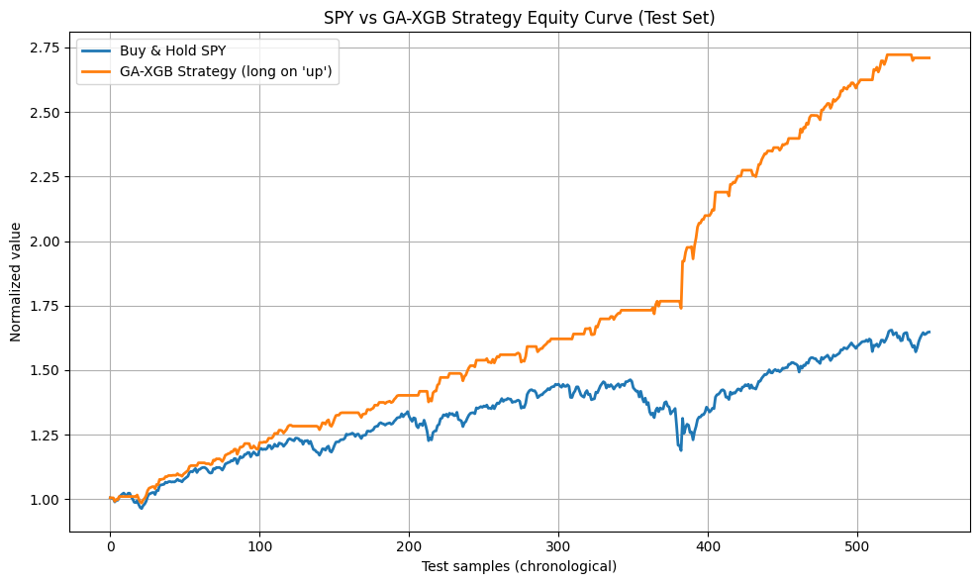
[GA-KNN] test acc: 0.4291

12/13/2025
Researched live futures data providers. Determined not worth it at the moment. Created Tradier account for options live access.

12/17/2025
Experimented with the label graph. I found that decreasing the sequence count from 5 to 3 in my add_pivots function increased the number of pivots found. Then I was able to add pivots to the local minima the labels were missing earlier.
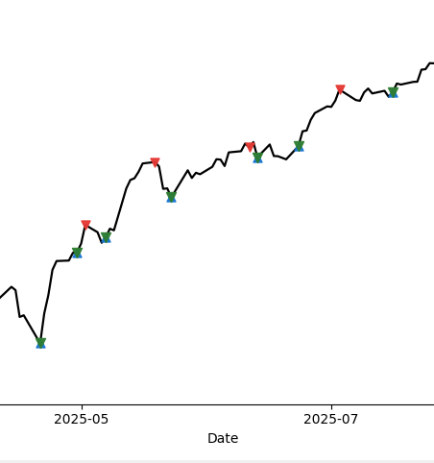
1/5/2026
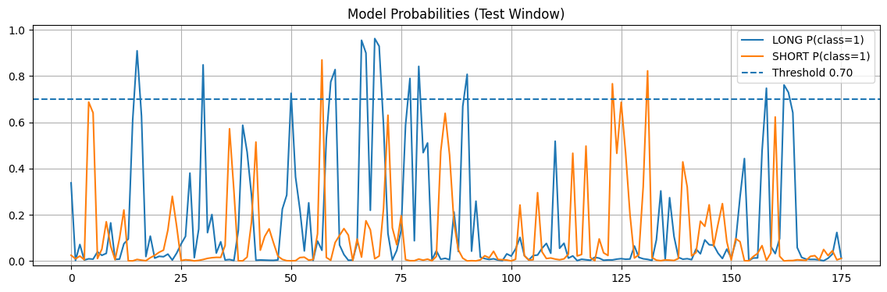
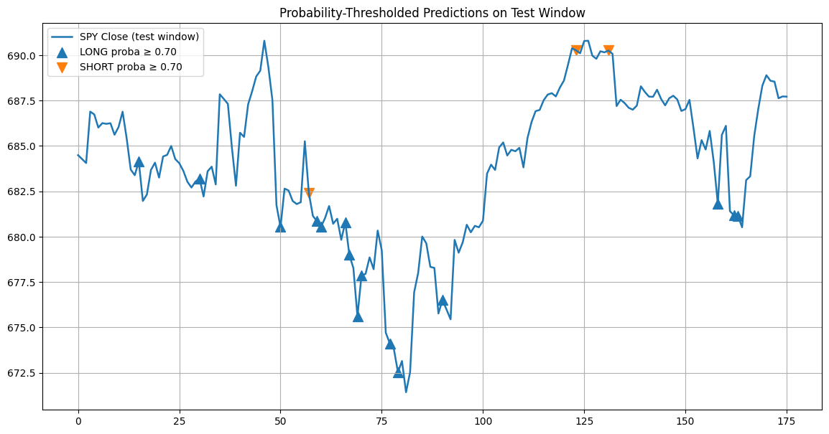
Running model on 1hr SPY data

1/6/2026
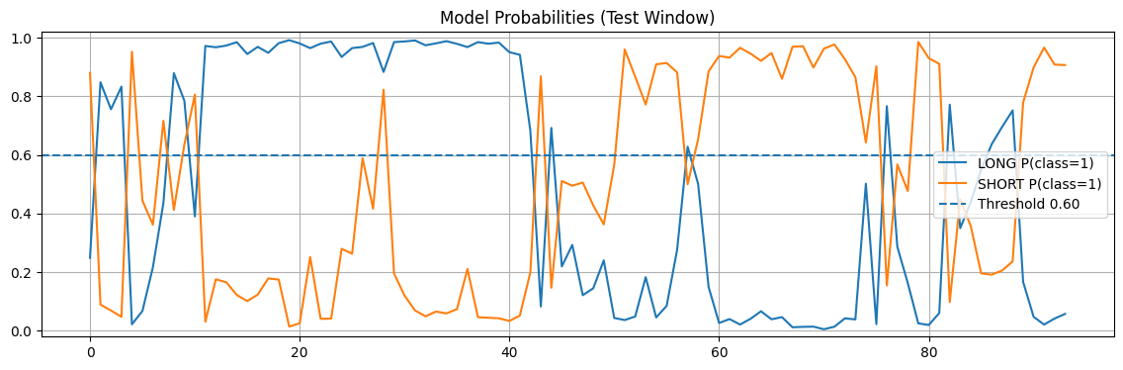
Running leg segmentation models on 1hr SPY data
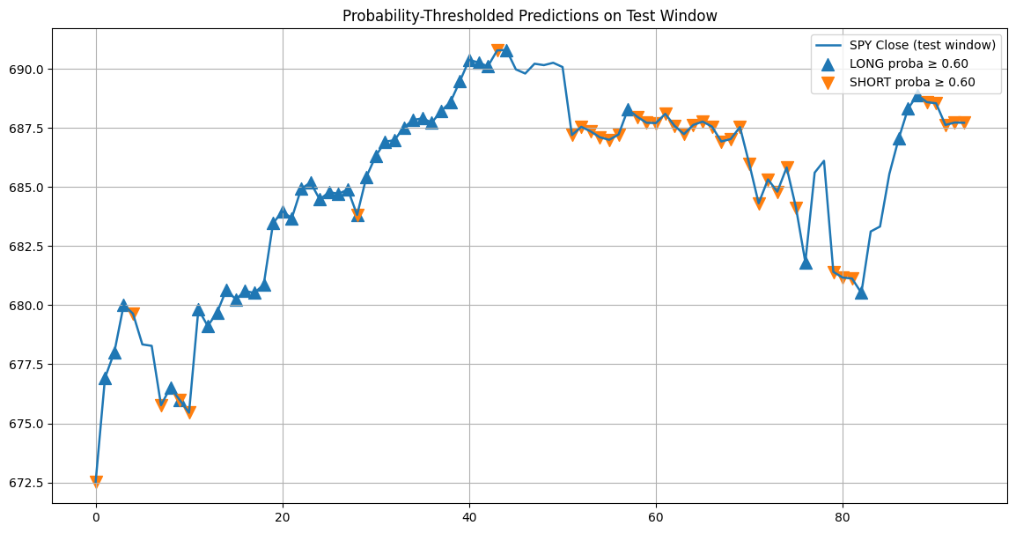
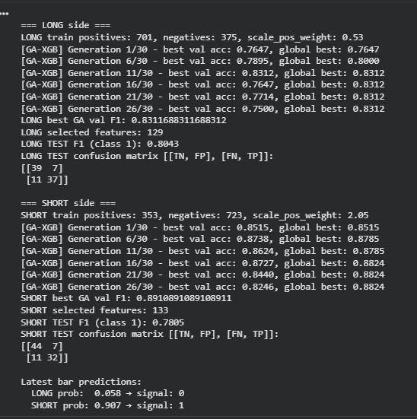

1/11/2026
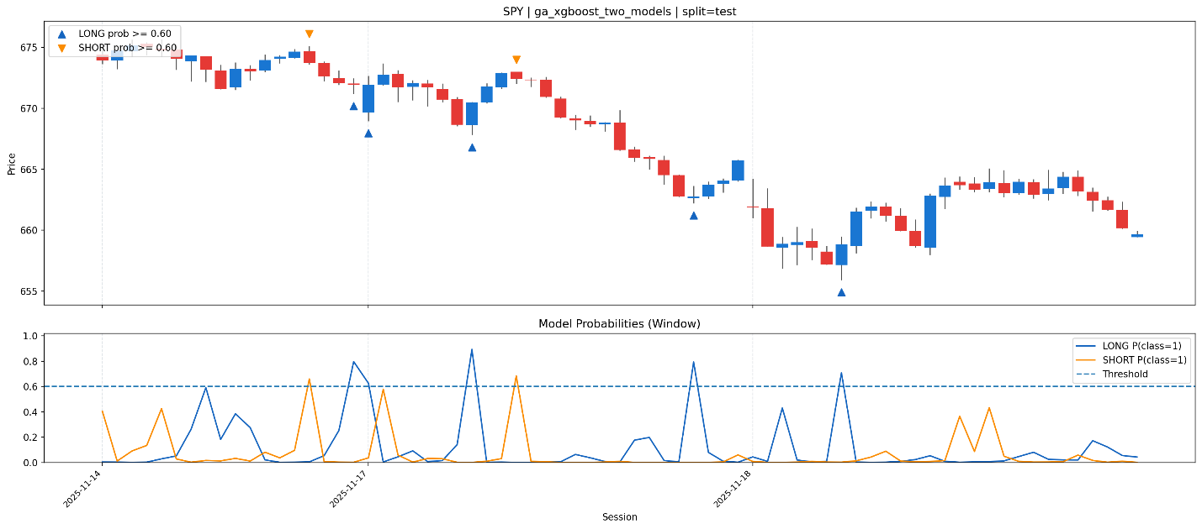
Trained XGBoost model inference on test set for 15min SPY bars

1/21/2026
Updated XGBoost model on test set 15min bars with threshold .8
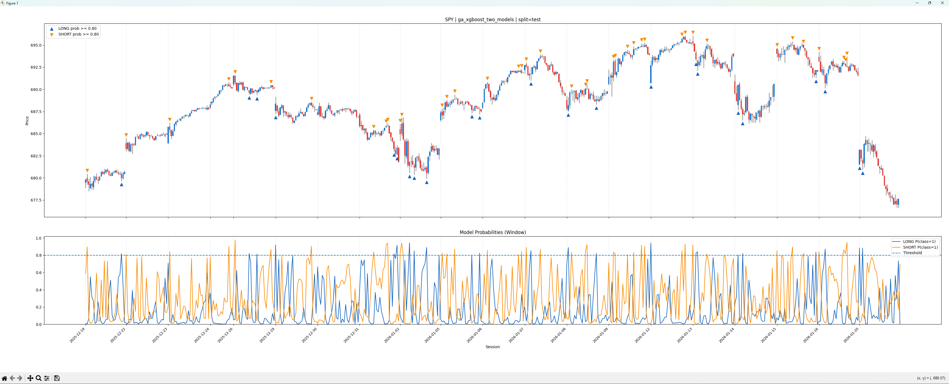

1/26/2026
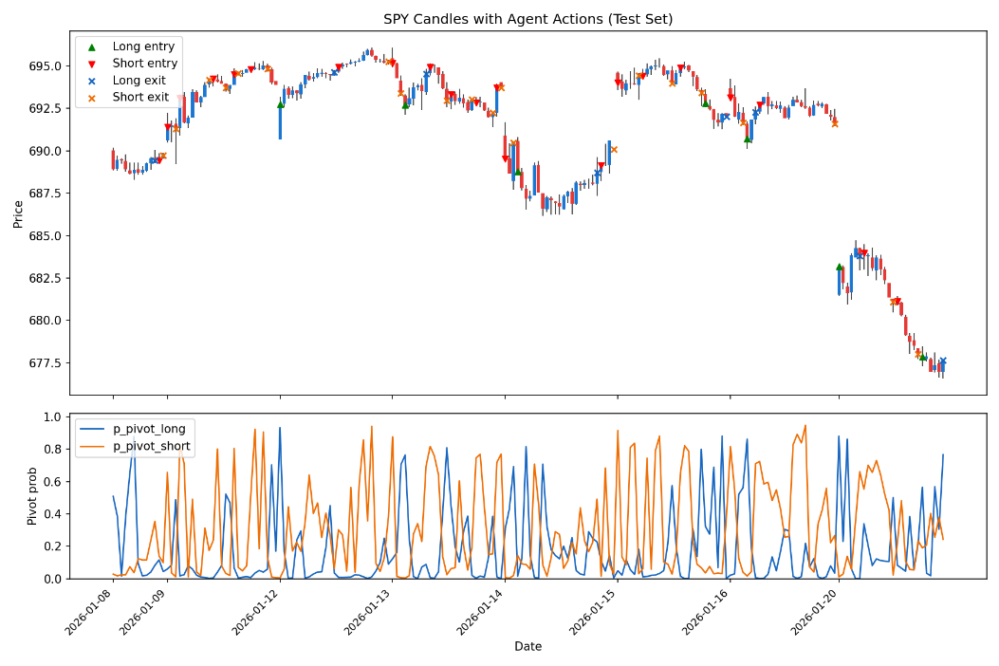
PPO Agent for policy. Test set results. Given pivot_proba and no other meta labels.

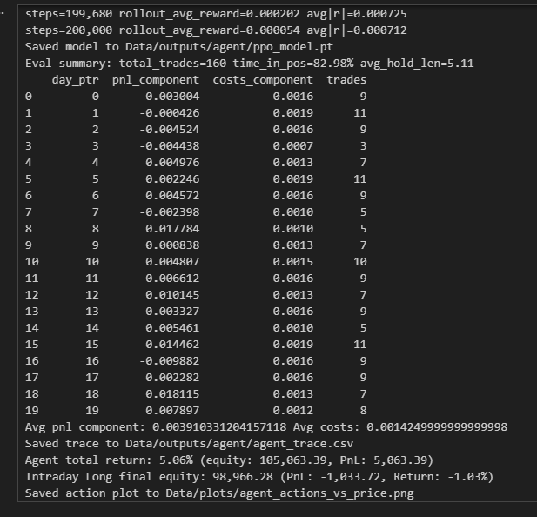
Training Output.

Comparison of luciddrains iTransformer modules original, 2d, and fft using exhaustion progress label.
variant | val_loss | test_loss | test_mse | test_mae | test_r2
------------------------------------------------------------------------------
original | 0.086642 | 0.117735 | 0.111004 | 0.248227 | -0.166270
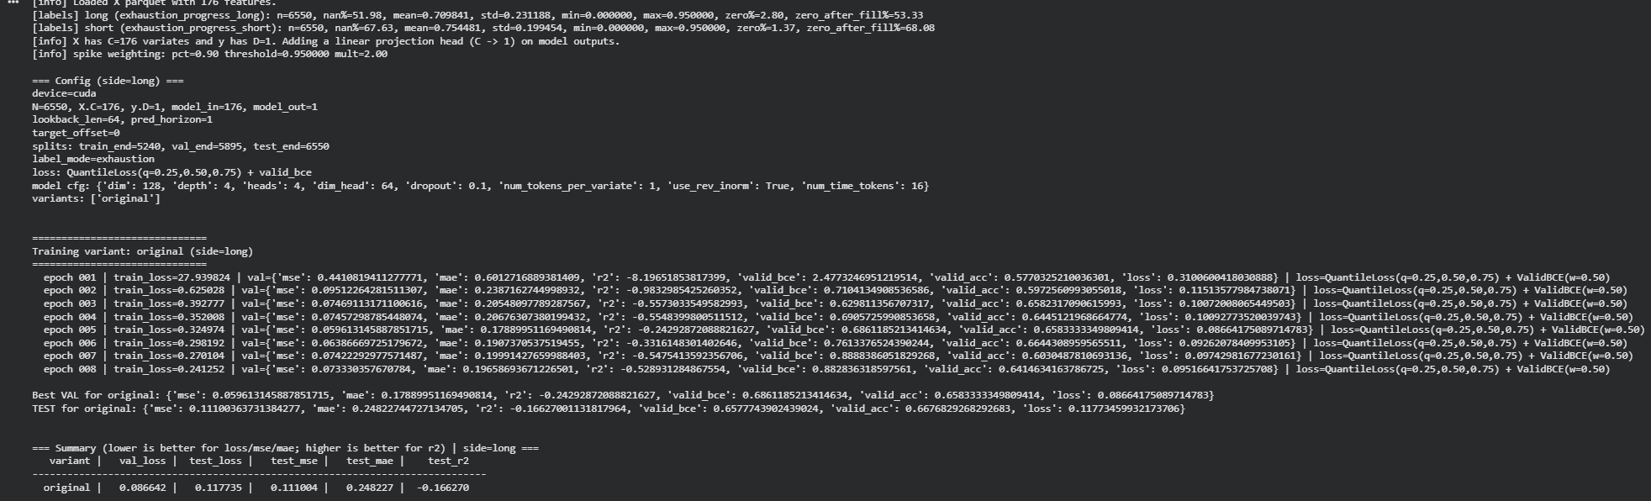
variant | val_loss | test_loss | test_mse | test_mae | test_r2
------------------------------------------------------------------------------
2d | 0.086154 | 0.117190 | 0.134940 | 0.251625 | -0.417761
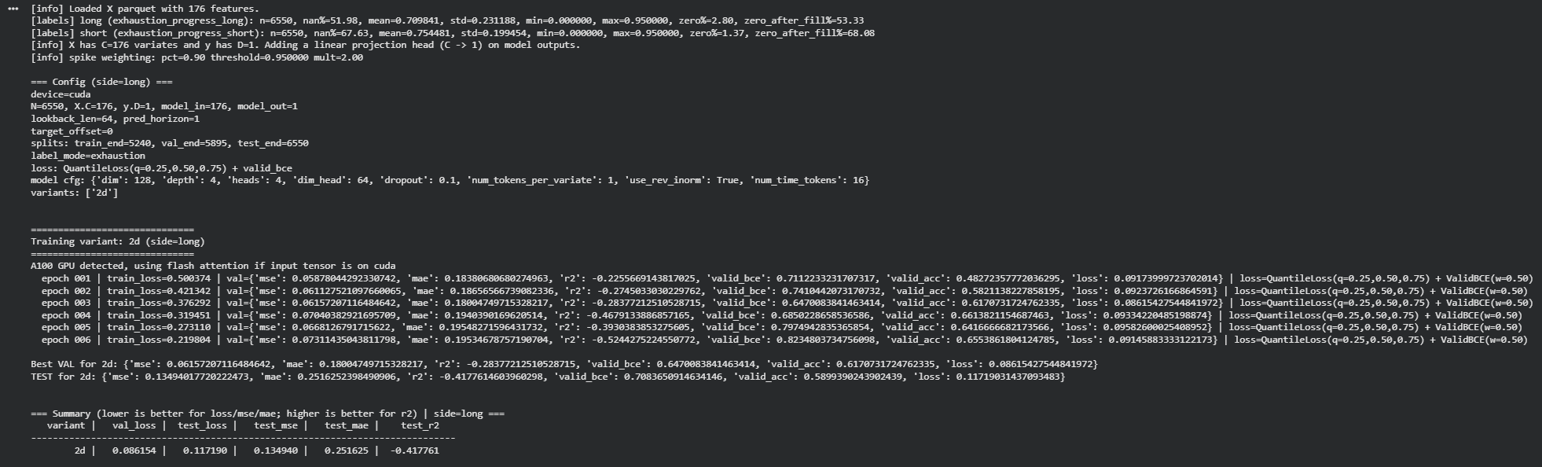
variant | val_loss | test_loss | test_mse | test_mae | test_r2
------------------------------------------------------------------------------
fft | 0.090150 | 0.128347 | 0.154748 | 0.275256 | -0.625877
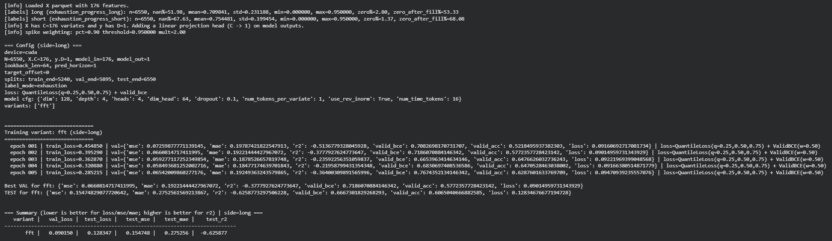
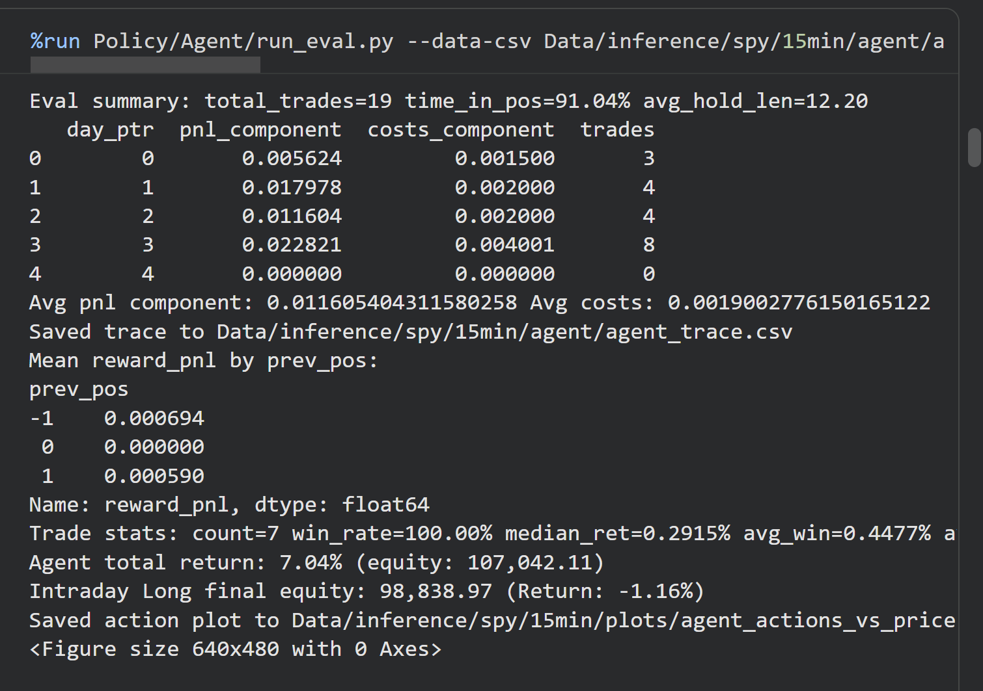
Example Agent Training in Colab Notebook

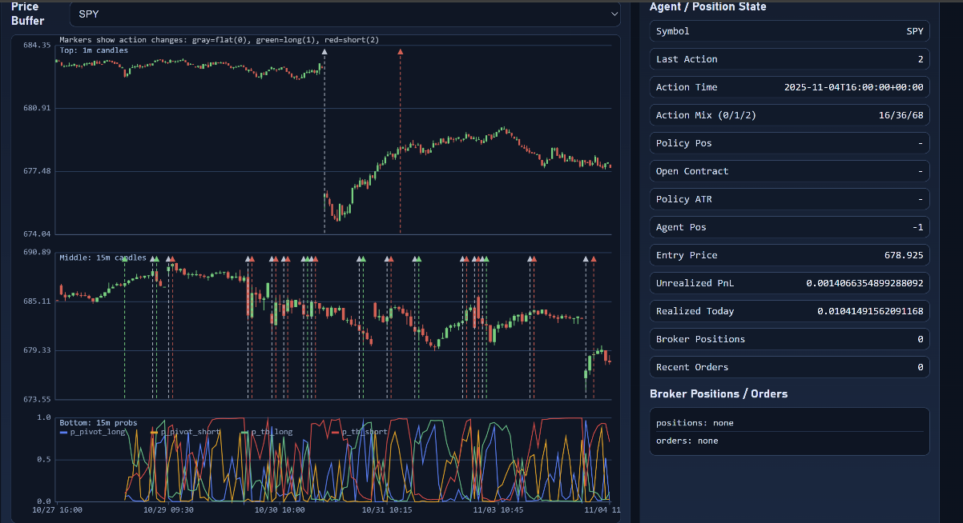
UI of replay tester with agent decisions and key probabilities it was fed.

13 February 2026
New dual head model with side and magnitude. Has convex reward. Achieves + 70% returns vs baseline
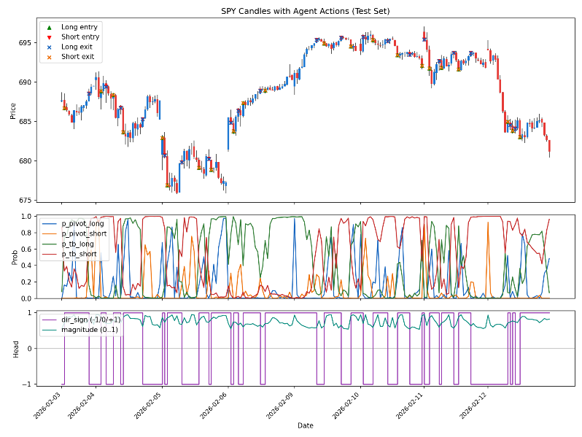
Eval summary: total_trades=239 time_in_pos=100.00% avg_hold_len=4.71
day_ptr pnl_component costs_component trades
0 0 0.016094 0.000582 27
1 1 0.051897 0.000481 27
2 2 0.078611 0.000736 26
3 3 0.120546 0.000844 27
4 4 0.019624 0.000653 27
5 5 0.051098 0.000488 27
6 6 0.074604 0.000748 26
7 7 0.053461 0.000822 26
8 8 0.053199 0.000594 26
Avg pnl component: 0.05768173362696773 Avg costs: 0.0006610093908839756
Eval loss metrics: actor=-0.190147 value=0.000446 entropy=0.485556 avg_reward=0.002112 avg_abs_reward=0.002415
Convex stats: mean_reward=0.002112 mean_reward_pnl=0.002163 mean_costs=0.000025 mean_reward_convex=0.001992 mean_reward_convex_linear=0.000342 mean_reward_convex_bonus=0.000092 mean_convex_term=0.001255 mean_convex_atr_scale=0.002221 mean_pivot_anchor=0.001595 mean_switch_penalty=0.000010 mean_size_penalty=0.000001 mean_mfe_atr=0.7350 total_mfe_bonus=0.041000
Trade stats: count=50 win_rate=80.00% median_ret=0.1048% avg_win=0.2113% avg_loss=-0.0846% trades_per_day=5.56
Agent total return: 66.74% (equity: 166,742.98)
Intraday Long final equity: 96,778.24 (Return: -3.22%)

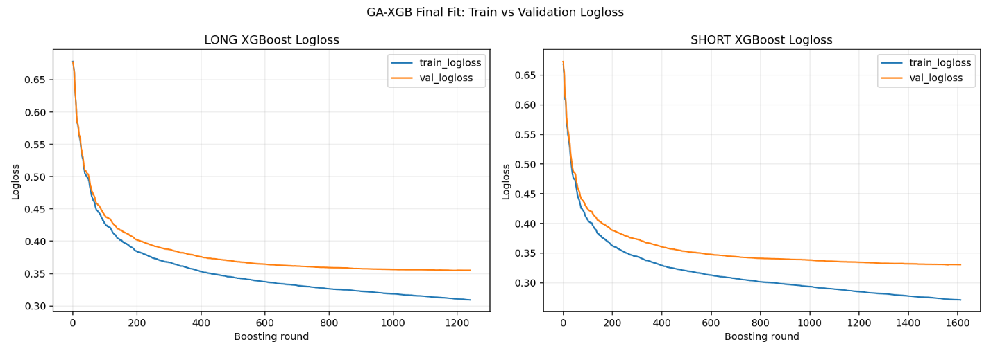
2/26/26 Updated XGBoost with DART style dropout and early validation stopping (max 2000 rounds)
3/19/2026 Meta model entry/exits updated with new dart boosters
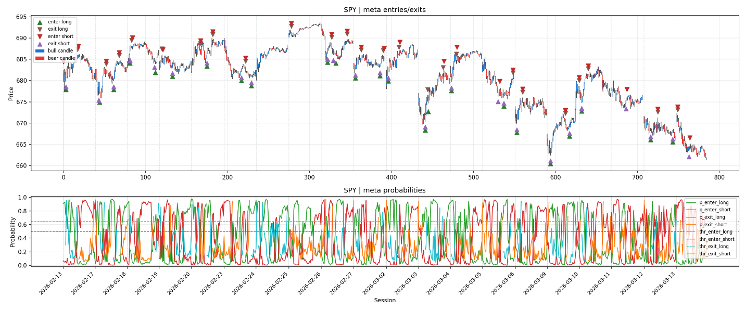

4/10/2026 Meta model is broken and have to redo everything
Apparently there was a leaky feature that was causing too-good results in backtesting. However, the model was working live for about a week and made $800 profit before breaking and losing it all. So now once I removed the leaky feature (DPO from pandas-ta), the swing model still works but performs worse, the tb model fails completely by collapsing to the mean, and meta model also collapses to the mean. I tried fixing in multiple ways but problem became to complex. Now I am reverting to just training the swing model. I am feeding the meta model features in with the original swing ta features. I am also trying to train a single multi-head model instead of two dual head models

Dual Head OOF training
[GA-XGB] LONG final-fit logloss: rounds=1492, best_val=0.30761 @ round 1442, final_train=0.33288, final_val=0.30910
[GA-XGB] SHORT final-fit logloss: rounds=1078, best_val=0.40156 @ round 1028, final_train=0.39481, final_val=0.40236
[GA-XGB] LONG OOF probs: mean=0.1786, p01=0.0000, p10=0.0002, p50=0.0158, p90=0.6635, p99=0.8908
[GA-XGB] SHORT OOF probs: mean=0.2151, p01=0.0002, p10=0.0014, p50=0.0672, p90=0.6796, p99=0.8899
[GA-XGB] LONG test probs: mean=0.2366, p01=0.0000, p10=0.0003, p50=0.0393, p90=0.7555, p99=0.8973
[GA-XGB] SHORT test probs: mean=0.2745, p01=0.0010, p10=0.0042, p50=0.1288, p90=0.7593, p99=0.8942
[GA-XGB] LONG best OOF F1 threshold=0.5148 (f1=0.3971)
[GA-XGB] LONG OOF metrics (thr=0.51): acc=0.8588, prec=0.2921, rec=0.6202, f1=0.3971, f1=0.3971, auc=0.8792, ap=0.3144, logloss=0.2768, tp=1832, fp=4440, tn=32002, fn=1122
[GA-XGB] LONG test metrics (thr=0.51): acc=0.8131, prec=0.2542, rec=0.8665, f1=0.3931, f1=0.3931, auc=0.9021, ap=0.3311, logloss=0.3382, tp=318, fp=933, tn=3953, fn=49
[GA-XGB] SHORT best OOF F1 threshold=0.6039 (f1=0.3501)
[GA-XGB] SHORT OOF metrics (thr=0.60): acc=0.8649, prec=0.2674, rec=0.5067, f1=0.3501, f1=0.3501, auc=0.8487, ap=0.2632, logloss=0.3271, tp=1434, fp=3928, tn=32638, fn=1396
[GA-XGB] SHORT test metrics (thr=0.60): acc=0.8336, prec=0.2783, rec=0.7576, f1=0.4071, f1=0.4071, auc=0.8882, ap=0.3284, logloss=0.3856, tp=300, fp=778, tn=4079, fn=96
OOF gap detected (early bars without prior data). long=7879, short=7879
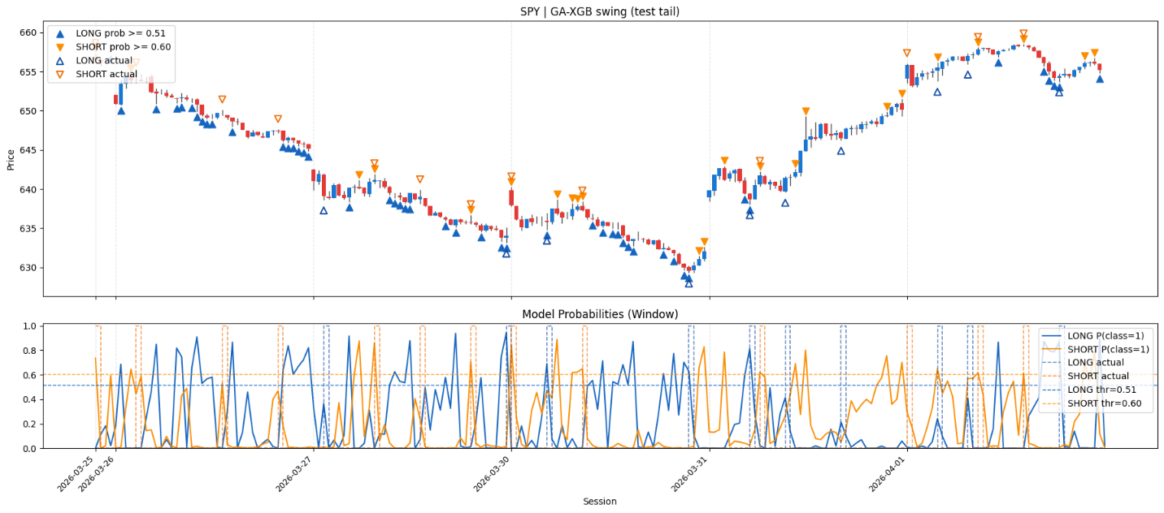

Dual Head OOF Training with Dart booster (dropout)
[GA-XGB] LONG final-fit logloss: rounds=1492, best_val=0.30761 @ round 1442, final_train=0.33288, final_val=0.30910
[GA-XGB] SHORT final-fit logloss: rounds=1078, best_val=0.40156 @ round 1028, final_train=0.39481, final_val=0.40236
[GA-XGB] LONG OOF probs: mean=0.1786, p01=0.0000, p10=0.0002, p50=0.0158, p90=0.6635, p99=0.8908
[GA-XGB] SHORT OOF probs: mean=0.2151, p01=0.0002, p10=0.0014, p50=0.0672, p90=0.6796, p99=0.8899
[GA-XGB] LONG test probs: mean=0.2366, p01=0.0000, p10=0.0003, p50=0.0393, p90=0.7555, p99=0.8973
[GA-XGB] SHORT test probs: mean=0.2745, p01=0.0010, p10=0.0042, p50=0.1288, p90=0.7593, p99=0.8942
[GA-XGB] LONG best OOF F1 threshold=0.5148 (f1=0.3971)
[GA-XGB] LONG OOF metrics (thr=0.51): acc=0.8588, prec=0.2921, rec=0.6202, f1=0.3971, f1=0.3971, auc=0.8792, ap=0.3144, logloss=0.2768, tp=1832, fp=4440, tn=32002, fn=1122
[GA-XGB] LONG test metrics (thr=0.51): acc=0.8131, prec=0.2542, rec=0.8665, f1=0.3931, f1=0.3931, auc=0.9021, ap=0.3311, logloss=0.3382, tp=318, fp=933, tn=3953, fn=49
[GA-XGB] SHORT best OOF F1 threshold=0.6039 (f1=0.3501)
[GA-XGB] SHORT OOF metrics (thr=0.60): acc=0.8649, prec=0.2674, rec=0.5067, f1=0.3501, f1=0.3501, auc=0.8487, ap=0.2632, logloss=0.3271, tp=1434, fp=3928, tn=32638, fn=1396
[GA-XGB] SHORT test metrics (thr=0.60): acc=0.8336, prec=0.2783, rec=0.7576, f1=0.4071, f1=0.4071, auc=0.8882, ap=0.3284, logloss=0.3856, tp=300, fp=778, tn=4079, fn=96
OOF gap detected (early bars without prior data). long=7879, short=7879


4/11/2026
Added fuzzy logic to create new swing support label instead of specific pivot bar logic. Also added single multi-class head that seems to perform better than dual binary heads.
[GA-XGB] SINGLE swing OOF metrics: acc=0.6768, macro_f1=0.4486, mlogloss=0.7010, cm=[[1171, 4704, 48], [1773, 24213, 1567], [40, 4602, 1278]]
[GA-XGB] SINGLE swing test metrics: acc=0.7234, macro_f1=0.4155, mlogloss=0.6266, cm=[[58, 678, 6], [52, 3603, 111], [0, 606, 139]]
[GA-XGB] SINGLE LONG OOF probs: mean=0.1518, p01=0.0006, p10=0.0027, p50=0.0616, p90=0.4412, p99=0.7187
[GA-XGB] SINGLE SHORT OOF probs: mean=0.1676, p01=0.0010, p10=0.0046, p50=0.0887, p90=0.4474, p99=0.7273
[GA-XGB] SINGLE NEUTRAL OOF probs: mean=0.6806, p01=0.2095, p10=0.4348, p50=0.7056, p90=0.8885, p99=0.9681
[GA-XGB] SINGLE LONG test probs: mean=0.1651, p01=0.0039, p10=0.0076, p50=0.1033, p90=0.4084, p99=0.6115
[GA-XGB] SINGLE SHORT test probs: mean=0.1561, p01=0.0054, p10=0.0107, p50=0.1128, p90=0.3457, p99=0.5386
[GA-XGB] SINGLE NEUTRAL test probs: mean=0.6788, p01=0.3500, p10=0.5217, p50=0.6979, p90=0.8061, p99=0.8670
[GA-XGB] SINGLE long best OOF F0.5 threshold=0.3565 (f0.5=0.4155)
[GA-XGB] SINGLE short best OOF F0.5 threshold=0.3367 (f0.5=0.3816)
[GA-XGB] SINGLE LONG OOF metrics (thr=0.36): acc=0.8092, prec=0.4197, rec=0.3996, f1=0.4094, f0.5=0.4155, auc=0.8037, ap=0.4007, logloss=0.3742, tp=2605, fp=3602, tn=29275, fn=3914
[GA-XGB] SINGLE LONG OOF metrics event±1: prec=0.4983, rec=0.5812, f1=0.5366, pred_hits=3093/6207, actual_hits=3789/6519
[GA-XGB] SINGLE SHORT OOF metrics (thr=0.34): acc=0.7857, prec=0.3718, rec=0.4267, f1=0.3973, f0.5=0.3816, auc=0.7713, ap=0.3598, logloss=0.3957, tp=2783, fp=4703, tn=28171, fn=3739
[GA-XGB] SINGLE SHORT OOF metrics event±1: prec=0.4467, rec=0.6021, f1=0.5129, pred_hits=3344/7486, actual_hits=3927/6522
[GA-XGB] SINGLE LONG test metrics (thr=0.36): acc=0.8277, prec=0.4603, rec=0.4488, f1=0.4545, f0.5=0.4580, auc=0.8276, ap=0.4780, logloss=0.3398, tp=377, fp=442, tn=3971, fn=463
[GA-XGB] SINGLE LONG test metrics event±1: prec=0.5214, rec=0.7012, f1=0.5981, pred_hits=427/819, actual_hits=589/840
[GA-XGB] SINGLE SHORT test metrics (thr=0.34): acc=0.8315, prec=0.4593, rec=0.3238, f1=0.3798, f0.5=0.4238, auc=0.8014, ap=0.4134, logloss=0.3560, tp=271, fp=319, tn=4097, fn=566
[GA-XGB] SINGLE SHORT test metrics event±1: prec=0.5288, rec=0.5711, f1=0.5491, pred_hits=312/590, actual_hits=478/837
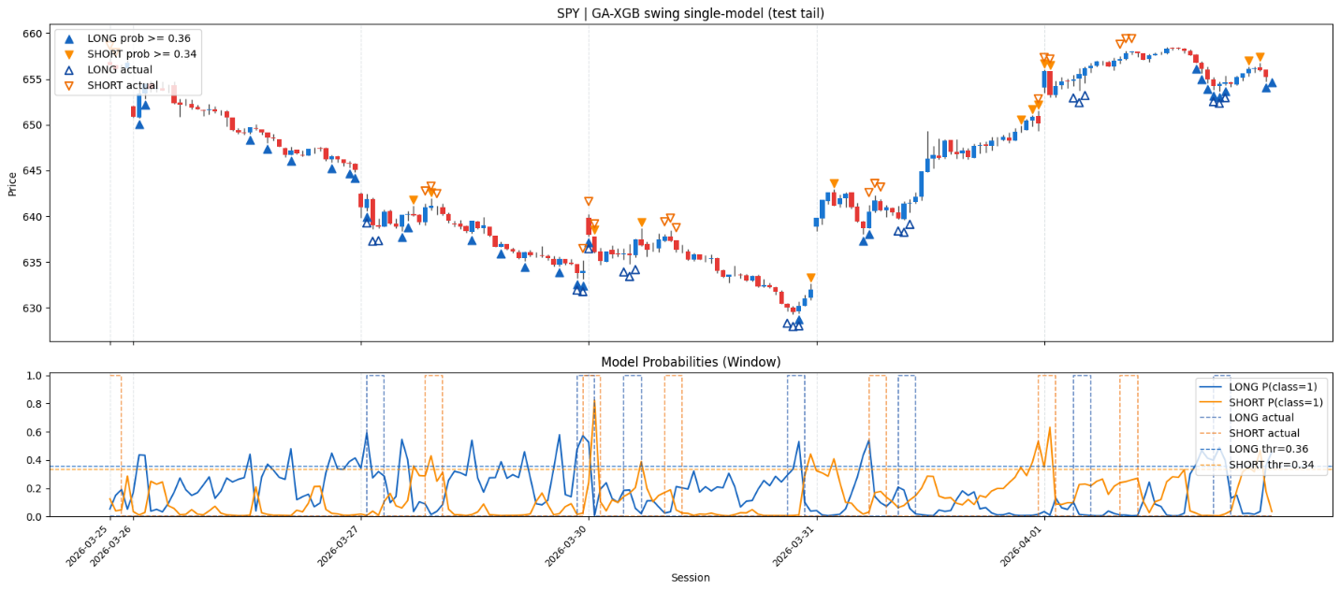

4/12/26 labelling schema for the swing support label. Fuzzy weighting in support zones. Only Best setup in trend kept and others dropped.

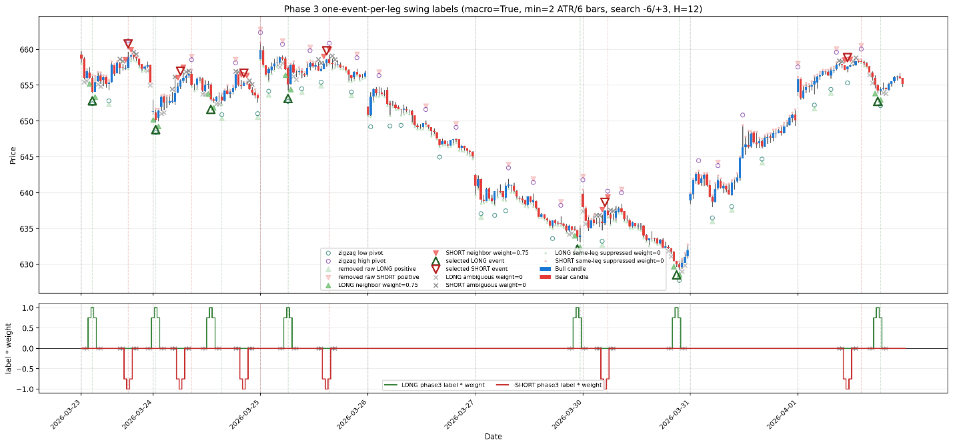

4/12/2026
Playing with the different order policies to see which one translates to the best Expected Value (EV)

Breakeven winrate calculated from pure take profit (tp) vs stop-loss (sl)
0 = win_rate * 1.0 - (1 - win_rate) * 0.8
0.8 = 1.8 * win_rate
win_rate = 44.4%

Meaning any win_rate above 44.5% and above will have a positive EV.

Initial comparison of trigger types
Entry policy | Best variant | Total EV (ATR) | Long EV | Short EV | Trades/day | Long WR | Short WR | Long trades | Short trades
10min entries | trigger_E_break_ema cooldown_only | +0.0667 | -0.0098 | +0.3077 | 0.40 | 43.9% | 61.5% | 41 | 13
1min entries | post_setup_break_prev_stop_1m_confirm cooldown_only_max4 | +0.0801 | +0.0721 | +0.0837 | 2.46 | 45.7% | 47.1% | 105 | 227
S/R entries | sr_breakout_24 cooldown_only_lookback24 | -0.3380 | -0.3050 | -0.3753 | 2.64 | 23.8% | 21.6% | 189 | 167

Asymmetric best trigger was:
policy | total EV | long EV | short EV | trades/day | long WR | short WR
long micro_reversal_1m, short break_prev_stop_1m_confirm | 0.1443 ATR | 0.2083 ATR | 0.0837 ATR | 3.27 | 53.0% | 47.1%
long micro_reversal_1m, short body_and_close | 0.1432 ATR | 0.2083 ATR | 0.0800 ATR | 3.23 | 53.0% | 46.6%
prior best micro-only | 0.1051 ATR | 0.2274 ATR | 0.0473 ATR | 4.87 | 54.0% | 44.7%
prior best 1m body/close | 0.0830 ATR | 0.0893 ATR | 0.0800 ATR | 2.41 | 46.7% | 46.6%

Policy | Total EV | Long EV | Short EV | Trades/day | Long WR | Short WR
New: long body+close, short body+close | +0.2037 ATR | +0.1872 | +0.2153 | 3.79 | 53.33% | 55.48%
Old: long body+close, short confirm | +0.1898 ATR | +0.1786 | +0.1976 | 3.79 | 52.86% | 54.49%

4/22/2026
I've created a sub-project which is a multi-day generalizable swing trader. It uses a 30-minute labeling scheme with the same swing setup and it enters using 5 min. It has its own order policy but it still uses the same XG boost model. We're training using 5 years of data for about 130, I think, stocks and ETFs from different market caps and different sectors. This is a good spread and the features are all engineered.
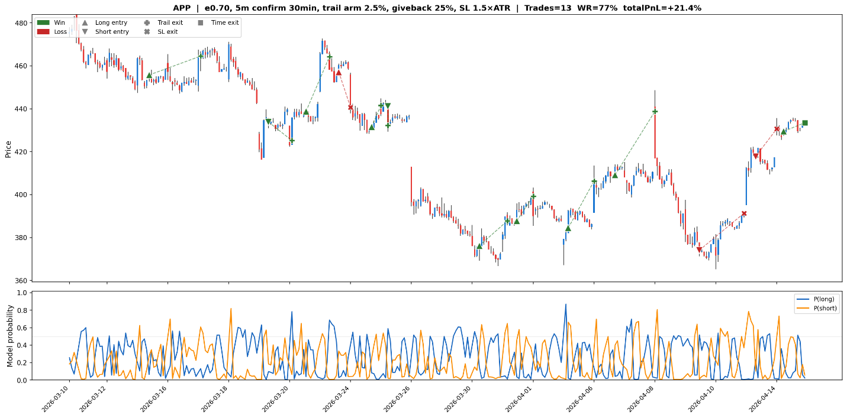

Notes
OOF on ga xgboost probas set removes ~5000 datapoints because of warmup set (5 folds) 34k 29k

Literature Cited
Kumbure, M. M., Lohrmann, C., Luukka, P., & Porras, J. (2022). Machine learning techniques and data for stock market forecasting: A literature review. Expert Systems with Applications, 197(1), 116659. https://doi.org/10.1016/j.eswa.2022.116659
‌

Rezaei, A., Abdellatif, I., & Umar, A. (2025). Towards Economic Sustainability: A Comprehensive Review of Artificial Intelligence and Machine Learning Techniques in Improving the Accuracy of Stock Market Movements. International Journal of Financial Studies, 13(1), 28. https://doi.org/10.3390/ijfs13010028

iTransformer: Inverted Transformers Are Effective for Time Series Forecasting
https://openreview.net/forum?id=JePfAI8fah

GA + XGBoost
https://www.sciencedirect.com/science/article/pii/S0957417421010988?fr=RR-2&ref=pdf_download&rr=9a75ea2e8a53376a

M + A + BiLSTM
https://www.frontiersin.org/journals/applied-mathematics-and-statistics/articles/10.3389/fams.2025.1588202/full

LSTM + GRU
https://pmc.ncbi.nlm.nih.gov/articles/PMC8446482/

Multi-Time frame LSTM
https://www.mdpi.com/2076-3417/10/11/3961

Sentiment Convergence
https://www.mdpi.com/2079-9292/11/2/250

Deep RL
https://www.mdpi.com/2571-5577/6/6/106

Transductive LSTM
https://ieeexplore.ieee.org/abstract/document/10528270

Ensemble with Sentiment Analysis
https://link.springer.com/article/10.1007/s10844-025-00928-6

Monte Carlo Integration
https://ttu-ir.tdl.org/server/api/core/bitstreams/9266039a-4c09-4df7-b188-62a6d742dbd6/content

Loss Landscape Visualization
https://arxiv.org/pdf/1712.09913

