OpenPal
Open source digital image transfer for amateur radio
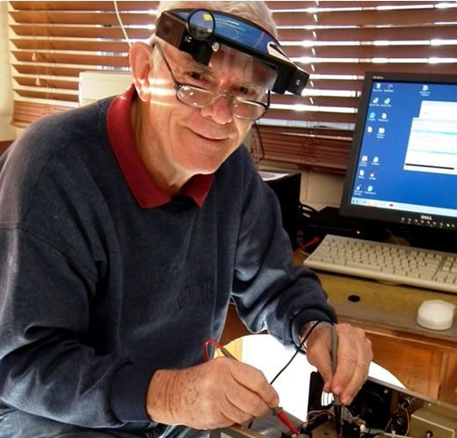
Erik Sundstrup
VK4AES · Silent Key · 14 March 2015
Inventor of EasyPal — Pilot — Engineer — Amateur Radio Pioneer

1. About this document
This document forms part of the OpenPal project — an open source digital image transfer system for amateur radio, written as a tribute to my good friend Erik Sundstrup VK4AES, the inventor of EasyPal. It records Erik's life, his remarkable contributions to amateur radio, and the story of EasyPal, so that his work is not forgotten.
OpenPal is written by Greg Weir VK4GDW and released under the GNU General Public Licence v3.

2. Erik Sundstrup VK4AES — a life in amateur radio

Early years and first licence
On 14 March 2015, amateur radio lost one of its brightest stars. Erik Sundstrup was born in Townsville to Henry and Jean Sundstrup. His father was a doctor who started his career in Brisbane before moving to Wondai and then Townsville with the RAAF, before retiring in Sydney.
"When I was very young, probably only six or seven, we had the children's encyclopaedia that my mother had us all read and there were two things in it that possessed me — one was aeroplanes and the other was radio."
— Erik Sundstrup VK4AES, in his own words
Erik spent time at a boarding school in Brisbane where he taught himself to build crystal sets, then valve radios. He built them so reliably that other students paid him to make radios for them. It was through those early experiments that he first heard amateur radio signals on the air — and was hooked.
A family friend, Bruce Glassop VK2BF, introduced him to the hobby properly. As a schoolboy Erik would ride 25 kilometres each way to visit Bruce's shack, captivated by the equipment.
Erik qualified for his licence before he was old enough to hold one. He had to obtain special permission from the headmaster of Shore School in Sydney — on the condition that he improved his mathematics. He studied hard, topped every maths subject, and on his birthday in 1955 his licence arrived in the post.
VK2AVS First licence, 1955, Middlecove NSW

RAAF pilot and early career
Around 1955–56 Erik joined AWA working on taxi radio systems, quickly heading the radio section. He then joined the Royal Australian Air Force as a pilot — of 35 students on his course, only 12 graduated. Fellow pilot Howard Morris described Erik as an absolute genius, recalling that Erik would spend most of his time relaxed and reading radio magazines, then study briefly before exams only to top the class with 95%.
Erik flew DC3s and Lincoln bombers, was stationed in Malaya on operational service, and while flying at Woomera witnessed an atomic test. In 1963 he moved to Melbourne and joined TAA, where he eventually became a Check Captain on DC-9s and Boeing 727s.
Even at altitude, amateur radio was never far away. On long overnight flights from Melbourne to Perth, Erik would work the world on the aircraft's Collins HF radio — the aerial was a heli-coil on the leading edge of the tail.

A shack wherever he landed
Fellow TAA pilot Clive Harman recalls visiting Erik's home shack in Glenroy, Melbourne, where Erik held the callsign VK3OK. Erik had built a USB transmitter from scratch. Clive writes:
"I can remember watching a demonstration of a USB transmitter he had built, while we both consumed many 807s. All the house lights dimmed."
— Clive Harman, fellow pilot
Erik was later posted to Papua New Guinea with TAA, operating Twin Otters and a DC3 from Lae. After PNG he returned to Adelaide on photographic survey work, then back to Melbourne, eventually settling at Macedon where he erected a 65-foot Metter's tower. Together with Clive, he got into RTTY using decommissioned teleprinters from DCA, then joined a computer club as computers began to emerge.
"Naturally it was difficult and unreliable. There were no amateur radio programs available then, let alone for RTTY, so using our new skills we wrote a RTTY program in basic. Erik converted the slow part to machine code in Hex — no assemblers then — and we were away."
— Clive Harman

Queensland and the birth of EasyPal
After leaving TAA, Erik and his wife Mary purchased Swan Island, Victoria, and began a new adventure. He used wire antennas in the windy island conditions and obtained a private pilot's licence, buying a Cessna to facilitate life on the island. They later moved to Sidmouth, Tasmania, where Erik kept several aircraft including a Subaru 4-seat, a Pitts Special, and eventually built an ultralight. It was on moving to Queensland that Erik obtained the callsign VK4AES.
VK4AES Queensland — final and best-known callsign
It was Clive who introduced Erik to SSTV — buying Erik an SSTV kit at a ham radio meeting. That small purchase set Erik on a path that would occupy the rest of his technical life.
"That got him started on the SSTV system which developed into the complex digital system he finished up writing. He also wrote many programs for amateur radio such as logbooks, PSK, improved RTTY. Erik became obsessed with writing AR programs — all free."
— Clive Harman
Erik's programs could be recognised by the suffix PAL. He developed EasyPal — a digital image transfer application using DRM (Digital Radio Mondiale) encoding that allowed amateur radio operators to send photographs over standard SSB audio channels with robust error correction. EasyPal spread through the VK and international amateur radio community and is still used today.
Erik also suffered a significant loss: his house was destroyed in the Black Wednesday bushfires. He had remarkable highs and lows throughout his life, and carried them all with quiet dignity.

3. EasyPal — what Erik built
EasyPal was a Windows application that wrapped the open-source Dream DRM decoder, adapting the DRM (Digital Radio Mondiale) digital broadcast standard for amateur radio image transmission. Key features included:
· DRM OFDM modulation across a narrow SSB audio passband (300–2700 Hz)
· Reed-Solomon forward error correction with interleaving for burst-fade resilience
· Partial image recovery — even if packets were lost, a usable image could still be decoded
· Bad Segment Request (BSR) — the receiving station could ask the transmitter to re-send only the missing packets
· Compatibility with HF, VHF and UHF links
EasyPal became the definitive digital image mode for amateur radio, used by operators worldwide. Its architecture was decades ahead of its time.

The loss
Erik's EasyPal source code was lost when a lightning strike destroyed his computer and backup media. He was never able to rebuild it. Erik passed away on 14 March 2015.
No one who knew Erik described him as anything other than generous with his knowledge, quiet in manner, and extraordinary in technical ability. His programs — all given freely to the amateur radio community — remain his legacy.

4. OpenPal — continuing Erik's work
OpenPal is a clean-room reimplementation of the concepts Erik pioneered in EasyPal. Written in Python for the Raspberry Pi, it implements:
· OFDM audio modulation — 16 carriers, QPSK, 300–2700 Hz passband
· Reed-Solomon error correction (RS-32) with packet interleaving
· Bad Segment Request (BSR) protocol — retransmit only missing packets
· Automated TX/RX with camera integration and website upload
· GPIO PTT control for embedded RF modules
The initial application is an automated airfield camera link at Mosquito Creek Airfield, Emerald, Central Queensland — transmitting on 434.500 MHz, 70cm band, over a 16.18 km path.
OpenPal is released under the GNU General Public Licence v3 and is dedicated to the memory of Erik Sundstrup VK4AES.

5. Erik's callsign history
VK2AVS First licence — 1955, Middlecove NSW
VK3OK Melbourne / Macedon period — TAA years
P29 Papua New Guinea — TAA operations from Lae
VK4AES Queensland — final and best-known callsign

OpenPal is dedicated to the memory of Erik Sundstrup VK4AES — pilot, engineer, and amateur radio pioneer.
Silent Key · 14 March 2015
Written by Greg Weir VK4GDW

