**VIET NAM NATIONAL UNIVERSITY,HO CHI MINH CITY**

**UNIVERSITY OF SCIENCE**

**FACULTY OF: INFORMATION TECHNOLOGY**



**Project report**

**| Instructor |**

**Mr. Trương Toàn Thịnh**

**Mr. Nguyễn Lê Hoàng Dũng**

**Mr. Mai Anh Tuấn**

**Mr. Nguyễn Thành An**

Hồ Chí Minh city – 2021

Caro Game

Contents

How to play. 3

1) Starting up. 3

2) Play game. 3

3) Save game. 5

4) Load game. 6

5) Instruction. 7

6) Exit. 7

Note. 8

Implementation. 8

1) Set up common variables, structure, functions. 8

***a.*** ***In use library.*** 8

***b.*** ***Global variables.*** 8

***c.*** ***Common Functions*** 10

2) Menu and in-game screen. 12

3) Processing the game. 13

4) Saving the game. 17

5) Loading game. 21

6) The main function. 24

# How to play.

1. **Starting up.**

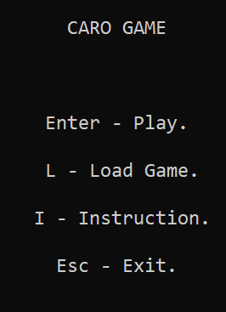

* When the game starts up, the main menu should be display on the user’s screen and each option all have its respective input precede of it.
* From this, player can choose which option they want to:
  + Start a new game.
  + Load a game from files..
  + Read instruction *“How to play”*.
  + Exit the game.

1. **Play game.**

To start the game, press the *Enter* button while on the main menu. The table of the chess should be appeared:

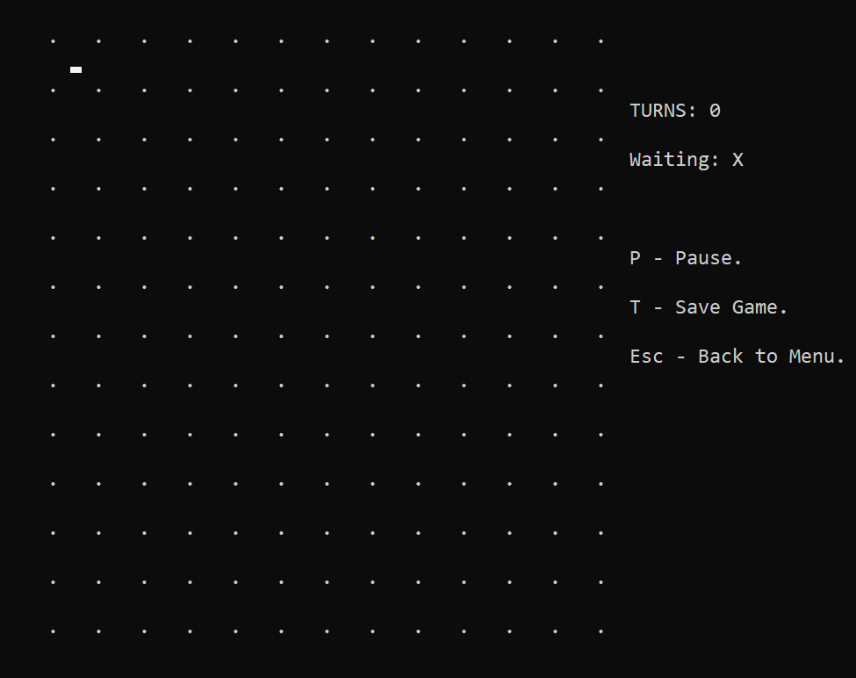

* Now, you can play the game by using *W / A / S / D* to move the curent cursor up / left / down / right and *Enter* to make a move in the current cell.
* From the most left side, there are some indexes, and some addictional operations when the players are playing the game.
  + The value after the *TURNS:* is the number of moves that players have been made.
  + The symbols *‘X’* or *‘O’* after the *Waiting:* shows the current turn of X or O player.
  + 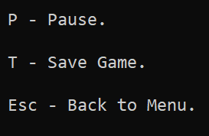Some accessibilities that players can use while playing the game by pressing the respective button like:
    - *P* – to pause the game
    - *T* – to save the current process into a file.
    - *Esc* – Return to the main menu.

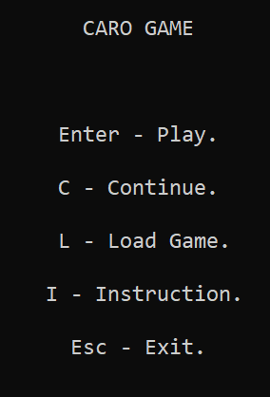

* When the player press *Esc* while in a game, it will bring back to the main menu and this time, it will appear the *‘C - Continue’* option:
* So to come back to the game, simily press *C* and the game should be loaded up again.

1. **Save game.**

While players want to stop playing but the game has not finished yet. Player can press the *T* button to open the save game menu.

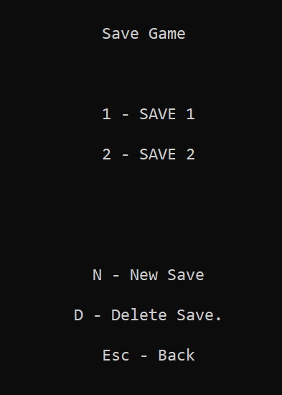

* From here, the user is allowed to choose the way to save the process.
* If the there is no file yet, the program should display *“EMPTY!”*. **
* If the user wants to save into an existed savefile, simply press the niche file’s index to overwrite into it.
* Player can save the process into a brand new file by pressing *“N”* **. It should start creating a new savefile with the following index of the previous file.
* When the a saving action is made, the progress bar should be displayed. 
* If the process of saving is done properly, it should display the “SUCCEED!” message. 
* The user can also delete a file by using the *‘D’* button . The deleting savefile menu should be display:

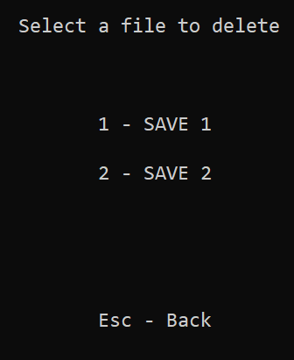

* From here, the user can select the file by pressing the respective index of it to delete. If they want to go back, just simply press the *Esc*.
* When the user are done, just press the *Esc* button to back to the game. 

1. **Load game.**

To load the game, press the *L* button while on the main menu. The load game menu should be appeared:

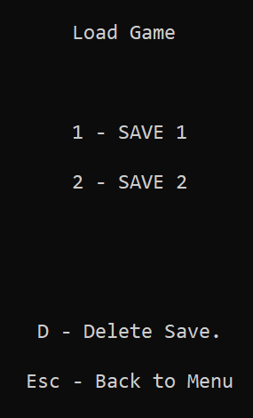

* From here, the user is allowed to choose the savefile to load.
* The user can also delete a file by using the *‘D’* button . The deleting savefile process in load game is similar with save game.
* When the a saving action is made, the progress bar should be displayed . When it is done, the chess board should be displayed on screen and players can continue playing.

1. **Instruction.**

To get to know how to play the game, press the *I* button while on the main menu. The *“HOW TO PLAY”* tab should be appeared:

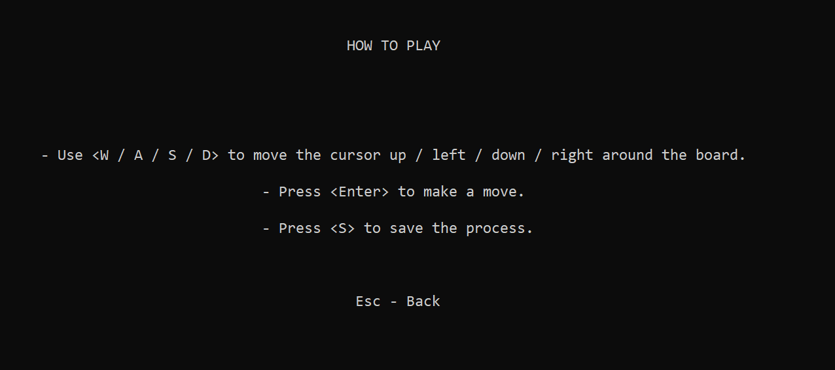

1. **Exit.**

To exit the game, press the *Esc* button while on the main menu. The message  will pop up on the screen and the program will terminate.

# Note.

* + - **Files.**
    - The game source code file is *main.cpp*.
    - Some save files: *SAVE X.txt* and *SAVE AUTO.txt*.
    - **Classify functions.**
* All the functions are classified in one specific group for easily managing and maintaining.
  + - **Saving files.**
* 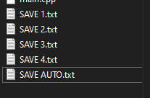All the progress saved files are text files and have the same name format - *“SAVE [FILE_NUM].txt”*.
* Except for the auto save file is always have the name - *“SAVE AUTO.txt”*.
* Other text files with different name formats will not be read whatsoever.
* The auto save is just a temporary save is easily got replaced.

# Implementation.

1. **Set up common variables, structure, functions.**
   1. ***In use library.***

Before starting the implementation, there are 6 built-in library that will be needed to use many utility functions in the process of developing the game include: *iostream.h*, *conio.h*, *windows.h*,*fstream, vector, sstream*.

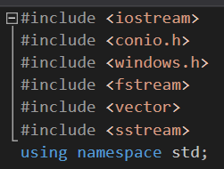

* 1. ***Global variables.***
     + **Const variables.**

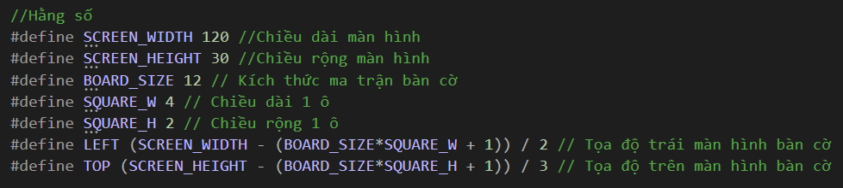

* *#define SCREEN_WIDTH 120*–width of the screen[1].
* *#define SCREEN_HEIGHT 30 –* height of the screen1.
* *#define BOARD_SIZE 12*-definding the size of the square chessboard (The default is 12x12).
* *#define SQUARE_W 4* – width of a square chess piece.
* *#define SQUARE_H 2* – height of a square chess piece.
* *#define LEFT (SCREEN_WIDTH - (BOARD_SIZE*4 + 1)) / 2*–is the coordinate from the left of the screen.
* *#define TOP (SCREEN_HEIGHT - (BOARD_SIZE*2 + 1)) / 3 -* is the coordinate from the top of the screen.
  + - **Utility Variables and Structures.**

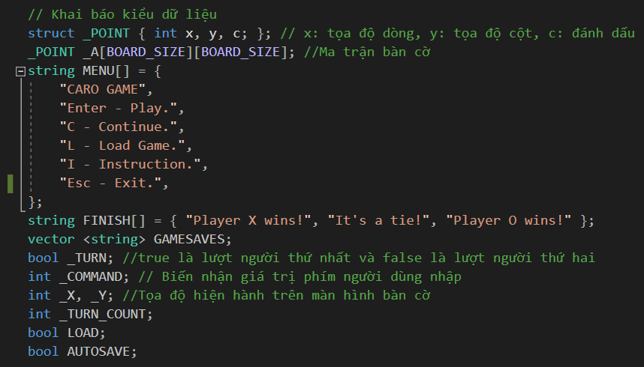

* *struct _POINT { int x, y, c; };* - define the pointer structure that has 2 integer coordinate *x*, *y* and the *c* will represent whether the cell is checked or not.
* *_POINT _A[BOARD_SIZE][BOARD_SIZE];* - The 2D array that contains elements and each elements stand for 1 chess piece.
* *string MENU[] = {…};* - The strings that need to be print on screen when user is at the menu.
* *string FINISH[] = {…};* - The strings that need to be print on screen when the game is over.
* *vector <string> GAMESAVES;* - a 1D vector array which elements contain a name of the save files that is currently available.
* *bool _TURN;* - to know which player’s current turn. (1 is X, 0 is O)
* *int _COMMAND; -* contains that user typed in.
* *int _X, _Y;* - The current x and y coordinate in the game.
* *int _TURN_COUNT;* - contains the number of moves has made.
* *bool LOAD;* - notifies the program to load from a file do not to reset the data.
* *bool AUTOSAVE;* - if it is true, it means that the file *“SAVE AUTO.txt”* is available.
  1. ***Common Functions***

*void FixConsoleWindow()*

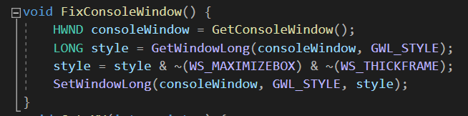

* This function will force the console window to be fixed for the players cannot resize the window while the game is running.

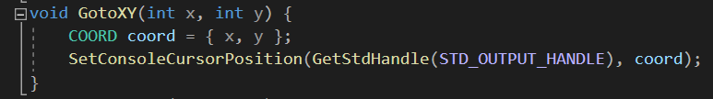

* Jump to the respective x and y coordinate to print on screen something.

*void ResetData();*

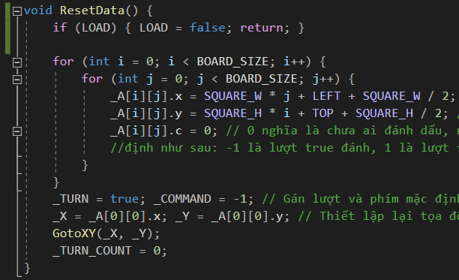

* Set up and initialize every global variables and the board array.
* The first if statement is used to notify the program to know that it is loading from the file, do not reinitialize the data.

*bool StartGame();*

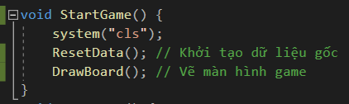

* A warp function will be in the process every time the program starts a game to make sure every thing is set up.

*Moving cursor functions*

* 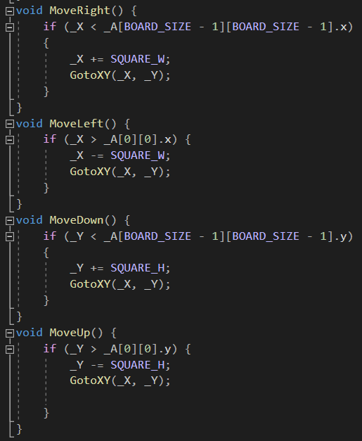These functions is executed while the player traversing along squares.
* They increase the cursor‘s current position value along X-axis or Y-axis every time the player make a move.

1. **Menu and in-game screen.**

*void DrawMenu();*

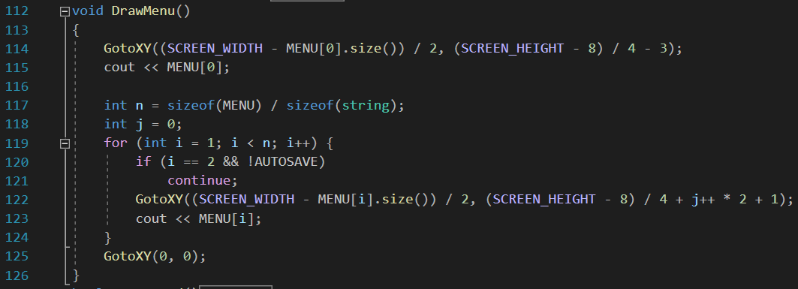

* Display all the strings of the menu on the screen whenever the user is at the menu.
* It use *GotoXY* functions to jump to a niche coordinates on the screen to print the strings.
* The first two lines print out the game name and the for loop prints the rest of the menu strings.
* The string on *MENU[2]* *("C - Continue.")* will only be printed when the auto save file is available. The if *(line 120 - 121)* will recognize and refuse to print the string.

*bool DrawBoard();*

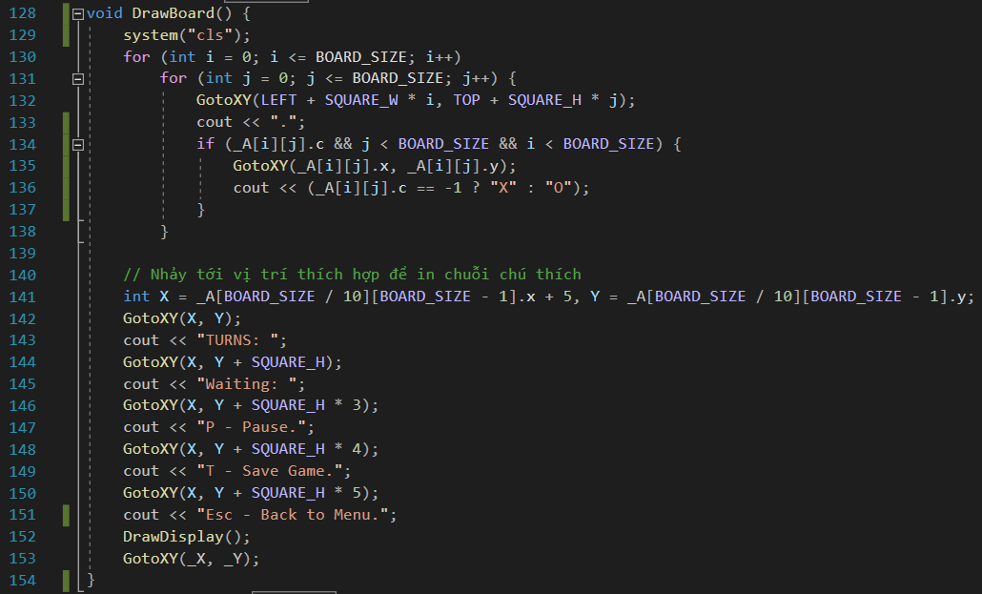

* The first part of this function will handle the process of print the board *(line 129 - 138)* by using a dot as the boundary between square chess pieces.
* The second part display the necessary displayments for indexes or supportive interface for the userto interact. *(line 141 – 153)*.

1. **Processing the game.**

*int CheckBoard(int pX, int pY)*

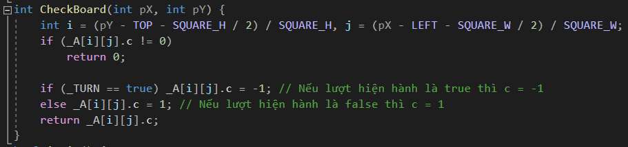

* Is used to check whether the player makes the move on the available square. If so, it will change it into a checked square. If not, it will do nothing and return 0.

*int ProcessFinish(int pWhoWin)*

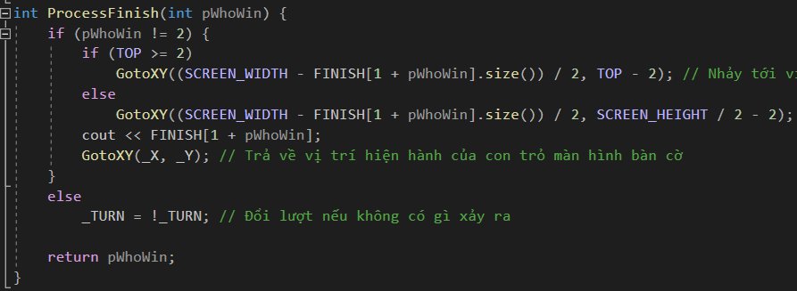

* Print out the *FINISH* strings when the game is finish.
* If no player has won, the game will switch turn and continue.

*bool isWin()*

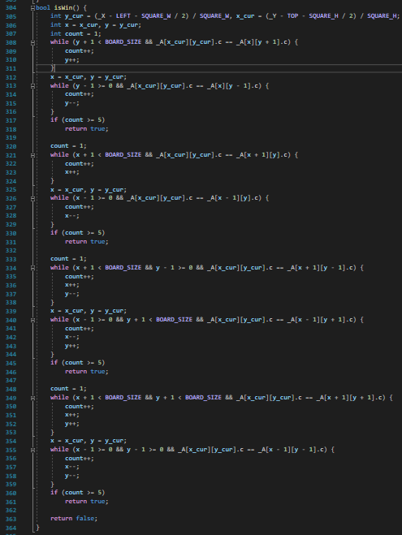

* The algorithm that return the winner by checking all the cases:
  + *line (308 – 318)* check 5 consecutive cells along the vertical row.
  + *line (320 – 331)* check 5 consecutive cells along the horizontal row.
  + *line (333 – 346)* check 5 consecutive cells along the sub diagonal.
  + *line (348 – 361)* check 5 consecutive cells along the main diagonal.
  + If none of the cases above are true, it mean no player has won yet.

*int TestBoard()*

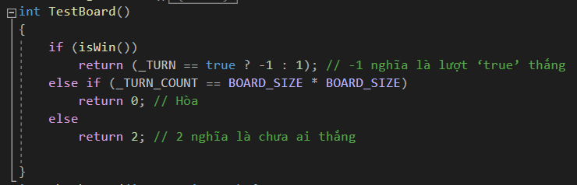

* Depend on the winner that is returned from the *isWin()* functions to decide the action.
* If the number of turns are equal with the number of squares *(BOARD_SIZE* BOARD_SIZE)* so it must be a tie.
* If none of the above, it will return 2 which mean no player has won.

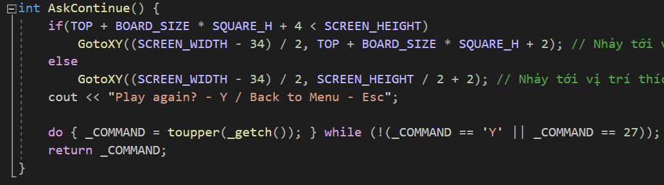

* Everytime after a game is over, the program will let the players to choose whether they want to play again or return to the menu by using this function.
* The input must be *‘Y’/’y’* or ‘*N’/’n’* to select the option.
* The return will be the option of the players.

*void PlayGame()*

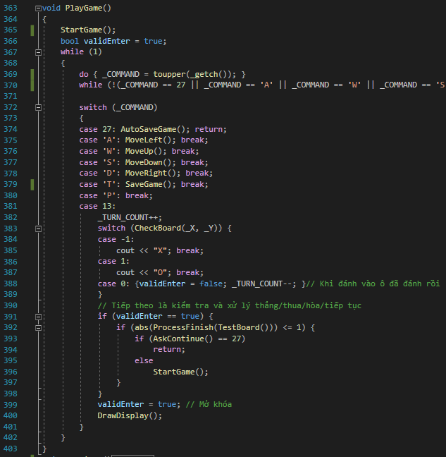

* When the user choose to play a new game. This function will be executed.
* First, It will build the game by running the *StartGame()* functions
* Then, it start receiving player inputs through the *_COMMAND* variable and make the right move for each input by using switch statement.
* If the _COMMAND contains one of the four moving keys *(‘W’, ‘A’, ‘S’, ‘D’)*, the moving cursor functions will be executed.
* The others will be executed with the respective functions like *‘T’* is for saving the game, *‘Esc’/27* is for automatically saving and back to the menu.
* If the _COMMAND contains the enter key (13), It mean that the player want to make a move in a specific square. So the process of handling it will be operated:
  + *(line 387 - 394)* the _TURN_COUNT will count up 1 index, next it will use *CheckBoard* function to check if the move is valid to print the mark or reduce the turn counter back.
  + *(line 396 – 404)* If the move is in a valid cell, it will continue to check whether the game is over by calling the *TestBoard()* and *ProcessFinish()* functions to process the conclusion. Then, It will call *AskContinue()* to take the player’s permission to start the game again.
* Afterall, the DrawDisplay() is called to update the utility indexes.

1. **Saving the game.**

*void SetUpGameSaves()*

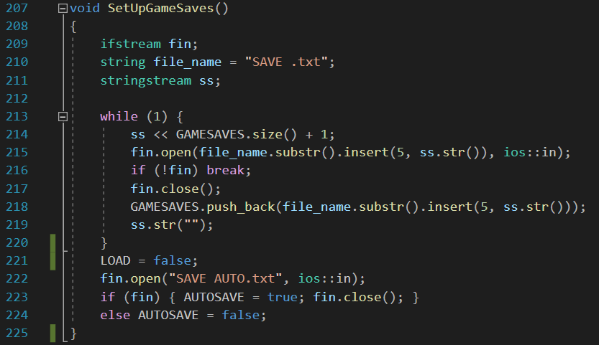

* This function will set up all the concepts of saving when the program first executes:
  + *(line 213 – 220)* to check and make all the valid existed save files appears available by pushing back the name strings into the *GAMESAVES* vector.
  + *(line 263 – 266)* to check whether the auto save file is currently exist or not.

*void SaveGame()*

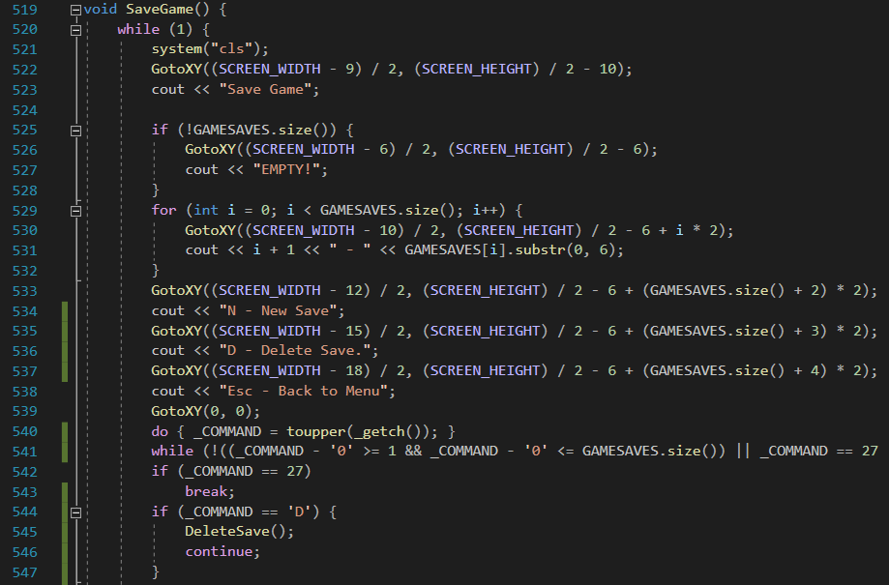

* The first part of the function prints out all the save files for the user to choose which file they want to save into or make a new save file.
* N is for creating a new save file, D is for deleting a save file.
* If there is no save file left. The *”EMPTY!”* notification will be displayed instead of the file names.

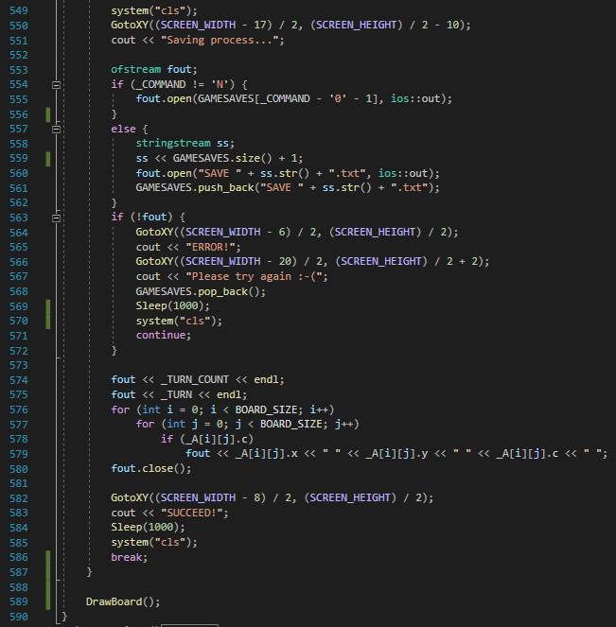

* After, the player has entered the file number, the process of saving will be executed:
  + *(line 554 – 563)* the function will try to open the user’s file name. However, if the user want to save into a new file, the function will create the new file with the following index number automatically.
  + *(line 564 – 572)* checks whether the file is opened properly. If the file is corrupted and can not be read, the ”ERROR!” notification will be displayed.
  + *(line 574 – 579)* prints out the all the process of the game with a specific format:

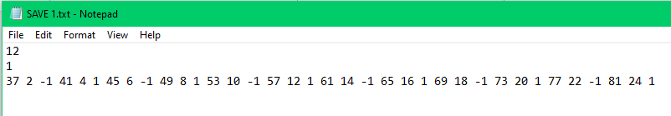

* + - The first line is the number of moves the players has made (_TURN_COUNT).
    - The second line is the player’s current turn (_TURN).
    - The last line is a long string of numbers each 3 number are the indexes of a cell, include the x and y coordinates and the value that represents the square is checked by which player.
* If the process of saving works properly, the ”SUCCEED!” notification will be displayed.

*void DeleteSave()*

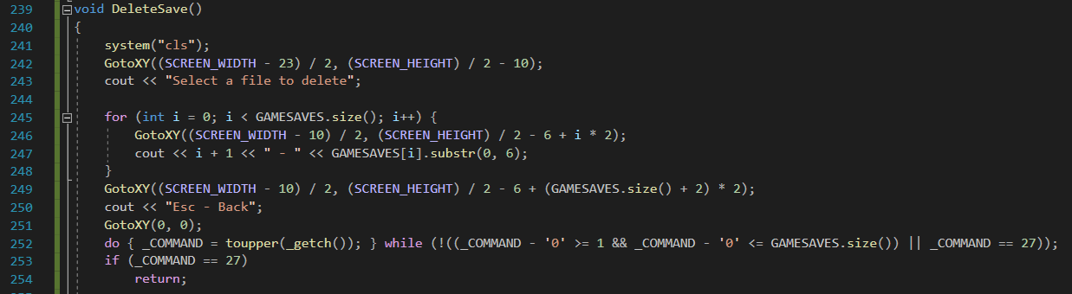

* The first part of the function prints out all the save files for the user to choose which file they want to delete.
* If there is no save file left. The *”EMPTY!”* notification will be displayed instead of the file names.
* Esc will bring back to the previous files menu.

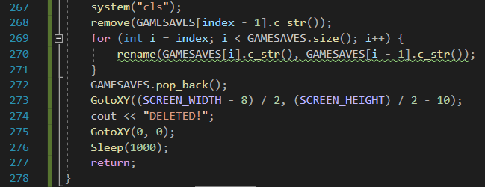

* Next, it will delete the file with the respective user’s input name.
* Then, the for loop will rename files in order to make a sequence of files with consecutive indexes and pop back the last element in the vector array.
* When it is done, the program will display *“DELETED!”*.

*void AutoSaveGame()*

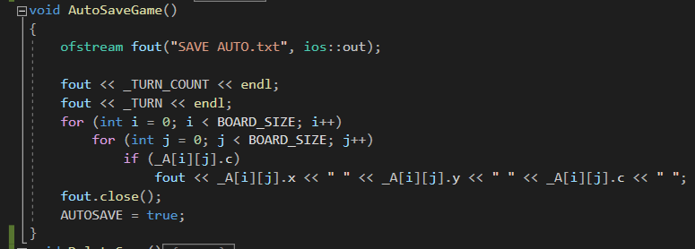

* This special function will help the players get back to the game after they return to the menu by save automatically.
* The file’s name contains the process is different from the rest which is *“SAVE AUTO.txt”*.
* The process is similar with the normal saving process above.
* After saving properly, the *AUTOSAVE* must be change into true which is necessary for the program to know the autosave file have been available.

1. **Loading game.**

*void LoadGame()*

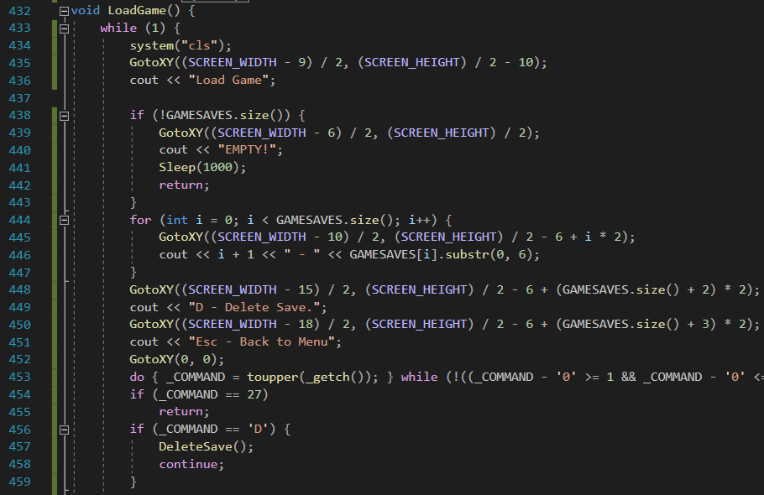

* The first part of the function prints out all the save files for the user to choose which file they want to load.
* D is for deleting a save file.
* If there is no save file left. The *”EMPTY!”* notification will be displayed instead of the file names and return back to menu.

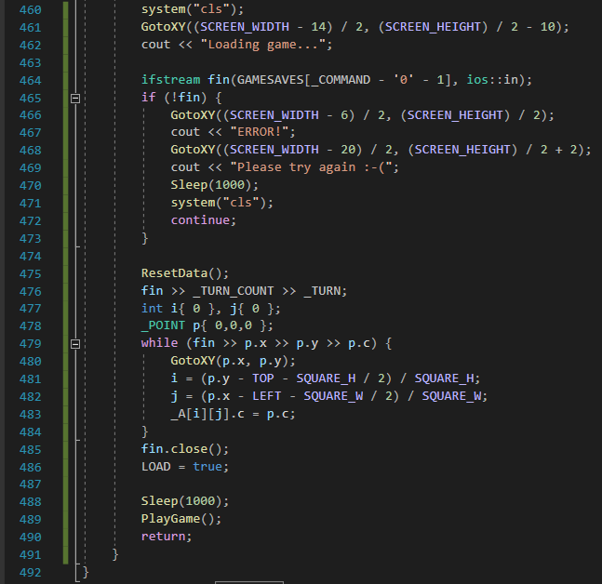

* After, the player has entered the file number, the process of saving will be executed:
  + *(line 464)* the function will try to open the user’s file name.
  + *(line 465 – 474)* checks whether the file is opened properly. If the file is corrupted and can not be read, the ”ERROR!” notification will be displayed.
  + *(line 475 – 486)* reset data and read all the all the process of the game with a specific format:



* + - The first line is the number of moves the players has made (_TURN_COUNT).
    - The second line is the player’s current turn (_TURN).
    - The last line is a long string of numbers each 3 number are the indexes of a cell, include the x and y coordinates and the value that represents the square is checked by which player.
* Also, change the *LOAD* into true so that it will not reset the data after read the file.

*void Continue()*

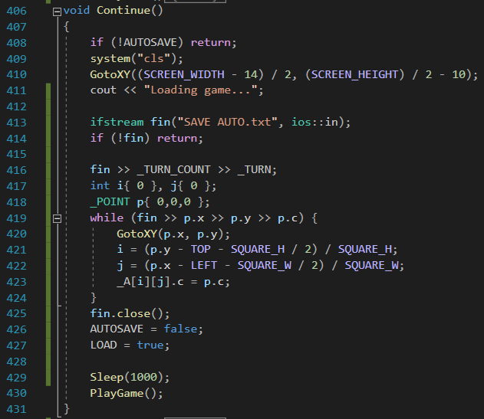

* The *Continue()* is one of the main operation at the menu.
* It helps players to load back the process where they have left off after pressing *Esc* by reading the *“SAVE AUTO.txt”* file.
* The process and format of reading the file is very similar to the *LoadGame()* function.
* After reading the file properly, change *AUTOSAVE* to false to make the file unavailable and *LOAD* to true to start the game with the load from file mode.

1. **The main function.**

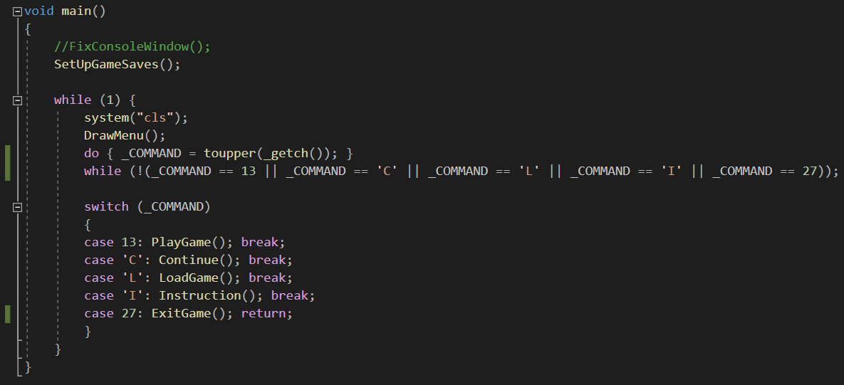

1. The size of the screen is depend the current console screen size of user. Typically, It have the size of 120x30.